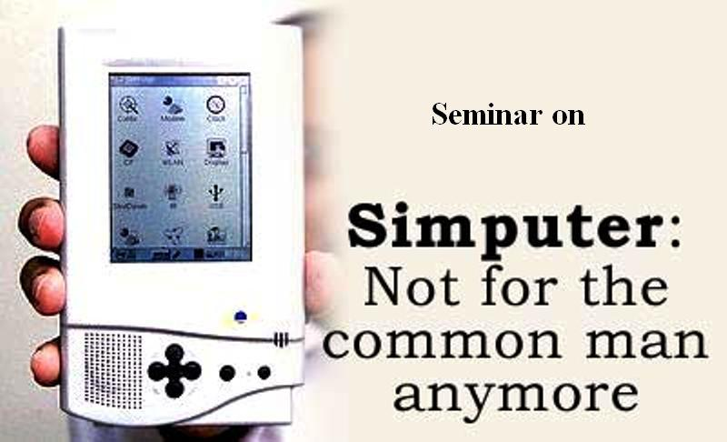

Prepared By:
Gajera Jimesh G.
(6020)
Index

1. Introduction 4
2. Just what is a SIMPUTER? 6
3. History 7
4. SIMPUTER Licensing 8
5. SIMPUTER Specification 9
6. Interfaces 10
7. Bundled Software 11
8. Features OF SIMPUTER 12
8.1 Text-to-Speech
8.2 Linux OS
8.3 Hand writing
8.4 Interfacing
8.5 Smart Cars reader/writer
8.6 Scribble Pad
9. Deployment 14
10. Success Inhibitors 15
10.1 Poor’s man computer
10.2 Lack of support from Government and NGO’s
10.3 License Cost
10.4 Comparisons with PDAs
10.5 Cost of Laptops
11. Some Questions related to Simputer 17
12. Some working area of Simputer 19
13. Conclusion 21
14. Biblography 22

1. Introduction:

The Simputer is a self-contained, open hardware handheld computer, designed for use in environments where computing devices such as personal computers are deemed inappropriate. PicoPeta Simputers Pvt. Ltd unveils Amida Simputer for the retail market.
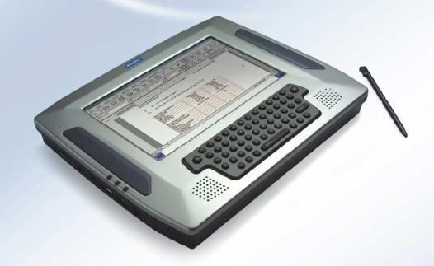
Fig. 1 Simputers
It's simple, it's portable. At about Rs. 9,000 per piece, it's highly affordable. It is compatible with your everyday PC, helps you check e-mail, browse the Net, keep accounts, and get information. When the invention of the Simputer (Simple Computer) was announced in 2001, it instantly captured the imagination of the world. The venerable New York Times called it the most important invention of 2001 ahead of Apples G4 and Microsoft’s Windows XP operating system. Here was a computer that was rewriting every rule associated with computers.
The goal of the Simputer project is to harness the potential of Information and Communication Technology (ICT) for the benefit of the weakest sections of society. The software developed by the Simputer Trust will be under GNU GPL and the hardware developed will be under Simputer General Public License (SGPL). The Simputer is a low cost portable alternative to PCs, by which the benefits of IT can reach the common man.
It has a special role in the third world because it ensures that illiteracy is no longer a barrier to handling a computer. The key to bridging the digital divide is to have shared devices that permit truly simple and natural user interfaces based on sight, touch and audio. The Simputer meets these demands through a browser for the Information Markup Language (IML). IML has been created to provide a uniform experience to users and to allow rapid development of solutions on any platform.
“The Simputer a cheap, pocket-sized computing device designed for use by rural populations in India has been hailed as a breakthrough in bringing the world of computing to the poor”.

2. Just what is a SIMPUTER?:

What exactly is the Simputer? Put quite simply, it is more complex and powerful than a palm top.
For example, in terms of screen size (320x240), memory capabilities (32MB RAM) and the OS (GNU/Linux). It runs on an Intel strong-arm chip. The chip is known for its low power consumption. The Simputer runs on three AAA batteries or off the mains. It can also use rechargeable batteries, but the charger is not built in. Thus, the Simputer is basically a low-cost computer with multiple connectivity options. It will be modular and based entirely on free software from the Open Source Initiative. Its primary input will be a touch-sensitive overlay on the LCD display panel.
The primary application interface would be a browser that can render the Information Markup Language. IML is a new XML application being designed specifically for handheld devices like the Simputer. The use of XML-based language is in line with the philosophy of utilizing global Internet standards. To the rural Indian poor, and even to most city dwellers, a computer is probably as remote an option as a trip to the moon. But things are about to change.

3. History:

The Simputer project was conceived during the organization of the Global Village, an International Seminar on Information Technology for Developing Countries, conducted during Bangalore IT.com event in October 1998.
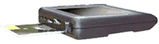

Fig 2. Simputer Layout
A discussion paper highlights the need for a low-cost mass access device that will bring local-language IT to the masses. The initial concept paper (PDF version) expanding on the initial discussions introduced the term Simputer as an obvious twist on the word Computer. For the purpose of establishing originality, a slightly more complex acronym was invented to fit the name Simputer: Simple, Inexpensive, Multi-lingual computer. And finally in order to appeal to computer geeks, ridiculously complex recursive acronym was also coined: Simputer: SIMPLE COMPUTER, which expands to Simple, In-expensive Multi-lingual PeopLE's compUTER. The concept paper outlines the technical requirements of the Simputer as well as the applications. However, this paper is quite dated, and useful only as a historic reference.
The writing of the Bangalore Declaration on Information technology for developing countries clarified and fortified the concept of the Simputer and its role in the larger picture. A few items in the Declaration, specifically highlight the role for a Simputer-like device.

4. SIMPUTER Licensing:

The system software of the Simputer, since it is Linux based is under GPL. We have been working on a license similar to the GPL, but applicable to hardware. We realized, after considerable discussions, that hardware has a significant difference that precludes the possibility of using a simple extension of the software GPL. We now have the first draft of the Simputer General Public License (SGPL) that we believe to be a practicable license which at the same time facilitates the rapid spread of Simputers.
The SGPL has been reviewed further and the new version is now ready. The Simputer General Public License
The hardware specifications of the Simputer can be downloaded only under SGPL. The SGPL permits anyone to build devices out of the downloaded specification. However, once a product is ready for commercialization, one of two possible licenses needs to be obtained from the Simputer Trust. These are
- The Simputer Device Manufacturing License.
The Simputer manufacturing License refers to a Core Simputer Specification, a functional description of the Simputer to be specified by the Simputer Trust and which evolves with the development of the Simputer.

5. SIMPUTER Specification:

Specifications
CPU | Intel PXA 255 processor @ 200 MHz
Memory | 64 MB of SDRAM  32 MB Flash memory
Display Options | Advanced TFT Colour with white LED backlight
Input Device | Touch tablet overlay on LCD
Audio Interface | Audio Codec with integrated speaker & microphone
Smartcard Interface | Integrated Smartcard Reader/Writer
Connectivity | Debug Serial  USB Slave  USB Master
Connectivity Options | IrDA  Integrated 56 Kbps Modem (V.90)  RS232 Communication
Power Supply | Li Polymer rechargeable batteries  Internal charge management  External AC adapter
System Software | Linux Kernel 2.x.x  XWindows  GTK Support  TCP/IP, FTP, Telnet, HTTP (Dillo Web browser)  SCEZ Smartcard Framework  Indian Language support, PC Sync Software

6. Interfaces:

- Touch panel overlay on liquid-crystal display.
- Speaker and microphone jacks
- Smart-card connector.
- USB connector (to function as host or device)
- Serial port
- Infrared Data Association (IrDA) port
- Grayscale /Super-twisted nematic display (STN)/Thin-film transistor (TFT) (depends on model and manufacturer).
- Multi-I/O connector (in Encore's Simputer) giving additional (slave) USB, and optional modem/VGA interfaces

7. Bundled Software:

The Simputer uses the Linux kernel (2.4.18 Kernel as of July 2005), and the Alchemy Window Manager (only the Amida Simputer). Software packages included provide:
- Scheduling (Amida Simputer only)
- Calendar (Amida Simputer only)
- Voice Recording and Playback (High quality compression on Amida Simputer only)
- Khatha (A simple spreadsheet) (Amida Simputer only)
- Internet and network connectivity
- Web browsing and email.
- an e-Library (Amida Simputer only)
- Games (in the Amida Simputer), including Chess, Breakout and Golgoli (a game that makes use of the accelerometer in the Amida Simputer).
- Java ME and Dot GNU (a free software implementation of .NET) are also available
- Encore also has a FLASH player available
In addition, both licensees developed custom vertical applications for micro banking, traffic police, medical applications, etc. Alchemy user interface used by the Amida Simputer has been released under the GPL with the name "Open Alchemy".

8. Features OF SIMPUTER:

8.1 Text-to-Speech.
It includes Text-to-Speech software. It is a kind of speech recognition, and you all know about this, Microsoft is still struggling to give accuracy in this technology.
8.2 Linux OS.
It runs GNU/Linux Operating System.
8.3 Hand writing.
Amida allows you to write on every screen using stylus and send such writings by mail. This is the world’s first instance of any computer permitting annotation and e-mailing. One can write in any language, so far the first time the knowledge of english is not pre-requisite to use hand held computers.
8.4 Interfacing.
Our Amida Simputer can be connected to a CDMA mobile phone and is used to browse the internet- while moving. This has two USB slots and opens the door to a wide variety of USB- compatible devices. Amida also connects to GSM and GPRS enabled phones for network connectivity, being enabled to connect to WiFi. Twin USB ports allow Amida to be connected to a range of HP and Epson printers as well as allow small portable battery operated printers to be connected for bill printing purposes.
8.5 Smart Cars reader/writer.
World’s first hand held computer that has built-in integrated Smart Card reader/writer.
8.6 Scribble Pad.
Doodle or take down a diagram during a meeting. With your own hand, draw diagram and save it in your Amida.
“Is your iPhone has all such features?” Hand writing and e-mailing, text to speech built-in, Scribble pad, Smart card reader/writer, have you ever found such a great device?
Yes this is all about our Amida designed and developed by our scientists. You might observed that i compared this with iPhone and you might feel that I am wrong because iPhone is a mobile phone and Amida simputer is a hand held computer, so I should not compare the both. I just compared the features that are there in Amida but not there in any other device in this world. Only Amida simputer has all.
“Why iPhone is so popular? Why not simputer?” as you know there are so many advanced features hidden in Amida, then why it is not popular? Infact most of the people are not even know about this, I am still in search of answer….

9. Deployment:

- Simputers were extensively used by the Government of Karnataka to automate the process of land records procurement.
- In 2005 they were used in a variety of innovative and interesting applications, such as automobile engine diagnostics (Mahindra and Mahindra in Mumbai).
- Used for Electronic Money transfer between UK, Ghana and others.
- Recently simputers are deployed by police force to track traffic offenders and issue traffic tickets.
- Used by Indian Military.

10. Success Inhibitors:

By 2005, sales of Simputers failed to live up to the ambitious goal of selling 50,000 units: only 4000 Simputers were sold .

10.1 Poor’s man computer
A reason often stated is that the poor have no need of computers before their basic needs (such as electricity) are met. However, the Simputer was never designed to be a "poor man's computer" (a position often used by the media)- it was a device designed to help bridge the digital divide. While most people tended to look at the cost of the Simputer as a factor, they ignored the fact that the "cost of ownership" for the end-user of the device in villages was not the cost of the device, but the cost of the Smart card used to store the user's data. The device itself should be considered shared infrastructure for the village.

10.2 Lack of support from Government and NGO’s
Another reason may be that lack of purchasing by the Indian government and NGOs (as earlier committed) led to lack of adoption in the field.

10.3 License Cost
The SGPL, the license under which simputer is marketed, asks for a license fee of 1 Million Indian Rupee to commercially exploit the Simputer design. This was perceived to be a high entry point for small scale organizations wishing to license the Simputer design.

10.4 Comparisons with PDAs
While the Simputer is not cheap when compared to PDAs available in the market at the time, this point is largely irrelevant, as it was not designed to be a PDA (which are used as PC companions) but as a standalone computer. The comparison with PDAs was a natural outcome because of the form-factor (and, to some degree, reports by the media).

10.5 Cost of Laptops
The decrease of prices of laptop computers may have reduced the Simputer's price competitiveness.

11. Some Questions related to Simputer:

- Q: Is the Simputer like a PC?
A: No. The Simputer is *NOT* a personal computer. It could however be a pocket computer.

- Q: Is the Simputer like a Palm?
A: Again no! The Simputer is much more powerful than a Palm. For example, in terms of screen size (320x240), memory capabilities (32MB RAM) and the OS (GNU/Linux).

- Q: How do I enter text? Can I attach a keyboard?
A: There are two options on the base simputer for entering text:
one is a soft keyboard, that can be brought up on the touch screen and you poke at it to enter one character at a time.
The second option is to use a novel character entry software called tap-a-tap which is similar in spirit to graffiti, but quite distinct (no patent infringement :-). But if you insist on entering tons of text using the Simputer, you may be able to attach a USB keyboard. We don't recommend the Simputer as a mass data-entry device.

- Q: What features set the Simputer apart from other handhelds?
A: The smart card reader in the Simputer. The Information Markup Language (IML) that is (amongst other things) smart card aware. The use of extensive audio in the form of text-to-speech and audio snippets.

- Q: What will the Simputer cost?
A: We expect the Simputer to cost about Rs 9000 when the volumes are upwards 100,000 units.

- Q: What processor does the Simputer run on?
A: It runs on an Intel strong-arm chip. The chip is known for its low power consumption.

- Q: What does the simputer run on?
A: Three AAA batteries or off the mains. It can also use rechargeable batteries, but the charger is not built in.

12. Some working area of Simputer:

- FORM-FILLING

I want to reserve a train ticket to Mumbai.
  - Use the Simputer to submit a reservation form.

- COMMUNICATION

Can I meet the Tahsildar today?
  - Use your Simputer to check his availability. You don’t have to trek ten km to find out.

E-mail, voice-mail to near & dear
  - Use the Simputer to send / receive

- MONEY ORDER

Dear Postman, can I withdraw Rs 100 from my account?
  - Your money order e-transaction has arrived on my Simputer. Let me credit your smart card first.

- EDUCATION / LITERACY

  - Simputer’s high-resolution display facilitates images, local-language text. Combined with audio files and text-to-speech in local languages, this will facilitate literacy, self-learning

- MICRO-BANKING

Use the Simputer to take banking to the individual’s doorstep, not the other way around. On-the-spot receipts electronically generated.

- RURAL HEALTH STATISTICS

State Health Depatments can empower their health workers with Simputers for collection of health statistics in the villages, regardless of location.

- HEALTH

Portable Ultrasound
Telemedicine

- DRINKING WATER

Simputer with appropriate sensor interfaces can facilitate quality checks

- POLICE

Information Retrieval
FIRs
Criminal records

- COMMUNITY KIOSKS

Public Services
Land Records
Utilities payments
Information dissemination

13. Conclusion:

Simputer is a low-cost multilingual, mass access handheld device that uses Indian language user interfaces to provide information technology based services to the multilingual population of India.

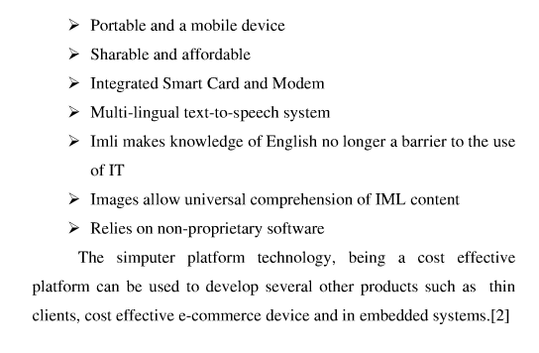

14. Biblography:

http://www.simputer.org/

http://en.wikipedia.org/wiki/Simputer

http://www.ncoretech.com/products/ia/simputer/index.html

http://www.scidev.net/en/features/simputer-computers-for-the-poor-or-an-idealistic.html

