I am Shantanu, a product manager, currently building AI Factory business unit at HCLTech.

This is my portfolio/profile website... here I have mentioned all career, education, what/how I think, project, experiences, etc.

This particular document is about my learning while building this portfolio website.

It is a basic website I vibe coded using Claude code. it is hosted right now on GitHub pages. I plan to buy a domain for myself and host it there in few a months...

this project is connected with GitHub as well. Whenever I am making changes to the index file, I keep on pushing it to the GitHub.

Now I evaluated portfolio site from SEO pov. Hence, Now I am trying to connect it to google search console.
google search console gives the google site verification meta tag which I included in the index file after that on search console, we need to request indexing as well.

Basically

• Search Console = tells Google your site exists and to index it

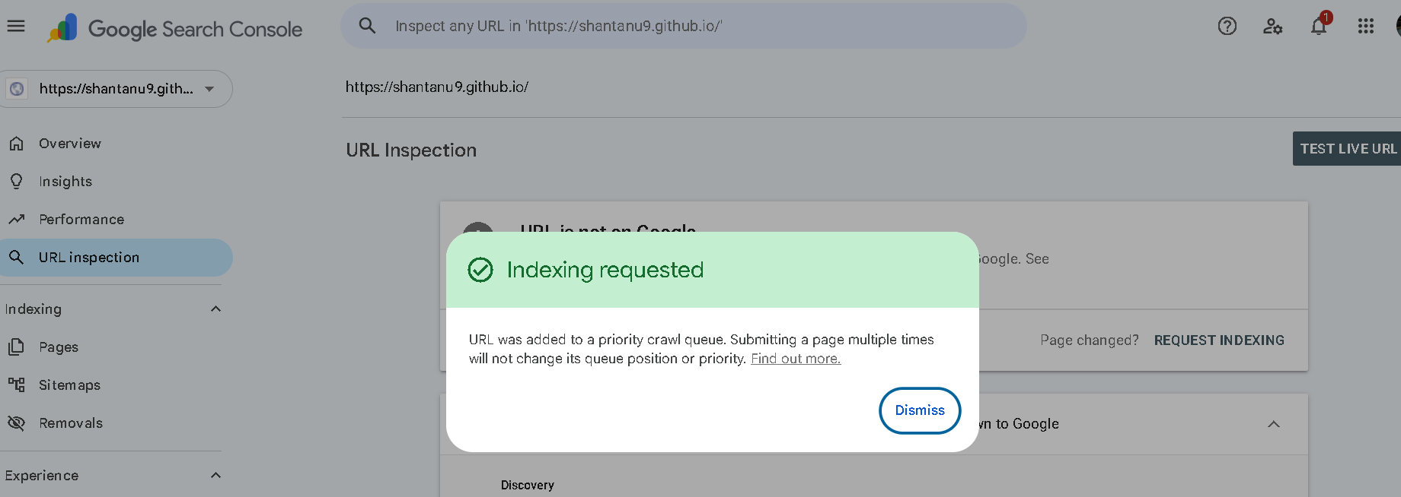

• Google Analytics = tracks visitors once they land on your site

After creating the google analytics account and the property…

Add the google tag in the index html

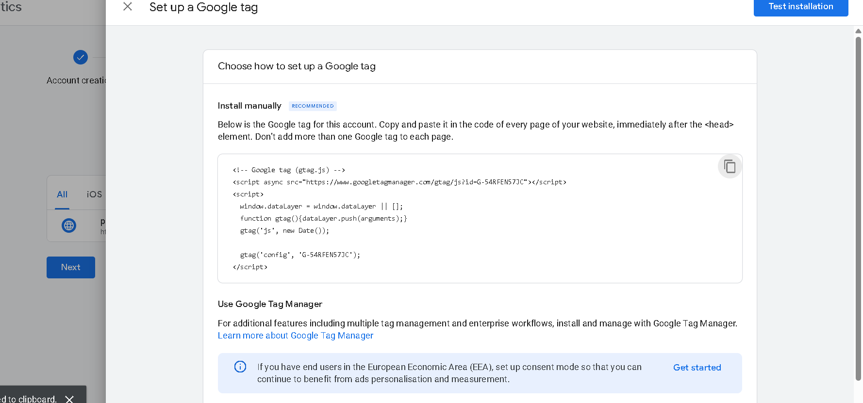

Success



