Motivation

Social interactions and social skills form the basis of human interpersonal relationships. From personal lives to professional growth, social skills play a very important role. The social skill set correspond to a complex combination of communicative gestures, body mannerisms, verbal and non-verbal cues, prosody, emotions and touch. These complex behaviors and mannerisms, reflected through a complex interplay of sensory, perceptive, cognitive and motor actions, enable seamless social interactions between two or more people. The lack of, or disability in any one of sensation, perception, cognition or motor system can hinder smooth transmission and/or reception of social signals and cues. For example, the simple act of shaking hands involves interactions of sensory, motor and cognitive events. Two individuals who engage in the act of shaking hands have to first make eye contact, exchange emotional desire to interact (this usually happens through a complex set of face and body gestures, such as smile and increased upper body movements), determine the exact distance between themselves, move appropriately towards each other maintaining Proxemics (interpersonal distance) that are befitting of their cultural setting, engage in shaking hands, and finally, move apart assuming a conversational distance which is invariably wider than the hand shake distance. Verbal exchanges may occur before, during or after the hand shake itself. This example shows the need for sensory (visual senses of face and bodily actions, auditory verbal exchange etc.), perceptual (understanding expressions, distance between individuals etc.), and cognitive (recognizing the desire to interact, engaging in verbal communication etc.) exchange during social interactions. Thus, the triggers for social connection lie deeply rooted in the complex web of actions within the human as a complete system.

Nearly 65% of all human interpersonal communications happen through non-verbal communication cues [3]. In a bilateral interpersonal interaction, while speech encodes all the information, non-verbal cues facilitate an elegant means for delivery, interpretation and exchange of this verbal information. For example, eye gaze, iconic body or hand gestures, and prosody enable effective and seamless role play in social interpersonal interactions. People communicate so effortlessly through both verbal and non-verbal cues in their everyday social interactions that they do not realize the complex interplay of their voice, face and body in establishing a smooth communication channel. Nearly 72% of non-verbal communication [1] takes place through visual cues encoded on the face and body of the interaction partners (see Figure 1). Unfortunately, people who are blind or visually impaired cannot access this huge portion of interpersonal information independently.

While most persons who are blind or visually impaired eventually make accommodations for the lack of visual information, and lead a healthy personal and professional life, the path towards learning any accommodations could be positively effected through the use of assistive aids. Specifically, children with visual disabilities find it very difficult to learn social skills while growing amongst sighted peers, leading to social isolation and psychological problems [2]. Social disconnect due to visual disability has also been observed at the college level [4] where students start to learn professional skills and independent living skills.

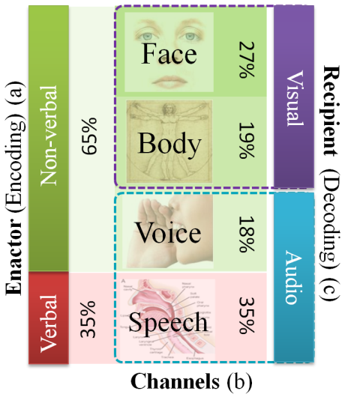

**Figure 1**: Relative importance of a) verbal vs non-verbal cues, b) four channels of non-verbal cues, and c) visual vs. audio encoding & decoding of bilateral human interpersonal communicative cues.

Most modern human communication theories build bilateral interpersonal communication process on top of the popular transactional model of human communication [REF]. Considering a dyadic interaction, communicators A and B are required to continuously encode and decode their verbal and non-verbal channels. People who are blind or visually impaired face two levels of difficulty when it comes to bilateral interpersonal communication.

1. The inability to decode visual non-verbal cues:

A major portion of the non-verbal communication happens through visual medium including the body and the face (See Figure 2). Though face and body are not the first channels to display affect (leakiness of the channels), together they encode nearly 70% of the NVC [1]. People who are blind or visually impaired don’t have the opportunity of receiving these signals due to their sensory disability. Affect is a complex state of mind of an individual triggered by various external factors including the communication partner. In a bilateral conversation, the lack of sight, removes an important feedback channel that can deliver important transactional affect cues.

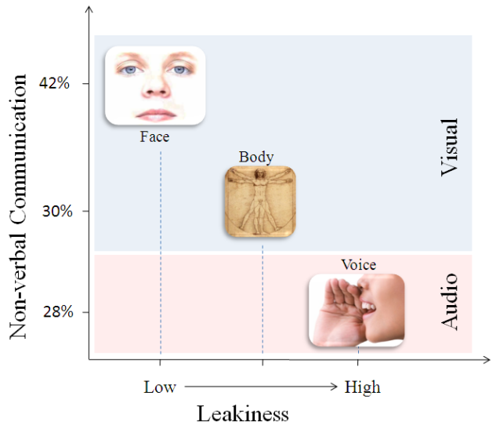

**Figure 2**: Comparison of the leakiness of the various communication channels with the information encoded on these channels.

1. The missed opportunity to learn non-verbal communication patterns within the current cultural setting:

When it comes to interpersonal communication, humans are in a constant state of learning. Culture of the geographical location and work place impose a huge learning requirement on humans. An important aspect of this learning is to watch and mimic people in the surroundings. For example, people who migrate from the East Asian countries to the US are overwhelmed by the strong upper body movements that are demonstrated typically in the West. But, overtime, most of these migrants tend to learn these body mannerisms and use them effectively in their communication. People who are blind face a very interesting challenge when it comes to learning body mannerisms that are appropriate for the current cultural setting.

People who are blind and visually impaired lack the ability to visually inspect and learn what and how much body movements are appropriate with different contextual settings. For example, crossing legs, leaning back on a chair, moving ones hand within their own personal space are all well suited for a professional work environment in the US, while none of these would be considered appropriate in Japan. Sighted individuals learn these movements both through direct observation and through non-verbal affect feedback that they get when inappropriate body movements are displayed. Visual impairment (as a sensory disability) prevents this affective feedback from imparting important *learning checkpoints*.

Most of the times, people with visual impairment tend not to display much of body movements with the trepidation of displaying inappropriate movements in the current context. Since they are not able to assess affective reactions of their sighted counterparts (like awkward stare, quick fixated glance, etc), people who are visually impaired may restrain from any body movements. Unfortunately, this unusual (unusual for those sighted individuals who are familiar with typical body movements) rigidity displayed by the target population may distract a smooth seamless communicative exchange.

Another important area of focus within the social interaction assistance realm falls into the role of leadership in one’s professional growth. Leadership qualities (there is significant confusion within the Psychology area as to what these qualities are) have been shown to be correlated to the ability of the individual to socially connect with their colleagues at various levels of an institutional hierarchy. Emotions play a vital role in large group decision making, abating professional conflict, inducing team commitment and involvement, etc. While people with visual disability have managed to overcome their sensory disability and have achieved high levels of professional growth, there still exists an employment gap that cannot be purely explained with the sensory disability, especially in this day and age where technologies can bridge the accessibility gap in many areas and the increasing use of computers in most jobs eliminate the barrier to information access.

On a wage comparison scale (data extracted from the 2008 American Community Survey questionnaires), the US visually impaired population make on an average 32% less than general population of the same age. When one includes education level in these statistics, the results are even more disappointing. People with visual disability, with post graduate education, make 47% less than the average population with post graduate education. See Figure 3a and 3b for the comparison of visually impaired population’s average salary and the average salary of the non-disabled population contrasted on the same age and education tracks, respectively.

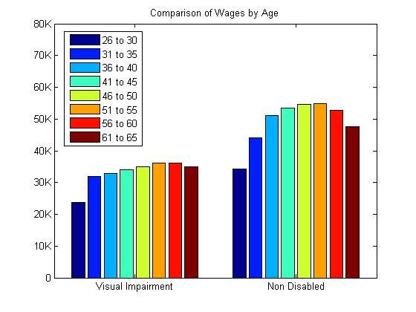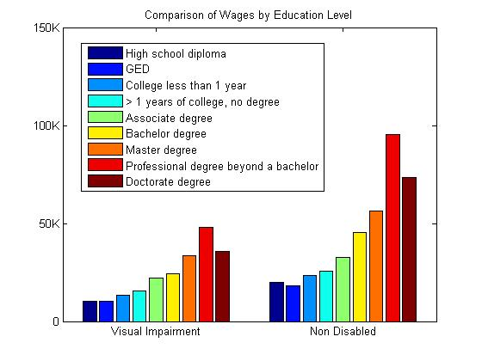

Figure 3: (a) Comparison of average yearly wages of the visually impaired population with the general population counterparts based on 5 ear age groups. (b) Comparison of average yearly wages of visually impaired and general population based on education level. Data extracted from the 2008 American Community Survey.

In order to understand the importance of visual social cues, we conducted a web based survey where the participants (16 persons who are blind, 9 with low vision and 2 sighted specialists in the area of visual impairment) rated the importance of 8 social needs that were identified from two open-ended focus groups [5]. The participants responded on a 5 point Likert scale; 5, implying strong agreement, to 1, implying strong disagreement. Figure 4 shows a non-parametric rank average analysis of the participants’ responses. The rank-ordered social needs list shows that participants’ most important need corresponds to feedback on their own body mannerism and how it was affecting their social interactions. Following this was their need to access facial expressions, body mannerisms, identity, eye gaze, proxemics (location) and appearance of their social interaction partners, in the presented order.

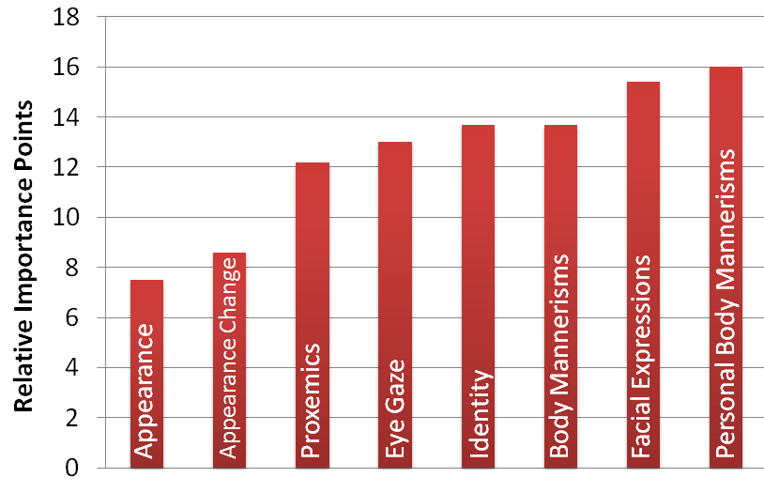

**Figure 4**: Self report importance (scaled over 100 points) of visual non-verbal cues obtained through an online survey of target population and specialists [5].

References:

[1] N. Ambady and R. Rosenthal, “Thin Slices of Expressive behavior as Predictors of Interpersonal Consequences : a Meta-Analysis,” *Psychological Bulletin*, vol. 111, 1992, pp. 274, 256.

[2] D. Jindal-Snape, “Generalization and Maintenance of Social Skills of Children with Visual Impairments: Self-Evaluation and the Role of Feedback,” *J. of Visual Impairment and Blindness*, vol. 98, 2004, pp. 470-483.

[3] M.L. Knapp, *Nonverbal Communication in Human Interaction*, Harcourt College Pub, 1996.

[4] K. Shinohara and J. Tenenberg, “Observing Sara: a case study of a blind person's interactions with technology,” Proceedings of the 9th international ACM SIGACCESS conference on Computers and accessibility, Tempe, Arizona, USA: ACM, 2007, pp. 171-178.

[5] S. Krishna, D. Colbry, J. Black, V. Balasubramanian, and S. Panchanathan, “A Systematic Requirements Analysis and Development of an Assistive Device to Enhance the Social Interaction of People Who are Blind or Visually Impaired,” *Workshop on Computer Vision Applications for the Visually Impaired (CVAVI 08), ECCV 2008*.