Assistive Technologies as Effective Mediators in Interpersonal Social Interactions for Persons with Visual Disability
Sreekar Krishna1 and Sethuraman Panchanathan1,

1 Center for Cognitive Ubiquitous Computing (CubiC), Fulton School of Engineering, Arizona State University, Tempe AZ, USA.
{Seekar.Krishna, Panch}@asu.edu
Abstract. In this paper, we discuss the use of assistive technologies for enriching the social interactions of people who are blind and visually impaired with their sighted counterparts. Specifically, we describe and demonstrate two experiments with the Social Interaction Assistant for, a) providing rehabilitative feedback for reducing stereotypic body mannerisms which are known to impede social interactions, and b) provide an assistive technology for accessing facial expressions of interaction partners. We highlight the importance of these two problems in everyday social interactions of the visually disabled community. We propose novel use of wearable computing technologies (both sensing and actuating technologies) for augmenting sensory deficiencies of the user population, while ensuring that their cognitive faculties are not compromised in any manner. Computer vision, motion sensing and haptic technologies are combined in the proposed platform towards enhancing social interactions of the targeted user population.
Keywords: Assistive Technology, Social Interactions, Dyadic Interpersonal Interaction, Computer Vision, Haptic Technology, Motion Sensors.
1 Introduction
Social interactions are part and parcel of everyday living for both personal and professional success of one’s life. From a neurological perspective, social interactions result from the complex interplay of cognition, action and perception tasks within the human brain. For example, the simple act of shaking hands involves interactions of sensory, motor and cognitive events. Two individuals who engage in the act of shaking hands have to first make eye contact, exchange emotional desire to interact (this usually happens through a complex set of face and body gestures, such as smile and increased upper body movements), determine the exact distance between themselves, move appropriately towards each other maintaining Proxemics (interpersonal distance) that are befitting of their cultural setting, engage in shaking hands, and finally, move apart assuming a conversational distance which is invariably wider than the hand shake distance. Verbal exchanges may occur before, during or after the hand shake itself. This example shows the need for sensory (visual senses of face and bodily actions, auditory verbal exchange etc.), perceptual (understanding expressions, distance between individuals etc.), and cognitive (recognizing the desire to interact, engaging in verbal communication etc.) exchange during social interactions.
Individuals who are disabled face myriad levels of difficulty during everyday social interactions depending on the kind of disability. This is due to the fact that nearly 65% of all human interpersonal communications happen through non-verbal cues [1]. Non-verbal cues are mostly interpretative and not instructive as verbal cues (such as speech) are. In a bilateral interpersonal interaction, while speech encodes all the information, non-verbal cues facilitate an elegant means for delivery, interpretation and exchange of this verbal information. People with sensory, perceptive, motor and cognitive disabilities may not be able to receive or process these non-verbal cues effectively. Though most individuals learn to make accommodations for the lack of a primary information channel, and lead a healthy personal and professional life, the path towards learning effective accommodations could be positively effected through the use of assistive aids. In this paper, we focus on the topic of building an assistive aid for social interactions and discuss how they could enrich interpersonal communications. We specifically focus on the issues emanating from the lack of sensory visual channel, like in the case of people who are blind or visually impaired, and describe the design and development of a social interaction assistant that conveys important dyadic non-verbal communication cues.
2. Related Work
The need for developing social interaction assistive technologies was the fall out of two focus group studies that we carried out with individuals who are blind and their abettors [2]. People who were blind identified social situations where visual disability stymied their ability to reach out to their sighted counterparts. Similar emphasis on the need for social interaction assistance was reported by Shinohara et al. [3], where, the researchers followed a college student who is blind and categorized the important needs for this individual in her day-to-day life. Jindal-Snape et al. [4] has highlighted the need for social assistance for children who are blind and visually impaired. Their work in India has tied the lack of sensory input to critical factors that lead to the development of socially distracting behaviors, like body rocking. These unfavorable behaviors are precursors for social isolation and related psychological problems. To the best of the authors’ knowledge, only one related work focuses on the issue of delivering social information to people who are blind: In [5], Réhman et.al., developed a haptic chair for presenting facial expression information to people who are blind. A chair was equipped with vibrotactile actuators on its back rest forming an inverted Y. A camera mounted elsewhere tracks the mouth of an interaction partner, and actuators vibrate along any one of the three axes of the Y, based on whether the interaction partner was neutral, happy, sad or surprised. No formal experiments were conducted with the target population. Further, this solution had the obvious limitation that users need to be sitting in the chair to use the system. In this paper, we illustrate how social interactions have myriad levels of non-verbal cueing, where facial expressions play a significant yet incomplete role. We discuss a social assistive technology framework and elaborate on two solutions that can enrich social interactions for the targeted user community.
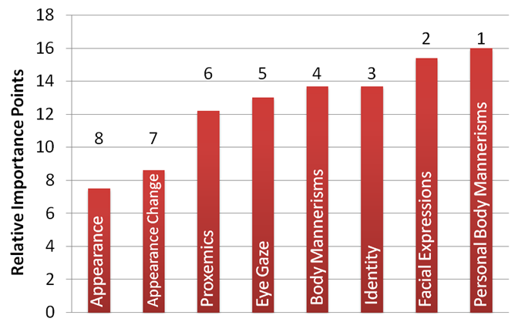
Fig. 1: Self report importance (scaled over 100 points) of visual non-verbal cues obtained through an online survey of target population and specialists [6].
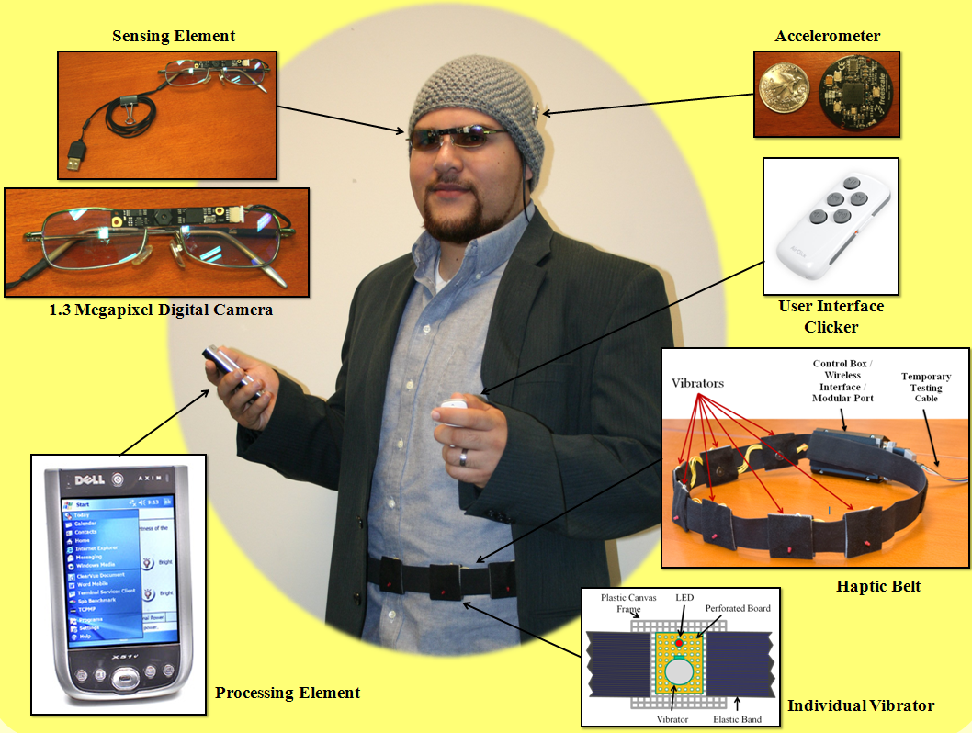
Fig. 2: Embodied Social Interaction Assistant Platform.
3. The Social Interaction Assistant
In [6], we identified 8 important social needs for individuals who are blind and visually impaired and rank ordered them through an online survey. A potential assistive technology platform for enriching social interactions was then proposed in [7], which relies on state-of-the-art wearable camera technology and computer vision algorithms for extracting important social interaction cues. In Fig. 1, we show the rank ordered needs list as graded by a group of individuals with visual impairment. This list shows that participants’ most important need corresponds to feedback on their own body mannerism and how it was affecting their social interactions. Following this was their need to access facial expressions, identity, body mannerisms, eye gaze, proxemics and appearance of their social interaction partners, in the presented order.

Fig. 2 shows the integrated social interaction assistant platform that we have developed towards enriching the social interactions of people who are visually impaired. A camera mounted on the nose-bridge of a pair of glasses, a wireless motion sensor mounted within the clothing of the users, and a handheld button based user input device act as inputs into the system. Any processed social scene information is either delivered through a pair of headphones or through vibrotactile actuation devices including a haptic belt [8] and a haptic glove [11]. In this paper, we discuss two important components of the prototype, corresponding to rank ordered needs 1 and 2, from the above chart. We have discussed solutions for need 3 in [8], while solutions for need 6 are addressed in [9].
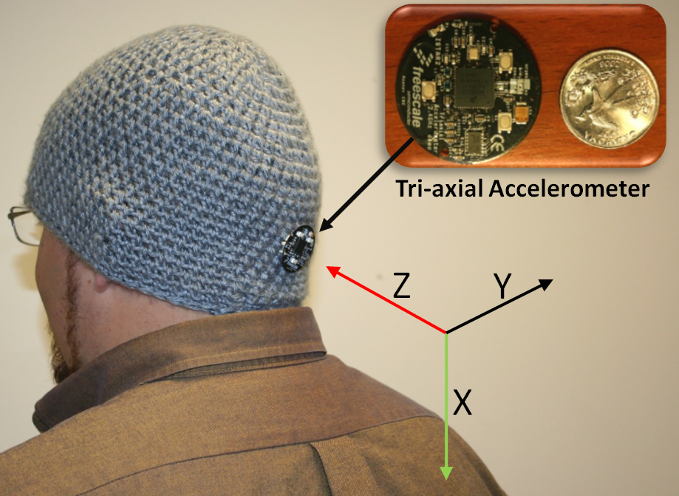
Fig. 3: Motion sensor for detecting body rocking stereotypy.
3.1 Components of the Social Interaction Assistant and Associated Research Questions
3.1.1 Detection of Stereotypic Body Mannerisms: Corresponding to the need 1 depicted in Fig. 1, in order to detect user’s non-social body mannerisms, we resort to the use of clothing-integrated motion sensors. Eichel [10] introduced taxonomy of stereotypic body mannerisms that people with blindness and visual impairment tend to display and identified that body rocking as one of the most commonly seen behavior stereotype. In order to detect body rocking, as shown in Fig. 3, we incorporated a wireless accelerometer on the social interaction assistant to detect and categorize upper body movements. Through the use of supervised pattern recognition algorithms, based on adaptive boosting of triaxial acceleration data, rocking pattern is isolated from other functional body movements, including bending, stooping, leaning etc., which involve motion similar to that of rocking but are functionally relevant.
Research Question: How well can body rocking be distinguished from other functional movements by using on-body motion sensors?
3.1.2 Conveying Facial Expressions of Interaction Partners: Following the need to realize their own body behaviors, individuals surveyed appealed for the need to understand the facial mannerisms and expressions of their interaction partner. Extracting and delivering facial mannerisms is a complex computational/engineering task. The human face is very dynamic when it comes to generating non-verbal communicative cues. Subtle movements in the facial features can convey great amounts of information. For example, slight opening of the eyelids conveys confusion or interest, whereas a slight closing of the eye lids conveys anger or doubt. In the past decade, computer vision research has achieved encouraging levels of capability in recognizing some of the human facial expressions. Little work (Ref. [5]) has been done towards finding a means of communicating this information back to people who are visually impaired. Most researchers and technologists have resorted to auditory cueing; but there is a strong growing discomfort in the target population when it comes to overloading their hearing. In the proposed approach, we explore the use of vibrotactile cueing (haptic/touch based cueing) on the back of the human palm (the human hand has a very large representation in the somatosensory cortex of the brain) to deliver any facial expression information. Camera on the wearable glasses (Fig. 2) is used for extracting the seven basic expressions (Happy, Sad, Surprise, Anger, Neutral, Fear and Disgust) of an interaction partner, which are then encoded as haptic cues. Fig. 4 shows the vibrotactile glove used in the social interaction assistant and the corresponding mapping of seven basic expressions. Please refer to [11] for details.
Research Question: How well can the seven basic human expressions be conveyed through haptic icons?
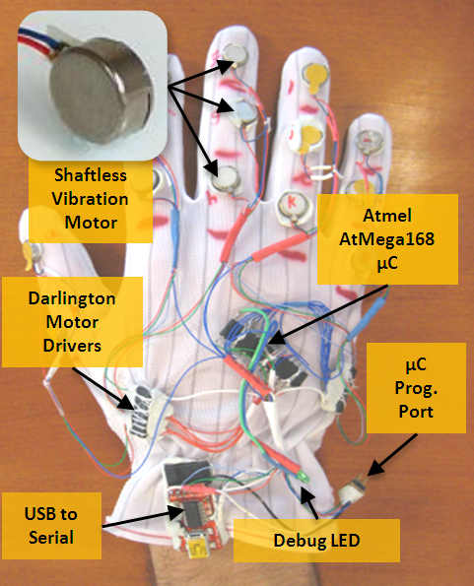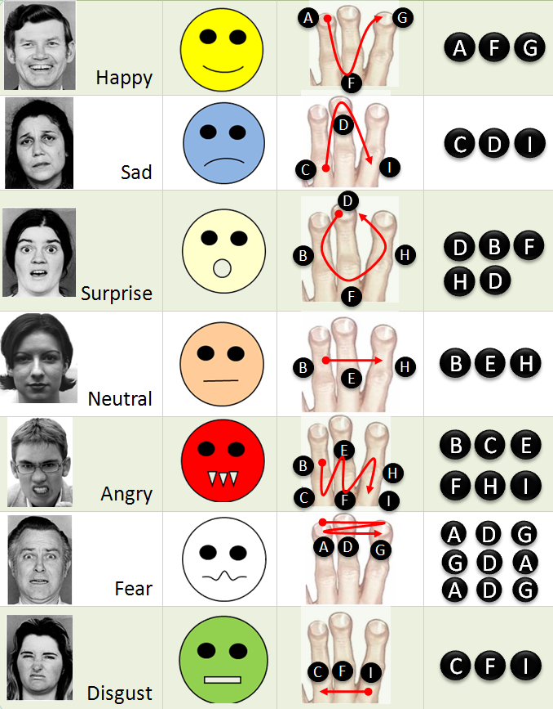
Fig. 4: Vibrotactile glove for conveying facial expressions and the vibrotactile mapping.
4 Experiments and Results:
Two experiments, corresponding to the two technologies described above, are presented below.
4.1 Detection of body rocking:
Rocking motion patterns and functional movement (like bending and stooping) patterns were collected on 10 participants for duration of 5 minutes each. A pattern recognition engine based on AdaBoost learning algorithm was trained to distinguish between rocking and non-rocking patterns. All experiments were conducted on time slices of the motion data by splitting the motion data into discrete packets of samples.
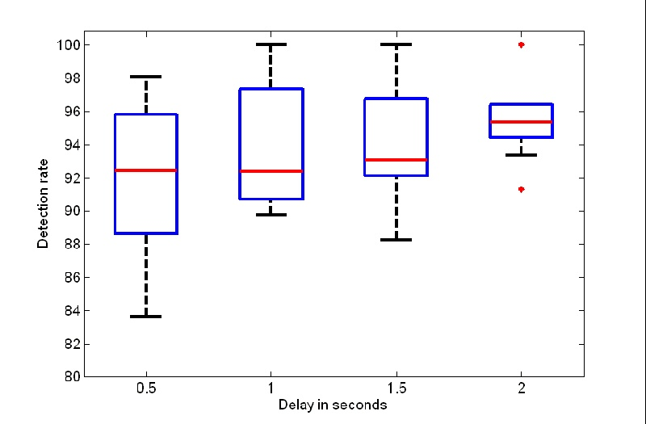
Fig. 5: Box plot analysis of the body rock detection component.
Fig. 5 shows the overall detection rates as a function of time slice length in seconds. It can be seen that the best performance of our device was to detect rocking from non-rocking on an average of 95% with a latency of 2s. It was possible to detect rocking at a much less latency (0.5s), but the detection rate went down to 92%. Thus, 95% of the time, we could inform a subject of his/her rocking activity within 2 seconds of them starting to rock. Further, we noticed that the average natural rocking motion of all 10 subjects was 2.22 seconds per rock, which implies that a latency of 2 seconds was well within the time duration of a single rocking action.
While tests were done on rocking as a stereotype, any bodily movement can be modeled similarly by choosing an appropriate location of the motion sensors. Similar to the above experiment, sensors could be placed on the hands, legs, spine etc. to capture and detect stereotypes like head weaving, hand or leg tapping, body swinging etc.
4.2 Conveying facial expressions through haptic icons:
The primary goal of the experiment was to determine how well participants were able to recognize seven haptic patterns, corresponding to seven basic expressions, on the haptic glove. The experiment was conducted with one individual who was blind and 11 other participants who were sighted, but were blindfolded. Fig. 6 shows the confusion matrix of communicating seven haptic expression icons. The diagonals correspond to the recognition accuracies and the off-diagonal elements represent the confusion between expressions. It can be seen that the participants were able to recognize the expressions with an average accuracy of 90%. Vibrotactile pattern corresponding to Sad had the worst performance of 80% while Fear and Disgust had a performance close to 98%.
Fig. 7 shows the average time taken by the subjects per expression when they recognized the haptic patterns correctly (cyan), and when they misclassified them (red). The bar graph shows excess or shortage of response time around the mean value. It can be seen that correct identification happened in just over a second (1.4s). When the subjects were not sure of the haptic pattern, they took more time to respond (mean of 2.31s). Fear, which had the highest performance in terms of recognition rate also had the least time of response. The results are promising and work is in progress to extend the glove to convey more complex facial movements allowing users to make the categorization on the expressions using their cognitive faculties.
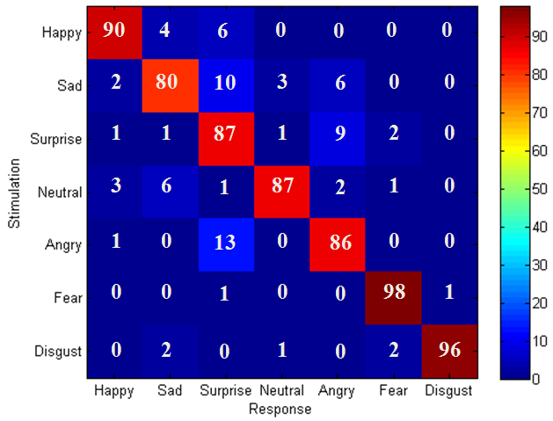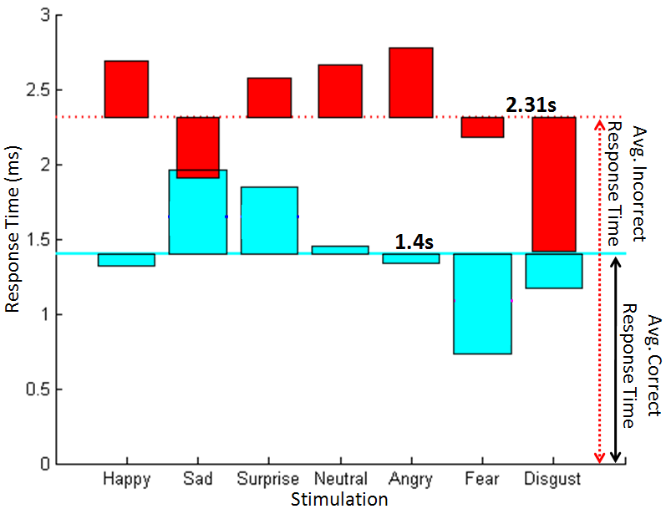
Fig. 6: Confusion Matrix for the seven expressions.
Fig. 7: Response time for each expression.
Conclusion and Future Work:
In this paper we have identified an important assistive technology area relating to the social interaction needs of individuals who are visually impaired. We have identified the important issues in social communication and demonstrate how wearable technology could offer enrichment technologies. Specifically, two promising solutions relating to the two primary needs of the target population are discussed. In the future, work will be progressed towards delivering subtle facial and body based non-verbal cues to a user who is visually impaired. More experiments with the target population will be carried out to measure the efficacy of the overall system.

Acknowledgments. We like to thank Stephen McGuire, Troy McDaniel, Shantanu Bala, Jacob Rosenthal, Narayanan Krishnan and Nathan Edwards for their participation in the design, development and testing of the above technologies. We also like to extend out thanks to Terri Hedgpeth and RaLynn McGuire at the Disability Resource Center, Arizona State University for their guidance for the Social Interaction Assistant project.
References
1. M.L. Knapp and J.A. Hall, Nonverbal Communication in Human Interaction, Wadsworth Publishing, 2005.
2. S. Krishna, V. Balasubramanian, J. Black, and S. Panchanathan, “Person-Speciﬁc Characteristic Feature Selection for Face Recognition,” Biometrics: Theory, Methods, and Applications (IEEE Press Series on Computational Intelligence), N.V. Boulgoris, ed., Wiley-IEEE Press, 2009.
3. K. Shinohara and J. Tenenberg, “A blind person's interactions with technology,” Communications of the ACM, vol. 52, 2009, p. 58.
4. D. Jindal-Snape, “Use of Feedback from Sighted Peers in Promoting Social Interaction Skills,” Journal of Visual Impairment and Blindness, vol. 99, Jul. 2005, pp. 1-16.
5. S.U. Réhman and L. Liu, “Vibrotactile Rendering of Human Emotions on the Manifold of Facial Expressions,” Journal of Multimedia, vol. 3, 2008.
6. S. Krishna, D. Colbry, J. Black, V. Balasubramanian, and S. Panchanathan, “A Systematic Requirements Analysis and Development of an Assistive Device to Enhance the Social Interaction of People Who are Blind or Visually Impaired,” Workshop on Computer Vision Applications for the Visually Impaired (CVAVI 08), 2008.
7. S. Krishna, T. McDaniel, and S. Panchanathan, Embodied Social Interaction Assistant, TR-10-001, Tempe, USA: Arizona State University, 2010. (http://cubic.asu.edu/d6/content/embodied-social-interaction-assistant)
8. T. McDaniel, S. Krishna, V. Balasubramanian, D. Colbry, and S. Panchanathan, “Using a haptic belt to convey non-verbal communication cues during social interactions to individuals who are blind,” Haptic Audio visual Environments and Games, 2008. HAVE 2008. IEEE Intl. Workshop on, 2008, pp. 13-18.
9. S. Krishna, G. Little, J. Black, and S. Panchanathan, “A wearable face recognition system for individuals with visual impairments,” Proc. 7th Intel ACM SIGACCESS Conf. on Computers and accessibility, 2005, pp. 106-113.
10. V.J. Eichel, “A taxonomy for mannerism of blind children,” J. of Visual Impairment & Blindness, vol. 73, 1979, pp. 167-178.
11. S. Krishna, S. Bala, T. McDaniel, S. McGuire, and S. Panchanathan, “VibroGlove: An Assistive Technology Aid for Conveying Facial Expressions,” Proc. 28th Intl. Conf. extended abstracts on Human factors in computing systems, 2010.

