Haptic Belt GUI
Functionality Manual

Table Of Contents

Tool Bar........................................................................................................................
Main Menu....................................................................................................................
Configure Motors.........................................................................................................
Magnitude Mode...........................................................................................................
Rhythm Mode...............................................................................................................

Tool Bar

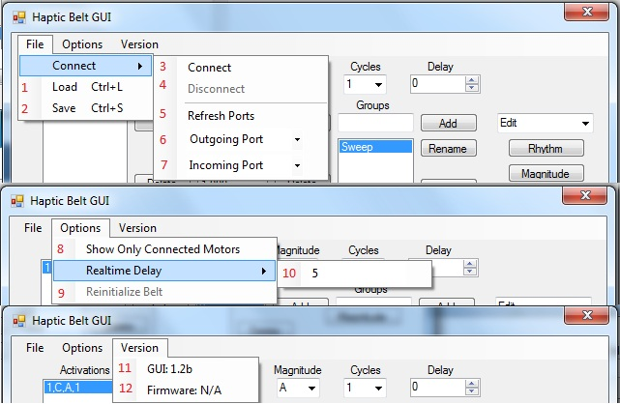

Main Menu

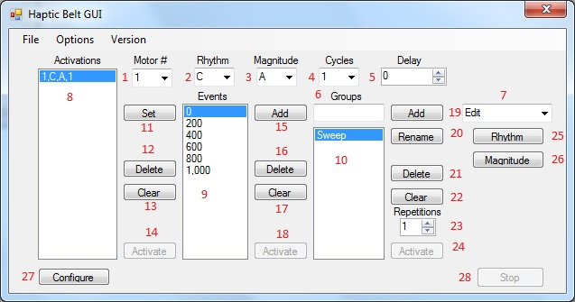

Configure Motors

Description:
Accessed through the main menu, this motor configuration applys to all groups, and all sets within groups. The intent of this configuration is that if the belt has motors physically moved on or off the haptic belt, the user of this GUI may easily re-configure all presets (groups and sets) to their original intended patterns. Otherwise, phyiscally moving motors may cause patterns to otherwise not make sense or retain their original purpose.
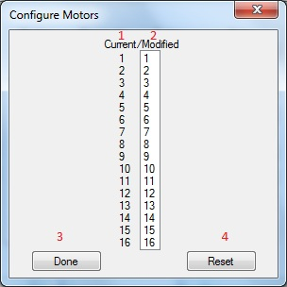

Fields/Buttons:
1.) Static Motor Label – Allows the user to see what the Dynamic Motor ListBox's motor number will be mapped to upon exit.
2.) Dynamic Motor ListBox - Allows a user select two motors simultaneously and swap the motors by holding Ctrl + Clicking the desired motor numbers. This allows them to be mapped to another motor number.
3.) Done Button - Allows a user to confirm changes to the motor configuration.
4.) Reset Button - Resets motor configurations to original state upon entering the configuration menu.

Magnitude Mode
Description:
This mode is accessed from the main menu, it is dependent upon each individual group. Thus each individual group has its own independent settings of magnitudes. This menu allows the user to program four seperate magnitudes per group, based on Period and Duty Cycle. The magnitudes, (and rhythms) don't actually get loaded onto the belt until the belt is connected and a group is selected.
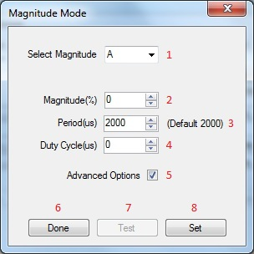

Fields/Buttons:
1.) Select Magnitude Combobox - Allows a user to select programable magnitudes A-D. Upon selection of a magnitude, fields 2, 3 and 4 will display the selected group's current magnitude that is selected. This allows the user to know the current selected magnitude and allow the user to modify it how they see fit.
1.) Select Magnitude Combobox - Allows a user to select programable magnitudes A-D. Upon selection of a magnitude, fields 2, 3 and 4 will display the selected group's current magnitude that is selected. This allows the user to know the current selected magnitude and allow the user to modify it how they see fit
2.) Magnitude (%) NumericUpDown - Allows a user to specify a percentage value for magnitude. This percentage automatically adjusts field 4, Duty Cycle, to a percentage of field 3, Period. *Directly related to Duty Cycle(us)*
3.) Period (us) NumericUpDown - Allows a user to specify a value in microseconds for a period. This value may range from 1-50000 (1 microsecond to 50 milliseconds). A default value of 2000 is defaulted to give functionality, but may not be optimal.
4.) Duty Cycle (us) NumericUpDown - Allows a user to specify a specific Duty Cycle in microseconds that is bound by 0 to field 3 Period's value. This duty cycle automatically adjusts field 2, percentage, to a percentage of field 3, Period. *Directly related to Magnitude (%)*

5.) Advanced Options Checkbox - Allows a user to display if checked, or hide if unchecked fields 3 and fields 4. On default this box is unchecked and allows a user to only view field 2 for modification of the rhythm.

6.) Done Button - Exits the Magnitude Form and returns the user back to the Main Form. This button does not save anything, all "un-Set" changes will be lost.

7.) Test / Stop Button - This button is enabled if there is a connection to the Haptic Belt, otherwise it is disabled. Upon click this button will vibrate the belt with a full "on" rhythm with the current magnitude fields. Furthermore, on click this button will also hide, and display the Stop Button, as well as disable any conventional means to back out of the test without hitting the Stop Button first, to insure belt integrity.

8.) Set Button - Sets the current group's selected magnitude using fields 3 and 4, reguardless of Advanced Options is checked or unchecked.

Definitions:
Period - Within the Haptic Belt the minimum "on" time for a Rhythm is 50ms. The period is a time specified in microseconds that segments each "on" 50ms chunk. Specifying a 2000 microsecond period, there will be 25 periods. Specifying a 1000 microsecond period there will be 50 periods. A value too large may result in the feeling of pulses when varying duty cycle. A Value too small may result in greater power draw or failure to vibrate the motor entirely.
Duty Cycle - Specifies the amount of time "on" within the specified period, the remainder will be "off" time. This value can range from 0 to Period. If the value is 0, this will result in 0 % magnitude. If the value is maxed out at Period's value, this will result in 100 % magnitude.

Rhythm Mode
Description:

This mode is accessed from the main menu, it is dependent upon each individual group. Thus each individual group has its own independent settings of rhythms. This menu allows the user to program five seperate rhythms per group, based a 3200ms period in 50ms chuncks. The rhythms, (and magnitudes) don't actually get loaded onto the belt until the belt is connected and a group is selected.

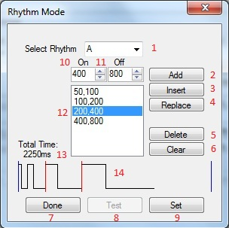

Fields/Buttons/Graphics:
1.) Select Rhythm Combobox - Allows a user to select programable rhythms A-E. Upon selection of a rhythm, fields 12, 13 and 14 will display the selected group's current rhythm that is selected. This allows the user to view and program the current selected rhythm and allow the user to modify it how they see fit.
2.) Add Button - Uses fields 10 and 11, and adds them into field 12 at the end of the list.

3.) Insert Button - Uses fields 10 and 11, and inserts them into field 12 before the selected entry.

4.) Replace Button – Uses fields 10 and 11, and replaces them into field 12 at the selected entry.
5.) Delete Button - Deletes the selected entry from field 12.

6.) Clear Button - Deletes all entires from field 12.

7.) Done Button - Exits the Rhythm Form and returns the user back to the Main Form. This button does not save anything, all "un-Set" changes will be lost.

8.) Test / Stop Button - This button is enabled if there is a connection to the Haptic Belt, otherwise it is disabled. Upon click this button will vibrate the belt with a full 100% magnitude and with the current specified rhythm. Furthermore, on click this button will also hide, and display the Stop Button, as well as disable any conventional means to back out of the test without hitting the Stop Button first, to insure belt integrity.
9.) Set Button - This button takes the current rhythm specified and sets it into the current rhythm selected. This updates the internal data structure, thus after using this button the previously known rhythm is replaced.
10.) On NumericUpDown - This value specifies the “On” duration of the pair that is going to be added/inserted/replaced. This value must be 0 or a multiple of 50, if the value is not a 0 or a multiple of 50, the system will round down to the nearest 50.

11.) Off NumericUpDown - This value specifies the “Off” duration of the pair that is going to be added/inserted/replaced. This value must be 0 or a multiple of 50, if the value is not a 0 or a multiple of 50, the system will round down to the nearest 50.

12.) Rhythm Pattern ListBox - This ListBox is a representation all of the pairs that have been entered.

13.) Total Time Label - A calculation of the total time used by the current specified rhythm. A maximum of 3200ms is allotted and cannot be exceeded due to the format limitations of the belt.

14.) Paint Rhythm Graphics – This graphic represents a visual representation of all the pairs that have been entered, it represents the entire rhythm as a whole, and is updated whenever a change is made to the Rhythm Pattern ListBox.

