Task 3:

1. Is your browser running HTTP version 1.0 or 1.1? What version of HTTP is the server running?

My browswer is running HTTP version 1.1, as well as the server.

2. What languages (if any) does your browser indicate that it can accept to the server?

It states Accept-Language: en-us, en;q=0.5 so I assume en stands for English, and us stands for the type of English (as opposed to say British English).

3. What is the IP address of your computer? Of the gaia.cs.umass.edu server?

192.168.0.102 (Mine) 128.119.245.12 (gaia)

4. What is the status code returned from the server to your browser?

Response code 200

5. When was the HTML file that you are retrieving last modified at the server?

Mon, 05 2009 at 3:09:40 GMT (I actually retrieved it on Sunday, 04 2009 at 8:12ish MST).

6. How many bytes of content are being returned to your browser?

128 Bytes of content

7. By inspecting the raw data in the packet content window, do you see any headers within the data
that are not displayed in the packet-listing window? If so, name one.

I don't see any raw data that isn't covered in the packet-listing window. However there is additional information the "Frame" +- box that shows capture stats.

8. Inspect the contents of the first HTTP GET request from your browser to the server. Do you see
an “IF-MODIFIED-SINCE” line in the HTTP GET?

No, however I found it in the 2nd HTTP GET request.

9. Inspect the contents of the server response. Did the server explicitly return the contents of the file?
How can you tell?

Yes, because under the Transmission Control Protocol, the Sequence number is 1, signifying the start of the first byte of data.

10. Now inspect the contents of the second HTTP GET request from your browser to the server. Do
you see an “IF-MODIFIED-SINCE:” line in the HTTP GET? If so, what information follows the
“IF-MODIFIED-SINCE:” header?

Yes, there is an If-Moddified_Since Statement. The information that follows is a Date and Time that signifies if the file has changed since that time, we need to update or re-download otherwise we would look in our cache for the result.

11. What is the HTTP status code and phrase returned from the server in response to this second
HTTP GET? Did the server explicitly return the contents of the file? Explain.

The code returned is 200 from Http/1.1 200 OK, the same as the first response. No the server didn't expleicity return the contents of the file, because it was found within the cache there is no need to retrieve it from the server. The packet's previous 200 OK message was re-created using the successful cached retrieval of the file.
12. How many HTTP GET request messages were sent by your browser.

GET /wireshark-labs/HTTP-wireshark-file3.html HTTP/1.1
GET /favicon.ico HTTP/1.1
GET /favicon.ico HTTP/1.1
Dunno why, but 3 separate GET messages appeared, the 2nd and 3rd both failed when the server responded with a 404 Not Found error. However only 1 GET message is corresponding the the HTML content.

13. How many data-containing TCP segments were needed to carry the single HTTP response?

Of 7 TCP Packets, 5 were from the host containing data. 2 Were sent from my computer to the host.

14. What is the status code and phrase associated with the response to the HTTP GET request?

HTTP/1.1 200 OK (text/html), so 200 OK. Was the associated response for the specific HTML file.

15. Are there any HTTP status lines in the transmitted data associated with a TCP induced
“Continuation”?

[TCP Segment of a reassembled PDU] appears under the Wireshark supplied info of the packet, which basically indicates this. However as far as the transmitted data goes, there is no indicator I can identify within the packet itself that this is a part of another file.

16. How many HTTP GET request messages were sent by your browser? To which Internet
addresses were these GET requests sent?

GET /wireshark-labs/HTTP-wireshark-file4.html HTTP/1.1 (gaia.cs.umass.edu)
GET /assets/hip/us/hip_us_pearsonhighered/images/pearson_logo.gif HTTP/1.1 (www.pearsonhighered.com)
GET /~kurose/cover_5th_ed.jpg HTTP/1.1 (manic.cs.umass.edu)
(The 2 GET attempts again for /favicon.ico and 404 failed attempts) (gaia.cs.umass.edu)

5 GET requests in total, 3 specifically for this page. The hosts are in parenthesis of the their respective GET request.

17. Can you tell whether your browser downloaded the two images serially, or whether they were
downloaded from the two web sites in parallel? Explain.

By analyzing the image sizes respectively .91kb and 98kb the first request for the .91kb image goes out and at packet no. 19, and an HTTP/1.1 200 OK message is received by line 24, then a request for the 2nd image goes out at packet 31, and finished at packet 139. So these images were received in series not in parallel, as one was completed before the other started.

18. What is the server’s response (status code and phrase) in response to the initial HTTP GET
message from your browser?

The server first responds with a 401 status message, which means Authorization is Required.

19. When your browser’s sends the HTTP GET message for the second time, what new field is
included in the HTTP GET message?

Within the GET packet under Hypertext Transfer Protocol, there is an Authorization Field which is encoded in Base64 format. "Basic d2lyZXNoYXJrLXN0dWRlbnRzOm5ldHdvcms". These are the credentials sent to the server to verify Authorization. Naturally the server will check these credentials and decide how to respond back.

Task 4:
1. Run nslookup to obtain the IP address of a Web server in Asia.

www.asdu.ait.ac.th/ - IP: 203.159.12.3

2. Run nslookup so that one of the DNS servers obtained in Question 2 is queried for the mail
servers for Yahoo! mail.

http://us.mc556.mail.yahoo.com : IP: 69.147.103.146, 69.147.102.99

3. Locate the DNS query and response messages. Are they sent over UDP or TCP?

UDP

4. What is the destination port for the DNS query message? What is the source port of DNS
response message?

53 is the destination, and the source port is 53158

5. To what IP address is the DNS query message sent? Use ipconfig to determine the IP address of
your local DNS server. Are these two IP addresses the same?

192.168.0.1, yes these two are the same IP addresses.

6. Examine the DNS query message. What “Type” of DNS query is it? Does the query message
contain any “answers”?

The type is Standard query A. The Queries section of the packet states Name: www.ietf.org, Type: A, Class IN. The answer RRS: 0 for the Query, so no it doesn't contain any "answers".

7. Examine the DNS response message. How many “answers” are provided? What does each of
these answers contain?

Answer RRS: 1. The Answer contains Name: www.ietf.org, Type: A, Class: IN, Time to live: 15 minutes, Data length: 4, and Addr: 64.170.98.32. There are Authority RRS: 6, and Additional RRS: 11, which also contain similar data.

8. Consider the subsequent TCP SYN packet sent by your host. Does the destination IP address of
the SYN packet correspond to any of the IP addresses provided in the DNS response message?

Yes, the destination responds to the Addr: 64.170.98.32 within the Answer section of the Queried data of the response.

9. This web page contains images. Before retrieving each image, does your host issue new DNS
queries?

No my host only issued one DNS query at the beginning, this appeared to have all needed information needed to process the entire page.

10. What is the destination port for the DNS query message? What is the source port of DNS
response message?

Destination port: 53, Source port of the DNS response message: 53

11. To what IP address is the DNS query message sent? Is this the IP address of your default local
DNS server?

192.168.0.1, yes this is my default local DNS server.

12. Examine the DNS query message. What “Type” of DNS query is it? Does the query message
contain any “answers”?

Name: www.mit.edu, Type: A (Host Address), Class: IN. No, this DNS query message does not contain any answers, only one question as specified by the DNS.

13. Examine the DNS response message. How many “answers” are provided? What does each of
these answers contain?

Answer RRS: 1, Authority RRS: 3. Additional RRS: 2. Each contains a name, type, class, time to live, data length, and Address (addr) or Name Server.

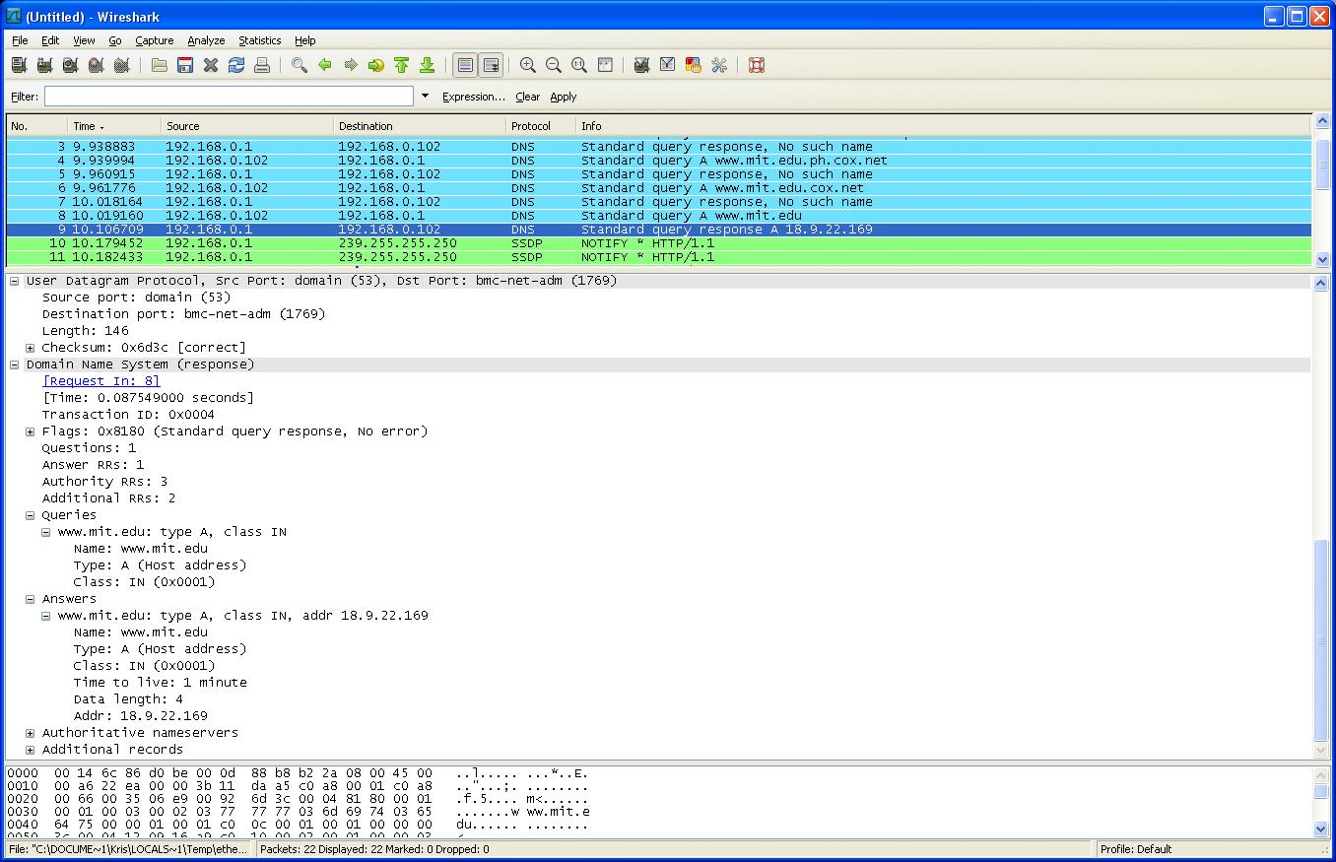
14. Provide a screenshot.

