Wireless Haptic Belt
Senior Design Project
Computer Science and Engineering
School of Computing and Informatics (SCI)
Fulton School of Engineering

Research and Development Team
Kris Blair <Kristopher.Blair@asu.edu>
Nathan Edwards <nathan.edwards@asu.edu>
Jon Lindsay <jonathan.lindsay@asu.edu>
Daniel Moberly <Daniel.Moberly@gmail.com>
Jacob Rosenthal <jakerosenthal@gmail.com>

Advisors
Dr. Sethuraman Panchanathan <Panch@asu.edu>
Director, Center for Cognitive Ubiquitous Computing

Troy McDaniel <troylmcdaniel@cox.net>
PhD Student

Sreekar Krishna <Sreekar.Krishna@asu.edu>
PhD Student

- Brief description of the student organization/project
Project:
The Haptic Belt is a vibro-tactile presentation device, worn around the waist, that can be used as an alternate form of information communication through the sense of touch. Touch is a promising modality for communicating information compared to vision or hearing as it is personal and unobtrusive. Haptics—a term that refers to the science of touch—is a growing area of research in human computer interaction and communication. At the Center for Cognitive Ubiquitous Computing (CUbiC), researchers have developed a Haptic Belt that is used for communicating non-verbal social cues (relative direction of communicators, interpersonal distance between communicators, etc.) through vibratory cues to individuals who are visually impaired, blind or cognitively disabled towards understanding everyday social interactions. A wired version of this belt has been successfully developed. Unfortunately, the current prototype limits the ability to research realistic situations as it requires that a laptop along with a cumbersome cabling system be carried at close proximity to the device. Consequently the configuration significantly inhibits any normal movement of a test subject. The goal of this capstone project is to convert the haptic belt into a wireless version. The design project would concentrate on hardware and software development towards the wireless belt.
Hardware development involves the construction of a replica vibrotactile belt with 7 vibrators that are controlled via a microcontroller. The microcontroller would then be interfaced with a wireless transceiver module, using Bluetooth or ZigBee protocol, that will be mounted on the belt as part of the wireless conversion. The interface between the microcontroller and the wireless module needs to be designed and implemented by the team. Software development consists of designing multithreaded applications on Windows OS using the Visual Studio development environment in C++ and/or C# languages. The threaded applications will provide opportunity for other software to send control signals to the belt via wireless connection. The figure below shows what has been developed as a wired version. This project is aimed at the conversion of this belt into a wireless version with expanded capability.
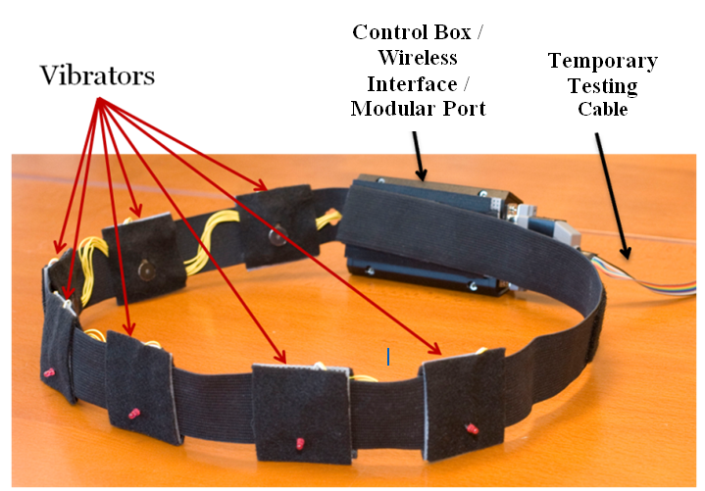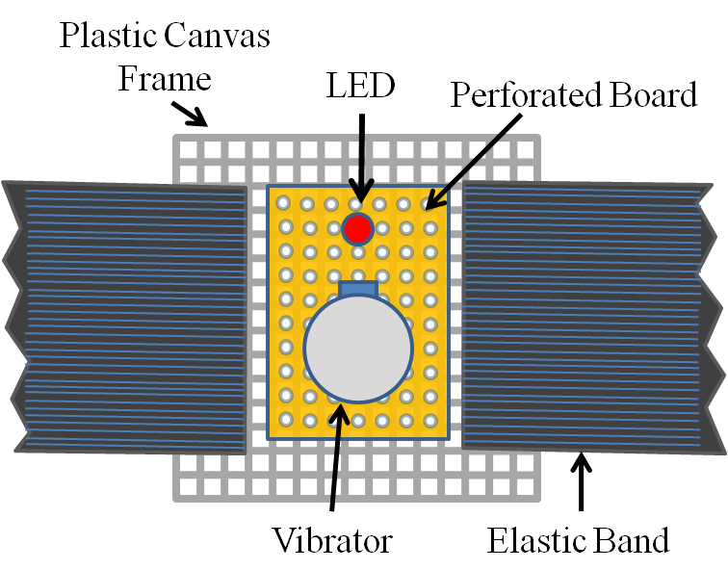
Figure: a) Proposed Haptic Belt with wired connection that needs to be converted to wireless version. b) Individual vibrator elements of the Haptic Belt.
Control Box
Wired Connection
Team:
The group consists of computer science seniors who are working on this project as part of their capstone (senior design project). The group has five students and they are working with two PhD students (advised by Dr. Panchanathan, Director of the Center for Cognitive Ubiquitous Computing (CubiC), School of Computing and Informatics (SCI)). The five students are:
- Daniel Moberly
- Jacob Rosenthal
- Jon Lindsay
- Kris Blair
- Nathan Edwards
They are working with the two PhD students:
- Sreekar Krishna <Sreekar.Krishna@asu.edu>
- Troy McDaniel <troylmcdaniel@cox.net>

- Total amount being requested, with an itemized budget (Maximum $1,000 per student design project per semester)
Item Number | Description | Price
1. | Small sized laptop – computing element (1) | $400
2. | Micro controller development module (2) | $150
3. | Electronic spare parts | $150
4. | ZigBee Wireless Module (2) | $75
6. | Hardware for making the belt | $100
7. | Power source for the belt (2) | $75
8. | Technical literature for emerging wireless standards | $50
Total |  | $1000

- Most recent financial records within one fiscal year (include past expenses and incomes), if applicable

(Not Applicable)

- How does this event/project/activity meet the funding requirements above (1, 2, or 3)?
- Promote the vision and mission of the Fulton School of Engineering
Fulton school of engineering is an integral part of ASU’s vision to become the icon of a new American university. ASU has been promoting excellence in its research and among its students, staff and faculty, increasing access to its educational resources and working with communities to positively impact social and economic development. To this end, our project is aimed towards advancing knowledge in the areas of human social needs and enabling access to social cues for people who are blind and visually impaired. For example, the belt developed in this project would be able to rehabilitate people who are blind in understanding everyday social norms, like making eye contact when talking to someone. It has been known that improving social skills are very important to the overall growth of an individual. Moreover, the belt would have applications in social rehabilitation for people who are autistic or have other cognitive disabilities.
- Encourage faculty/student interaction
The haptic belt is part of a larger project, the Social Interaction Assistant, which is aimed at developing technology that analyzes social behaviors of individuals on a daily basis and provides necessary assistance and rehabilitation to people with needs. From the conception of this project, nearly 5 years prior, more than 4 Master’s students have graduated with a background in developing assistive technologies. Two PhD students are currently engaged in advancing the knowledge barriers in developing assistive technology. One capstone team has successfully worked on integrating parts of the project and the current team (with a highly focused goal) would be working very closely with end users and researchers in understanding and implementing the design.
- Enhance the engineering education of students
The proposed project has been translated to international conference quality papers in four occasions. Students have presented the work in Canada, India, France and nationally. The wired version of the haptic belt won the best student paper award at last year’s IEEE International Workshop on Haptic Audio Visual Environments and Games 2008 (HAVE 2008). We intend to further the understanding by building the wireless belt and expanding the scope of experiments that can be carried out. The end result would allow for generating a lot more technical publications in international conferences and journals.

- Itemized list of other funding sources and the amount requested from each source
The wired version of the belt was developed by funding provided as a part of NSF ITR grant that was concentrated on developing assistive technology for people who are blind. This project will require significant funding. Without funding from this grant, we will still have enough monetary sources as provided by Dr. Panchanathan which will allow for the creation of a functioning belt. However, we are actively searching for additional funding which will allow us to expand the scope of the project and research alternate design strategies which may prove more effective.

- Evaluation method for this event/project/activity. (How will you evaluate the success of the event?)
CUbiC works closely with the Disability Resource Center (DRC) on campus. The director of DRC, Dr. Terri Hedgpeth and their Accessibility Expert, RaLynn West, work very closely with CUbiC and are involved in providing active feedback on the development of any device. We are currently seeking participants who are blind and visually impaired to test the wired haptic belt. Any feedback from participants would be incorporated into the wireless version of the belt.

Last year, doctoral student, Troy McDaniel, presented the project at HAVE 2008 in Canada, and brought international attention to the project. We received constructive feedback from peer researchers and the new design will incorporate them.

Doctoral student, Sreekar Krishna, is presenting the wired version of the belt at the 24th International Conference on Disabilities that is scheduled for March 19th, 2009. Our paper has already been accepted by peer researchers, and any feedback from the conference would be integrated into the wireless versions of the belt.

Future evaluations of the project include evaluative product testing, the successful delivery of a functional wireless haptic belt, and the commencement of additional studies on the use of haptic technology with regard to multi-body positions and realistic social interactions.

