# Book

The following is the Book dataset

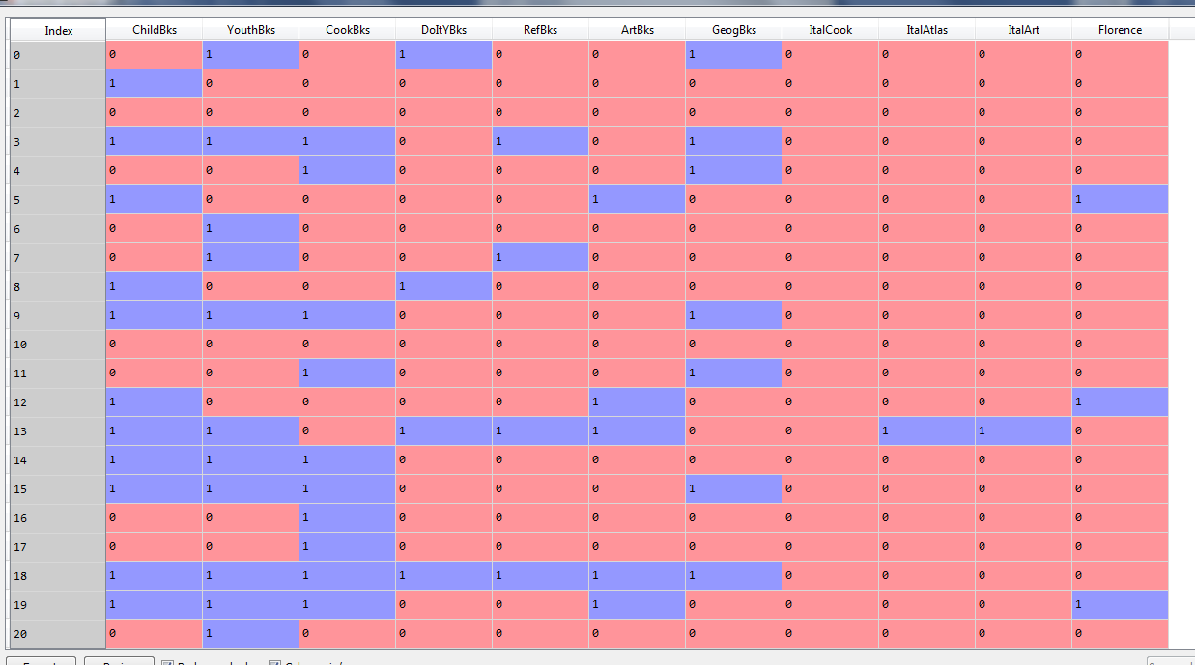

Executing Apriori algorithm to the book dataset

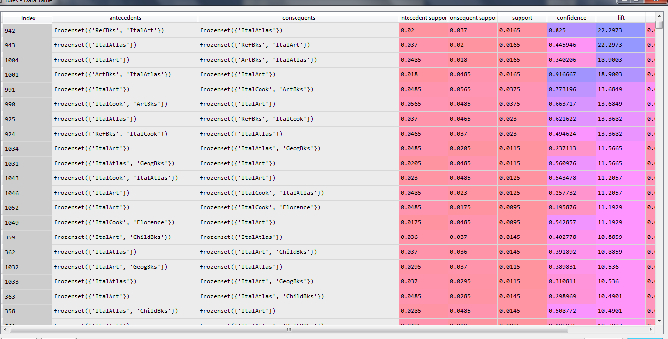

The associations are sorted according the lift ratios.

With the lift ratio of 22.29, there is a strong association with the items RefBks, ItalArt and ItalAtlas.

But, there is also a redundancy with the association with the same lift ratio. The second item with the antecedent being ItalAtlas and consequent being RefBks, ItalArt.

Removing the redundancy and we get the following results

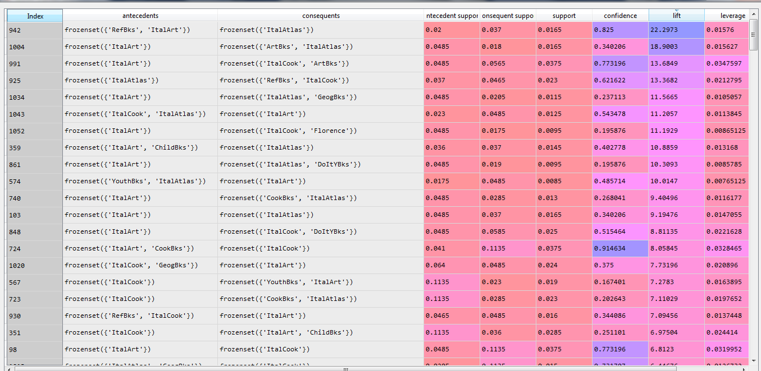

In the above results we get the association of RefBks, ItalArt and ItalAtlas with lift ratio 22.29

The second relationship is between shopping ItalArt and ArtBks, ItalAtlas with a lift ratio of 18.90

Basically, if a person buys RefBks, ItalArt he/she is also likely to buy ItalAtlas

The scatter plot of the support and confidence is as follows:

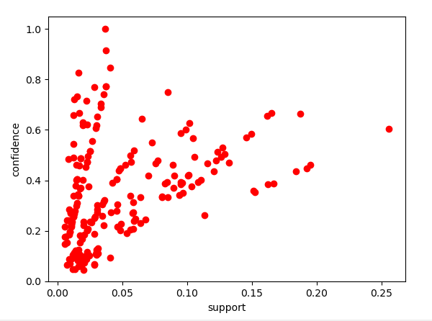

**For minimum support = 0.01**

The following are the results

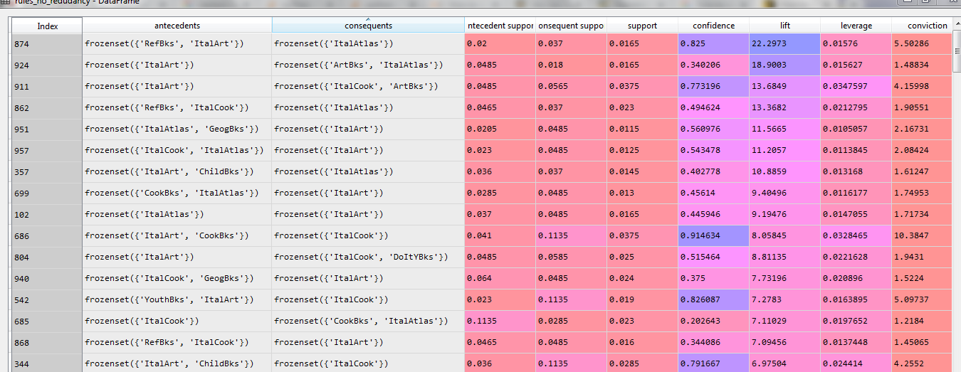

The top of the association is the relationship between RefBks, ItalArt and ItalAtlas

**For minimum support = 0.03 and max len = 4**

The following are the results

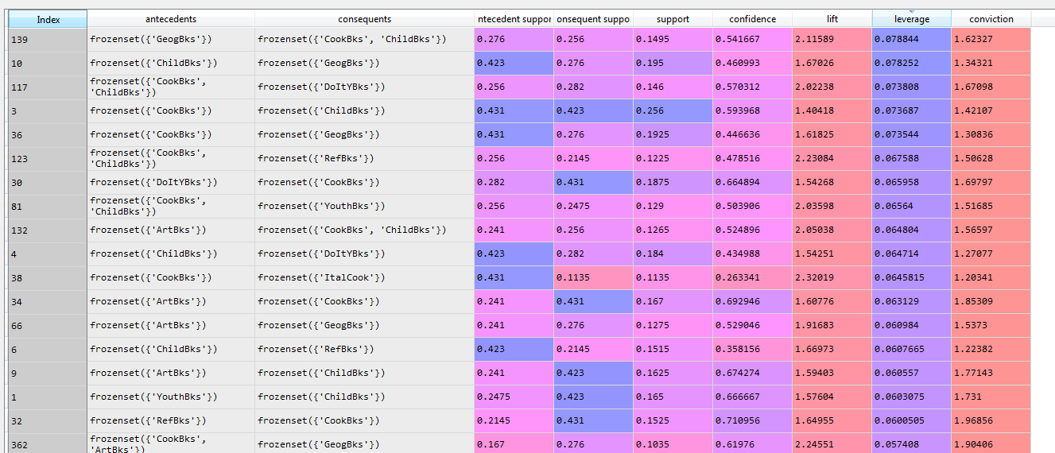

The top of the association is the relationship between other ItalArt, CookBks & ItalCook, ArtBks with lift ratio 16.1882