# Groceries

The following is the data collected at a point of sale in a grocery store.

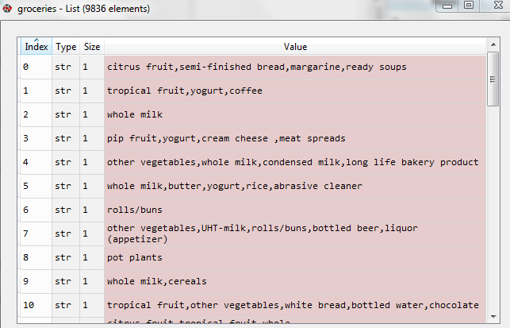

We then process to count the number of individual items in the list and plot of bar chart displaying the items and their frequencies

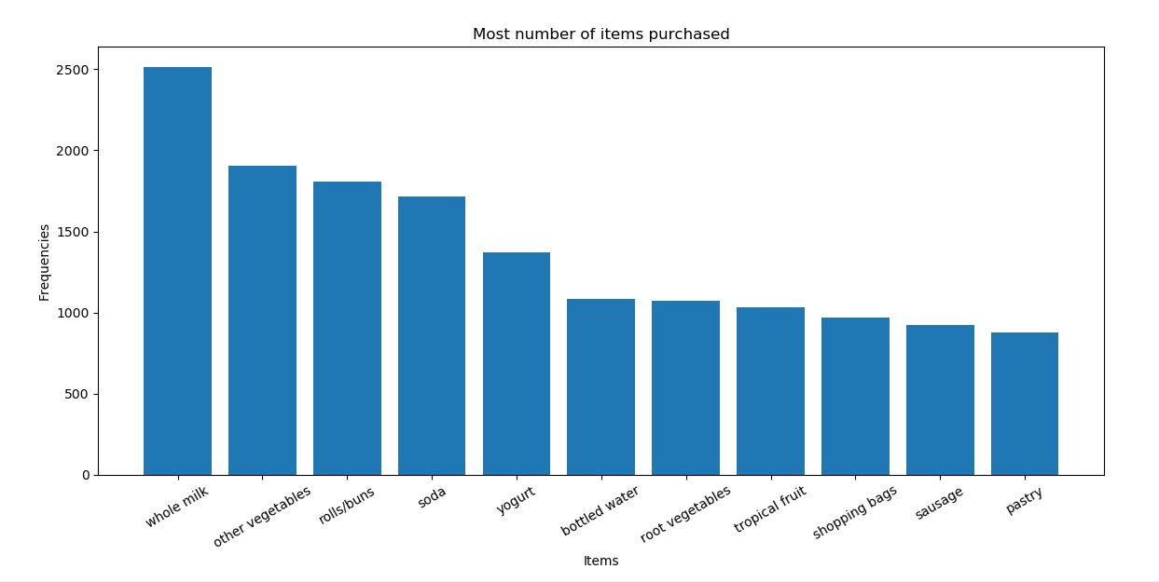

In the above bar chart the item whole milk has the highest frequency followed by other vegetables

Setting the minimum support to 0.005 and max_len to 3

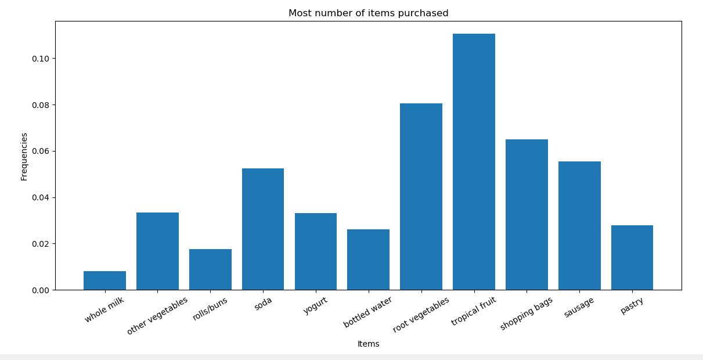

With support to 0.005 we have tropical fruit that is bought frequently

Once the apriori algorithm is executed the following are the results:

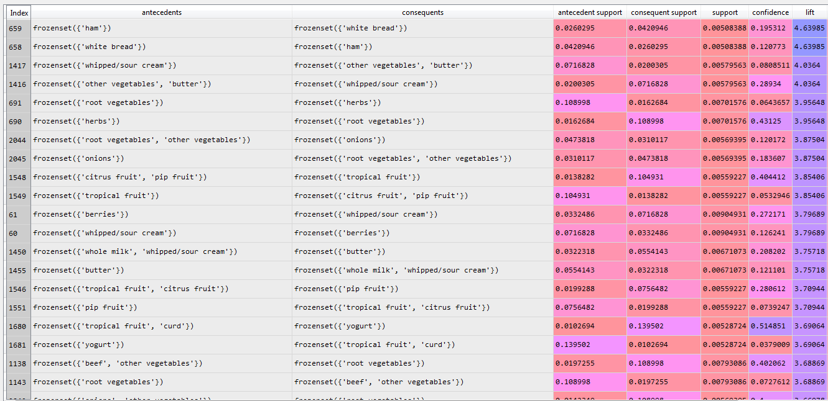

The associations are sorted according the lift ratios.

With the lift ratio of 4.63, there is a strong association with the items ham and white bread.

But, there is also a redundancy with the association with the same lift ratio. The second item with the antecedent being white bread and consequent being ham.

Removing the redundancy and we get the following results

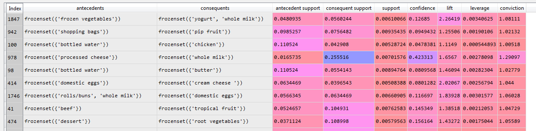

In the above results we get the association of frozen vegetables and yogurt & whole milk with lift ratio 1.08

The second relationship is between shopping bags and pip fruit.

Basically, if a person buys vegetables he/she is also likely to by yogurt & whole milk

The scatter plot of the support and confidence is as follows:

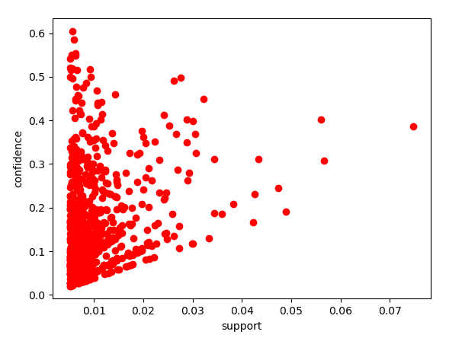

**For minimum support = 0.01**

The following are the results

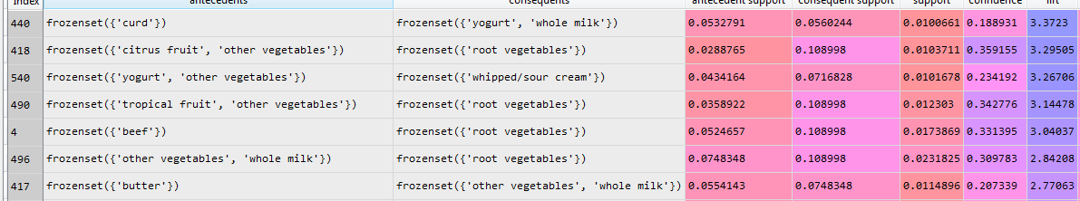

The top of the association is the relationship between curd and yogurt & milk

**For minimum support = 0.03 and max len = 4**

The following are the results

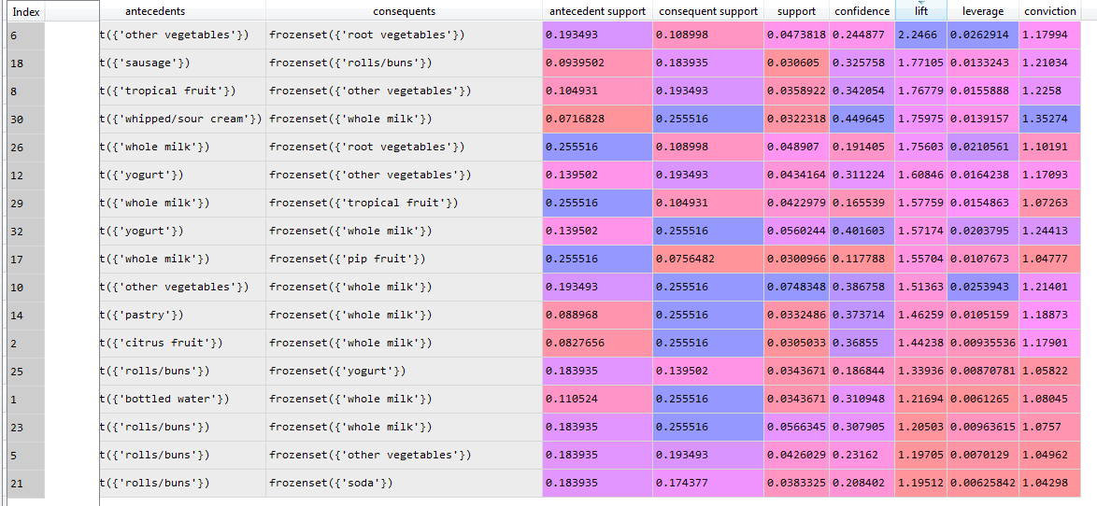

The top of the association is the relationship between other vegetables and root vegetables