# My Movies

The following is the data collected for my movies

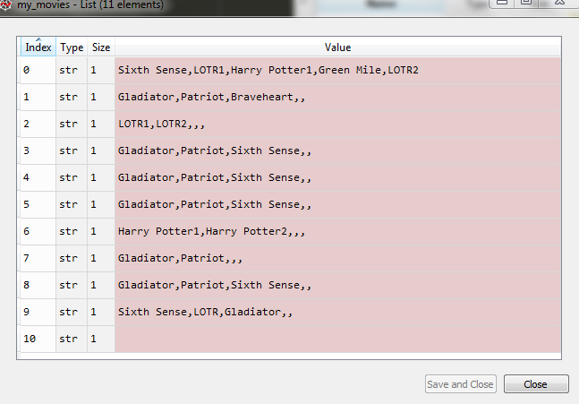

We then process to count the number of individual items in the list and plot of bar chart displaying the items and their frequencies

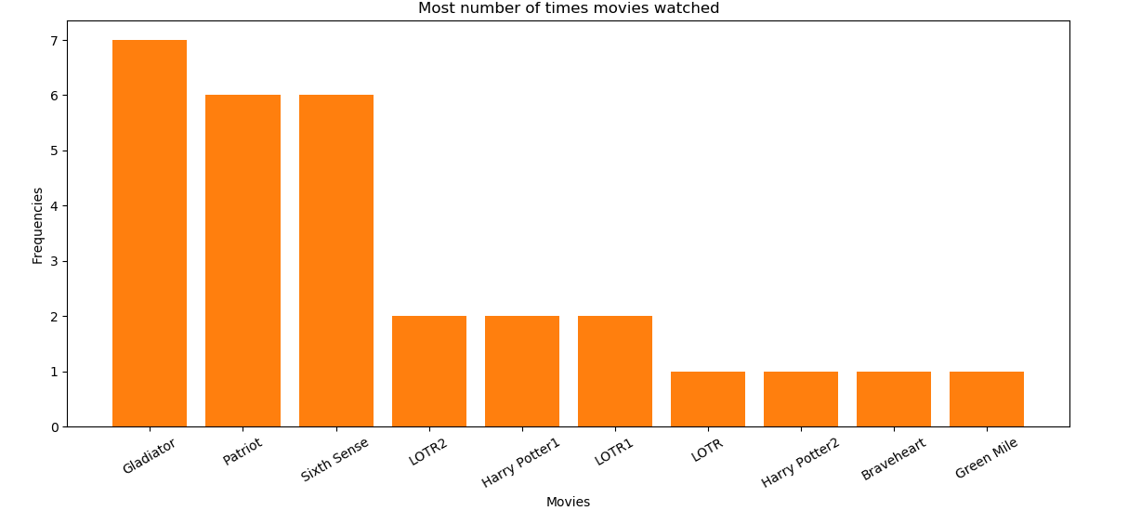

In the above bar chart the movie “Gladiator” has the highest frequency followed the movie “Patriot”

Setting the minimum support to 0.005 and max_len to 3

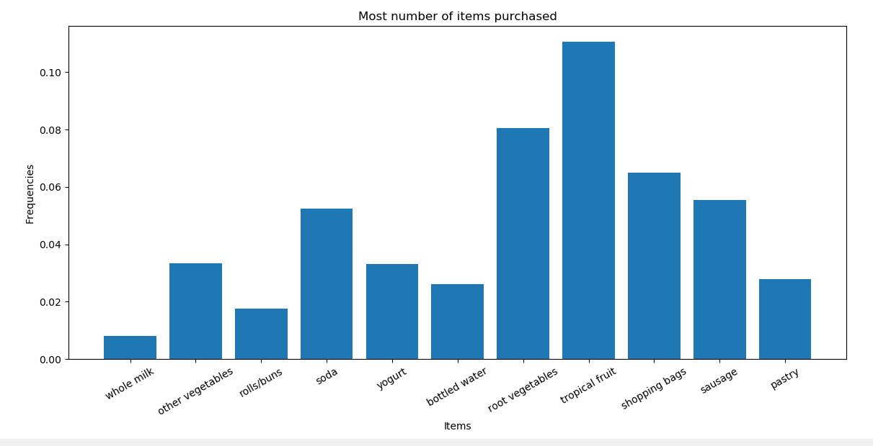

With support to 0.005 we have tropical fruit that is bought frequently

Once the apriori algorithm is executed the following are the results:

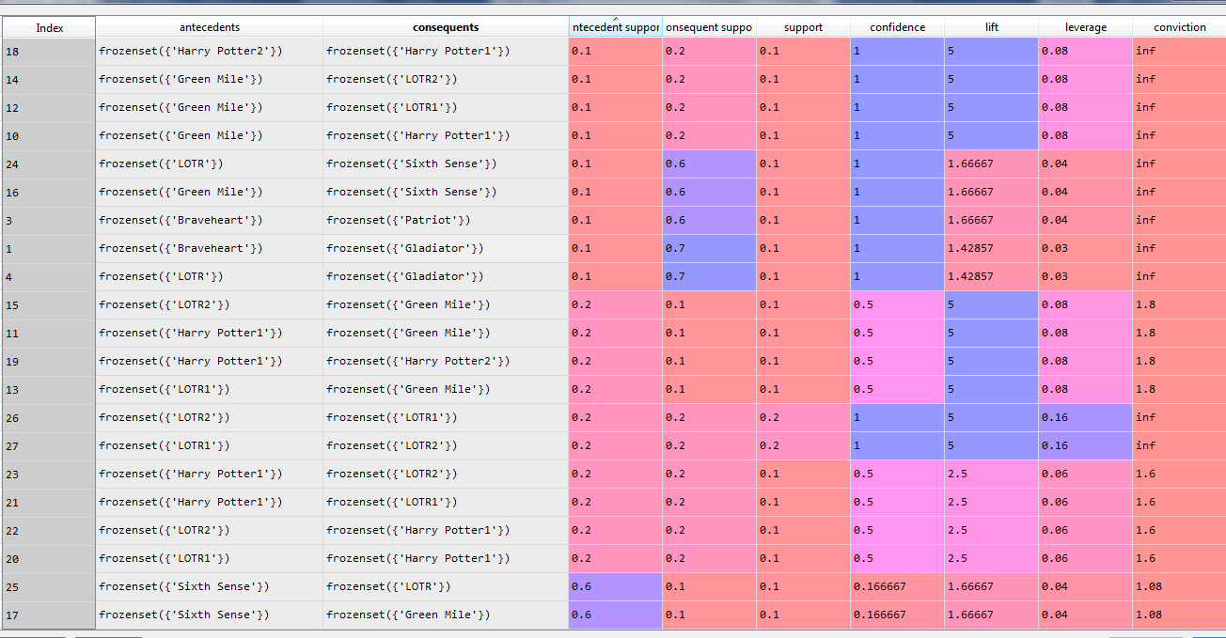

The associations are sorted according the lift ratios.

With the lift ratio of 5, there is a strong association with the movies Harry Potter 1 & Harry Potter 2, LOTR1 & LOTR2, Harry Potter 1 & Green mile and LOTR1 and Green mile.

But, there is also a redundancy with the association with the same lift ratio.

Removing the redundancy and we get the following results

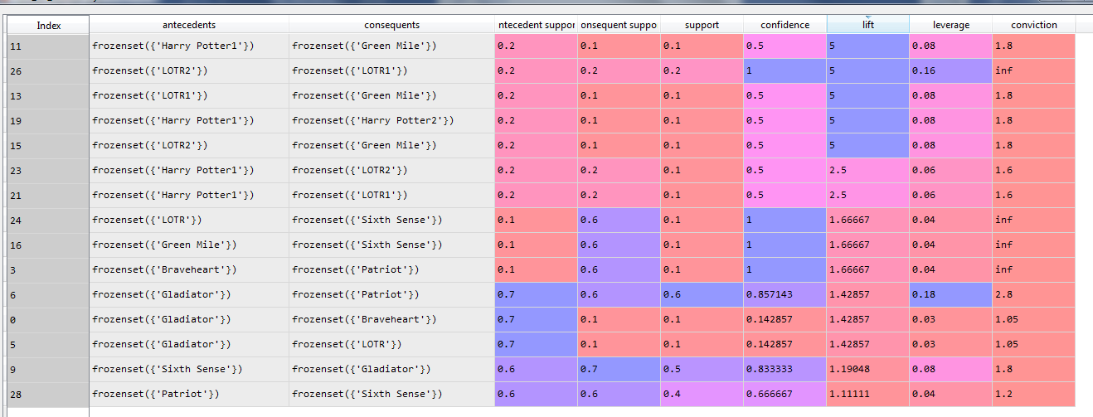

In the above results we get the association of frozen vegetables and LOTR1 and LOTR2 with lift ratio 5 and confidence 1

If a person watches LOTR 1 then he would also like to watch LOTR 2

The scatter plot of the support and confidence is as follows:

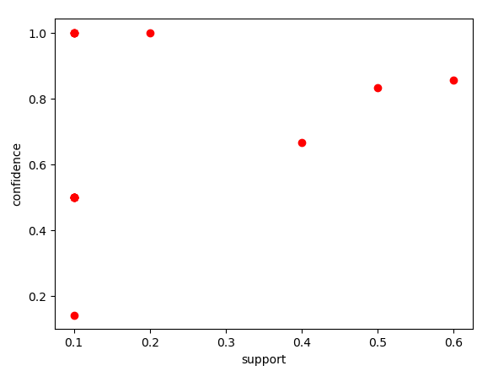

**For minimum support = 0.01**

The following are the results

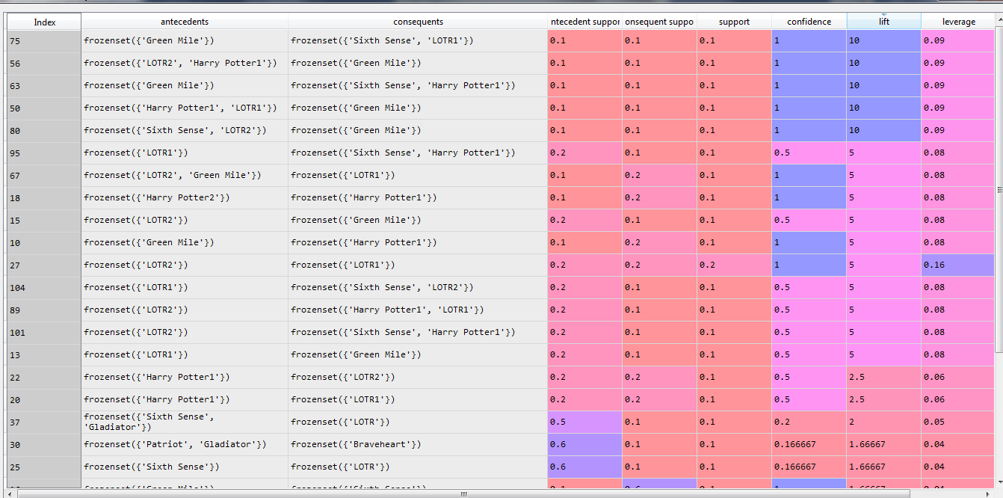

The top of the association is the relationship between Green Mile and Sixth Sense & LOTR1

**For minimum support = 0.03 and max len = 4**

The following are the results

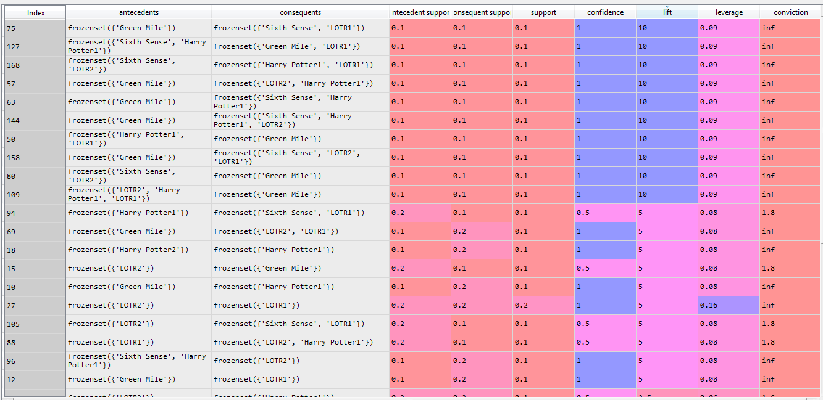

The top of the association is the relationship between Green Mile and Sixth Sense & LOTR1. The results are almost same when minimum is set to 0.01