# Forecasting algorithm for Airlines data

Problem Statement:

Forecast Airlines Passengers data set. Prepare a document for each model explaining

how many dummy variables you have created and RMSE value for each model. Finally which model you will use for

Forecasting.

Considering the airline dataset as follows:

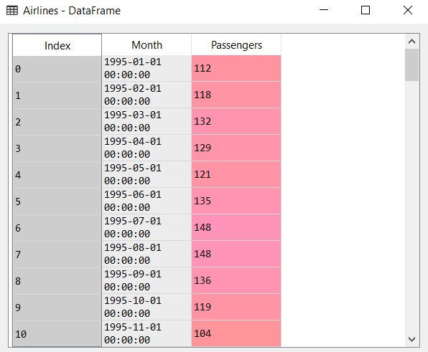

From the above dataset. The date containing the month and the year is extracted:

We get the following dataset:

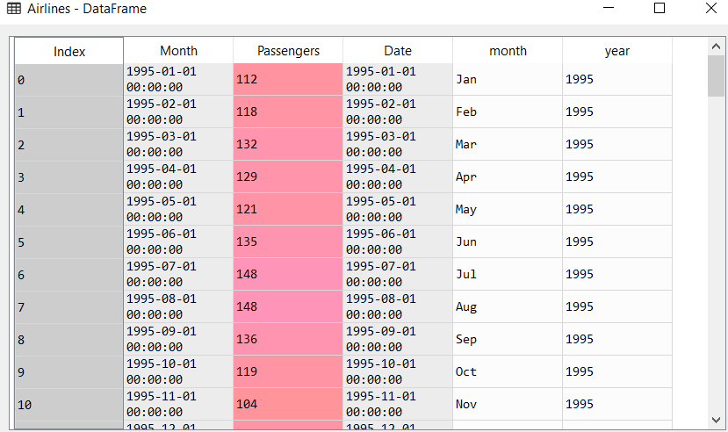

Once the date is extracted into month and year, we create dummy variables for all the months as shown below:

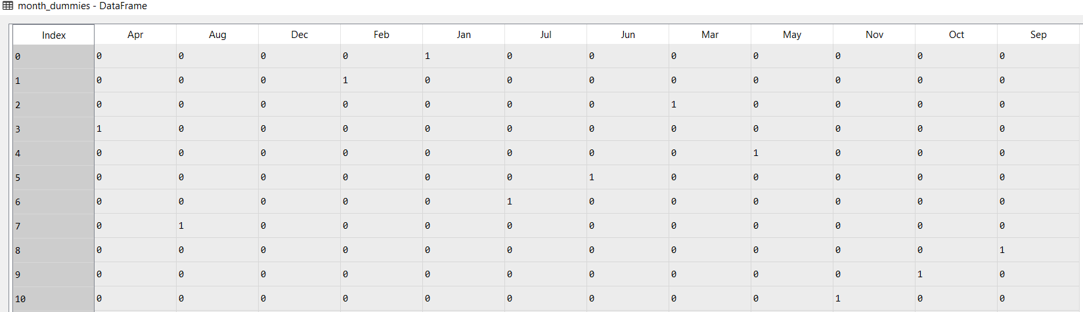

We then proceed to concatenate the above dummy variables with a new dataframe Airlines1 as follows:

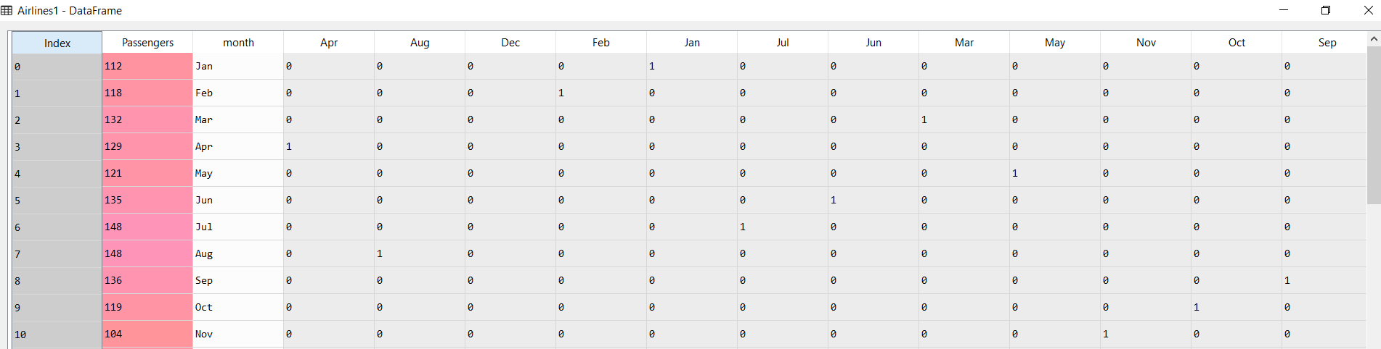

T, t-squared and the log value of passengers variable is calculated.

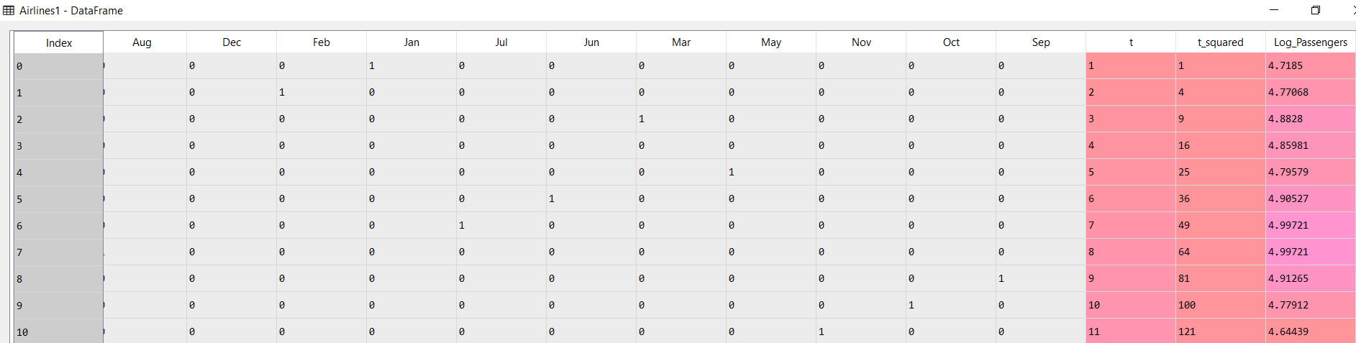

The following is the trend plot of Passengers variable

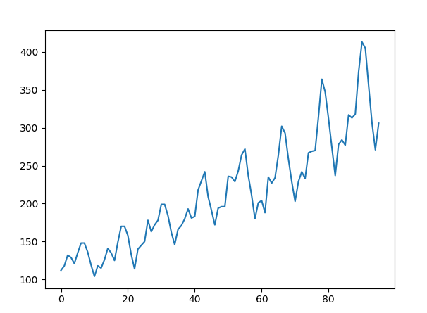

The above plot shows that the number of passengers are having and upward trend with multiplicative additive seasonality.

After splitting the data into test and train we execute ordinary least square method. The results of the various models are as follow:

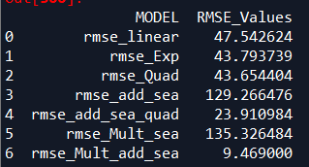

From the above results. The root mean square of multiplicative additive seasonality model is having the least RMSE value. Hence we choose this model for prediction.