# K-Nearest Neighbor Algorithm

Problem Statement:

Implement a KNN model to classify the animals in to categorie

The following is the dataset of glass dataframe:

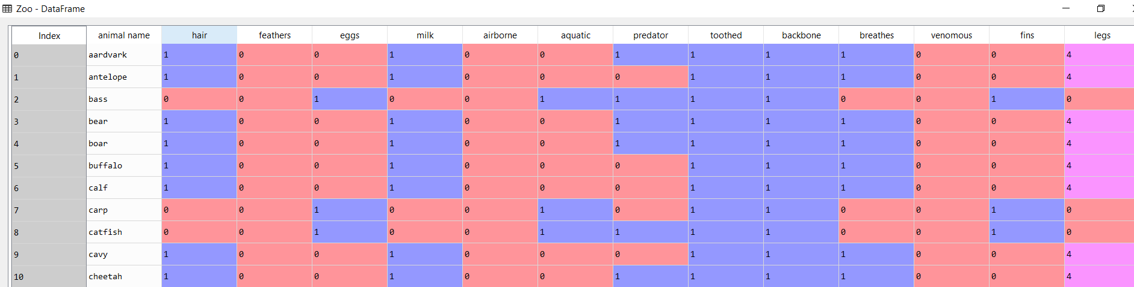

We then split the data into test and train datasets

Train data:

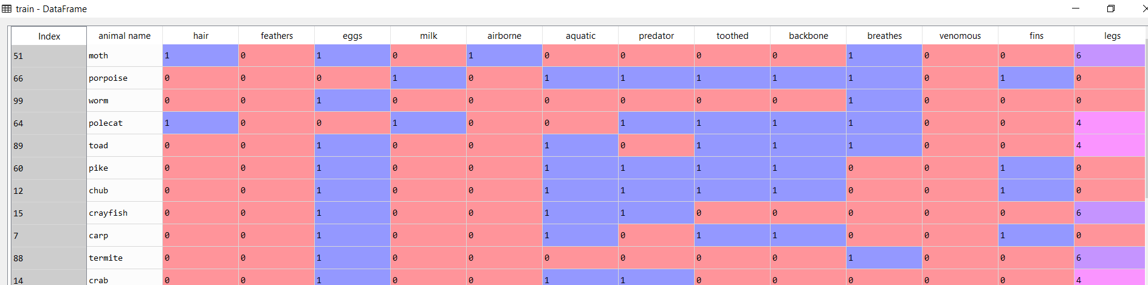

Test data:

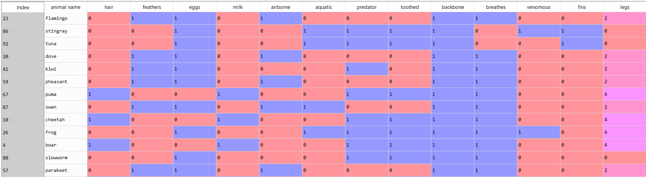

We execute the algorithm for 3 nearest neighbors

The following are the results:

Train accuracy: 0.9625

Test accuracy: 0.9523809523809523

We execute the algorithm for 5 nearest neighbors

Train accuracy: 0.925

Test accuracy: 0.9523809523809523

By running KNN algorithm for 3 to 50 nearest neighbours(odd numbers) and storing the accuracy values. We get a plot as follows:

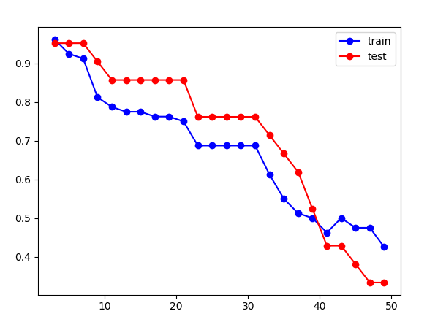

In the above plot the accuracy of the test and train data when K = 3 is about 95%. The optimum K value would be 3 since the test accuracy is greater than train accuracy for K values greater than 3.