# Snapdeal trimmer product nova sentiment analysis

Problem Statement:

1) Extract reviews of any product from ecommerce website

2) Perform sentimental analysis

After data extraction from snapdeal, the following is the information on the product review of nova trimmer 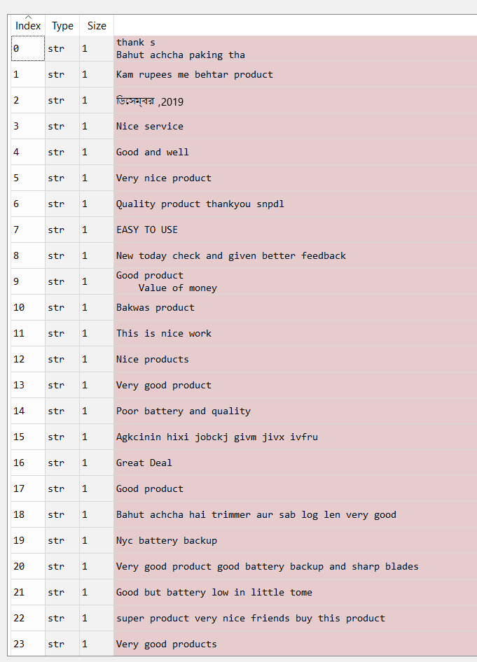

Creating a DTM matrix with shape (131,315)

Creating a wordcloud for all the words in the corpus

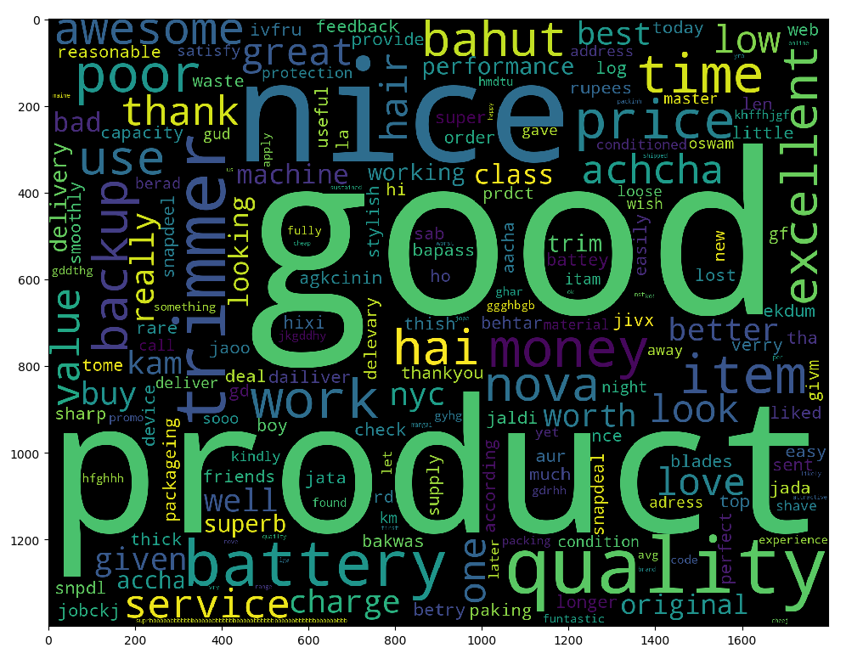

From the above wordcloud, the key words displayed are good, product, quality and nice which shows us the sentiments that people are happy and satisfied with the product.

The following is the negative words that are used in the product review

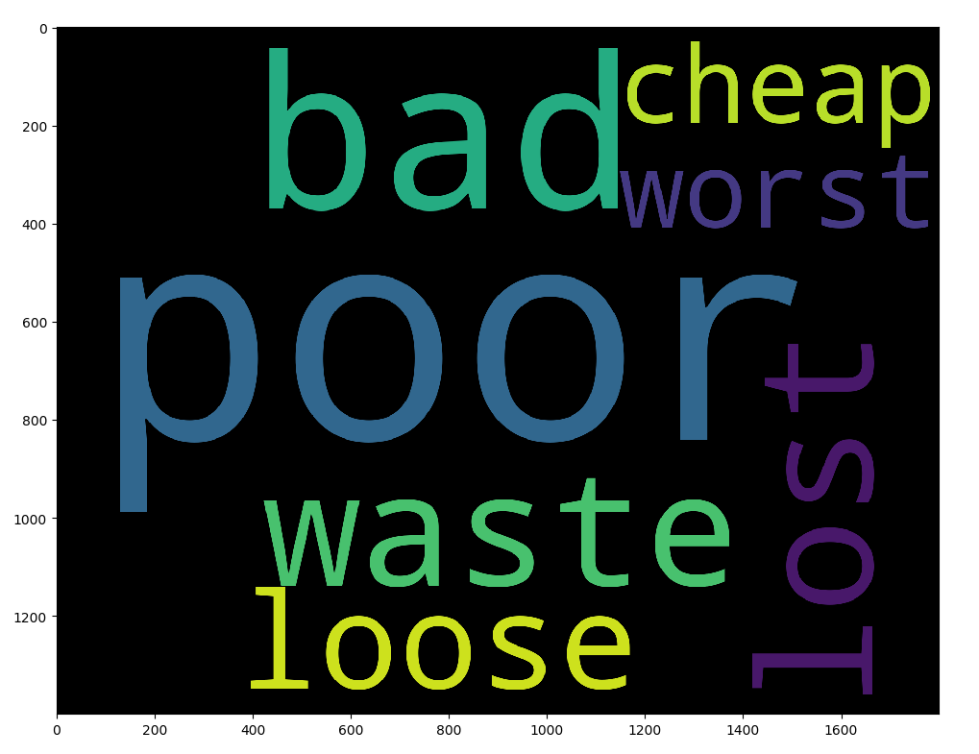

The use of word like poor, bad, waste are predominately used by the dissatisfied customers

The following is the positive words that are mostly used by the user

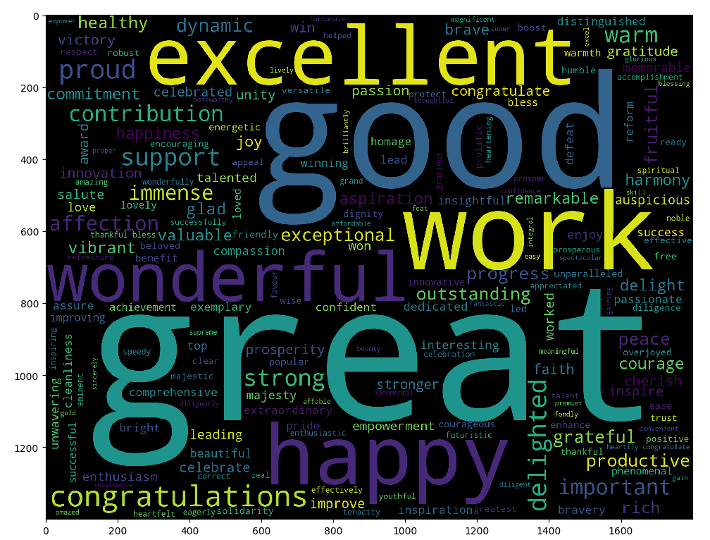

Words like great, good, excellent, work and other less predominant words like congratulations, grateful, wonderful projects a sentiment of appreciation and gratitude.