# Twitter account sentiment analysis

Problem Statement:

1) Extract tweets for any user (try choosing a user who has more tweets)

2) Perform sentimental analysis on the tweets extracted from the above

After data extraction from twitter, the following is the information on the twitter user narendramodi 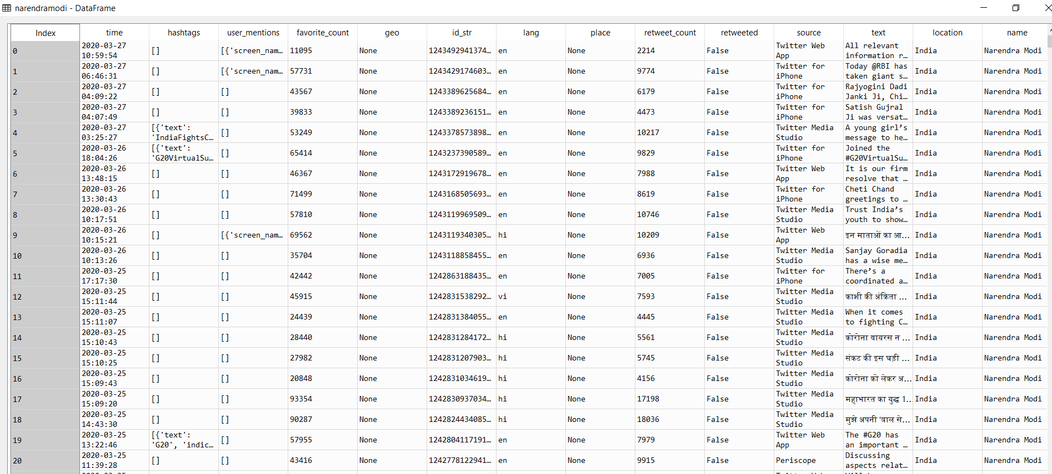

We segregate each tweet into individual document to form a corpus:

The following is the segregation:



Creating a wordcloud for all the words in the corpus

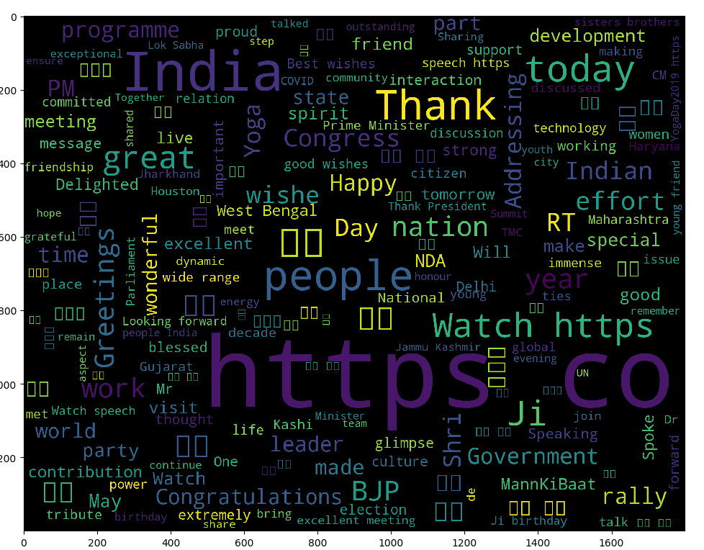

From the above wordcloud, apart from https co, which would have appeared when the user is sharing web links, the predominant words used are represented by the font size of the letters. The words such as Thank, Happy , Great, India, People displays patriotic sentiments.

The following is the negative words that are mostly used by the user

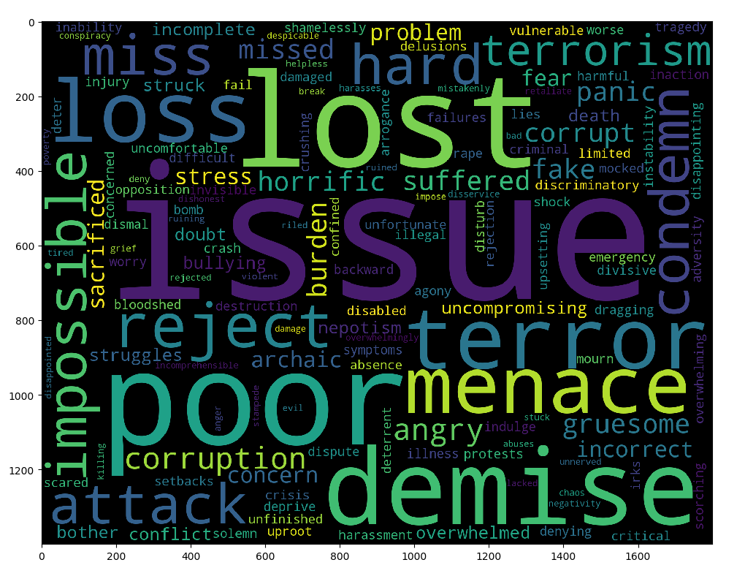

The use of word like issue, loss, terror, menace, demise provides an insight of the user’s sentiments of the negative phenomenon.

The following is the positive words that are mostly used by the user

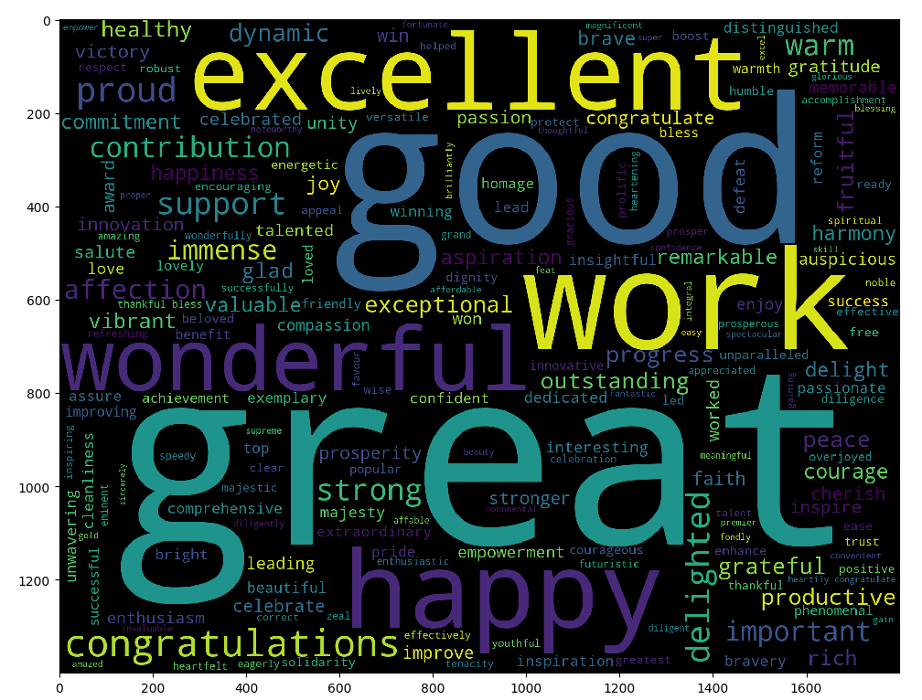

Words like great, good, excellent, work and other less predominant words like congratulations, grateful, wonderful projects a sentiment of appreciation and gratitude.