**Instructions to install Environment for Python for CE3007**

Date: 2 Jan 2018

Author: Chng Eng Siong

1. We will be using Anaconda Environment for Python (Python 3.6)

<https://www.anaconda.com/download/>

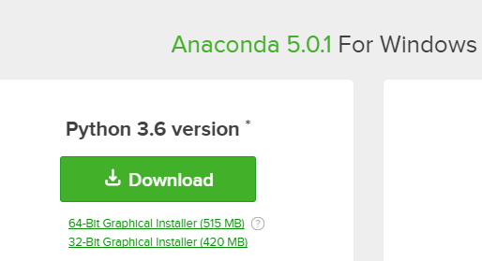

1. You need to install the following libraries using conda install
   1. <https://docs.anaconda.com/anaconda-cloud/user-guide/howto#use-packages>

Libraries you will need:

1. https://anaconda.org/anaconda/numpy
2. <https://anaconda.org/anaconda/scipy>
3. <https://anaconda.org/anaconda/matplotlib>

and you will use: https://docs.python.org/2/library/winsound.html

1. You can consider using PyCharm <https://www.jetbrains.com/pycharm/>

Some Help:

1. You will need to learn how to organize python code into packages:
   1. <http://intermediate-and-advanced-software-carpentry.readthedocs.io/en/latest/structuring-python.html>