**Lab 2 Hint: Frequency Response of LTI System**

**Date: 9 Feb 2018**

**Note: only help you about (less than) 50% of the Lab quiz – good luck!**

0) In this Lab Quiz and Lab (e.g, Q4), you can use Matlab to check frequency response of filters being analysed. It will provide for insights and help you answer the question more easily. However, even if you don’t use Matlab, you should be able to solve all the given questions. Matlab available in SCSE hardware lab PCs.

1) You should learn how to evaluate frequency response in all ways:

- measuring vs theoretical vs Matlab computation of frequency response.

A sinusoid is an eigen function of LTI system.

Generate $x\left[n\right]=1*cos⁡(ω n)$ for $ω=0..2π$ in step $0.1π$ of 5 cycles of the signal at each frequency. Convolve this signal with $h\left[n\right]=\{0.2,0.3,-0.5\}$, n = 0,1,2. Now perform the following 3 tasks to measure frequency response.

a) Measuring: Plot the input and output signal together on the same graph for a required $ω$. Eye-ball the input and output sinusoid to estimate the magnitude and phase response for that frequency. Repeat for all needed frequency.

b) Given impulse response, find $H\left(e^{jω}\right)$ by DTFT. Compute its magnitude and phase at $ω=0..2π$ step of 0.1 $π$, compare your results to (a).

c) Use matlab fvtool(B,A) ; where in the above, its simply type:



- Visualize the magnitude and phase response.   
Note: convert the magnitude scale to Magnitude! Not in dB scale.

- Note: x-axis is 0..1 *($π$) : normalized to pi

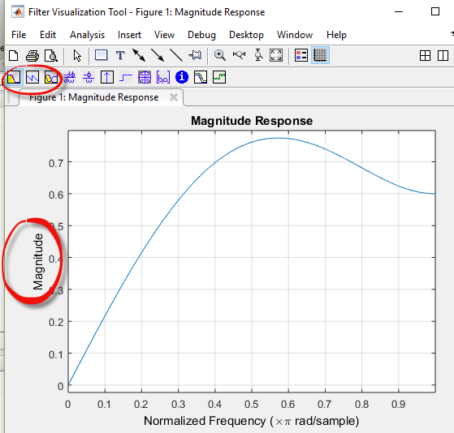

Fig: magnitude response of the LTI system being analysed using fvtool

2) IIR Filter’s frequency response. You can try the above Q1 for IIR filter by computing for various B, A coefficients using fvtool(B,A) .

Eg: Try Q1 with B=[ 1 2 3]; A = [1 0.1 0.2]. You can visualize magnitude,phase, impulse response, as well as pole/zero plots.



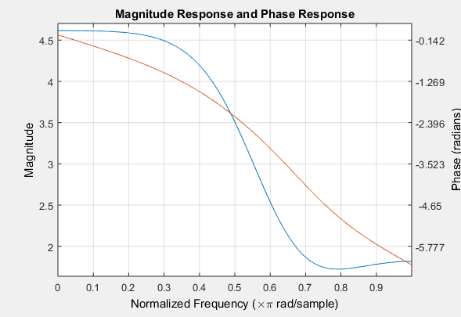

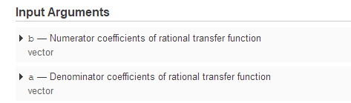

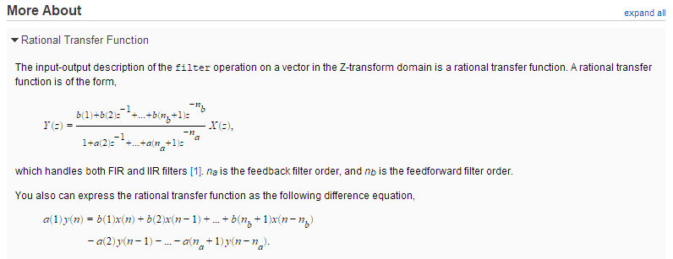

Impulse and Pole Zero plots

