**Aim of Practical 5: Write and execute SQL queries- subqueries, joins.**

**Practical 5 part 1**

SQL Subqueries

## What is a Subquery?

A **subquery** is a query inside another query, used to retrieve intermediate results before executing the main query.

## Types of Subqueries:

1. **Single-row subqueries** → Return a single value.
2. **Multi-row subqueries** → Return multiple values.
3. **Correlated subqueries** → Reference columns from the outer query.

# Example Database: Supermarket

Use a **SupermarketDB** with the following tables:

**Customer** (customer_id, name, email, phone, address)

**Product** (product_id, name, category, price, stock_quantity) **Order_Details** (order_id, customer_id, order_date, total_amount) **Order_Item** (order_id, product_id, quantity, subtotal)

**Employeee** (employee_id, name, role, salary, hire_date)

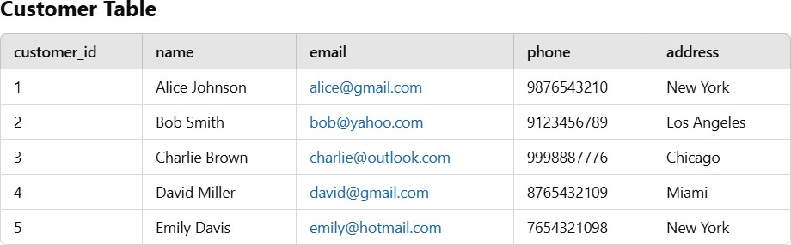

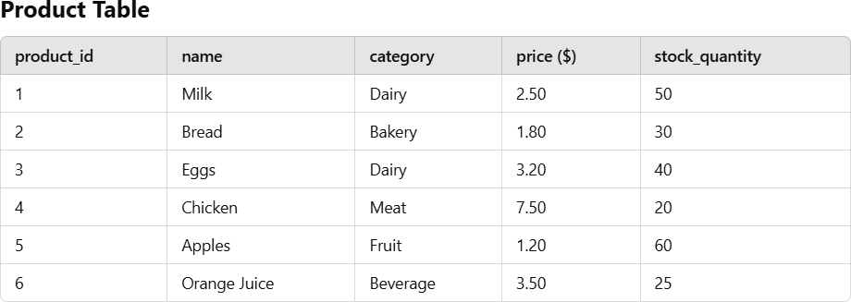

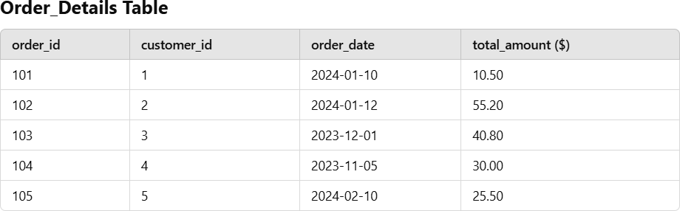

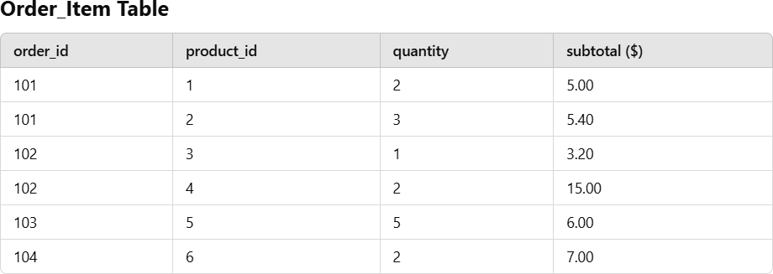

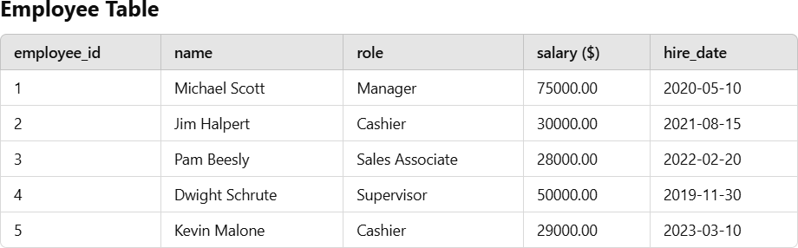

# Examples of Subqueries

## Find customers who placed orders over $50.00

SELECT * FROM Customer

WHERE customer_id IN (SELECT customer_id FROM Order_Details WHERE total_amount > 50);

## Retrieve products that cost more than the average product price

SELECT * FROM Product

WHERE price > (SELECT AVG(price) FROM Product);

## Find employees earning more than the lowest manager’s salary

SELECT * FROM Employeee

WHERE salary > (SELECT MIN(salary) FROM Employeee WHERE role = 'Manager');

## Find employees hired after the most recent hire date of a cashier

SELECT * FROM Employeee

WHERE hire_date > (SELECT MAX(hire_date) FROM Employeee WHERE role = 'Cashier');

## Find customers who haven’t placed any orders

SELECT * FROM Customer

WHERE customer_id NOT IN (SELECT customer_id FROM Order_Details);

## Find the name of the highest-paid employee

SELECT name FROM Employeee

WHERE salary = (SELECT MAX(salary) FROM Employeee);

## Retrieve the total revenue generated from orders placed in January 2024

SELECT SUM(total_amount) FROM Order_Details

WHERE order_date BETWEEN TO_DATE('2024-01-01', 'YYYY-MM-DD')

AND TO_DATE('2024-01-31', 'YYYY-MM-DD');

## Find the most ordered product

SELECT name FROM Product

WHERE product_id = (SELECT product_id FROM (

SELECT product_id, SUM(quantity) AS total_sold FROM Order_Item

GROUP BY product_id ORDER BY total_sold DESC

)

WHERE ROWNUM = 1

);

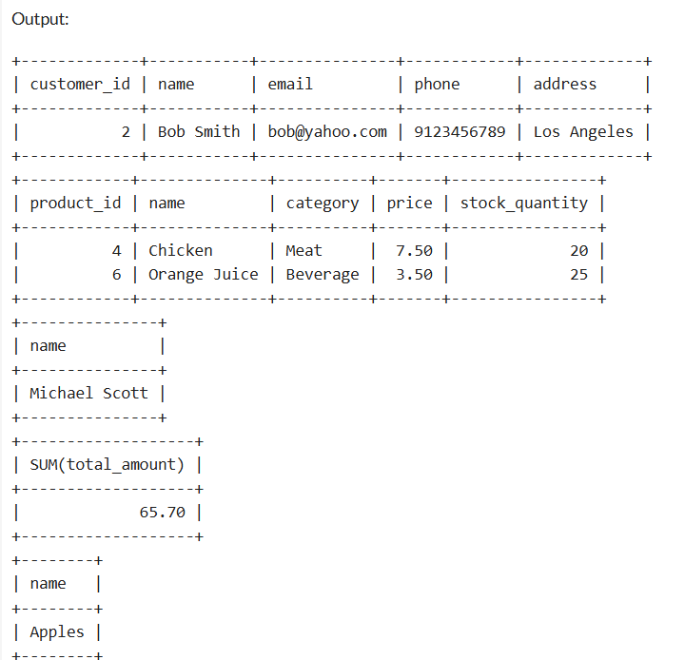

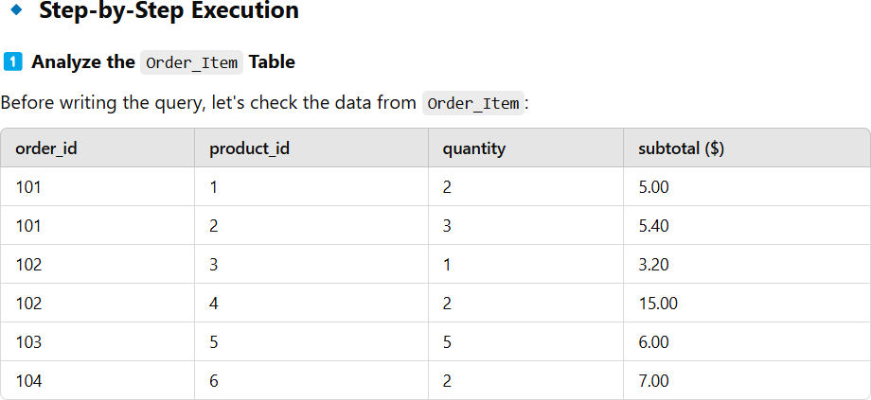

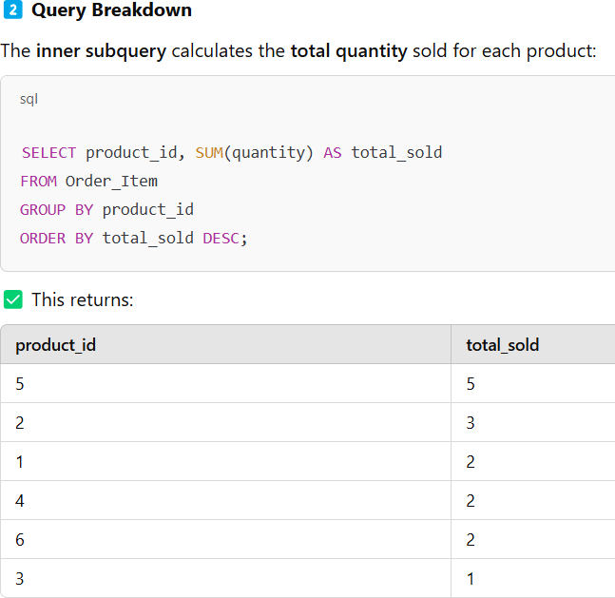

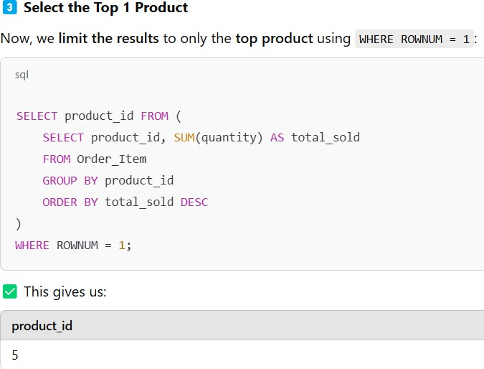

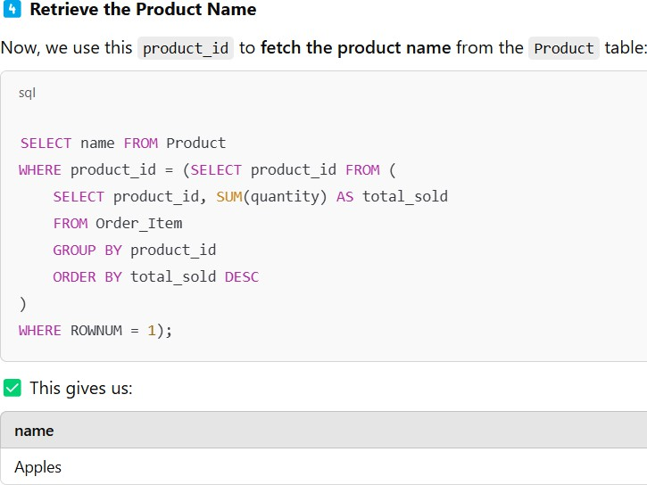

## Retrieve employees who earn above the average salary of all employees

SELECT * FROM Employeee

WHERE salary > (SELECT AVG(salary) FROM Employeee);

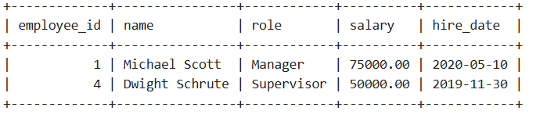

## Find customers who placed orders only in 2023 but not in 2024

SELECT * FROM Customer WHERE customer_id IN (

SELECT customer_id FROM Order_Details

WHERE order_date BETWEEN TO_DATE('2023-01-01', 'YYYY-MM-DD')

AND TO_DATE('2023-12-31', 'YYYY-MM-DD')

)

AND customer_id NOT IN (

SELECT customer_id FROM Order_Details

WHERE order_date BETWEEN TO_DATE('2024-01-01', 'YYYY-MM-DD')

AND TO_DATE('2024-12-31', 'YYYY-MM-DD')

);

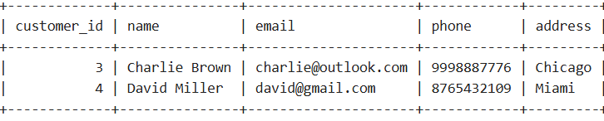

## Subquery Tasks

1. Find customers who placed orders over **$50**.
2. 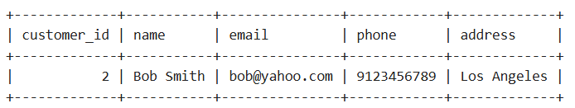
3. Retrieve products that cost more than the **average product price**.
4. 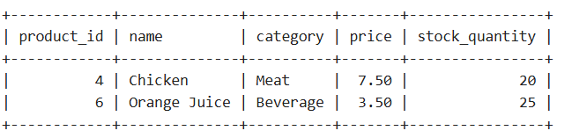
5. Find employees hired after the **most recent hire date of a cashier**.
6. List customers who **haven’t placed any orders**.
7. Retrieve employees who earn **above the average salary**.
8. 