Assignment -3

**1. Program to write the first 10 numbers.**

Code:

for (i = 0; i < 10; i++) {  
console.log(i);

}

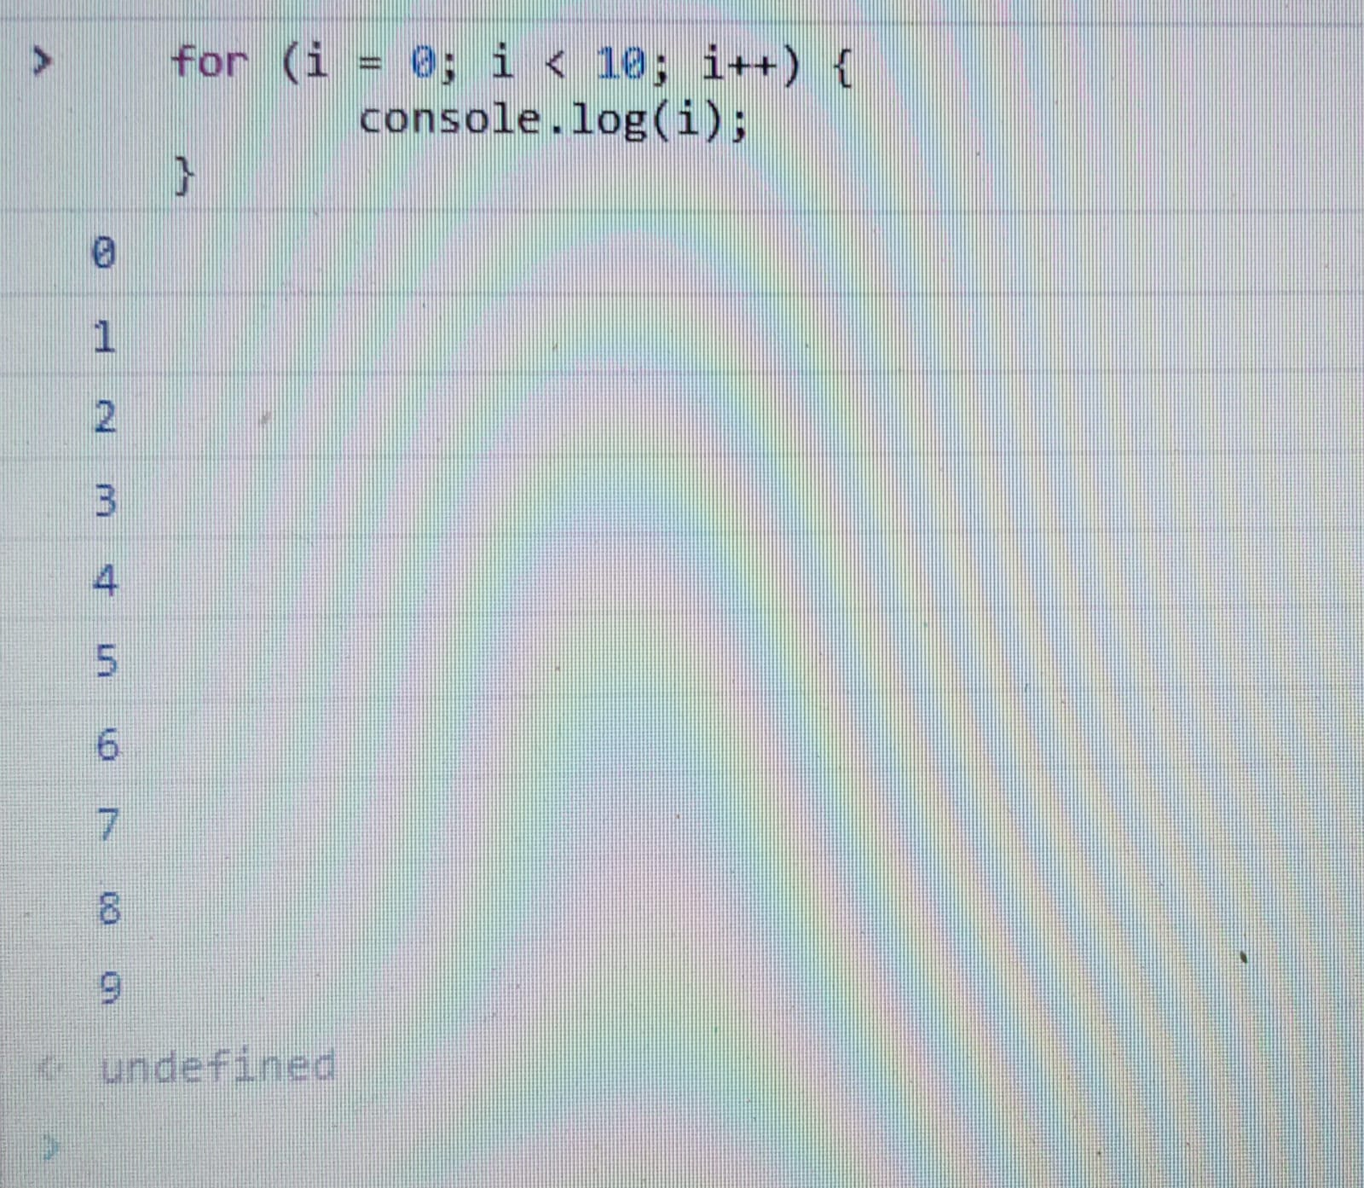

**2. Program to calculate the sum of first 10 numbers.**

Code:

let sum=0;

for(let i=1;i<=10;i++){

sum=sum+i;

}

console.log(sum);

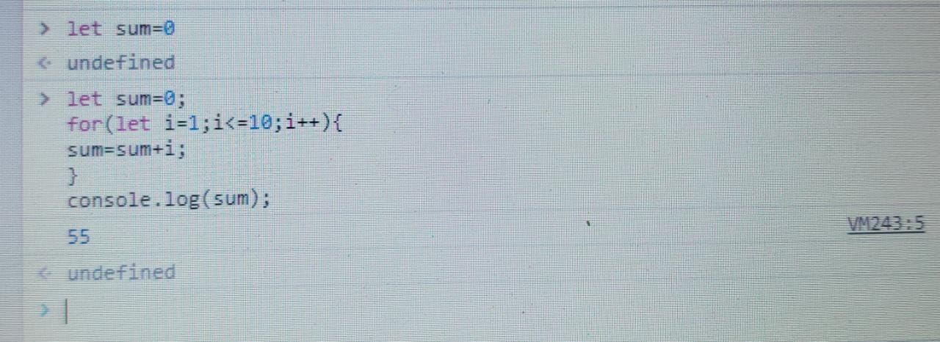

**3. Make the loop stop when i is 5.**

for (i = 0; i < 10; i++) {  
console.log(i);  
if (i == 5) {   
break;  
}  
}

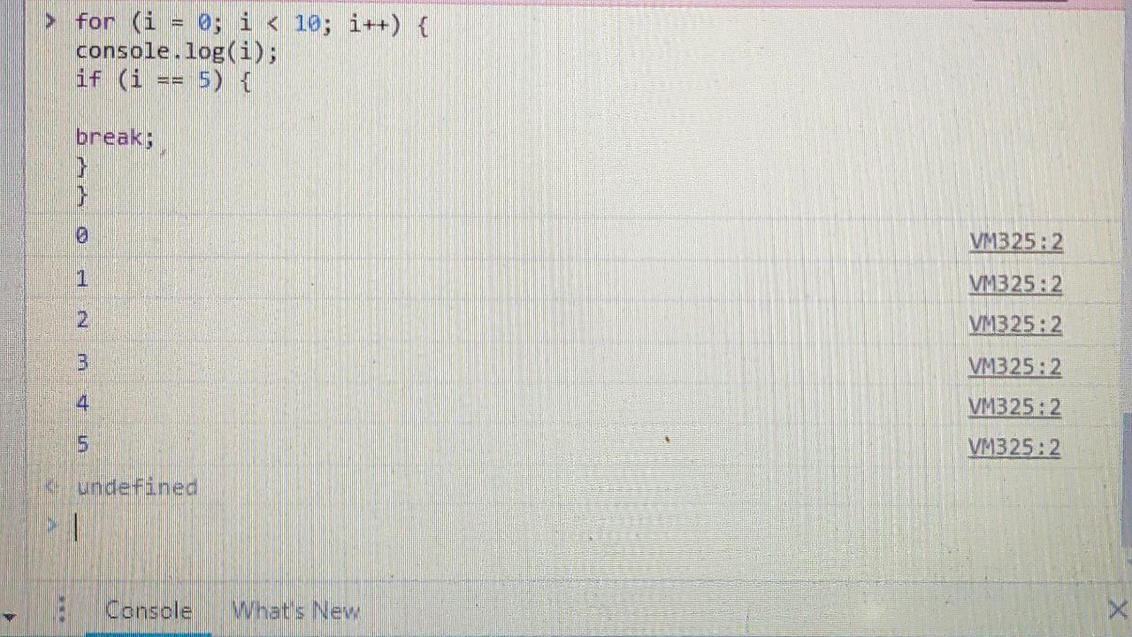

**4. Write a program to print day of week name using switch case**.

Syntax:

switch(number){

Case 0:print"Sunday";

break;

Case 1:print"Monday";

break;

Case 2:print"Tuesday";

break;

Case 3:print"wednesday";

break;

Case 4:print"Thursday";

break;

Case 5:print"Friday";

break;

Case 6:print"Saturday";

break;

Default:print"Number is invalid";

break;

}

**5.Write a program print total number of days in a month using switch case.**

**Syntax:**

switch(month)

{

case 1:

print("31 days");

break;

case 2:

print("28/29 days");

break;

case 3:

print("31 days");

break;

case 4:

print("30 days");

break;

case 5:

print("31 days");

break;

case 6:

print("30 days");

break;

case 7:

print("31 days");

break;

case 8:

print("31 days");

break;

case 9:

print("30 days");

break;

case 10:

print("31 days");

break;

case 11:

print("30 days");

break;

case 12:

print("31 days");

break;

default:

print("Invalid input! Please enter month number between 1-12");

}