System Requirements Statement (SRS) –

Score Zone

(A Football Tournament Manager)

**Table of Content**

1. Introduction 3

2. Functional Requirements 4

2.1 Admin Module 5

2.2 Tournament Manager Module 7

2.3 Match updater Module 11

2.4 Team Manager Module 13

2.5 Viewer Module 17

2.6 use case Diagram 18

# Introduction

This document explains the system requirements and scope for developing Score Zone.

Score Zone could be divided in following main parts:

1. Admin part
2. Tournament Manager part
3. Match Updater part
4. Team Manager part
5. Viewer part

# Functional Requirements

Score Zone has 5 major modules and their respective processes are described below:

|  |  |  |
| --- | --- | --- |
| **No.** | **BRS requirement ID** | **Description** |
| **2.1** | **Admin Module** | |
| **2.1.1** | **F1** | Login Process |
| **2.1.2** | **F2** | Approve Registration Requests |
| **2.1.4** | **F3** | Adding New Venues for different tournaments |
| **2.1.5** | **F4** | Report generation of tournament |
| **2.2 Tournament Manager Module** | | |
| **2.2.1** | **F5** | Account Creation Process |
| **2.2.2** | **F6** | Login Process |
| **2.2.3** | **F7** | Change Password Process |
| **2.2.4** | **F8** | Update Account Process |
| **2.2.5** | **F9** | Generate Tournament |
| **2.2.6** | **F10** | Generate Matches |
| **2.2.7** | **F11** | Schedule Matches |
| **2.2.8** | **F12** | Generate Login for Match Updater |
| **2.3 Match Updater Module** | | |
| **2.3.1** | **F13** | Login Process |
| **2.3.2** | **F14** | Update Match Details |
| **2.3.4** | **F15** | Declare Result |
| **2.3.5** | **F16** | Update Player Performance |
| **2.4 Team Manager Module** | | |
| **2.4.1** | **F17** | Account Creation Process |
| **2.4.2** | **F18** | Login Process |
| **2.4.3** | **F19** | Change Password Process |
| **2.4.4** | **F20** | Update Account Process |
| **2.4.5** | **F21** | Register Team |
| **2.4.6** | **F22** | Participate in Tournament |
| **2.4.7** | **F23** | Edit Players in Team |
| **2.4.4** | **F24** | View Upcoming Matches |
| **2.4.5** | **F25** | View Other Team’s Details |
| **2.5** | **Viewer Module** | |
| **2.5.1** | **F26** | View Live Score |
| **2.5.2** | **F27** | View Team Performance |
| **2.5.3** | **F28** | View Player Performance |
| **2.5.4** | **F29** | View Team Fixtures |
| **2.5.5** | **F30** | Predict Winner |

#### Admin Module

* Admin is the super user of the system who has access to all the features.
* For Admin module the account is pre-created, the functions of Admin are as follows

### Login Process

* The user authentication demands UserID and Password. The UserID and the Password should be checked in two ways.
  + First, the UserID and the Password should exist and should be correct.
* If The UserID and the Password are not equal to what is pre-created then the registered Admin authentication cannot be provided.
  + Second, the User Type linked to the UserID should be "Admin".
* When the User Type is "Admin", user should be directed to “Admin Home Page”.
* The admin account should alive for as long as the duration decided by Admin.
* Only when the two checks are successfully completed, Admin can will be directed on respected page.
* The “Admin Home” provides some functions described as below.

1. A trigger to Logout
2. A trigger to authorize registration requests from TM and TEM.
3. A trigger to add new venues for different tournaments.
4. A trigger to view current tournaments.
5. A trigger to view live matches.
6. A trigger to view points table.
7. A trigger to view player performance.

### Approve Login Requests

* Admin should have the ability to authorize the users registering in the system.
* Admin should be directed to the approval page once he clicks on the Authorize Request menu on his dashboard.
* There are two types of users:
  1. Tournament Manager
  2. Team Manager

### Adding New Venues

* Admin should have the ability to add new venues based on the discussions (virtual) with different Tournament Organizers.
* Multiple venues for single tournament should also be allowed.

### Generation of Report

* At end of tournament, admin should be able to generate a tournament summary in the form of report.

### Tournament Manager Module

* Tournament Manager is one of the Sub User of this system.
* The TM has to create his own account, the functions of TM are as follows

### Account Creation Process

* Score Zone compels to create the account before using it. So, it should provide a function which makes the Tournament Managers create their own accounts by filling the following Login Information.
* **Login information**
* The Login information consists of following properties described as below.

1. UserID
2. Password
3. First Name
4. Last Name
5. User Type
6. Email Address
7. Contact Number
   * All details are to be compulsorily filled with proper constraints as described below.
   * UserID:

* The UserID should be unique. If the UserID corresponds to a non-case-sensitive data entry which is previously registered, the UserID should not be registered as an account.
  + Password
* The Password has few constrains which makes the password consist of more than or equal 8 and less than or equal 16 characters with various constraints described as below.

1.Numeric figure (at least one)

2.Capital alphabet (A-Z) (at least one)

3.Small alphabet (a-z) (at least one)

4.Special character (#, $, %, &, etc.) (at least one)

* + User Type
* The User Type falls into two categories described as below.

1. Tournament Manager
2. Team Manager

* The form will ask whether you are a Tournament Manager or Team Manager.
* The user has to select “Tournament Manager”.
* Once the data the filled and submitted it will be authorized by the admin.
* After the Authorization is completed, the user can successfully login.

### Login Process

* The user authentication demands UserID and Password. The UserID and the Password should be checked in three ways.
  + First, The UserID and the Password should exist and should be correct.
* If The UserID and the Password are not equal to what the user has registered, the user authentication cannot be provided.
  + Second, the User Type linked to the UserID should be "TM".
* When the User Type is "TM", user should be directed to “Tournament Manager Home”.
* Only when the checks are successfully completed, TM should be placed on respected page.
* The “Tournament Manager Dashboard” provides information described as below.

1. A trigger to Logout
2. A trigger to Update Account
3. A trigger to Change Password
4. A trigger to Generate Tournament
5. A trigger to Generate Matches
6. A trigger to Schedule Matches
7. A trigger to create Login for Match Updater

### Change Password Process

* When TM wants to change their password, a feature should be provided by Score Zone.
* Therefore, Score Zone should provide the function which is available after getting the TM authentication.
* Only when the current password is correct, TM could change their password.
* The function demands the current password and the new password.
  + The new password should follow all the constraints described during account creation process.
  + The current password and the new password are masked by using dummy characters.
  + The new password is demanded to be enter twice to avoid a typing error.
* When the current password is changed into new password, Score Zone compels the TM to Login again.

### Update Account Process

* Score Zone should provide a function which helps the TM to update his account.
* The TM could update his Login Information for the following updatable properties

1. First Name
2. Last Name
3. E-mail address
4. Contact Number
   * The UserID will be fixed, all remaining properties can be updated.
   * All properties are compulsory demanded, but updating is optional.

### Generate Tournament

* The Tournament Manager should have the ability to create tournaments and make it live.
* While creating tournaments TM should mention the following details:

1. Pool Size (Number of teams that should participate)
2. Start Date
3. End Date

### Generate Matches

* The TM should have the ability to generate the matches between the participated teams for that particular tournament.
* Generated matches will be visible to the TM on the basis of that they should be able to schedule the matches which will be visible to TEM.

### Schedule Matches

* TM schedule the matches which they have generated and the respective teams will be able to view these scheduled matches.
* While scheduling matches the TM should mention the following details:

1. Match Venue
2. Match Date
3. Reporting Time
4. Start Time

### Generate Login Credentials for Match Updater

* TM should have the ability to generate the login credentials of the Match Updater.
* The credentials should be set as per proper constraints which are required for login.
* The Match Updater will have the following details

1. UserID
2. Password
3. First Name
4. Last Name
5. User Type

### Match Updater Module

* Match Updater is one of the Sub User of this system.
* The MU has a pre-created account by the TM, the functions of MU are as follows

### Login Process

* The user authentication demands UserID and Password. The UserID and the Password should be checked in two ways.
  + First, the UserID and the Password should exist and should be correct.
* If The UserID and the Password are not equal to what is created by the TM then the registered user authentication cannot be provided.
  + Second, the User Type linked to the UserID should be "Match Updater".
* When the User Type is " Match Updater ", user should be directed to “Match Updater Home Page”.
* Only when the checks are successfully completed, MU should be placed on respected page.
* The “Match Updater Dashboard” provides information described as below.

1. A trigger to Logout
2. A trigger to View the scheduled matches

### Update Match Details

* The MU should have the ability to view Scheduled Matches of the ongoing Tournament.
* There should be an option to Update Match Details.
* Match Detail updating should include following information

1. Number of goals scored
2. Player who scored the goal
3. Time at which the goal is scored

### Declare Result

* MU should have the ability to declare the result of every match after the end of Live Match.
* There should be a trigger to End Match, after which the result of the match will be updated throughout the system.
* Declaring results should include following information

1. If goals are equal then the result should be “Draw”
2. If A Team has more goals than B Team or vice versa “A/B Team Won”

### Update Player Performance

* The MU should have the ability to Update Individual Player Performance after result declaration.
* There should be a trigger to Update Performance though which the MU can update the following details which will be updated throughout the system.

1. Goal scored by players in that particular match

### Team Manager Module

* Team Manager is one of the Sub User of this system.
* The TEM has to create his own account, the functions of TEM are as follows

### Account Creation Process

* Score Zone compels to create the account before using it. So, Score Zone should provide the function which makes the Team Managers create their own accounts by filling the following Login Information.
* **Login information**
* The Login information consists of following properties described as below.

1. UserID
2. Password
3. First Name
4. Last Name
5. User Type
6. Email Address
7. Contact Number
   * All details are to be compulsorily filled with proper constraints as described below.
   * UserID:

* The UserID should be unique. If the UserID corresponds to a non-case-sensitive data entry which is previously registered, the UserID should not be registered as an account.
  + Password
* The Password has few constrains which makes the password consist of more than or equal 8 and less than or equal 16 characters with various constraints described as below.

1.Numeric figure (at least one)

2.Capital alphabet (A-Z) (at least one)

3.Small alphabet (a-z) (at least one)

4.Special character (#, $, %, &, etc.) (at least one)

* + User Type
* The User Type falls into two categories described as below.

1. Tournament Manager
2. Team Manager

* The form will ask whether you are a Tournament Manager or Team Manager.
* The user has to select “Team Manager”.
* Once the data the filled and submitted it will be authorized by the admin.
* After the Authorization is completed, the user can successfully login.

### Login Process

* The user authentication demands UserID and Password. The UserID and the Password should be checked in three ways.
  + First, The UserID and the Password should exist and should be correct.
* If The UserID and the Password are not equal to what the user has registered, the user authentication cannot be provided.
  + Second, the User Type linked to the UserID should be "TEM".
* When the User Type is "TEM", user should be directed to “Team Manager Home”.
* Only when the checks are successfully completed, TM should be placed on respected page.
* The “Team Manager Dashboard” provides some items described as below.

1. A trigger to Logout
2. A trigger to Update Account
3. A trigger to Change Password
4. A trigger to Register Team
5. A trigger to Participate in ongoing Tournaments
6. A trigger to Edit Players in Team
7. A trigger to View Upcoming Matches
8. A trigger to View Other Team Details

### Change Password Process

* When TEM wants to change their password, a feature should be provided by Score Zone.
* Therefore, Score Zone should provide the function which is available after getting the TM authentication.
* Only when the current password is correct, TEM could change their password.
* The function demands the current password and the new password.
  + The new password should follow all the constraints described during account creation process.
  + The current password and the new password are masked by using dummy characters.
  + The new password is demanded to be enter twice to avoid a typing error.
* When the current password is changed into new password, Score Zone compels the TEM to Login again.

### Update Account Process

* Score Zone should provide a function which helps the TEM to update his account.
* The TEM could update his Login Information for the following updatable properties

1. First Name
2. Last Name
3. E-mail address
4. Contact Number
   * The UserID will be fixed, all remaining properties can be updated.
   * All properties are compulsory demanded, but updating is optional.

### Register Team

* The Team Manager should have the ability to register his team in the system
* TEM will be provided with a Sample File in which he should add the details of his team, which consists of following:

1. Player First Name
2. Player Last Name
3. Player Position
4. Player Age

* TEM should provide his Team Name and Team Description/Team History.

### Participate in Tournament

* Team Manager should have the ability to participate in the ongoing tournaments which are created by TM.

### Edit Players in Team

* Team Managers should have the ability to edit the players of their respective team for further tournaments.
* TEM can add new players and delete the old players from the system.

### View Upcoming Matches

* The TEM should view the upcoming matches on his dashboard.
* TEM can finalize his playing 11 players for the upcoming match.
* Also, the past performance should be visible.

### View Other Team Details

* Team Manager should have the ability to view the details of other teams who are participated in the tournament.
* Points table should be visible to the TEM.

### Viewer Module

* Viewer is one of the Sub User of this system.
* Viewer is a visiting entity and do not need Authentication for using Score Zone.

### View Live Score

* Viewers will be able to view the Live Scores of ongoing matches.
* Live Score includes following information

1. Goals
2. Goal Scorer Name
3. Goal Time

### View Team Performance

* Viewer should be able to view the Team performance.
* Team performance will display the match results.

### View Player Performance

* Viewer should be able to view the player performance of every team.
* Player performance will show following information

1. Player First Name
2. Player Last Name
3. Player Position
4. Goals Scored

### View Team Fixtures

* Viewers should have the ability to view the Team Fixtures of every team participated in the tournament.
* Viewer will be able to see the following details:

1. Match Venue
2. Match Date and Time

### Predict Winner

* Viewers can predict the winners during the live match
* This feature is available for fun purpose.

#### 2.6 Use Case Diagram

**Admin:**

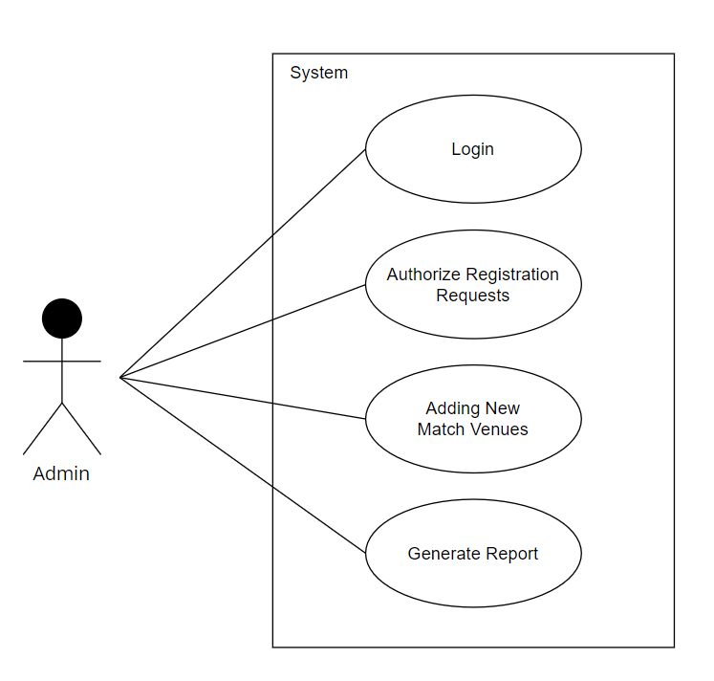

*Fig. Use case diagram for admin*

1. In Admin use case diagram Admin is the Actor.
2. Admin can handle following use cases:
3. Login
4. Authorize Registration Requests
5. Adding New Match Venues
6. Report Generation

**Tournament Manager:**

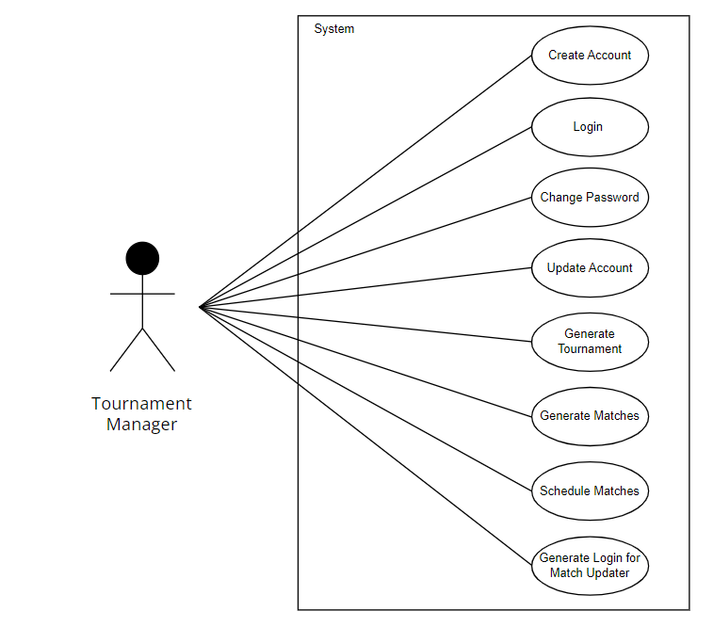

*Fig. Use case diagram for Tournament Manager*

1. In Tournament Manager use case diagram Tournament Manager is the Actor.
2. Tournament Manager can handle following use cases:
3. Request Registration
4. Login
5. Change password
6. Update Account
7. Generate Tournament
8. Generate Matches
9. Schedule Matches
10. Generate Login Credentials for Match Updater

**Team Manager:**

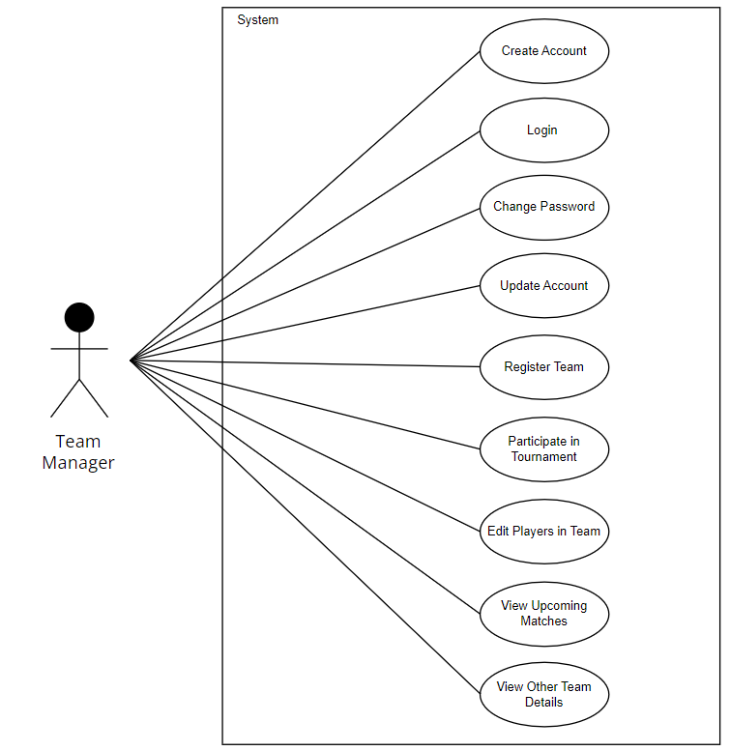

*Fig. Use case diagram for Team Manager*

1. In Team Manager use case diagram Team Manager is the Actor**.**
2. Team Manager can handle following use cases:
3. Create Account
4. Login
5. Change Password
6. Update Account
7. Register Team
8. Participate in Tournament
9. Edit Players in Team
10. View Upcoming Matches
11. View Other Team Details

**Match Updater:**

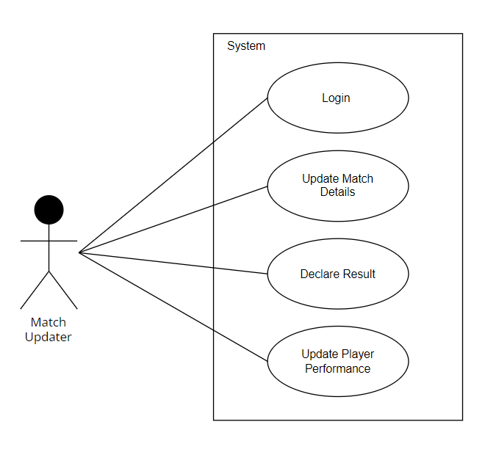

*Fig. Use case diagram for Match Updater*

1. In Match Updater use case diagram Match Updater is the Actor**.**
2. Match Updater can handle following use cases:
3. Login
4. Update Match Details
5. Declare Result
6. Update Player Performance

**Viewer:**

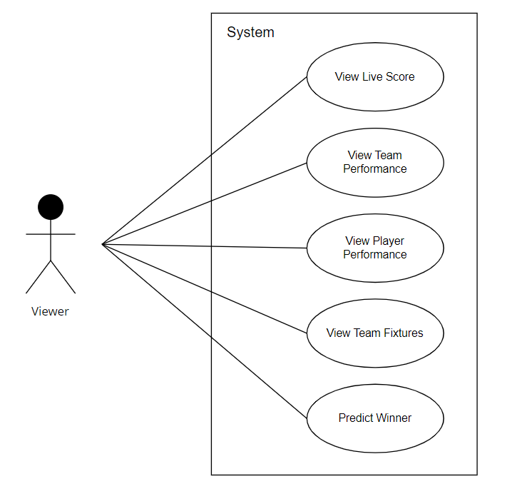

*Fig. Use case diagram for Viewer*

1. In Viewer use case diagram Viewer is the Actor**.**
2. Viewer have following use cases:
3. View Live Score
4. View Team Performance
5. View Player Performance
6. View Team Fixtures
7. Predict Winner