**Q1)**

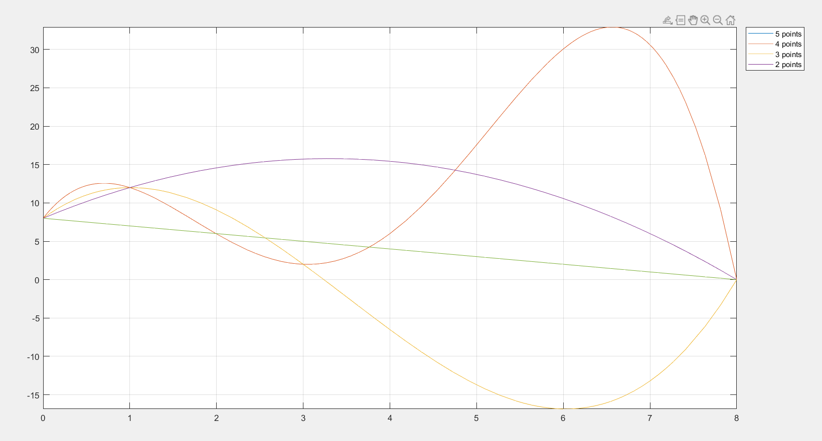

**Q2)a)**

**Lagrange’s form of Interpolating Polynomial**

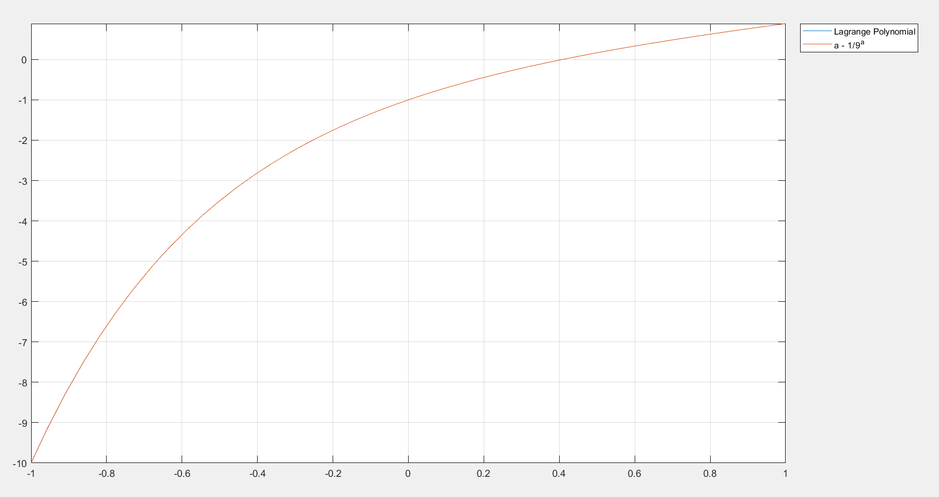

**Newton’s form of Interpolating Polynomial** 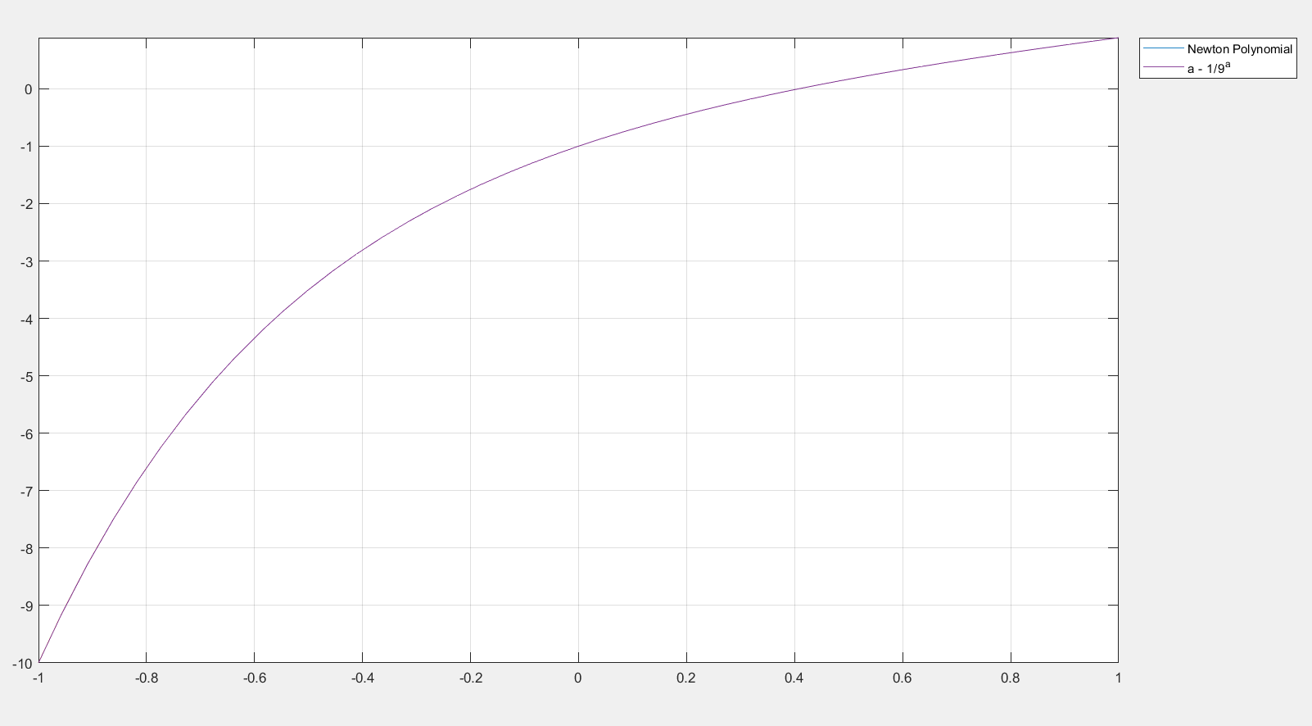

**Q3) error plot for n=5**

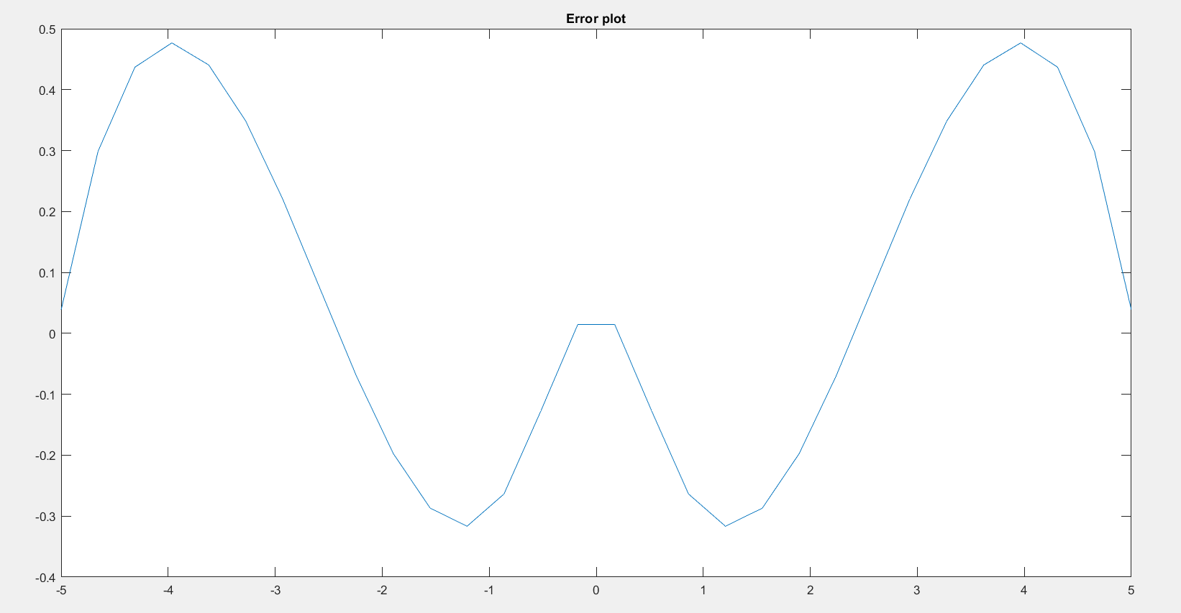

**error plot for n=10**

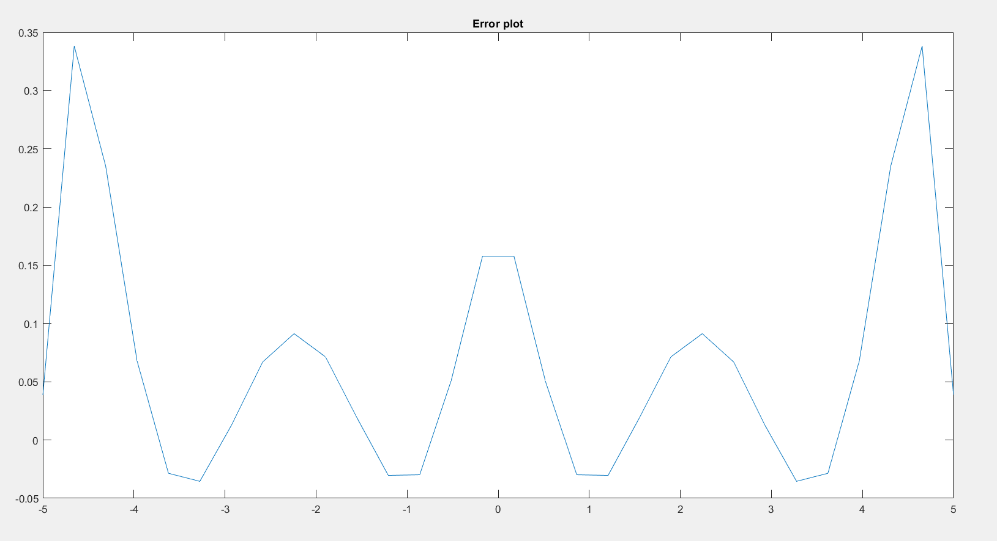

**error plot for n=15**

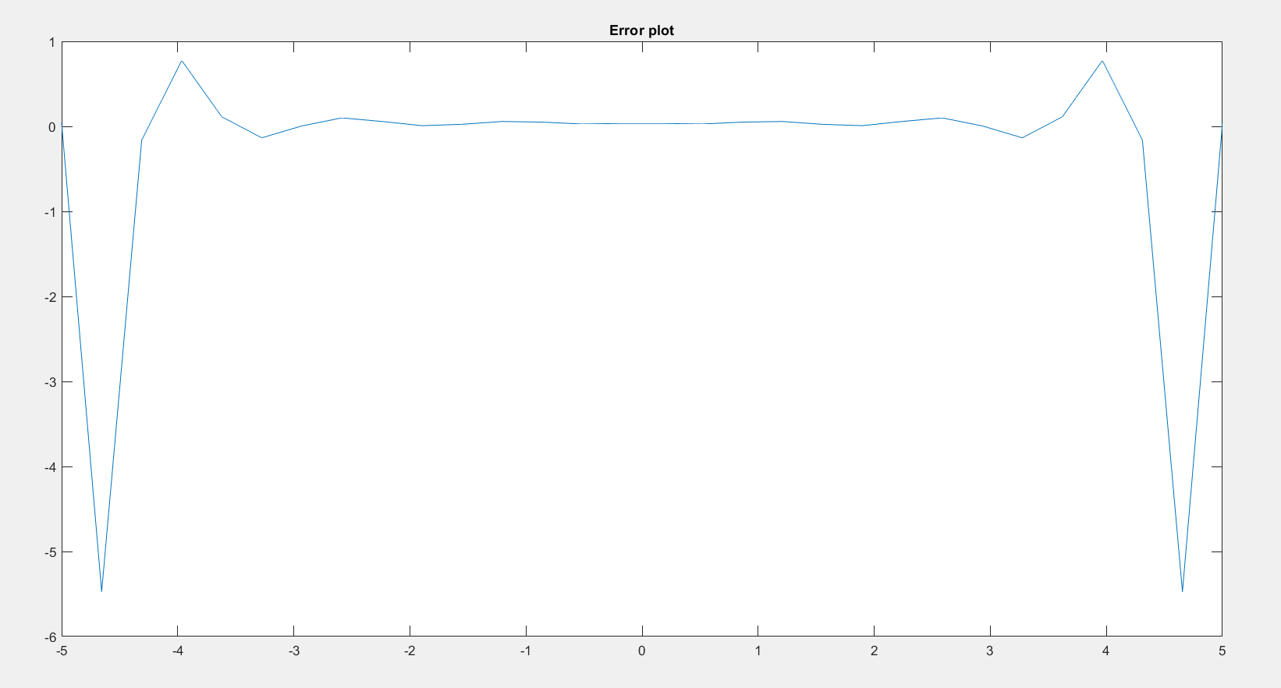

**Combined Error Plot**

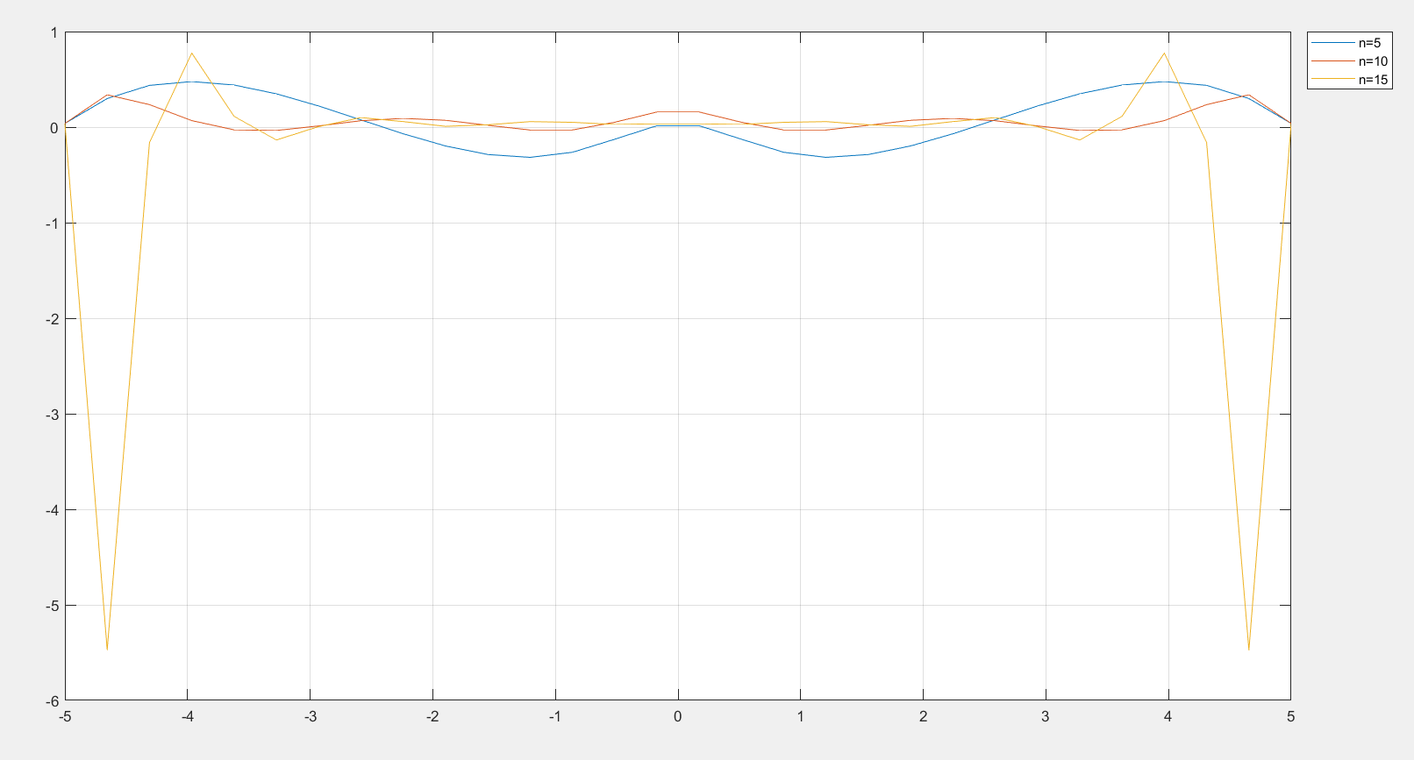

**Polynomial plots**

