**CONCLUSION**

India has a rich cultural heritage and is the land inhabited by lords themselves who have left their divine presence at placed marked by temples. These temples are known for their architectural magnificence and sculptural splendour and also have political, social, economic, environmental and cultural significance and attract worldwide attention especially the annual festivals organised in these temples.

In India, temples have a great importance in society. Temples, in fact, reflect the broad context of society. It's interesting to note that many ancient Lord Shiva temples including Kedarnath and Chidambaram are located on the same longitude.

Compare and Contrast between North and South Indian temples:

* First obvious difference you would see between North and South Indian temples is the sheer size. Southern temples are much larger in comparison. It is fair to say that, South Indian kings invested a lot in temples than their palaces, which is quite the opposite in the North.
* North Indian temples are truly gifted in the sense they have more natural beauty to them.
* South Indian temples follow very strict agamam culture.  Agamam is a set of text that defines the worship, temple traditions and ritual protocols. There are three agamams: Saiva (for Shiva temples) and Vaikanasam & Paancharaatram (for Vishnu temples)
* 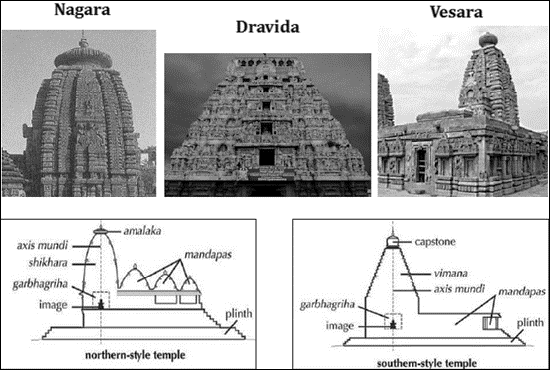North Indian temples have relaxed rituals. Moreover, the modality of rituals is not unified in all North Indian temples. This even allows common people to touch the idols
* All South Indian temples have idols being both moolavar (made of stone) and utsavar (usually made of panchalogam - 5 metals - gold, silver, copper, iron, lead)
* In most North Indian temples, the idols are a represented in a very humble way, and they don't have a utsavar idols for processions. White marble representation of deity is quite common in North Indian temples, which is the opposite in South India, where idols are made of black stone.
* Tamil Nadu has a unique way of representing Shiva in dancing form called Nataraja, which is very important to Tamil people.
* Nandi (bull - chief of Shiva’s staff) plays a very important role in South Indian temples too, represented by a huge monolithic structure.
* Nataraja in his manifestation of formlessness is worshipped in Chidambaram. This concept is very alien to Hinduism. Nataraja is said to continuously dance in a state of eternal bliss, with his consort Shakti or energy.
* Talking specific about Kedarnath, administration is not solely maintained by government officials or only by priests, but it is done by their co-operation. People of Kedarnath follows many ancient traditions in administration, e.g. head priest should be belonging to "Veerashaiva" community of Karnataka.
* Dravidian temple architecture usually has a Raja Gopuram (biggest tower) at the main gate and a small tower for the sanctum sanctorum (exception being Tanjore Big temple). South Indian temple gopurams are extremely intricate filled with statues
* This is quite the reverse in North Indian temples, where the height of the structure is progressive starting from a lower height gate leading to a tall tower where the sanctum is present. North Indian temple towers are mostly presented in a minimalist fashion with less or no statues in them.
* South Indian temples use elephants in temple rituals and processes, which isn't done in North India.
* Most of the North Indian temples do not contain a large walled complex surrounding the temple, surrounding corridors and halls. Many South Indian temples have a large walled complex with many corridors and halls.
* South Indian temples are ancient and have been preserved. North Indian temples, although equally old, especially the ones in Gangetic plains had been subjected to destruction by invaders.
* South Indians have an artificially made Temple Pond in their complex for ritualistic purposes. Most of North Indian temples have a river, stream or natural pond close to their premises.
* Both the cases showcase excellent examples of redistribution, wherein the wealth obtained by the temple through donations is redistributed and reciprocated. In both the temples trans-valuation of gifts donated by donor to deity is done in the same way by offering it to deity which places donor in the transactional relationship with the deity. After trans-valuation these gifts, which are now known as honours, leavings get distributed among people who are involved in that ritual process. Temple staff also gets its share.
* Deity ha the same importance and role irrespective to the temple, it is the moral, economic and iconographic centre of the temple. Every person working in the temple has his own relation with the deity. Deity can command the resources of the temple. Thus, importance of the deity is same for both.
* Procedures which take place during practice of this rituals can be differ like mantras that are spoken can be differ, but their intentions are same. Even processions that are carried away in the temples are pretty much same. There is chariot in which small idol of God is carried and then it is taken to the streets where worshippers live. Many procedures in these processions are same for both the temples.
* Both the temples have some organisation or trust that manages the temple and is nominated by the respective state governments.