HM 116

**Economics of Tyre Market**

Group 32

horizontal line

# 

India's **waste tyres** account for about 6-7% of the global total. It is estimated that 60% are disposed of through illegal dumping

# Introduction

To the average buyer, tires-like wheat or eggs-merely are something to be purchased wherever they're offered for the lowest price.

# The tyre market can be classified into 2 categories

1. Market split based on type: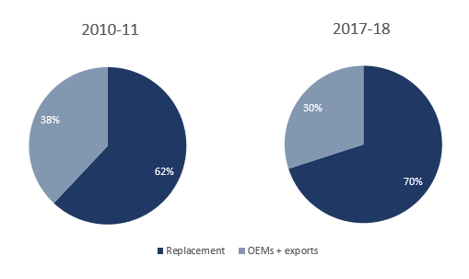

* OEM: These are the tyres that are supplied with the vehicle by default by the manufacturer.
* Replacement: These are the tyres bought as a substitute for various reasons, either due to wearing out of original tyres or other reasons.

From the above data, in Indian tyre market, the replacement segment has a high contribution.

1. Market split based on product category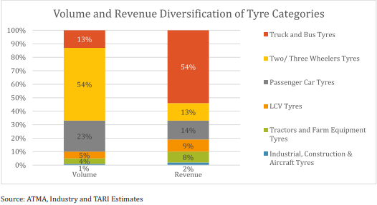

* Two-wheeler tyres
* Passenger cars
* Truck and bus
* Tractors

We can conclude that the Indian tyre market is a broad market because it doesn't concentrate only the needs of a particular group of customers but concentrates on a large group of customers.

**Supply and Demand**

To manufacture a simple tyre, around 250 raw materials are put together. In India, demand for raw materials like rubber is more than supply. India almost imports 470,000 tonnes of rubber. India has enough crude like carbon black, but because of increasing exports, the demand-supply gap increased in last two years, which leads us to import carbon black. Over the previous two years, due to an increase in rubber and carbon black prices, the tyre industry was under raw material pressure. Demand for tyre is estimated to grow by 7-9 percent over the next five years (FY 2019-23) supported by a favourable outlook for the domestic automotive industry. The expanding automobile industry and increasing automobile sales are significant factors that boost demand for tyres in India.

1. **OEM** -  The demand from the OEM market directly fluctuates with end-user demand for construction or automobile segments.
2. **Replacement Market** - Demand for this depends on road conditions, vehicle scrappage rules, overloading norms, rethreading intensity and miles driven, etc.

A few factors affecting the demand for tyres are: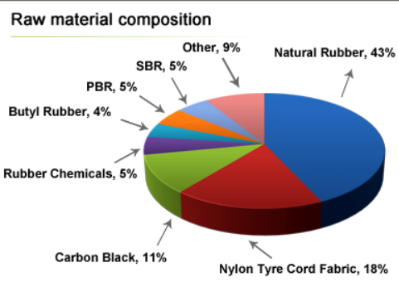

* The level of industrial activity
* availability and cost of credit
* Transportation values and network of roads
* Execution of vehicle loading rule
* Radicalization
* Rethreading and exports

**GDP Contribution**

The tyre industry contributes to around 3% of India's manufacturing GDP and 0.5% of the total GDP. The type industry has seen as much as two times growth from 2010-11 to 2017-18 from Rs. 30000 Cr to Rs. 59,500 Cr. The most revenue comes from the domestic market, which comprises 90-95% of the total market.

A large portion of the GDP in India is due to the truck and bus segment. It contributes to a massive 55% of the market. While the passenger vehicles contribute to 22% and 2/3 wheeler contributes to 13%. Other types of vehicles contribute to 10% of the entire industry.

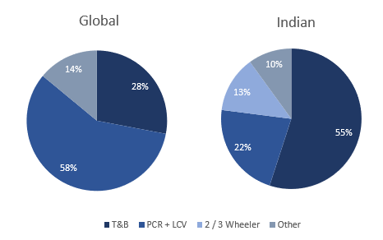**Indian vs Global Market**

The rising demand for Tyre across the world is driving the global tyre market. China was leading the global tyre market in 2017, accounting for almost 49% of the total tyre manufacturing. The tyre industry in India is also growing by the rapidly increasing domestic demand for automobiles. India is expected to be the third-largest global tyre manufacturer by 2021. The automobile industry in India is one of the fastest-growing sectors. With growing insistence to lower emission levels and enhance fuel-efficiency, besides reducing weights, the Indian car market is reaching new heights in developing sustainable car models. All these factors will aid the growth of the tyre industry in India.

### Competition and Strategy

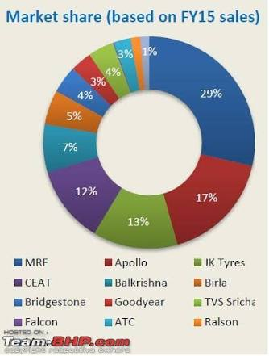MRF dominates competition in the Indian tyre market. MRF is the market leader with more than $ 2 billion in revenue in 2019 with a market share of 35%. Other market leaders include Apollo, JK and CEAT with 29% and 19%, and 16% of the shares, respectively and have different leads in different tyre market subdivisions. JK, for instance, gets most of its income from rethreading. Several brands perform various methods to advertise their product in the market. Apollo tires have introduced 360-degree product and service delivery in the Indian market. MRF's marketing campaign has become one of the most innovative in the history of Indian advertising, thus attracting a full customer. The Indian tyre industry is an example of oligopoly market, with the top 5 to 7 players controlling the majority share. The trend among consumers in the non-commercial segment is towards long-lasting radicalized tyres rather than the currently prevalent biased tyres. Competition is leading tyre manufacturers towards aggressive pricing, which is likely to impact the margins going forward, particularly exports.

**Government Policies and Import/Export**

Tyres have been in India since the 1920s. As there was no domestic manufacturing back then, the only way was to import the finished products and thus, the government allowed for liberal import policies on tyres. As with time, companies set up manufacturing facilities in the country and technology progressed. The government changed its policies to suit the domestic manufacturers and encourage them while protecting them from external competition. The policies have evolved over time to be stricter for imports and support export from the Indian manufacturers. The tyre industry has had its own challenges with raw materials, rupee appreciation and cheap imports from China, which are 30-50% less expensive than the Indian tyres. India is one of the few countries which are self-sustainable in manufacturing all kinds and sizes of tyres and exporting to over 100 countries. With better policy implementation and import restrictions, domestic manufacturing can reach its full potential if specific roadblocks, especially regarding accessing natural rubber are removed. Currently, finished products can be imported at a much lesser duty (<10%) than the primary raw material i.e., natural rubber (~25%), which is short in supply domestically.

**Situation due to COVID’19**

The industry is facing problems on the supply part and the product manufacturing momentum. As a result, the revenue is estimated to grow at a lower rate of 3-4 percent in FY2020 compared to FY2019 and FY2018. Despite the pandemic, there will be continuous demands for tyre from the rural and semi-urban areas. Currently, the automobile industry is passing through its tough times as demand for four-wheelers and two-wheelers is at an unprecedented low. So the industry has moved to BS-VI vehicles, which are slowly getting absorbed in the market and the company is accepting that there will be a growth in demands of vehicles in upcoming financial years. The vehicle business would see new patterns, with the business attempting to recuperate from the COVID-19 pandemic-initiated downturn. There could be an inclination for individual versatility, with section level vehicles remaining to profit. Also, the industry noted that the road to recovery would not be smooth. Tractors and two-wheelers are more likely to do better than the other segments. According to MRF, some experts estimate that auto industry volumes will be down by 25% in the financial year 2021.

**Circular Economy**

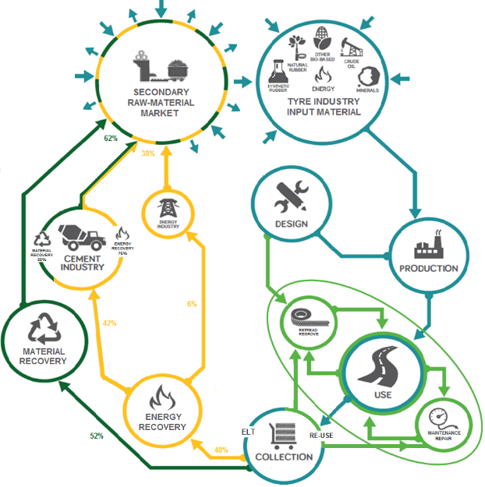Unlike the linear economy, the circular economy is a closed-loop economic system that focuses on reducing wastage and longevity of products. Almost all of the major tyre companies are now shifting their model circular economy mainly because millions of tons of used tyres are discarded as waste every year. The tyre replacement sector has more market share than the originally produced tyre. Thus, there is an increasing number of opportunities to use tyre-derived materials, creating new businesses and jobs, thus increasing GDP. Circular economy calls for revamping the entire life cycle of a tyre. The first idea is farfetched: biodegradable tyres, so we shift to the other idea, which is finding new technology. This can include finding rubber substitutes or design changes like we saw in the case of the shift to tubeless tyres. Companies are working on airless tyres as well. These days, the entire design perspective has shifted to incorporating green ideas from production to the final product. As a result, numerous steps are being taken to make tyres so that repair and remanufacturing become easier. Truck tyres, for instance, are usually designed to be retreaded up to three times. Rethreading diminishes roughly 160 kg of waste for each tire. However, this requires cooperation across the entire supply chain. The demand for tyres will keep increasing in the future because of the budding electric car market, but the supply will keep decreasing due to raw materials being scarce. This model will keep a check on the demand-supply equilibrium by ensuring continuous supply. One obstacle that prevents us from achieving this is that the GDP index doesn't consider social and environmental externalities, discouraging value creation in both these areas.

**Dependent Market**

Analysing tyre market/business as an independent entity is worthless. We do not buy tyres alone; we buy them when we have an automobile already purchased or to be bought. From the Dependent Demanded Goods definition: "Dependent demand goods is the demand for the parts or pieces needed to complete a finished product." So all the markets associated with tyres as a dependent market are more likely to impact upon this market. For example, if the price of a car chassis' price increases, the tyre cost/price may decrease or the buyer may buy the cheaper quality of tyres to attain his/her budget. Some countries that cannot even produce tyres may have a significant impact on the automobile industries. India is not heavily dependent upon other countries for imports except the specialized tyres, which are also called luxury tyres and that's why Indian automobile is not impacted much by the tyre industries because other countries earn when we import goods and our country earns when we export our goods.

The Wagon R LXI on-road cost is around 500,000 INR at Surat. Now the most expensive tyre is from Michelin, which costs about 3,727 INR, so this share is approximately 0.745%. So the remaining cost is around 496,273 INR. Now let's say our budget is 500,000 INR then this tyre fits in our budget and we will buy it. But now let's say somehow the remaining cost increased from 496,273 to 497,300 and we need to follow the budget strictly then now we cannot buy the Michelin tyres, but we are left with less choices to purchase tyres in the cheaper range. In this case we can buy Apollo tyres which costs 2,696 INR. But the leading player here is the Indian policies. Michelin is not an Indian brand, so they import from the country of manufacturing and there, the Indian policy imposes import duty and hence the price increases. From the budget perspective, if the recommended tyres are way under the budget, then we have no problem, but when it is close to the budget, then it becomes susceptible towards other dependent markets.

**Research and development**

There has been great progress and significant growth in the Indian tyre industry in last few years. In the previous 10 years, the Indian tyre industry's production has gone up to 180 million units from 80 million units. In recent times, the production of tyres by tyre industry is significantly more than its demand. The primary research in tyres is about the use of raw materials.

Factors responsible for the growth of tyre industry are:

**1.** Growth of the automobile industry: Due to urbanization, we have seen significant growth in the automobile industry, and so there is excellent progress in the tyre industry.

**2.** Increment in the use of radial tyres: Tyre industry has been shifting towards radial tyres from cross-ply tyres because they are fuel-efficient and have a better life expectancy. There will be a good demand for them in the future.

**3.** Capacity expansion of tyre industry: Due to the higher demand for tyres, the industry has increased its production capacity much more. It is expected to have better growth but smaller margins due to higher prices of raw materials and global competition.

**4.** Large distribution network: Large marketing and distribution networks helped the Indian tyre industry proliferate.

A few upcoming challenges are:

**1.** Volatile prices of raw materials: Due to volatility in raw materials costs, profit may go up or go down also for the Indian tyre industry.

**2.** Competition with low cost manufacturing tyre countries: India has done well in the domestic tyre market, but its turnover in the export is stable because it competes with low-cost manufacturing industries. It will be a big challenge to increase net export.

**3.** Higher interest rate: Higher interest rate may affect the profit in the future.

If the Indian tyre industry tackles the above challenges superbly, the future of the Indian tyre industry will be very bright because demand is expected to be high for the upcoming years also so there will be profitable growth in terms of production of tyres in India if we encounter certain challenges carefully.

**References**

<https://www.automotiveproductsfinder.com/cover-story/The-R-D-spend-by-Indian-tyre-industry-has-gone-up-by-four-times/133841>

<https://www.moneyworks4me.com/investmentshastra/indian-tyre-industry-analysis-and-review/>

<https://www.alphainvesco.com/blog/understanding-the-indian-tyre-industry/>

<https://economictimes.indiatimes.com/markets/stocks/news/the-credit-profile-of-tyre-industry-is-likely-to-weaken-in-fy2020-icra/articleshow/70553334.cms?utm_source=contentofinterest&utm_medium=text&utm_campaign=cppst>

<https://www.thehindu.com/business/Industry/rural-areas-bright-spot-for-tyre-industry-amid-covid-19-challenge-says-mrf/article32535002.ece>

<https://cfo.economictimes.indiatimes.com/news/dont-see-any-significant-impact-of-coronavirus-outbreak-jk-tyre-cfo/74126893>

<https://www.alphainvesco.com/blog/understanding-the-indian-tyre-industry/#:~:text=Indian%20tyre%20industry%20has%20almost,share%20in%20terms%20of%20revenue>

<https://youmatter.world/en/definition/definitions-circular-economy-meaning-definition-benefits-barriers/>

<https://blogs.ucl.ac.uk/sustainable-resources/2014/03/10/three-challenges-to-the-circular-economy/>

<https://www.etrma.org/key-topics/circular-economy/>

<https://www.imarcgroup.com/tyre-manufacturing-plant>

<https://www.expertmarketresearch.com/pressrelease/global-tire-market>

<https://www.alphainvesco.com/blog/understanding-the-indian-tyre-industry/>

[https://www.thehindubusinessline.com/economy/with-policy-support-india-can-lead-as-a-global-tyre-production-centre/article31475121.ece#](https://www.thehindubusinessline.com/economy/with-policy-support-india-can-lead-as-a-global-tyre-production-centre/article31475121.ece)

<https://auto.economictimes.indiatimes.com/news/auto-components/how-tyre-industry-is-evolving-and-adjusting-to-global-trends-and-requirements/64977118>

<https://www.researchgate.net/search/publication?q=tyre+industry+competition>

<https://study.com/academy/lesson/independent-versus-dependent-demand-goods.html>

<https://www.tyremarket.com/tyremantra/maruti-wagon-r-car-tyres-price-list/>