# Customer care Database

for

## A banking system by: s10_t2

#### **Prepared by:**

#### 201801015 – Shantanu Tyagi

#### 201801030 – Nikhil Mehta

#### 201801162 – Vatsal Gujarati

#### 201801408 – Arkaprabha Banerjee

#### **Mentored by:**

#### Mayank jr.

##### 4 November 2020

# InDEX

1. Final version of SRS.
2. Final Noun Analysis.
3. Final ER-Diagrams all versions.
4. Conversion of Final ER-Diagram to Relational Model.
5. Normalization and Schema Refinement.
6. Final DDL Scripts, Insert statements, 40 SQL Queries, Snapshots of output of each query.

Final version of srs

# Introduction

## Purpose

The primary purpose of this document is to provide support information and an overview regarding the Customer Database Project for Financial Institutions. It attempts to explain the primary functionality and features of the aforementioned product from a broad perspective. Customer Care services are primarily required to cater to various kinds of queries and issues which the customer of that particular service might have. For services which operate on a huge scale it is imperative that a proper database is present which contains all the relevant information pertaining to that service and also possesses the capability to efficiently fetch and modify data with proper provisions for validation and login for the end users. This shall serve as a comprehensive piece of documentation with regard to each of these functionalities and User Classes in detail.

## Intended Audience and Reading Suggestions

While the software requirement specification (SRS) document is written for a more general audience, this document is intended for:

* Developers who can review project’s capabilities and more easily understand where their efforts should be targeted to improve or add more features to it (design and code the application – it sets the guidelines for future development).
* Project testers can use this document as a base for their testing strategy as some bugs are easier to find using a requirements document. This way testing becomes more methodically organized and efficient as well.
* End users of this application who wish to read about what this project can do. Most of the end users are often in the dark regarding certain functionalities of any system. This document shall strive to educate them regarding the same.
* Developers and Testers are encouraged to have a pre-requisite knowledge regarding Database Design and SQL functionalities/queries. The project shall primarily be open-source in nature, hence this pre-requisite knowledge shall enable them to understand the existing flaws and provide feasible solutions to it as well.

This document need not be read sequentially. Readers are encouraged to jump to any section they find relevant.

## Product Scope

The primary purpose of this Customer Care Database is to meet the expectations of the customers with regards to an array of services/queries spanning over a wide variety of Financial Institutions. In addition to that it also aims to provide customers with constructive solutions for a user-friendly and hassle-free experience for their desired query/service. This product also aims to understand the queries of the customers and ensure that they enjoy a cost-effective and flawless experience with respect to their service. It furthermore enables the Service Providers to gain better insights with regards to the usability of their products which in turn helps them improve their services/products and makes them more efficient.

# Overall Description

## Product Perspective

Users can get information regarding their account/balance after validating their account and can furthermore transfer money to other valid accounts. In addition to that customers can also block their existing accounts in case of extraordinary events. New users can also create accounts. Other general queries within the purview of the system shall also be catered to. Administrators would have access to the entire database in order to maintain information integrity throughout the database. Service Providers would have a lower sense of privilege with regards to the Admin and can only modify/provide information when prompted by the user. End Users can only view information pertaining to their own account after validation. Auditors can view the entire database and report faulty transactions to the admin and the bank as well. The owner also has admin privileges to facilitate policy changes for customers.

## Background Readings

**Description:**

* **Book**:

Database System Concepts by Abraham Silberschatz: We read part 1-Relational languages, and part 2- Database design from the book. We learned now the relational model remains the primary data model for commercial data-processing applications. It attained its primary position because of its simplicity, which eases the job of the programmer, compared to earlier data models such as the network model or the hierarchical model. We also learned about important concepts, logic and different terminologies that will be useful while working on this project. Continuing the reading we were introduced to database design using ER model and how can it be transformed into a set of relation schemas and how some of the constraints can be captured in this design. The various features of the E-R model offer the database designer numerous choices in how to best represent the enterprise being modelled. Concepts and objects may, in certain cases, be represented by entities, relationships, or attributes. Aspects of the overall structure of the enterprise may be best described by using weak entity sets, generalization, specialization, or aggregation. Often, the designer must weigh the merits of a simple, compact model versus those of a more precise, but more complex one. UML is a popular modelling language. UML class diagrams are widely used for modelling classes, as well as for general-purpose data modelling.

* **Websites**:

We read numerous blogs and articles on individual database concepts but more importantly we had to understand what kinds of customer care services do most banks offer so that we could decide what features we wanted to include and also helped us the existing problems and possible solutions and how can we implement them. In order to properly understand customer care solutions, we looked up for various companies and start-ups providing such services and how they are trying to optimize and utilizing the queries to improve their services.

* **Videos:**

PostgreSQL Tutorial For Beginners | Learn PostgreSQL | Introduction to PostgreSQL | Edureka: Since we will be working on PostgreSQL, we had to take a basic course to strengthen our fundamentals. It covered all beginner topics from commands, keys, entity, constraints, operators, triggers and functions.

How to Design Your First Database: This video covered the rules to follow when designing databases, as well as general design principles.

**References:**

* <https://www.geeksforgeeks.org/how-to-write-a-good-srs-for-your-project/>
* <https://medium.com/@vincetran_28429/software-requirements-specification-srs-document-fd9ab103b18>
* <https://www.geeksforgeeks.org/introduction-of-er-model/>
* <https://www.tutorialspoint.com/dbms/er_model_to_relational_model.htm>
* <https://nptel.ac.in/courses/106/106/106106093/>
* <https://www.creditmantri.com/customer-care/>
* <https://www.slideshare.net/AshwinkumarDinoriya/banking-database>
* <https://www.youtube.com/watch?v=-VO7YjQeG6Y>
* <https://www.youtube.com/playlist?list=PLQVJk9oC5JKohoyVILfdxOOzyl6w-yOur>

## Combined requirements:

* Problem analysis
* Determine the purpose of the database
* Determining data to be stored
* Find and organize the information required
* Determining data relationships
* Logically structuring data
* ER diagram
* Divide the information into tables
* Physical Schema Design
* Specify constraints
* Set up the table relationships
* Apply the normalization rules

## Customer Care Database: Interview Plan

**Interview 1**

**System:** Alphabet Consultancy

**Project Reference**: SF/SJ/20XX/XX

**Interviewer:** 1) Arkaprabha Banerjee

**Designation**: Backend Developer for Customer Care Database

**Contact Details**: 7016570121

**Organization Details:** CEO at Alphabet Consultancy

**Interviewee:** 1) Harish Tyagi

**Designation:** Software Auditor

**Date:** 27th September 2020 **Time:** 10:30 AM

**Duration:** 30 minutes **Place:** Online Zoom meeting

**Purpose of the Interview:** Preliminary meeting to understand how the existing customer care services can be improved by better encryption.

**Agenda:** To discuss and deliberate upon the existing flaws in the system in terms of security so as to provide comprehensive suggestions to the aforementioned database project.

**Documents to be interviewed:** Any documents relating to current customer care services.

**Interview 2**

**System:** Alphabet Consultancy

**Project Reference**: SF/SJ/20XX/XX

**Interviewer:** 1) Arkaprabha Banerjee

**Designation**: Backend Developer for Customer Care Database

**Contact Details**: 7016570121

**Organization Details:** CEO at Alphabet Consultancy

**Interviewee:** 2) Durgadas Mahato

**Designation:** Retired army personnel

**Date:** 27th September 2020 **Time:** 11:00 AM

**Duration:** 38 minutes **Place:** Online Zoom meeting

**Purpose of the Interview:** Preliminary meeting was to understand how frequently elderly people use customer care services and their requirements.

**Agenda:** To discuss and deliberate upon the frequency of these services which are accessed so as to improve the customer experience.

**Documents to be interviewed:** Few documents relating to the frequency of the current banking customer care availing services.

**Interview 3**

**System:** Alphabet Consultancy

**Project Reference**: SF/SJ/20XX/XX

**Interviewer:** 1) Arkaprabha Banerjee

**Designation**: Backend Developer for Customer Care Database

**Contact Details**: 7016570121

**Organization Details:** CEO at Alphabet Consultancy

**Interviewee:** 3) Alpesh Sharma

**Designation:** Banker at Goldman Sachs

**Date:** 27th September 2020 **Time:** 12:00 PM

**Duration:** 35 minutes **Place:** Online Zoom meeting

**Purpose of the Interview:** Preliminary meeting was to understand the time constraints of middle age/working people.

**Agenda:** To know and deliberate upon the time constraints that people might have with respect to different age groups.

**Documents to be interviewed:** Documents showing his working hours and general statistics regarding the end users and the bank.

**Interview 4**

**System:** Alphabet Consultancy

**Project Reference**: SF/SJ/20XX/XX

**Interviewer:** 1) Arkaprabha Banerjee

**Designation**: Backend Developer for Customer Care Database

**Contact Details**: 7016570121

**Organization Details:** CEO at Alphabet Consultancy

**Interviewee:** 4) Abhishek Mehra

**Designation:** System Administrator at Juniper Networks.

**Date:** 27th September 2020 **Time:** 1:00 PM

**Duration:** 40 minutes **Place:** Online Zoom meeting

**Purpose of the Interview:** To understand how existing banking customer care services can be improved.

**Agenda:** To discuss upon the current flaws of the banking customer care services so as to improve upon them and enhance the user experience.

**Documents to be interviewed:** Any documents related to the improvements which the existing customer care databases should have.

**Interview 5**

**System:** Alphabet Consultancy

**Project Reference**: SF/SJ/20XX/XX

**Interviewer:** 1) Arkaprabha Banerjee

**Designation**: Backend Developer for Customer Care Database

**Contact Details**: 7016570121

**Organization Details:** CEO at Alphabet Consultancy

**Interviewee:** 5) Nikhil Shah

**Designation:** Service provider at TCS.

**Date:** 27th September 2020 **Time:** 5:00 PM

**Duration:** 40 minutes **Place:** Online Zoom meeting

**Purpose of the Interview:** To understand how a constructive feedback loop can be put in place to improve the existing services.

**Agenda:** To discuss upon the current flaws in the feedback system of the banking customer care services.

**Documents to be interviewed:** Any documents related to the improvements, which the existing customer care databases should have.

## Combined Requirements:

* Prioritizing issues for middle-aged and elderly people as they primarily face a lot of time constraints as opposed to the younger generation.
* Issues which demand immediate attention (Blocking or suspending accounts) should be prioritized irrespective of the age group.
* Recurring Issues should be solved more efficiently at later stages.
* Need to implement better encryption thus increasing reliability.
* The database shall strive to attain a constructive feedback loop with respect to its customers in order to foster a more holistic environment to improve the current system.

## Questionnaire:

**Question 1**

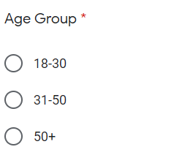

**Purpose of asking this question:** We exactly wanted to know which age group of people use the customer care services because then it will help us know for which age group should our database be inclined and accordingly modify the schema.

**Question 2**

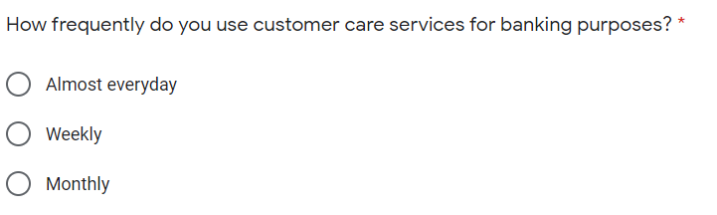

**Purpose of asking this question:** Our motto behind asking this question was to understand the frequency at which people use the customer care services so that we can understand what flaws are there in our database because only then we’ll know why people aren’t using our customer care service.

**Question 3**

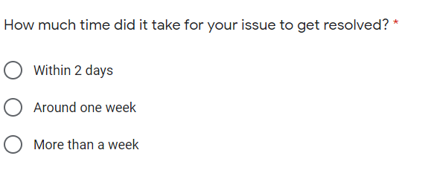

**Purpose of this question:** After the response of this question, we understood that how long does it take for an issue to get resolved because for example if an issue takes too long to get resolved then it is possible that the user would not be happy with the customer care service. According to the time it takes for an issue to get resolved, we’ll modify and improve our database accordingly.

**Question 4**

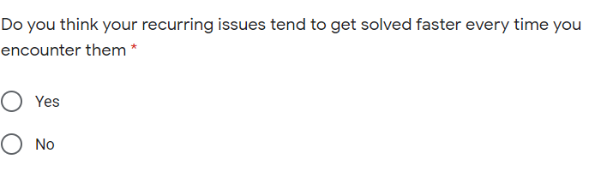

**Purpose of this question:** We wanted to understand that if a person lodges a complaint along the previous lines, how long does it take to get resolved. It is possible that a new complaint which gets registered might get stored somewhere in the database which when tried to access again, takes a very long time. So, if this is the case then we’ll design our database in such a manner so that if we complaint along the previous lines, it should not take too long for that complaint to get resolved.

**Question 5**

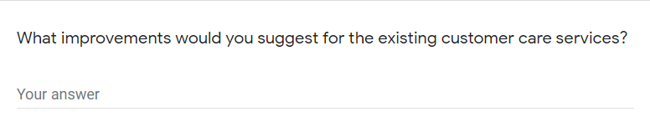

**Purpose of this question:** The most important component of our customer care database will be the user. If the user is not happy then we’ll have to modify our database accordingly. So, suggestions from the users were taken and we tried to understand what difficulties the users are facing and how can we improve upon them.

## OBSERVATIONS

* The first graph represents the age distribution of the people who filled up the survey form. This demography distribution shall help us to understand the rest of the survey responses better and furthermore help in generating a constructive feedback loop to understand the existing flaws and implement thee required functionalities.

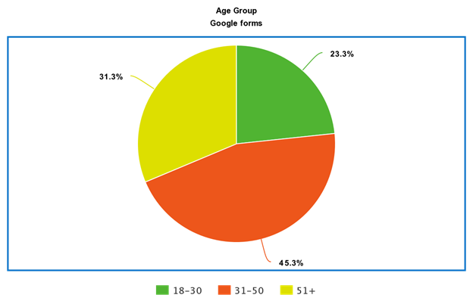

* The second graph represents the response to Q2 present in the form. The following observations have been made:
  1. Most of the people in the age bracket of 18-30 years, tend to require these services almost every day. This can be explained by that fact that most of these people tend to have a lot of bank transactions via digital forms. Hence its essential that they stay updated to avoid faulty/erroneous transactions
  2. We observe that people in the age range of 31-50 years primarily use these services on a weekly basis. This can be attributed to the fact that they are working professionals and can’t devote time for such issues on a daily basis. Time is an important factor for this class of people.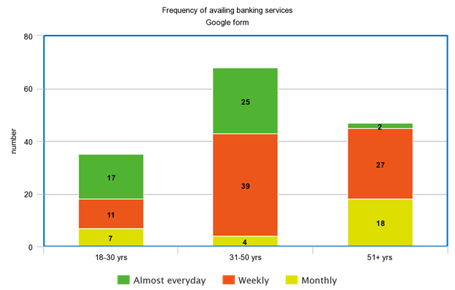
  3. For elderly people, most of them have contact the customer care in a weekly or monthly. Since they are not involved in frequent transactions, hence their interaction on a daily basis with customer care services is quite diminished.
* This graph primarily represents the time required to solve issues pertaining to the banking services offered:
  1. For the younger audience most of their queries were solved within a day or two. This is primarily due to the fact that most of their issues are less complex in nature and hence can be done faster.
  2. For the middle aged there is an equitable distribution in all 3 categories. This is because their issues span over a wide range of services. Still there remains a considerable number of issues which take up a large amount of time (around a week). This is worrisome especially since they have a time constraint imposed upon them.

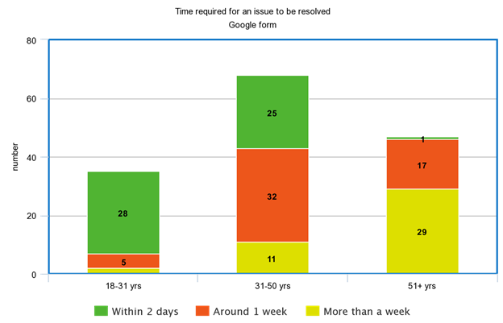

* 1. For the elderly, majority of their issues take a large amount of time to get solved. The complexity of their issues may have a role to play in this scenario.
* About 87.3% of the people seem to think that the existing service does not seem to get more efficient when they have an issue which they had also previously faced. This is a major point to work upon as it affects all the age groups.

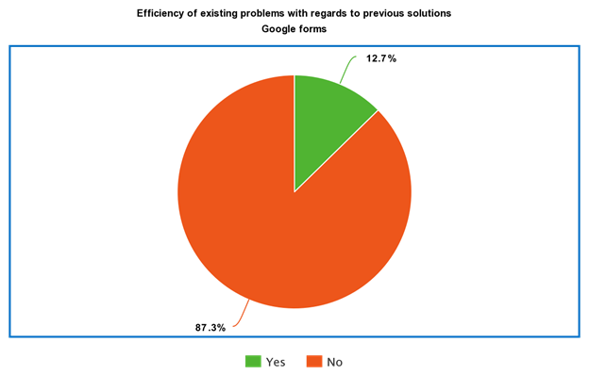

# FACT FINDING CHART

|  |  |  |  |
| --- | --- | --- | --- |
| **Objective** | **Technique** | **Subject(s)** | **Time Commitment** |
| To know, how often do people need banking services | Interview | One elderly person,  a middle aged person | 2x1 hour each |
| To know how long does it take for one’s complaint to get registered and get resolved | Interview, Survey | Google forms, a few middle aged people | 1 day for google form, Number of people x ½ hour each |
| To know that if any complaint lodged is along the previous lines, how long does it take to get resolved. | Survey | Google forms | 1 day |
| To know how can the existing banking services could be improved | Interview | People from all the age group | 2 days |
| The study of schema of bank databases and how are customers catered | Background reading | Online websites, journals | 1 day |
| To find how people prefer the banking services, i.e. online or offline. | Interview and survey | Google forms, people from all the age group | 1 day |

# LIST REQUIREMENTS

* A major requirement especially among elderly and middle-aged people was with regards to efficiency. Recurring Issues which have been already solved in the past should typically be solved faster and shouldn’t take the same amount of time as that of the previous ones.
* Issues pertaining to middle-aged and elder people should typically be prioritized in cases where a significant time is already being invested in solving the issue. This is primarily to facilitate the time crunch faced by middle-aged people and to accommodate the elderly as well.
* The System must have provisions to accommodate cancelling cards/accounts in extreme situations on an urgent priority basis irrespective of the age group.
* The database shall strive to attain a constructive feedback loop with respect to its customers in order to foster a more holistic environment to improve upon the current system.
* The system shall provide storage of all databases on redundant computers with automatic switchover.
* The system shall provide for replication of databases to off-site storage locations.
* The system shall provide RAID V Disk Stripping on all database storage disks.
* The system’s back-end servers shall only be accessible to authenticated administrators
* The system’s back-end databases shall be encrypted

# USER CLASSES AND CHARACTERISTICS

There are basically five categories of users: -

* Administrator: These people are involved in managing the database from an overall point of view.
* Service Provider: These are responsible for providing services to the customers by accessing the relevant data from the database.
* End user: These are the people who avail the services.
* Auditor – They have full access to view the database and the admin menus in order to conduct timely audits to maintain data integrity.
* Owner Bank: The bank using the database can update it’s information.

# OPERATING ENVIRONMENT

**Recommended Operating Systems: -**

* **Windows:** 7 or newer
* **MAC:** OS X v10.7 or higher
* **Linux:** Ubuntu

**Hardware Requirements: -**

* We strongly recommend a computer fewer than 5 years old.
* Processor: Minimum 1 GHz; Recommended 2GHz or more.
* Hard Drive: Minimum 32 GB; Recommended 64 GB or more.
* Memory (RAM): Minimum 1 GB; Recommended 4 GB or above.
* Some classes require a camera and microphone.

**Recommended Operating Browsers: -**

* Safari version 7 and above.
* Chrome version 44 and above.
* Firefox version 40 and above.

# PRODUCT FUNCTIONS

This section provides the functional overview of the customer care database. Various functional modules that can be accessed by the user are:

1. **Login:**

This module allows valid customers to access the functionalities provided by the bank. Customer logins by entering customer id and the login pin.

1. **Get balance information:**

This module maintains the balance details of a particular account. This system must be networked to the bank’s computer. The updated database of every customer is maintained with bank. Hence the balance information of every account is available in the database and can be displayed to the customer.

1. **Customer info:**

This module allows the customer to view and update the profile of their account. It also allows them to view their account status, load information and transaction details.

1. **Transfer Money:**

This module allows the customers to transfer funds from one account to another within the same bank.

**5. General Grievances:**

This module allows the customer to suspend their account and block their cards and allows new users to create a new account.

# PRIVILEGES

* **Administrator:** His role includes capacity planning, installation configuration, database design, data recovery etc. These are exclusive tasks and are only to be performed by the administrator. No one else except the admin has the access to person these tasks.
* **Service Provider:** The service provider primarily has access to look into the database. This allows them to help the customers with resolving their queries and providing them with services. Also, the service provider can modify certain fields of the database to cater to the immediate needs of the user provided he/she has provided the login credentials.
* **End User:** They will not be having any access, i.e. they cannot modify or look up the entire database. They can just avail the services and will only be allowed to look into their own data, i.e. their account number, bank balance, etc.
* **Auditor:** They shall have complete access to view the entire database and the changes incorporated by the Service Provider and the Administrator as well. Their primary role is to maintain data integrity and look for faulty transactions. In case of an issue, it shall notify the same to the Administrator and the Bank as well.
* **Owner Bank:** They shall have complete edit and view access to the entire database. This is primarily to facilitate policy changes for its customers or update information regarding certain queries.

# ASSUMPTIONS

* We have assumed that the customer care services possess the complete data regarding the customer’s bank accounts and are not dependent on the banks to explicitly provide that information.
* We have also assumed that the service providers/admin can block any account or any debit/credit card if the customer wishes so. There is no need for a confirmation from the bank regarding this issue.
* The bank has given explicit authority to the customer care center to read and modify the information of the customers.

# BUSINESS CONSTRAINTS

* Scalability of the aforementioned database could be an issue if the user pool is extremely large. Distributed Database Systems need to be used for that.
* The data needs to be stored on a server. For large amounts of data, storing it on cloud servers could be an expensive affair.
* For highly scaled systems, there should be dedicated personnel to maintain and handle the complete system.

Final NOUN ANALYSIS

Table listing all nouns and verbs:

|  |  |  |  |  |
| --- | --- | --- | --- | --- |
| Noun | Noun | Noun | Noun | Noun |
| Customer Care services | various kinds | queries | issues | the customer |
| that particular service | services | a huge scale | it | a proper database |
| all the relevant information | that service | the capability | data | proper provisions |
| validation | login | the end users | The primary purpose | this Customer Care Database |
| the expectations | the customers | regards | an array | services/queries |
| a wide variety | Financial Institutions | addition | it | customers |
| constructive solutions | a user-friendly and hassle-free experience | their desired query/service | This product | the customers |
| they | a cost-effective and flawless experience | respect | their service | It |
| the Service Providers | better insights | regards | the usability | their products |
| turn | them | their services/products | them | Users |
| information | their account/balance | their account | money | other valid accounts |
| addition | customers | their existing accounts | case | extraordinary events |
| New users | accounts | Other general queries | the purview | the system |
| Administrators | access | the entire database | order | information integrity |
| the database | Service Providers | a lower sense | privilege | regards |
| the Admin | information | the user | End Users | information |
| their own account | validation | Auditors | the entire database | faulty transactions |
| the admin | the bank | The owner | admin privileges | policy changes |
| customers | Every User class | different pages | respect | their functionality |
| five categories | users | His role | capacity planning | installation configuration |
| database design | exclusive tasks | the administrator | addition | they |
| the following functions | The service provider | access | the database | them |
| the customers | their queries | them | services | the service provider |
| certain fields | the database | the immediate needs | the user | he |
| she | the login credentials | the functions | a service provider | They |
| any access | the database | information | their own account | they |
| the entire database | the actions | a user | access | They |
| complete access | the entire database | the changes | the Service Provider | the Administrator |
| Their primary role | data integrity | faulty transactions | case | an issue |
| it | the Administrator | the Bank | the functions | an auditor |
| They | complete edit | access | the entire database | policy changes |
| its customers | information | certain queries | Scalability | the aforementioned database |
| an issue | the user pool | Distributed Database Systems | The data | a server |
| large amounts | data | it | cloud servers | an expensive affair |
| complete reconfiguration | the complete system | This section | the functional overview | the customer care database |
| Various functional modules | the user | The customer | an obligation | secrecy |
| regard | Username | Password | the Bank | The bank |
| valid Username | Password | a valid session | none | the customer |
| The customer | secrecy | regard | Username | Password |
| the Bank | The bank | valid Username | Password | a valid session |
| none | the customer | The customer | User ID | password |
| any other person | Any loss | the customer | non-compliance | this condition |
| his/her own risk | responsibility | the Bank | any manner | The login page |
| all the people | different page | different user classes | their functionality | This module |
| the balance details | a particular account | The updated database | every customer | bank |
| the balance information | every account | the database | the customer | This module |
| the customer | the profile | their account | It | them |
| their account status | load information | transaction details | This module | the customers |
| funds | one account | the same bank | the customer | a sufficient enough balance |
| online payment | bills | you | the unique bill number | the vendor |
| Customers | the bills | their account | A secure way | the billing |
| Online shopping | them | the easiest way | their items | the moment |
| the bank balance | the billing amount | It | the services | you |
| recurring payments | the internet connectivity | the customer care | you | recurring payment |
| you | It | your account | the moment | you |
| it | the moment | the bank balance | the billing amount | card payment |
| we | large amounts | no card payment machine | you | a cheque |
| it | a few payments | the cheque book | the bank | a new cheque book |
| you | it | it | you | a few days |
| This module | the customer | their account | their cards | new users |
| a new account | A customer | more than one bank account | a bank | this case |
| the customer | which account | money | these operations | customers |
| their owned bank accounts | it | the administrations | the system | It |
| the customer | his history | transactions | past 1-year transactions | It |
| him | the opportunity | his bank balance | needs | Bank staff |
| a record | it | transactions | the branch | it |
| the bank staff | the balance | a specific person | its record | the customer care services |
| the complete data | the customers bank accounts | the banks | that information | We |
| the service providers/admin | any account | any debit/credit card | the customer | no need |
| a confirmation | the bank | this issue | The bank | explicit authority |
| the customer care centre | the information | the customers | highly scaled systems | the complete system |

|  |  |  |  |  |
| --- | --- | --- | --- | --- |
| Verb | Verb | Verb | Verb | Verb |
| require | cater | may | operate | contain |
| pertain | possess | fetch | modify | meet |
| span | aim | provide | desire | aim |
| understand | query | ensure | enjoy | enable |
| gain | help | improve | make | can |
| regard | validate | can | transfer | can |
| block | exist | can | create | shall |
| cater | would | maintain | would | can |
| modify | provide | prompt | can | view |
| pertain | can | view | report | facilitate |
| log | will | redirect | include | perform |
| can | perform | follow | look | allow |
| help | resolve | provide | can | modify |
| cater | provide | provide | follow | can |
| perform | will | have | pertain | can |
| modify | look | follow | shall | view |
| incorporate | maintain | look | shall | notify |
| follow | can | perform | shall | view |
| facilitate | update | need | store | store |
| could | may | require | could | need |
| use | provide | can | access | maintain |
| register | presuppose | login | use | initiate |
| maintain | register | presuppose | login | use |
| initiate | should | keep | should | divulge |
| sustain | will | will | would | remain |
| log | will | come | accord | maintain |
| maintain | can | display | allow | view |
| update | allow | view | allow | transfer |
| can | type | pay | will | shop |
| pay | will | provide | will | provide |
| buy | sell | will | may | happen |
| use | would | require | recur | would |
| allow | set | recur | need | pay |
| will | deduct | cancel | will | prefer |
| need | pay | a | will | pay |
| go | issue | can | order | will |
| deliver | allow | suspend | block | allow |
| create | can | prompt | decide | use |
| debit | credit | can | add | own |
| will | approve | will | view | save |
| will | provide | maintain | will | search |
| update | need | will | will | check |
| update | assume | possess | regard | provide |
| assume | can | block | wish | regard |
| give | read | modify | scale | should |
| dedicate | maintain | handle | modify | open |

Table listing Nouns after truncation:

|  |
| --- |
| Nouns |
| Service Providers |
| Customers |
| the Bank |
| Users |
| The service provider |
| the vendor |
| Auditors |
| Administrators |
| credit card |
| debit card |
| online payment |
| Online shopping |
| Account details |
| recurring payment |

List of rejected nouns with reasons:

|  |  |  |  |  |  |  |  |  |  |  |  |
| --- | --- | --- | --- | --- | --- | --- | --- | --- | --- | --- | --- |
| **Noun** | | **Reject Reason** | | **Noun** | | **Reject Reason** | | **Noun** | | **Reject Reason** | |
| all the people | | General | | various kinds | | Vague | | the customer care database | | General | |
| a cheque | | Duplicates | | valid Username | | Attributes | | issues | | General | |
| him | | General | | information | | General | | card payment | | Associations | |
| General | | General | | better insights | | Irrelevant | | certain fields | | Vague | |
| services/ products | | General | | customers | | Duplicates | | their account status | | Attributes | |
| new users | | Duplicates | | every customer | | Duplicates | | Other general queries | | General | |
| New users | | Duplicates | | this Customer Care Database | | General | | load information | | General | |
| the end users | | Duplicates | | we | | General | | the bank | | Duplicates | |
| the admin | | Duplicates | | the Service Provider | | Attributes | | Some classes | | General | |
| the customer care centre | | General | | the following functions | | Irrelevant | | a confirmation | | Attributes | |
| Financial Institutions | | General | | them | | General | | she | | General | |
| cloud servers | | Irrelevant | | a few payments | | Attributes | | that particular service | | general | |
| a server | | General | | the Service Providers | | Attributes | | constructive solutions | | Associations | |
| the user pool | | General | | Processor | | Irrelevant | | the purview | | Vague | |
| Bank staff | | Attributes | | 1 GB | | Irrelevant | | the system | | General | |
| the customer | | Duplicates | | the opportunity | | General | | their service | | Attributes | |
| a bank | | Duplicates | | immediate needs | | Attributes | | a lower sense | | Vague | |
| A customer | | Duplicates | | aforementioned database | | Vague | | the services | | Attributes | |
| the administrations | | Duplicates | | faulty transactions | | Attributes | | validation | | Attributes | |
| an auditor | | Duplicates | | complete reconfiguration | | Attributes | | the moment | | Vague | |
| the complete data | | General | | other valid accounts | | Attributes | | any other person | | Duplicates | |
| a user | | Duplicates | | the balance details | | Attributes | | the profile | | Attributes | |
| responsibility | | Vague | | a new cheque book | | Irrelevant | | regard | | Vague | |
| large amounts | | General | | 4 GB | | Irrelevant | | no need | | Vague | |
| The data | | General | | needs | | General | | transaction details | | Attributes | |
| the customer care | | Associations | | the Admin | | Attributes | | data | | Attributes | |
| which account | | Vague | | respect | | Irrelevant | | The login page | | Attributes | |
| these operations | | Vague | | access | | Vague | | case | | Vague | |
| the login credentials | | Attributes | | microphone | | Irrelevant | | the information | | Attributes | |
| services | | General | | their cards | | Attributes | | certain queries | | Attributes | |
| a particular account | | Vague | | This module | | Attributes | | Password | | Attributes | |
| their own account | | General | | Hard Drive | | Irrelevant | | the complete system | | General | |
| a valid session | | Associations | | one account | | General | | the internet connectivity | | Irrelevant | |
| 1 GHz | | Irrelevant | | complete access | | Attributes | | database design | | General | |
| his bank balance | | Attributes | | the bank staff | | Irrelevant | | the entire database | | General | |
| Various functional modules | | Vague | | the database | | General | | the balance information | | Attributes | |
| This product | | Vague | | a specific person | | General | | data integrity | | Associations | |
| money | | Associations | | all the relevant information | | Vague | | Every User class | | Vague | |
| secrecy | | Associations | | privilege | | Irrelevant | | that information | | Vague | |
| any manner | | Vague | | services/queries | | Duplicates | | the customer care services | | Associations | |
| the customers | | Duplicates | | the billing | | Attributes | | this condition | | Vague | |
| information integrity | | Associations | | The owner | | Duplicates | | their account | | Attributes | |
| the banks | | Duplicates | | transactions | | Attributes | | the functional overview | | Vague | |
| their functionality | | Vague | | Minimum | | Irrelevant | | they | | General | |
| password | | Attributes | | its record | | Vague | | different page | | Vague | |
| The primary purpose | | Vague | | any access | | Vague | | the unique bill number | | Attributes | |
| an obligation | | Irrelevant | | a service provider | | Duplicates | | a sufficient enough balance | | Attributes | |
| extraordinary events | Vague | | a user-friendly and hassle-free experience | | Associations | a wide variety | Vague | | past 1-year transactions | | Attributes |
| The customer | Duplicates | | Scalability | | Associations | It | Duplicate | | every account | | Vague |
| complete edit | Associations | | They | | General | a few days | General | | a record | | General |
| the Administrator | Duplicate | | its customers | | Duplicates | accounts | Attributes | | the expectations | | Vague |
| funds | General | | RAM | | Irrelevant | queries | Duplicate | | installation configuration | | Vague |
| explicit authority | Vague | | A secure way | | Associations | We | General | | this case | | Vague |
| His role | Irrelevant | | their items | | Vague | the changes | General | | recurring payments | | Duplicates |
| admin privileges | Attributes | | the same bank | | Duplicates | the service providers/admin | Duplicate | | their existing accounts | | Attributes |
| the easiest way | Vague | | any account | | General | none | General | | the bank balance | | Attributes |
| their products | Vague | | the usability | | Associations | Their primary role | Vague | | the bills | | Attributes |
| This section | General | | the functions | | Vague | policy changes | Attributes | | exclusive tasks | | General |
| highly scaled systems | Irrelevant | | Any loss | | Vague | bank | Duplicate | | regards | | Vague |
| The bank | General | | Customer Care services | | Duplicates | a proper database | General | | your account | | Attributes |
| you | General | | the user | | Duplicates | Memory | Irrelevant | | no card payment machine | | Irrelevant |
| the branch | Attributes | | capacity planning | | General | Distributed Database Systems | General | | proper provisions | | General |
| an array | Vague | | the customer's bank accounts | | Attributes | Username | Duplicate | | he | | General |
| a new account | Attributes | | The updated database | | Associations | the administrator | Duplicate | | different user classes | | General |
| User ID | Attributes | | a camera | | Irrelevant | the balance | Attributes | | different pages | | Vague |
| login | Attributes | | his history | | General | End Users | Duplicate | | their account/balance | | Attributes |
| bills | Attributes | | more than one bank account | | Irrelevant | the capability | Irrelevant | | that service | | General |
| the billing amount | Attributes | | the cheque book | | Irrelevant | their desired query/service | Duplicate | | an expensive affair | | Vague |
| his/her own risk | Irrelevant | | their queries | | General | 64 GB | Irrelevant | | turn | | Vague |
| it | General | | the service provider | | Duplicates | a cost-effective and flawless experience | Associations | | this issue | | Attributes |

Truncated table listing the verbs:

|  |  |  |  |  |
| --- | --- | --- | --- | --- |
| **Verb** | **Verb** | **Verb** | **Verb** | **Verb** |
| span | enjoy | cancel | make | can |
| accord | come | pay | own | add |
| remain | buy | pertain | prefer | order |
| facilitate | type | follow | recur | meet |
| keep | happen | resolve | debit | approve |
| notify | presuppose | exist | desire | fetch |
| scale | perform | query | understand | recommend |
| deliver | require | maintain | incorporate | shall |
| view | transfer | regard | login | wish |
| aim | register | create | need | have |
| improve | redirect | enable | use | access |
| update | issue | contain | sell | possess |
| ensure | sustain | cater | modify | validate |
| â€™ | block | suspend | prompt | may |
| assume | initiate | operate | read | should |
| credit | display | deduct | go | include |
| shop | report | help | search | give |
| log | look | save | handle | would |
| check | dedicate | will | set | allow |
| store | could | decide | gain | provide |

Final ER diagram all versions

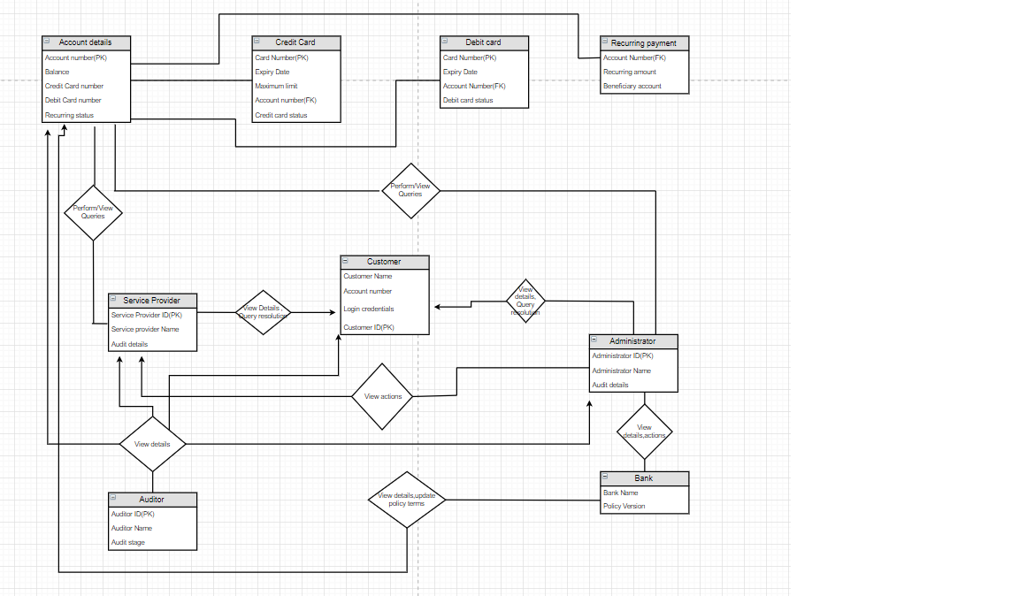

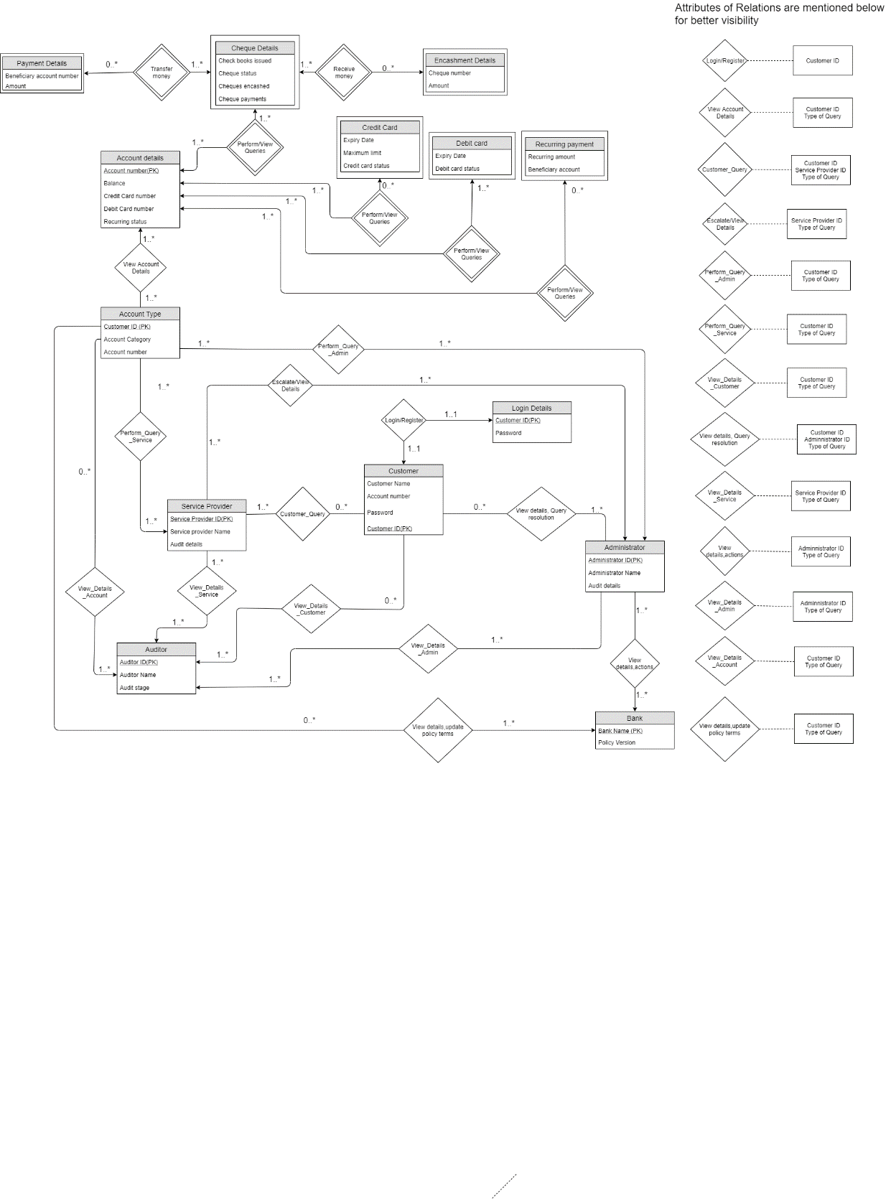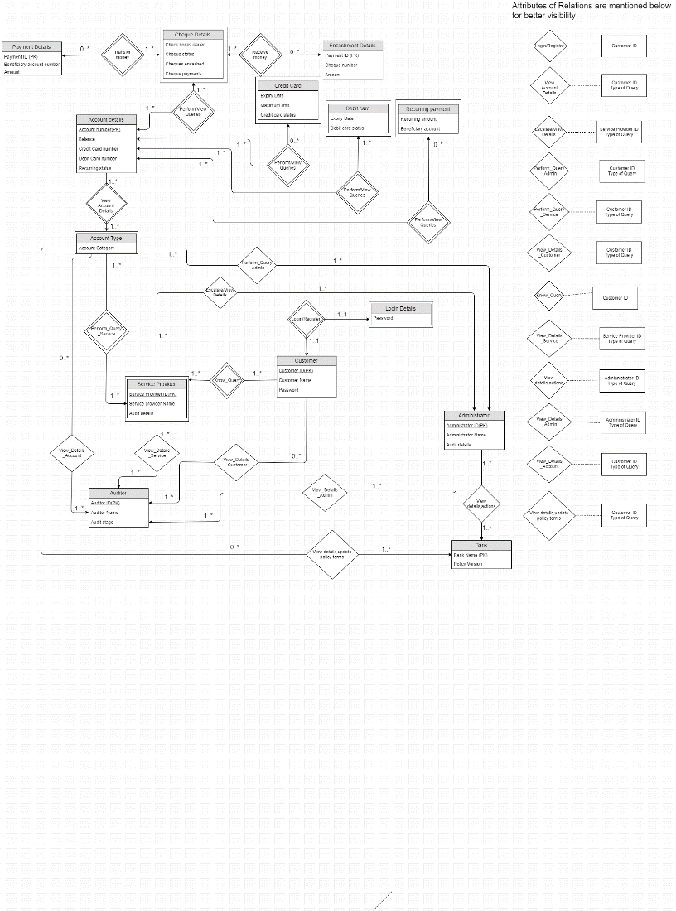

Conversion of final er diagram to relational model

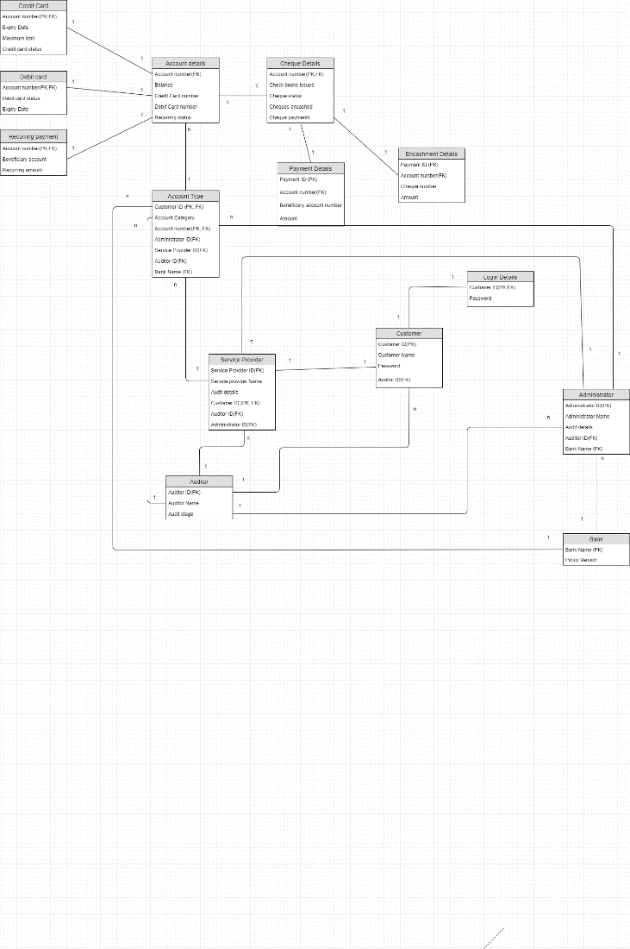

Normalisation and schema refinement

For the removal of redundancies, for most of the cases, i.e. many of the tables had a single primary key and so there were no redundancies in that. For two tables that are Encashment details, and Account details, we removed the redundancies while removing and modifying the DDL and schema accordingly. We analysed each and every table this way.

There are primarily three kinds of anomalies we need to look upon while removing the redundancy. These are insertion anomaly, deletion anomaly, and updating anomaly.

For any table, a primary key can never be NULL and so if the table is not reduced to its highest form, it may cause insertion anomaly wherein no new data could be inserted in the database unless there’s a corresponding primary key associated to it or not. Similarly, if we want to update any data, it may so happen that due to redundancy we may end up updating the same piece of information in thousands of rows. If our table has redundancy, then deletion of one tuple may delete the corresponding data even though it was not supposed to be.

Credit Card: (BCNF)

* Primary Key : Account Number
* Foreign Key : Account Number
* Functional Dependency   
    
  Account Number →Maximum Limit ,Credit Card Status, Expiry Date

Since we have atomic attributes, hence it is in first normal form. Furthermore we have a single attribute primary key, hence it is in second normal form. Since there is one candidate key, hence it is in BCNF as well.  
  
Debit Card (BCNF)

* Primary Key : Account Number
* Foreign Key : Account Number
* Functional Dependency   
    
  Account Number →Debit Card Status, Expiry Date

Since we have atomic attributes, hence it is in first normal form. Furthermore we have a single attribute primary key, hence it is in second normal form. Since there is one candidate key, hence it is in BCNF as well

Recurring Payment (BCNF)

* Primary Key : Account Number
* Foreign Key : Account Number

Functional Dependency   
  
Account Number →Beneficiary account, Recurring amount

Since we have atomic attributes, hence it is in first normal form. Furthermore we have a single attribute primary key, hence it is in second normal form. Since there is one candidate key, hence it is in BCNF as well.   
Login Details (BCNF)

* Primary Key : Customer ID
* Foreign Key : Customer ID
* Functional Dependency   
    
  Customer ID → Password

Since we have atomic attributes, hence it is in first normal form. Furthermore we have a single attribute primary key, hence it is in second normal form. Since there is one candidate key, hence it is in BCNF as well  
  
Payment Details (BCNF)

* Primary Key : Payment ID
* Foreign Key : Account Number

Functional Dependency   
  
 Payment ID → Account Number, Beneficiary Account Number, Amount  
Since we have atomic attributes, hence it is in first normal form. Furthermore we have a single attribute primary key, hence it is in second normal form. Since there is one candidate key, hence it is in BCNF as well  
  
 Account details (BCNF)

* Primary Key : Account Number
* Account Number is Primary Key
* Credit Card Number and Debit Card Number are Candidate keys
* Functional Dependency   
    
  Account Number → Balance, Credit Card number, Debit Card number, Recurring Status  
  Credit Card number→ Balance, Debit Card number, Recurring Status, Account Number  
  Debit Card number→ Balance, Recurring Status, Account Number, Credit Card number  
    
   (Account Number,Credit Card number) - 1  
  (Account Number, Debit Card number,) -2   
  (Account Number,Balance Recurring Status) - 3

We have applied Heath’s theorem for transforming a non-BCNF table to a BCNF table.  
Let us take an example for explaining the heath’s theorem where we have Initialized S = {R}  
While S has a relation R' that is not in BCNF do:   
 Pick a FD: X->Y that holds in R' and violates BCNF  
 Add the relation XY to S  
 Update R' = R'-Y  
Return S  
So, now if s={ABCDE}  
S = {ACDE, AB} // Pick FD: A->B which violates BCNF  
S = {ACE, AB, CD} // Pick FD: C->D which violates BCNF  
// Return S as all relations are in BCNF  
  
Bank (BCNF)

* PRIMARY KEY:- Bank Name
* Functional Dependency  
    
  Bank Name → Policy Version

Since we have atomic attributes, hence it is in first normal form. Furthermore we have a single attribute primary key, hence it is in second normal form. Since there is one candidate key, hence it is in BCNF as well.  
  
Auditor (BCNF)

* Primary Key : Auditor ID
* Functional Dependency   
    
  Auditor ID →Auditor Name ,Audit Stage

Since we have atomic attributes, hence it is in first normal form. Furthermore we have a single attribute primary key, hence it is in second normal form. Since there is one candidate key, hence it is in BCNF as well.

Encashment Details (BCNF)

* Primary Key : Payment ID
* Foreign Key : Account Number
* Functional Dependency   
    
  Payment ID→Cheque Number , Amount  
  Cheque Number → Payment ID,Amount  
    
  (Payment ID,Cheque Number) -1  
  (Payment ID,Amount)-2

We have applied Heath’s theorem for transforming a non-BCNF table to a BCNF table.  
Let us take an example for explaining the heath’s theorem where we have Initialized S = {R}  
While S has a relation R' that is not in BCNF do:   
 Pick a FD: X->Y that holds in R' and violates BCNF  
 Add the relation XY to S  
 Update R' = R'-Y  
Return S  
So, now if s={ABCDE}  
S = {ACDE, AB} // Pick FD: A->B which violates BCNF  
S = {ACE, AB, CD} // Pick FD: C->D which violates BCNF  
// Return S as all relations are in BCNF

Cheque details (BCNF)

* Primary Key : Account Number
* Foreign Key : Account Number
* Functional Dependency   
    
  Account Number → Cheques encashed, Cheque payments, Check books issued, Cheque Status

Since we have atomic attributes, hence it is in first normal form. Furthermore we have a single attribute primary key, hence it is in second normal form. Since there is one candidate key, hence it is in BCNF as well.   
Service Provider (BCNF)

* PRIMARY KEY:- Service Provider ID, Customer ID
* FOREIGN KEY:- Customer ID, Administrator ID, Auditor ID
* Functional Dependency  
    
  (Service Provider ID, Customer ID) →Service Provider Name, Audit Details, Administrator ID, Auditor ID

Since we have atomic attributes, hence it is in first normal form. Furthermore, in none of the dependencies the non-prime attributes don’t depend on a proper subset and hence there’s no partial dependency and therefore it’s in second normal form. Since there is one candidate key, hence it is in BCNF as well.

Administrator (BCNF)

* PRIMARY KEY:- Administrator ID
* FOREIGN KEY:- Bank Name, Auditor ID
* Functional Dependency  
    
   Administrator ID →Administrator Name, Bank Name, Auditor ID,Audit Details

Since we have atomic attributes, hence it is in first normal form. Furthermore we have a single attribute primary key, hence it is in second normal form. Since there is one candidate key, hence it is in BCNF as well.

Account Type (BCNF)

* Primary Key : Account Number,Customer ID
* Foreign Key : Account Number, Administrator ID, Service Provider ID, Auditor ID, Bank Name
* Functional Dependency

(Account Number,Customer ID)→ Account Category,Administrator ID, Service Provider ID, Bank Name , Auditor ID

Since we have atomic attributes, hence it is in first normal form. Furthermore, in none of the dependencies the non-prime attributes don’t depend on a proper subset and hence there’s no partial dependency and therefore it’s in second normal form. Since there is one candidate key, hence it is in BCNF as well.

Customer (BCNF)

* Primary Key : Customer ID
* Foreign Key : Auditor ID
* Functional Dependency   
    
   Customer ID →Customer Name , Password, Auditor ID

Since we have atomic attributes, hence it is in first normal form. Furthermore we have a single attribute primary key, hence it is in second normal form. Since there is one candidate key, hence it is in BCNF as well.

**PostgreSQL CODE to create tables: (UPDATED)**

CREATE TABLE Auditor(

Auditor_ID CHAR(20) NOT NULL,

Auditor_Name CHAR(20),

Audit_stage INT,

PRIMARY KEY (Auditor_ID))

CREATE TABLE Customer(

Customer_ID CHAR(20) NOT NULL,

Customer_Name CHAR(20),

Account_number CHAR(20),

Pass_word CHAR(20),

Auditor_ID CHAR(20),

PRIMARY KEY (Customer_ID),

FOREIGN KEY (Auditor_ID) REFERENCES Auditor

ON DELETE CASCADE)

CREATE TABLE Login_Details(

Customer_ID CHAR(20) NOT NULL,

Pass_word CHAR(20),

PRIMARY KEY(Customer_ID),

FOREIGN KEY (Customer_ID) REFERENCES Customer

ON DELETE CASCADE)

CREATE TABLE Bank(

Bank_Name CHAR(20) NOT NULL,

Policy_Version numeric(4,2),

PRIMARY KEY(Bank_Name))

CREATE TABLE Administrator(

Audit_Details NUMERIC(4,2),

Auditor_ID CHAR(20),

Administrator_ID CHAR(20) NOT NULL,

Administrator_Name CHAR(20),

BANK_NAME CHAR (20),

PRIMARY KEY(Administrator_ID),

FOREIGN KEY (Bank_Name) REFERENCES Bank ON DELETE CASCADE,

FOREIGN KEY (Auditor_ID) REFERENCES Auditor ON DELETE CASCADE)

CREATE TABLE Service_Provider(

Service_Provider_ID CHAR(20) NOT NULL,

Service_Provider_Name CHAR(20),

Audit_Details NUMERIC(4,2),

Auditor_ID CHAR(20),

Administrator_ID CHAR(20),

Customer_ID CHAR(20),

PRIMARY KEY(Service_Provider_ID, Customer_ID),

FOREIGN KEY (Customer_ID ) REFERENCES customer ON DELETE CASCADE,

FOREIGN KEY (Administrator_ID) REFERENCES Administrator ON DELETE CASCADE,

FOREIGN KEY (Auditor_ID) REFERENCES Auditor ON DELETE CASCADE)

CREATE TABLE Account_Details_1(

Account_Number CHAR(20) NOT NULL,

Credit_Card_number INTEGER,

PRIMARY KEY (Account_Number))

CREATE TABLE Account_Details_2(

Account_Number CHAR(20) NOT NULL,

Debit_Card_number INTEGER,

PRIMARY KEY (Account_Number))

CREATE TABLE Account_Details_3(

Account_Number CHAR(20) NOT NULL,

Balance NUMERIC(8,2),

Recurring_Status BOOLEAN,

PRIMARY KEY (Account_Number))

CREATE TABLE Account_type(

Customer_ID CHAR(20) NOT NULL,

Account_Category CHAR(20),

Account_number CHAR(20),

Administrator_ID CHAR(20),

Service_Provider_ID CHAR(20),

Auditor_ID CHAR(20),

Bank_Name CHAR(20),

PRIMARY KEY (Customer_ID, Account_number),

FOREIGN KEY (Account_number) REFERENCES Account_Details_1 ON DELETE CASCADE,

FOREIGN KEY (Administrator_ID) REFERENCES Administrator ON DELETE CASCADE,

FOREIGN KEY (Service_Provider_ID, Customer_ID) REFERENCES Service_Provider ON DELETE CASCADE,

FOREIGN KEY (Auditor_ID) REFERENCES Auditor ON DELETE CASCADE,

FOREIGN KEY (Bank_Name) REFERENCES Bank ON DELETE CASCADE)

CREATE TABLE Credit_card(

Account_Number CHAR(20) NOT NULL,

Expiry_Date DATE,

Maximum_Limit INTEGER,

Credit_Card_Status BOOLEAN,

PRIMARY KEY (Account_Number),

FOREIGN KEY (Account_Number) REFERENCES Account_Details_1

ON DELETE CASCADE)

CREATE TABLE Debit_card(

Account_Number CHAR(20) NOT NULL,

Expiry_Date DATE,

Debit_Card_Status BOOLEAN,

PRIMARY KEY (Account_Number),

FOREIGN KEY (Account_Number) REFERENCES Account_Details_2

ON DELETE CASCADE)

CREATE TABLE Recurring_payment(

Account_Number CHAR(20) NOT NULL,

Beneficiary_account CHAR(20),

Recurring_amount INTEGER,

PRIMARY KEY (Account_Number),

FOREIGN KEY (Account_Number) REFERENCES Account_Details_3

ON DELETE CASCADE)

CREATE TABLE Cheque_details(

Account_Number CHAR(20) NOT NULL,

Cheques_encashed INTEGER,

Cheque_payments NUMERIC(8,2),

Check_books_issues INTEGER,

Cheque_Status BOOLEAN,

PRIMARY KEY (Account_Number),

FOREIGN KEY (Account_Number) REFERENCES Account_Details_1

ON DELETE CASCADE)

CREATE TABLE Encashment_Details_1(

Payment_ID CHAR(20) NOT NULL,

Account_Number CHAR(20) NOT NULL,

Cheque_Number CHAR(20),

PRIMARY KEY (Payment_ID),

FOREIGN KEY (Account_Number) REFERENCES Cheque_Details

ON DELETE CASCADE)

CREATE TABLE Encashment_Details_2(

Payment_ID CHAR(20) NOT NULL,

Account_Number CHAR(20) NOT NULL,

Amount INTEGER,

PRIMARY KEY (Payment_ID),

FOREIGN KEY (Account_Number) REFERENCES Cheque_Details

ON DELETE CASCADE)

CREATE TABLE Payment_Details(

Account_Number CHAR(20) ,

Payment_ID CHAR (20) NOT NULL,

Beneficiary_Account_Number CHAR(20),

Amount INTEGER,

PRIMARY KEY (Payment_ID),

FOREIGN KEY (Account_Number) REFERENCES Cheque_Details

ON DELETE CASCADE)

**IMPORTING CSV DATA**

**Auditor CSV insertion**

COPY auditor(Auditor_ID,Auditor_Name,Audit_stage)

FROM 'C:\Users\Public\auditor.csv'

DELIMITER '|'

CSV HEADER;

**Customer CSV insertion**

COPY customer(Customer_ID,Customer_Name,Account_number,Pass_word,Auditor_ID)

FROM 'C:\Users\Public\Customer.csv'

DELIMITER ','

CSV HEADER;

**Login details CSV insertion**

COPY login_details(Customer_ID,Pass_word)

FROM 'C:\Users\Public\login.csv'

DELIMITER ','

CSV HEADER;

**Bank**

COPY Bank(Bank_name,Policy_version)

FROM 'C:\Users\Public\bank.csv'

DELIMITER ','

CSV HEADER;

**Administrator**

COPY Administrator(Audit_Details,Auditor_ID,Administrator_ID,Administrator_Name,BANK_NAME)

FROM 'C:\Users\Public\administrator.csv'

DELIMITER ','

CSV HEADER;

**Service_Provider**

COPY Service_Provider(

Service_Provider_ID,Service_Provider_Name,Audit_Details,Auditor_ID,Administrator_ID,Customer_ID)

FROM 'C:\Users\Public\service_provider.csv'

DELIMITER ','

CSV HEADER;

**Account_Details_1**

COPY Account_Details_1(Account_Number,Credit_Card_number)

FROM 'C:\Users\Public\account_details_1.csv'

DELIMITER ','

CSV HEADER;

**Account_Details_2**

COPY Account_Details_2(Account_Number,Debit_Card_number)

FROM 'C:\Users\Public\account_details_2.csv'

DELIMITER ','

CSV HEADER;

**Account_Details_3**

COPY Account_Details_3(Account_Number,Balance,Recurring_Status)

FROM 'C:\Users\Public\account_details_3.csv'

DELIMITER ','

CSV HEADER;

**Account_type**

COPY Account_type(

Customer_ID,Account_Category,Account_number,Administrator_ID,Service_Provider_ID,Auditor_ID,Bank_Name)

FROM 'C:\Users\Public\Account_type.csv'

DELIMITER ','

CSV HEADER;

**Credit_Card**

COPY Credit_card(Account_Number,Expiry_Date,Maximum_Limit,Credit_Card_Status)

FROM 'C:\Users\Public\credit_card.csv'

DELIMITER ','

CSV HEADER;

**Debit_card**

COPY Debit_card(Account_Number,Expiry_Date,Debit_Card_Status)

FROM 'C:\Users\Public\debit_card.csv'

DELIMITER ','

CSV HEADER;

**Recurring_payment**

COPY Recurring_payment(Account_Number,Beneficiary_account,Recurring_amount)

FROM 'C:\Users\Public\recurring_payment.csv'

DELIMITER ','

CSV HEADER;

**Cheque_details**

COPY Cheque_details(Account_Number,Cheques_encashed,Cheque_payments,Check_books_issues,Cheque_Status)

FROM 'C:\Users\Public\cheque_details.csv'

DELIMITER ','

CSV HEADER;