# ProBLEM Description

## Product Perspective

Customer Care services are primarily required to cater to various kinds of queries and issues which the customer of that particular service might have. For services which operate on a huge scale it is imperative that a proper database is present which contains all the relevant information pertaining to that service and also possesses the capability to efficiently fetch and modify data with proper provisions for validation and login for the end users. The primary purpose of this Customer Care Database is to meet the expectations of the customers with regards to an array of services/queries spanning over a wide variety of Financial Institutions. In addition to that it also aims to provide customers with constructive solutions for a user-friendly and hassle-free experience for their desired query/service. This product also aims to understand the queries of the customers and ensure that they enjoy a cost-effective and flawless experience with respect to their service. It furthermore enables the Service Providers to gain better insights with regards to the usability of their products which in turn helps them improve their services/products and makes them more efficient.

Users can get information regarding their account/balance after validating their account and can furthermore transfer money to other valid accounts. In addition to that customers can also block their existing accounts in case of extraordinary events. New users can also create accounts. Other general queries within the purview of the system shall also be catered to. Administrators would have access to the entire database in order to maintain information integrity throughout the database. Service Providers would have a lower sense of privilege with regards to the Admin and can only modify/provide information when prompted by the user. End Users can only view information pertaining to their own account after validation. Auditors can view the entire database and report faulty transactions to the admin and the bank as well. The owner also has admin privileges to facilitate policy changes for customers. Every User class after logging in will be redirected to different pages with respect to their functionality.

## USER CLASSES

There are basically five categories of users: -

* **Administrator:** His role includes capacity planning, installation configuration, database design, data recovery etc. These are exclusive tasks and are only to be performed by the administrator. In addition to this they can also perform the following functions:
  + Create Individual Accounts
  + Manage existing accounts
  + View all transactions
  + Update/Delete/close account
  + View Account Information
  + View Active/Inactive accounts
  + User details list
  + Approve or reject customer transaction request
* **Service Provider:** The service provider primarily has access to look into the database. This allows them to help the customers with resolving their queries and providing them with services. Also, the service provider can modify certain fields of the database to cater to the immediate needs of the user provided he/she has provided the login credentials. Following are the functions that a service provider can perform:
  + Create Individual Accounts
  + Manage existing accounts
  + View Account Information
  + Balance Enquiry
  + View account specific transaction histories
* **End User:** They will not be having any access to the database apart from information pertaining to their own account, i.e. they cannot modify or look up the entire database. Following are the actions a user has access to:
  + User login
  + Use PIN system
  + Creating/open new account
  + Registration
  + Funds transfer (local/international/domestic)
  + View statements transaction
  + User account details
  + Change Password and PIN, recover password
  + delete profile
  + View about developer details
* **Auditor:** They shall have complete access to view the entire database and the changes incorporated by the Service Provider and the Administrator as well. Their primary role is to maintain data integrity and look for faulty transactions. In case of an issue it shall notify the same to the Administrator and the Bank as well. Following are the functions that an auditor can perform:
  + View all transactions
  + View Account Information
  + View Active/Inactive accounts
  + User details list
* **Owner Bank:** They shall have complete edit and view access to the entire database. This is primarily to facilitate policy changes for its customers or update information regarding certain queries.
  + Update policy terms
  + Manage existing accounts
  + View Account Information
  + View Active/Inactive accounts
  + User details list
  + Approve or reject customer transaction request

## PRODUCT FUNCTIONS

This section provides the functional overview of the customer care database. Various functional modules that can be accessed by the user are:

1. **Login:**

The customer has an obligation to maintain secrecy in regard to Username & Password registered with the Bank. The bank presupposes that login using valid Username and Password is a valid session initiated by none other than the customer. The customer has to maintain secrecy in regard to Username & Password registered with the Bank. The bank presupposes that login using valid Username and Password is a valid session initiated by none other than the customer. The customer should keep his/her User ID and password strictly confidential and should not divulge the same to any other person. Any loss sustained by the customer due to non-compliance of this condition will be at his/her own risk and responsibility and the Bank will not be liable for the same in any manner. The login page would remain same for all the people but after logging in different page will come for different user classes according to their functionality.

1. **Get balance information:**

This module maintains the balance details of a particular account. The updated database of every customer is maintained with bank. Hence the balance information of every account is available in the database and can be displayed to the customer.

1. **Customer info:**

This module allows the customer to view and update the profile of their account. It also allows them to view their account status, load information and transaction details.

**4. Transfer Money:**

This module allows the customers to transfer funds from one account to another within the same bank. This is possible only if the customer has a sufficient enough balance.

**5. Pay Bills:**

For online payment of bills, you can just type in the unique bill number of the vendor and pay. Customers will be able to shop online and pay the bills from their account. A secure way will be provided for the billing. Online shopping will provide them the easiest way to buy and sell their items. This will be only possible until the moment the bank balance is sufficient and more than the billing amount.

**6. Setup recurring bill payments:**

It may happen that some of the services which you use would require recurring payments like the internet connectivity, television subscription etc. So, the customer care would allow you to set recurring payment so that you don’t need to pay every time. It will automatically get deducted from your account until the moment you cancel it. This will be only possible until the moment the bank balance is sufficient and more than the billing amount.

**7. Order cheques:**

Although nowadays card payment is preferred but when we need to pay large amounts and especially when there’s no card payment machine available, you’ll be paying through a cheque. So, it is possible that after a few payments the cheque book finishes. So, rather than going to the bank to issue a new cheque book, you can simply order it online and it will be delivered to you in a few days.

**8. General Grievances:**

This module allows the customer to suspend their account and block their cards and allows new users to create a new account.

**9. Bank Accounts:**

A customer can have more than one bank account in a bank so, in this case, the customer is prompted to decide which account to use for debiting and crediting money. For these operations customers can add their owned bank accounts here and it will be approved by the administrations of the system.

**10. Save or view up to 1-year past history of transaction:**

It will be easy for the customer to view or save his history transactions up to past 1-year transactions. It will provide him the opportunity to maintain his bank balance and needs.

**11. Online record search:**

Bank staff will easily search a record and update it if needed transactions will be faster even physically from the branch because it will be very easy for the bank staff to check the balance of a specific person and update its record if necessary.

## DESIGN CONSTRAINTS

* Scalability of the aforementioned database could be an issue if the user pool is extremely large. Distributed Database Systems need to be used for that.
* The data needs to be stored on a server. For large amounts of data, storing it on cloud servers could be an expensive affair and might require complete reconfiguration of the complete system.
* For highly scaled systems, there should be dedicated integrity checks to maintain and handle the complete system.

Table listing all nouns and verbs:

|  |  |  |  |  |
| --- | --- | --- | --- | --- |
| **Noun** | **Noun** | **Noun** | **Noun** | **Noun** |
| Customer Care services | various kinds | queries | issues | the customer |
| that particular service | services | a huge scale | it | a proper database |
| all the relevant information | that service | the capability | data | proper provisions |
| validation | login | the end users | The primary purpose | this Customer Care Database |
| the expectations | the customers | regards | an array | services/queries |
| a wide variety | Financial Institutions | addition | it | customers |
| constructive solutions | a user-friendly and hassle-free experience | their desired query/service | This product | the customers |
| they | a cost-effective and flawless experience | respect | their service | It |
| the Service Providers | better insights | regards | the usability | their products |
| turn | them | their services/products | them | Users |
| information | their account/balance | their account | money | other valid accounts |
| addition | customers | their existing accounts | case | extraordinary events |
| New users | accounts | Other general queries | the purview | the system |
| Administrators | access | the entire database | order | information integrity |
| the database | Service Providers | a lower sense | privilege | regards |
| the Admin | information | the user | End Users | information |
| their own account | validation | Auditors | the entire database | faulty transactions |
| the admin | the bank | The owner | admin privileges | policy changes |
| customers | Every User class | different pages | respect | their functionality |
| five categories | users | His role | capacity planning | installation configuration |
| database design | exclusive tasks | the administrator | addition | they |
| the following functions | The service provider | access | the database | them |
| the customers | their queries | them | services | the service provider |
| certain fields | the database | the immediate needs | the user | he |
| she | the login credentials | the functions | a service provider | They |
| any access | the database | information | their own account | they |
| the entire database | the actions | a user | access | They |
| complete access | the entire database | the changes | the Service Provider | the Administrator |
| Their primary role | data integrity | faulty transactions | case | an issue |
| it | the Administrator | the Bank | the functions | an auditor |
| They | complete edit | access | the entire database | policy changes |
| its customers | information | certain queries | Scalability | the aforementioned database |
| an issue | the user pool | Distributed Database Systems | The data | a server |
| large amounts | data | it | cloud servers | an expensive affair |
| complete reconfiguration | the complete system | This section | the functional overview | the customer care database |
| Various functional modules | the user | The customer | an obligation | secrecy |
| regard | Username | Password | the Bank | The bank |
| valid Username | Password | a valid session | none | the customer |
| The customer | secrecy | regard | Username | Password |
| the Bank | The bank | valid Username | Password | a valid session |
| none | the customer | The customer | User ID | password |
| any other person | Any loss | the customer | non-compliance | this condition |
| his/her own risk | responsibility | the Bank | any manner | The login page |
| all the people | different page | different user classes | their functionality | This module |
| the balance details | a particular account | The updated database | every customer | bank |
| the balance information | every account | the database | the customer | This module |
| the customer | the profile | their account | It | them |
| their account status | load information | transaction details | This module | the customers |
| funds | one account | the same bank | the customer | a sufficient enough balance |
| online payment | bills | you | the unique bill number | the vendor |
| Customers | the bills | their account | A secure way | the billing |
| Online shopping | them | the easiest way | their items | the moment |
| the bank balance | the billing amount | It | the services | you |
| recurring payments | the internet connectivity | the customer care | you | recurring payment |
| you | It | your account | the moment | you |
| it | the moment | the bank balance | the billing amount | card payment |
| we | large amounts | no card payment machine | you | a cheque |
| it | a few payments | the cheque book | the bank | a new cheque book |
| you | it | it | you | a few days |
| This module | the customer | their account | their cards | new users |
| a new account | A customer | more than one bank account | a bank | this case |
| the customer | which account | money | these operations | customers |
| their owned bank accounts | it | the administrations | the system | It |
| the customer | his history | transactions | past 1-year transactions | It |
| him | the opportunity | his bank balance | needs | Bank staff |
| a record | it | transactions | the branch | it |
| the bank staff | the balance | a specific person | its record | the customer care services |
| the complete data | the customers bank accounts | the banks | that information | We |
| the service providers/admin | any account | any debit/credit card | the customer | no need |
| a confirmation | the bank | this issue | The bank | explicit authority |
| the customer care centre | the information | the customers | highly scaled systems | the complete system |

|  |  |  |  |  |
| --- | --- | --- | --- | --- |
| **Verb** | **Verb** | **Verb** | **Verb** | **Verb** |
| require | cater | may | operate | contain |
| pertain | possess | fetch | modify | meet |
| span | aim | provide | desire | aim |
| understand | query | ensure | enjoy | enable |
| gain | help | improve | make | can |
| regard | validate | can | transfer | can |
| block | exist | can | create | shall |
| cater | would | maintain | would | can |
| modify | provide | prompt | can | view |
| pertain | can | view | report | facilitate |
| log | will | redirect | include | perform |
| can | perform | follow | look | allow |
| help | resolve | provide | can | modify |
| cater | provide | provide | follow | can |
| perform | will | have | pertain | can |
| modify | look | follow | shall | view |
| incorporate | maintain | look | shall | notify |
| follow | can | perform | shall | view |
| facilitate | update | need | store | store |
| could | may | require | could | need |
| use | provide | can | access | maintain |
| register | presuppose | login | use | initiate |
| maintain | register | presuppose | login | use |
| initiate | should | keep | should | divulge |
| sustain | will | will | would | remain |
| log | will | come | accord | maintain |
| maintain | can | display | allow | view |
| update | allow | view | allow | transfer |
| can | type | pay | will | shop |
| pay | will | provide | will | provide |
| buy | sell | will | may | happen |
| use | would | require | recur | would |
| allow | set | recur | need | pay |
| will | deduct | cancel | will | prefer |
| need | pay | a | will | pay |
| go | issue | can | order | will |
| deliver | allow | suspend | block | allow |
| create | can | prompt | decide | use |
| debit | credit | can | add | own |
| will | approve | will | view | save |
| will | provide | maintain | will | search |
| update | need | will | will | check |
| update | assume | possess | regard | provide |
| assume | can | block | wish | regard |
| give | read | modify | scale | should |
| dedicate | maintain | handle | modify | open |

Table listing Nouns after truncation:

|  |
| --- |
| **Nouns** |
| Service Providers |
| Customers |
| the Bank |
| Users |
| The service provider |
| the vendor |
| Auditors |
| Administrators |
| credit card |
| debit card |
| online payment |
| Online shopping |
| Account details |
| recurring payment |

List of rejected nouns with reasons:

|  |  |  |  |  |  |  |  |  |  |  |  |
| --- | --- | --- | --- | --- | --- | --- | --- | --- | --- | --- | --- |
| **Noun** | | **Reject Reason** | | **Noun** | | **Reject Reason** | | **Noun** | | **Reject Reason** | |
| all the people | | General | | various kinds | | Vague | | the customer care database | | General | |
| a cheque | | Duplicates | | valid Username | | Attributes | | issues | | General | |
| him | | General | | information | | General | | card payment | | Associations | |
| General | | General | | better insights | | Irrelevent | | certain fields | | Vague | |
| services/ products | | General | | customers | | Duplicates | | their account status | | Attributes | |
| new users | | Duplicates | | every customer | | Duplicates | | Other general queries | | General | |
| New users | | Duplicates | | this Customer Care Database | | General | | load information | | General | |
| the end users | | Duplicates | | we | | General | | the bank | | Duplicates | |
| the admin | | Duplicates | | the Service Provider | | Attributes | | Some classes | | General | |
| the customer care centre | | General | | the following functions | | Irrelevant | | a confirmation | | Attributes | |
| Financial Institutions | | General | | them | | General | | she | | General | |
| cloud servers | | Irrelevent | | a few payments | | Attributes | | that particular service | | general | |
| a server | | General | | the Service Providers | | Attributes | | constructive solutions | | Associations | |
| the user pool | | General | | Processor | | Irrelevant | | the purview | | Vague | |
| Bank staff | | Attributes | | 1 GB | | Irrelevant | | the system | | General | |
| the customer | | Duplicates | | the opportunity | | General | | their service | | Attributes | |
| a bank | | Duplicates | | immediate needs | | Attributes | | a lower sense | | Vague | |
| A customer | | Duplicates | | aforementioned database | | Vague | | the services | | Attributes | |
| the administrations | | Duplicates | | faulty transactions | | Attributes | | validation | | Attributes | |
| an auditor | | Duplicates | | complete reconfiguration | | Attributes | | the moment | | Vague | |
| the complete data | | General | | other valid accounts | | Attributes | | any other person | | Duplicates | |
| a user | | Duplicates | | the balance details | | Attributes | | the profile | | Attributes | |
| responsibility | | Vague | | a new cheque book | | Irrelevant | | regard | | Vague | |
| large amounts | | General | | 4 GB | | Irrelevant | | no need | | Vague | |
| The data | | General | | needs | | General | | transaction details | | Attributes | |
| the customer care | | Associations | | the Admin | | Attributes | | data | | Attributes | |
| which account | | Vague | | respect | | Irrelevant | | The login page | | Attributes | |
| these operations | | Vague | | access | | Vague | | case | | Vague | |
| the login credentials | | Attributes | | microphone | | Irrelevant | | the information | | Attributes | |
| services | | General | | their cards | | Attributes | | certain queries | | Attributes | |
| a particular account | | Vague | | This module | | Attributes | | Password | | Attributes | |
| their own account | | General | | Hard Drive | | Irrelevant | | the complete system | | General | |
| a valid session | | Associations | | one account | | General | | the internet connectivity | | Irrelevent | |
| 1 GHz | | Irrelevent | | complete access | | Attributes | | database design | | General | |
| his bank balance | | Attributes | | the bank staff | | Irrelevant | | the entire database | | General | |
| Various functional modules | | Vague | | the database | | General | | the balance information | | Attributes | |
| This product | | Vague | | a specific person | | General | | data integrity | | Associations | |
| money | | Associations | | all the relevant information | | Vague | | Every User class | | Vague | |
| secrecy | | Associations | | privilege | | Irrelevant | | that information | | Vague | |
| any manner | | Vague | | services/queries | | Duplicates | | the customer care services | | Associations | |
| the customers | | Duplicates | | the billing | | Attributes | | this condition | | Vague | |
| information integrity | | Associations | | The owner | | Duplicates | | their account | | Attributes | |
| the banks | | Duplicates | | transactions | | Attributes | | the functional overview | | Vague | |
| their functionality | | Vague | | Minimum | | Irrelevant | | they | | General | |
| password | | Attributes | | its record | | Vague | | different page | | Vague | |
| The primary purpose | | Vague | | any access | | Vague | | the unique bill number | | Attributes | |
| an obligation | | Irrelevent | | a service provider | | Duplicates | | a sufficient enough balance | | Attributes | |
| **Noun** | **Reject Reason** | | **Noun** | | **Reject Reason** | **Noun** | **Reject Reason** | | **Noun** | | **Reject Reason** |
| extraordinary events | Vague | | a user-friendly and hassle-free experience | | Associations | a wide variety | Vague | | past 1-year transactions | | Attributes |
| The customer | Duplicates | | Scalability | | Associations | It | Dulpicate | | every account | | Vague |
| complete edit | Associations | | They | | General | a few days | General | | a record | | General |
| the Administrator | Dulpicate | | its customers | | Duplicates | accounts | Attributes | | the expectations | | Vague |
| funds | General | | RAM | | Irrelevent | queries | Dulpicate | | installation configuration | | Vague |
| explicit authority | Vague | | A secure way | | Associations | We | General | | this case | | Vague |
| His role | Irrelevant | | their items | | Vague | the changes | General | | recurring payments | | Duplicates |
| admin privileges | Attributes | | the same bank | | Duplicates | the service providers/admin | Dulpicate | | their existing accounts | | Attributes |
| the easiest way | Vague | | any account | | General | none | General | | the bank balance | | Attributes |
| their products | Vague | | the usability | | Associations | Their primary role | Vague | | the bills | | Attributes |
| This section | General | | the functions | | Vague | policy changes | Attributes | | exclusive tasks | | General |
| highly scaled systems | Irrelevant | | Any loss | | Vague | bank | Dulpicate | | regards | | Vague |
| The bank | General | | Customer Care services | | Duplicates | a proper database | General | | your account | | Attributes |
| you | General | | the user | | Duplicates | Memory | Irrelevant | | no card payment machine | | Irrelevent |
| the branch | Attributes | | capacity planning | | General | Distributed Database Systems | General | | proper provisions | | General |
| an array | Vague | | the customer's bank accounts | | Attributes | Username | Dulpicate | | he | | General |
| a new account | Attributes | | The updated database | | Associations | the administrator | Dulpicate | | different user classes | | General |
| User ID | Attributes | | a camera | | Irrelevent | the balance | Attributes | | different pages | | Vague |
| login | Attributes | | his history | | General | End Users | Dulpicate | | their account/balance | | Attributes |
| bills | Attributes | | more than one bank account | | Irrelevent | the capability | Irrelevant | | that service | | General |
| the billing amount | Attributes | | the cheque book | | Irrelevent | their desired query/service | Dulpicate | | an expensive affair | | Vague |
| his/her own risk | Irrelevant | | their queries | | General | 64 GB | Irrelevant | | turn | | Vague |
| it | General | | the service provider | | Duplicates | a cost-effective and flawless experience | Associations | | this issue | | Attributes |

Truncated table listing the verbs:

|  |  |  |  |  |
| --- | --- | --- | --- | --- |
| **Verb** | **Verb2** | **Verb3** | **Verb4** | **Verb5** |
| span | enjoy | cancel | make | can |
| accord | come | pay | own | add |
| remain | buy | pertain | prefer | order |
| facilitate | type | follow | recur | meet |
| keep | happen | resolve | debit | approve |
| notify | presuppose | exist | desire | fetch |
| scale | perform | query | understand | recommend |
| deliver | require | maintain | incorporate | shall |
| view | transfer | regard | login | wish |
| aim | register | create | need | have |
| improve | redirect | enable | use | access |
| update | issue | contain | sell | possess |
| ensure | sustain | cater | modify | validate |
| â€™ | block | suspend | prompt | may |
| assume | initiate | operate | read | should |
| credit | display | deduct | go | include |
| shop | report | help | search | give |
| log | look | save | handle | would |
| check | dedicate | will | set | allow |
| store | could | decide | gain | provide |

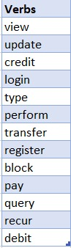

These are the accepted verbs.

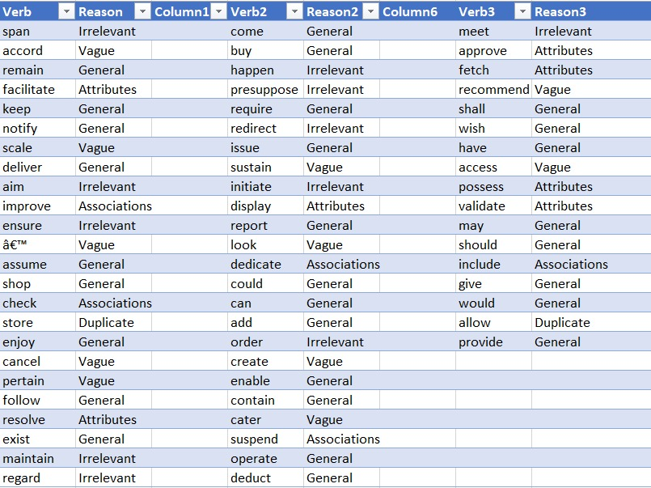

There are the rejected verbs with the reasons for rejection.

# ER DIAGRAM

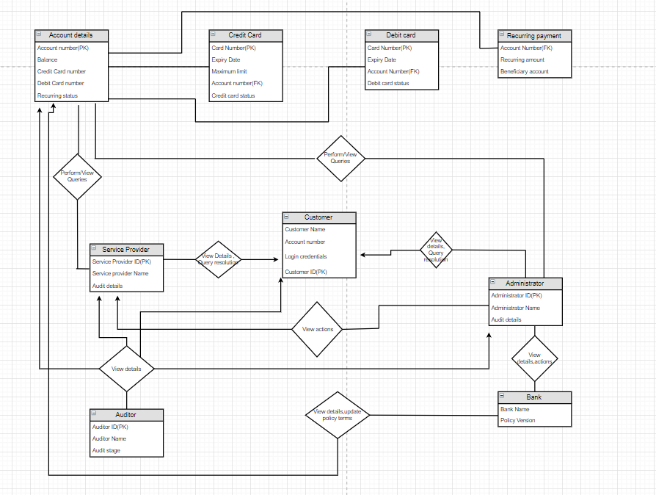

**Version 1**

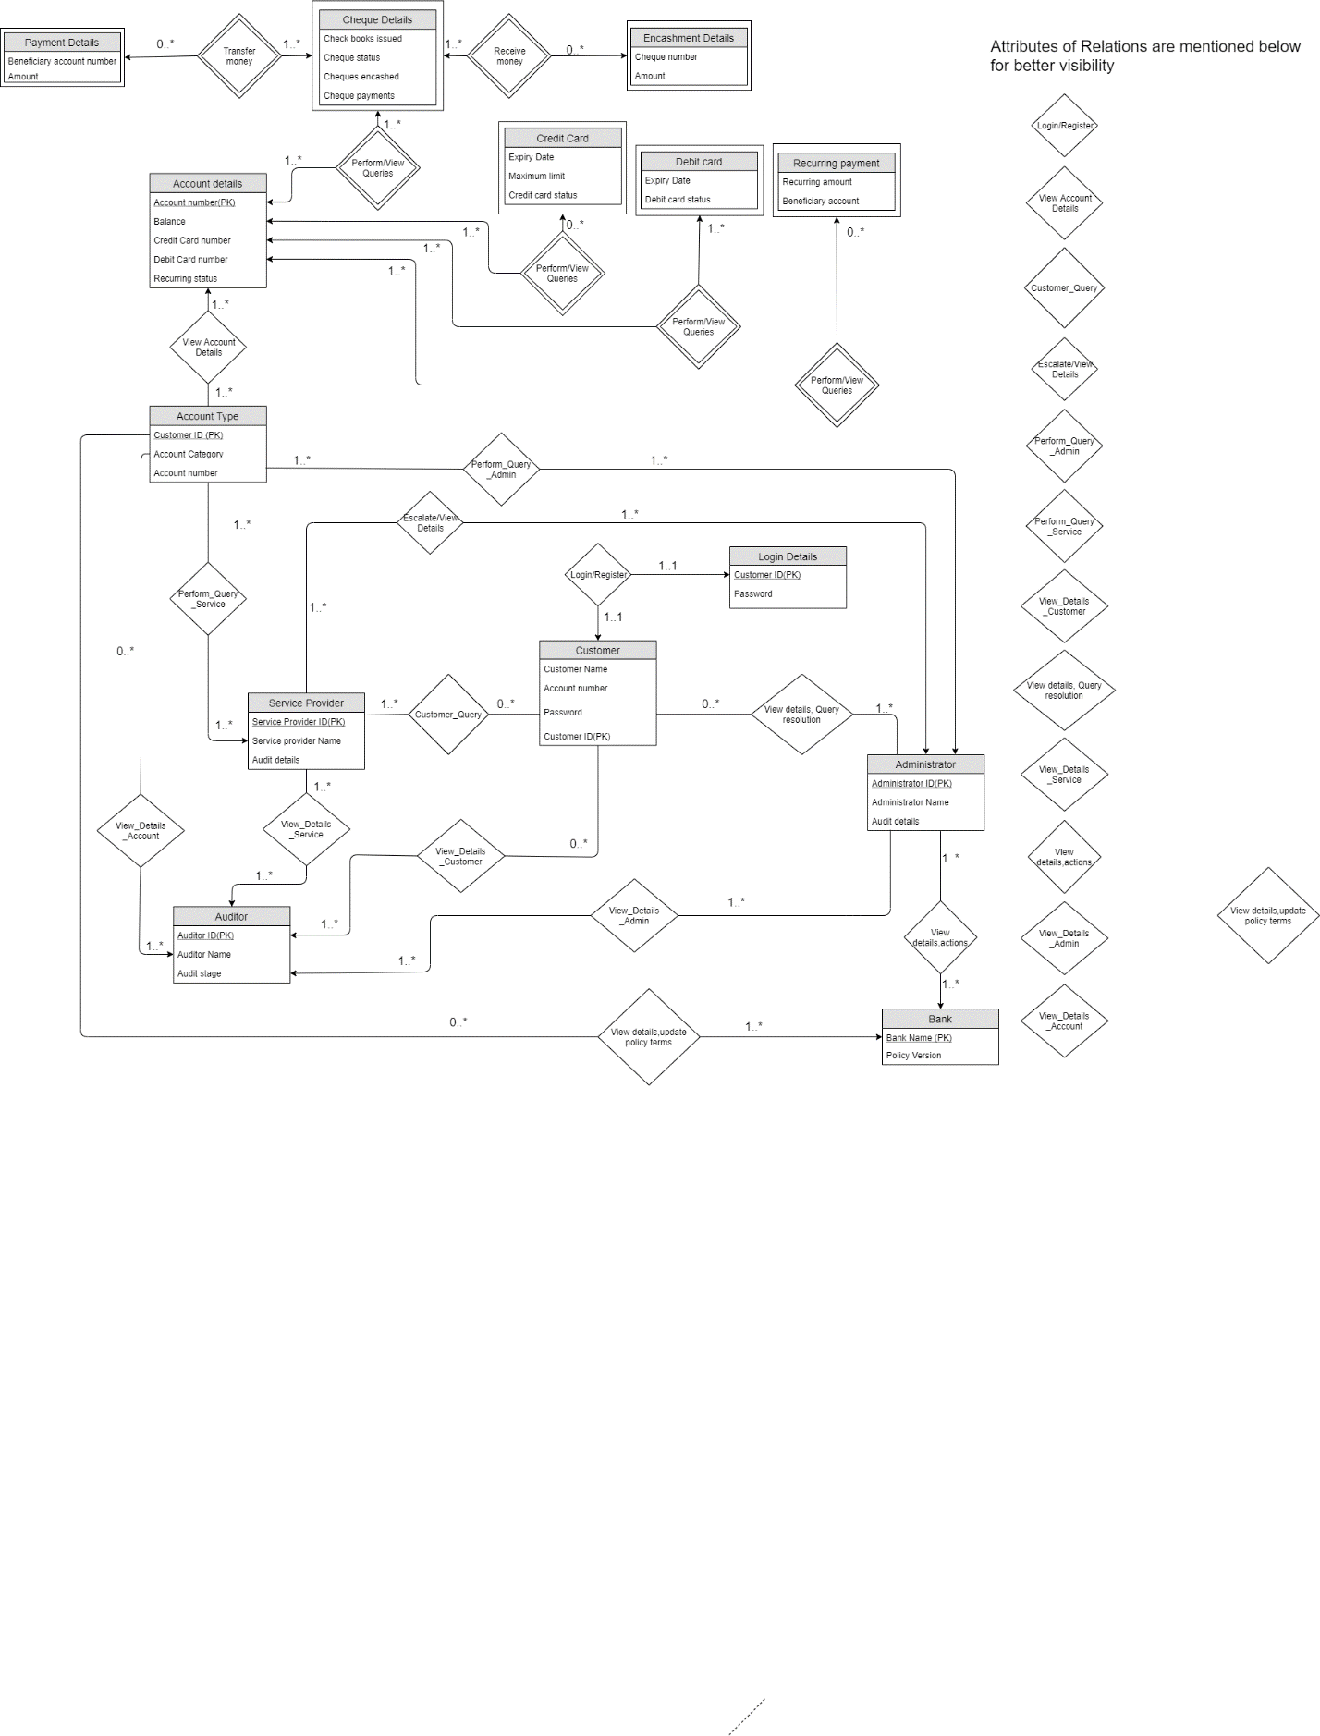

**Version 2**