#### **LAB 10**

#### **2.**

**2.1**  DHCP messages are sent via UDP.

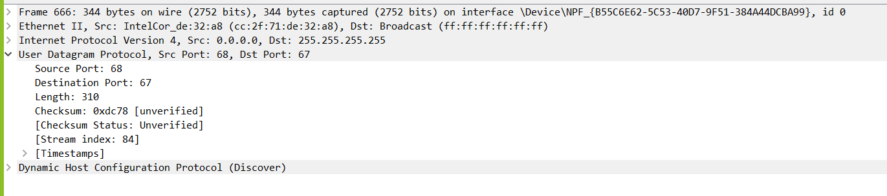

**2.2** The timing datagram illustrating the sequence of the first four-packet is given below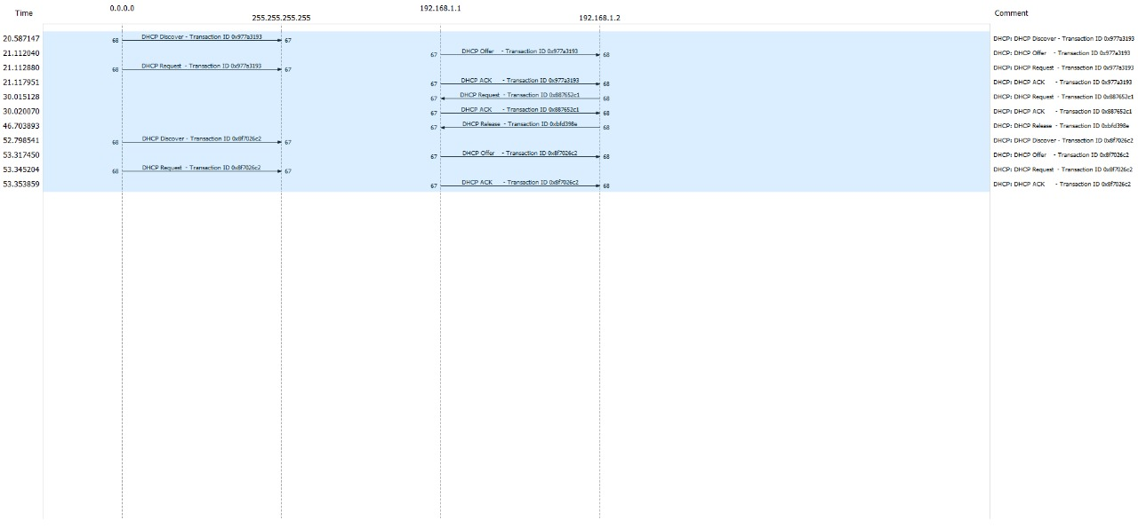

The port numbers are the same as in the example given.

1) Src – 68, Dst – 67

2) Dst – 67, Src – 68

3) Src – 68, Dst – 67

4) Dst – 67, Src – 68

**2.3** The link-layer address of the host is cc:2f:71:de:32:a8

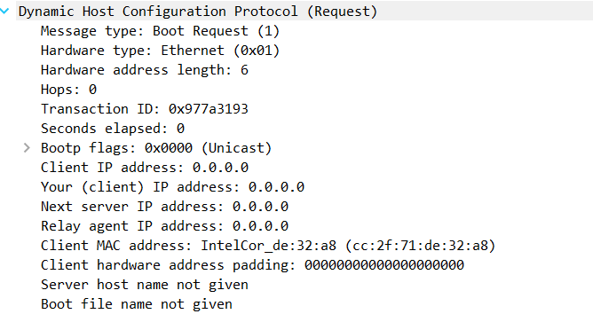

**2.4** The message type value differentiates from the discover and request message. 1 is for discover and 3 is for request as shown in the screenshots below.



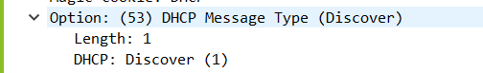

**2.5** Transaction IDs are different so that the host can differentiate between different groups of messages

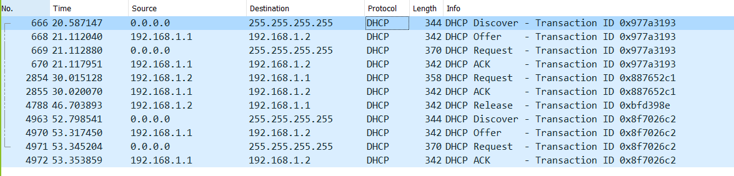

**2.6** Source and destination IP addresses of 4 DHCP messages are shown below:

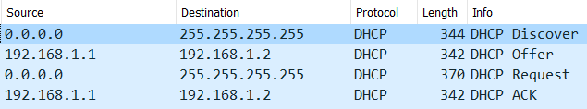

**2.7** The IP address of my DHCP server is 192.168.1.2

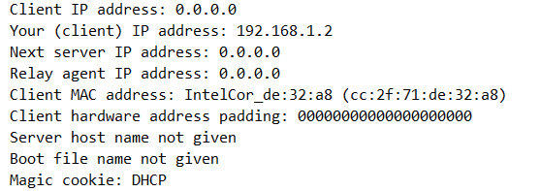

**2.8** The offered IP address is 192.168.1.2



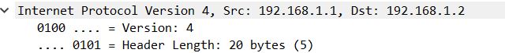



**2.9** The value that indicates that there’s no relay agent is 0.0.0.0. In the screenshot, the value for the relay agent is 0.0.0.0. If there were an IP there then we could give values in the trace.

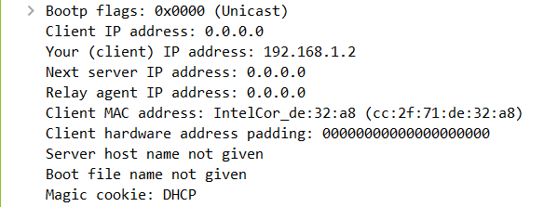

**2.10**  a) Subnet mask line tells the client which subnet mask to use.

b) The router line indicates where the client should send the messages by default.

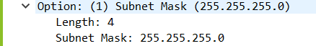

**2.11**

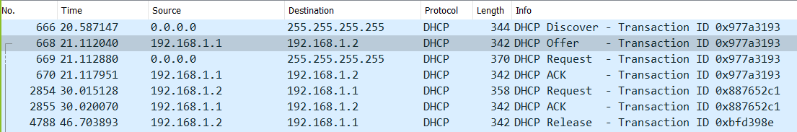

For the first iteration the Destination IP Address in DHCP Offer Packet doesn't match the Source IP address for the next DHCP Request Packet, hence the client doesn’t accept this address.

But after the first iteration, this scheme is not followed and the Destination IP Address in DHCP Offer Packet matches the Source IP address for the next DHCP Request Packet. Hence the client now accepts the offered address.

**2.12** The lease time tells the client how long they can use the specific IP address or connection assigned by the server before they will have to be assigned a new one.

The lease time in this experiment is 1 day.

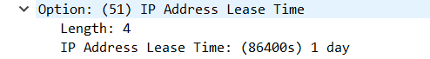

**2.13** The purpose of the release message is to release the IP address back to the server.

There is no verification that the release message has been received by the server.

If the message is lost, the client releases the IP address, but the server will not reassign that address until the client’s lease on the address expires. It will just continue to run until the lease expires.

**2.14** Yes, they appear in between the sent and received packets of the DHCP. They are broadcast packets.These broadcasts are sent out by the network to build up the known IP addresses by the client’s network. These packets help to sort out the mac and ip addresses.



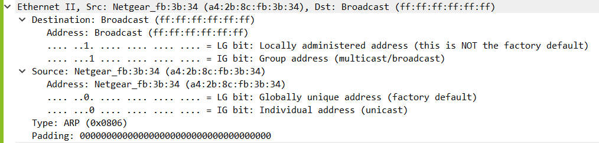

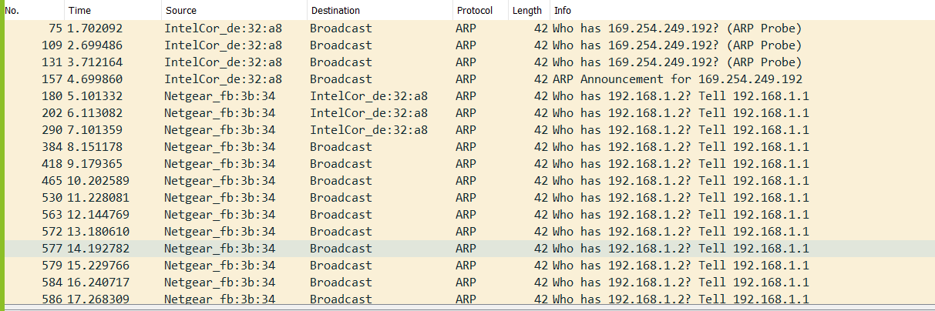

# **3. Screenshot of the topology:**

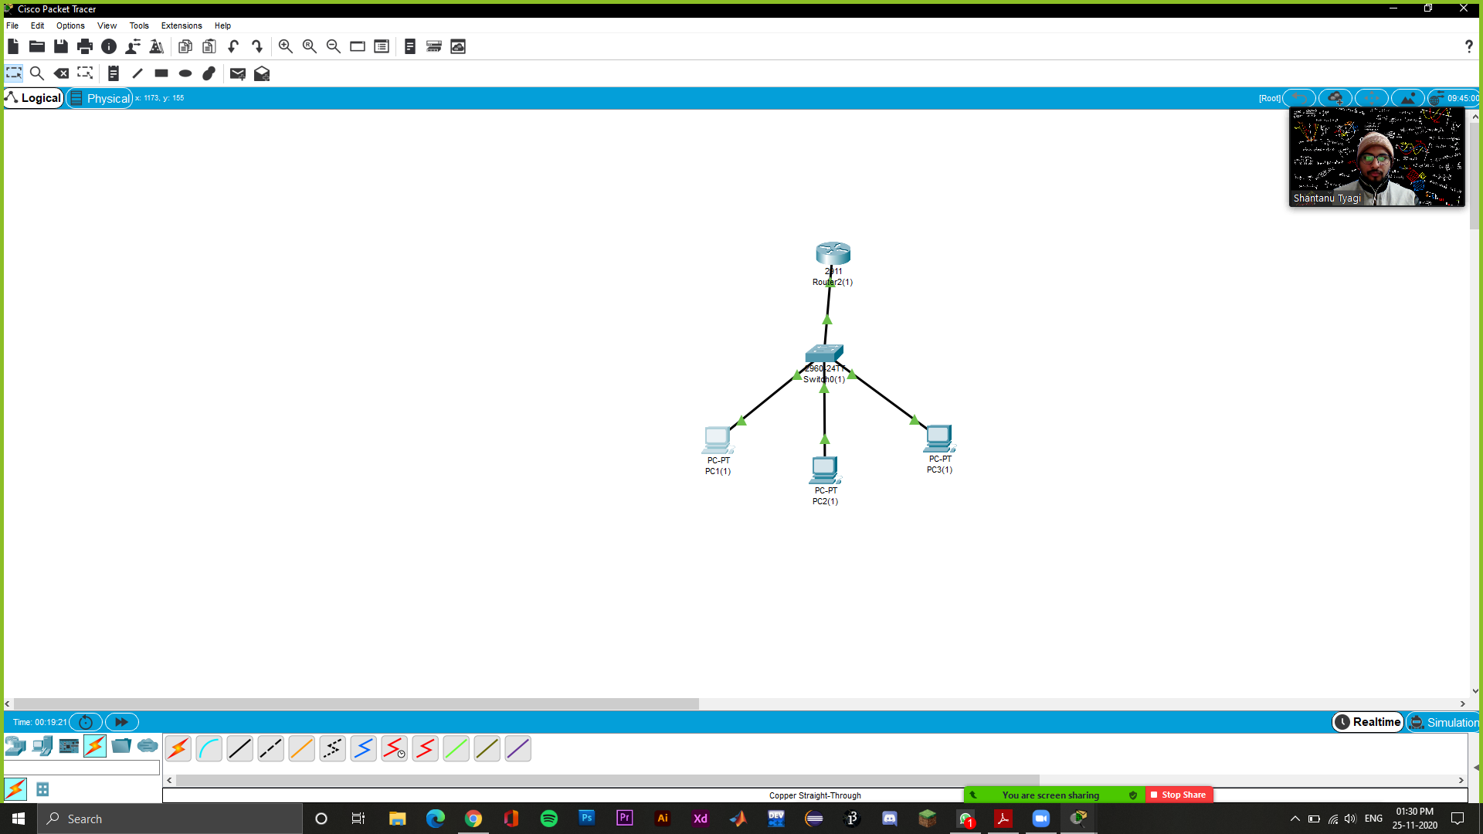

The IPs assigned to the PCs are shown below

PC1: 192.168.1.11

PC2: 192.168.1.12

PC3:192.168.1.13