**3.2)**

**Ans 1,2)**

**Hello** - Each router sent its neighbour a hello packet to discover and establish Bi-directional communication with them. These packets are sent between every pair of neighbours in the topology.

**DD** - Once the Hello packets are exchanged and two-way communications are established , the database description packets are sent using the exchange database protocol. The exchange database protocol exchanges a description of the link-state databases between adjacent partners, using the database description packet.These packets are sent between every pair of neighbours in the topology.

**LSR** - After exchanging Database Description packets with a neighboring router, a router may find that parts of its topological database are out of date. The Link State Request packet is used to request the pieces of the neighbor's database that are more up to date. This is done until all neighbours are synchronized fully with their neighbours. Although these packets are sent between neighbours in the topology, it circulates throughout all the routers in the topology as seen in the animation .

**LSU** - These requests are followed with a flooding of Link-state updates containing the requested information. Although these packets are sent between neighbours in the topology, it circulates throughout all the routers in the topology as seen in the animation.

**LSA** - Each link-state update packet is acknowledged, either explicitly with a link-state acknowledgment packet or implicitly in the link-state packets. The routers are fully adjacent when the link-state databases are fully synchronized. Although these packets are sent between neighbours in the topology, it circulates throughout all the routers in the topology as seen in the animation.

Ans 3)- Time duration obtained practically:-

Hello packet-> 10.44micro sec

D-D packet -> 10.76micro sec

LSR packet -> 9.48micro sec

LSU packet -> 11.72micro sec

LSA packet -> 10.12micro sec

Theoretically the value of Time taken to exchange can be calculated by subtracting the physical layer end time - physical layer start time.

The formula by which we can find it out is l/c ,where l is the length of the link and c is speed of light.

Ans 4)

All OSPF packets share a common OSPF Header of 24-bytes. This header allows the receiving router to validate and process the packets. Below is the general packet structure.

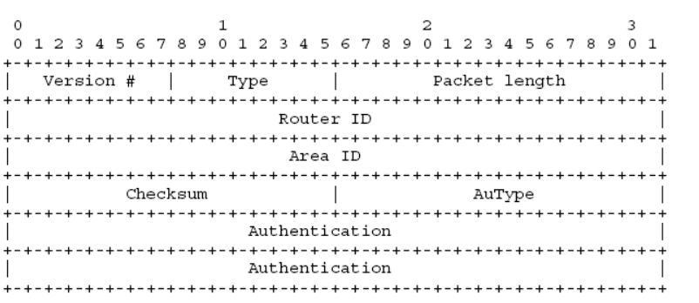

**Type-** It specifies the type of OSPF packet. There are 5 different types of OSPF packets. (1-byte)

**1- Hello packet**

**2- Database Descriptor packet**

**3- Link State Request packet**

**4- Link State Update packet**

**5- Link State Acknowledgment packet**

**Packet Length-** Total length of the OSPF packet (2-bytes)

**Router ID-** The Router ID of the advertising router

**Area ID-** 32-bit Area ID assigned to the interface sending the OSPF packet (4-bytes)

**Checksum-** Standard IP Checksum of OSPF packet excluding Authentication field (2-bytes)

**AuType-** Authentication Type (2-bytes)

**0- No Password**

**1- Plain-text password**

**2- MD5 authentication**

**Authentication-** Authentication data to verify the packet's integrity (8-bytes)

* Hello Packet :

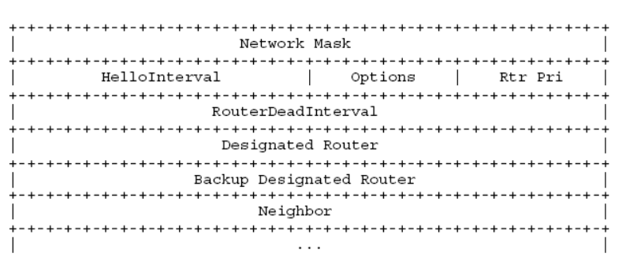

**Network Mask-** Subnet mask of the advertising OSPF interface. For unnumbered point-to-point interfaces and virtual-links, it is set to 0.0.0.0 (4-bytes)

**HelloInterval-** Interval at which Hello packets are advertised. By default, 10 seconds for point-to-point link and 30 seconds for NBMA/Broadcast links (2-bytes)

**Options-** The local router advertises its capabilities in this field. (1-byte)

**Rtr Pri-** The Priority of the local router. It is used for DR/BDR election. If set to 0, the router is ineligible for the election. (1-byte)

**RouterDeadInterval-** The Dead Interval as requested by the advertising router. By default, 40 seconds for point-to-point link and 120 seconds for NBMA/Broadcast links (4-bytes)

**Designated Router-** The IP address of the current DR. Set to 0.0.0.0 if no DR is elected yet. (4-bytes)

**Backup Designated Router-** The IP address of the current BDR. Set to 0.0.0.0 if no BDR is elected yet. (4-bytes)

**Neighbor-** The Router IDs of all OSPF routers from whom a valid Hello packet have been seen on the network.

**Database Descriptor**

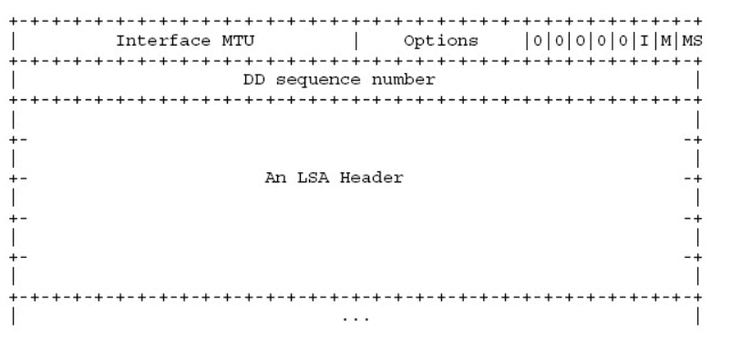

**Interface MTU-** Contains the MTU value of the outgoing interface. For virtual-links, this field is set to 0x0000. (2-bytes)

**Options-** Same as Options field in a Hello packet (1-byte)

**I-** Initial Bit. Indicates this is the first in the series of DBD packets (1-bit)

**M-** More bit. Indicates whether the DBD packet is the last in the series of packets. Last packet has a value of 0, while all previous packets have a value of 1. (1-bit)

**MS-** Master/ Slave bit. Master=1, Slave=0 (1-bit)

**DD Sequence Number-** Used to sequence the collection of DBD packets. The initial value should be unique. The sequence number then increments by 1 until the complete database description has been sent.(4-bytes)

**LSA Header-** This field contains the LSA headers describing the local router's database. (variable length)

* LSR Packet

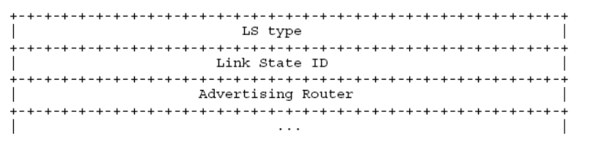

**LS Type-** Type of LSA requested (4-bytes)

**Link State ID-** Depends upon the type of LSA (4-bytes)

**Advertising Router-** Router ID of the requesting router (4-bytes)

* LSU Packet

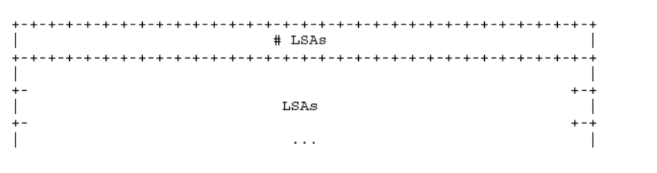

**LSAs-** Number of LSAs within an LSU packet (4-bytes)

**LSAs-** The complete LSA is encoded within this field. The LSU may contain single or multiple LSAs.

* LSA Packet

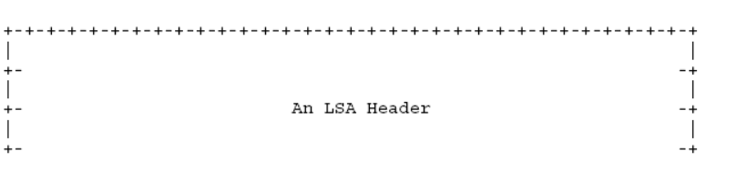

**LSA Header-** List of LSA Headers being acknowledged.

2) ->

For the first scenario cost of each link is:-

L2 -> 1

L3 -> 1

L4 -> 1

L5 -> 1

L6 -> 1

L8 -> 1

L9 -> 1

For the second scenario cost of each link is:-

L2 -> 1

L3 -> 1

L4 -> 1

L5 -> 1

L6 -> 1

L8 -> 10

L9 -> 10

3)-> The formula for link-cost is = (Reference Bandwidth)/(Uplink speed)

and the netSim value of Reference bandwidth is 100Mbps.

4) For Part 1 :

Path L8-L9 :1+1+1+1 = 4

Path L2-L3-L4-L5-L6 : = 1+1+1+1+1+1 = 6

For Part 2 :

Path L8-L9 :10+10+1+1 = 22

Path L2-L3-L4-L5-L6 : = 1+1+1+1+1+1 = 6

**Graphs for Part 1 :**

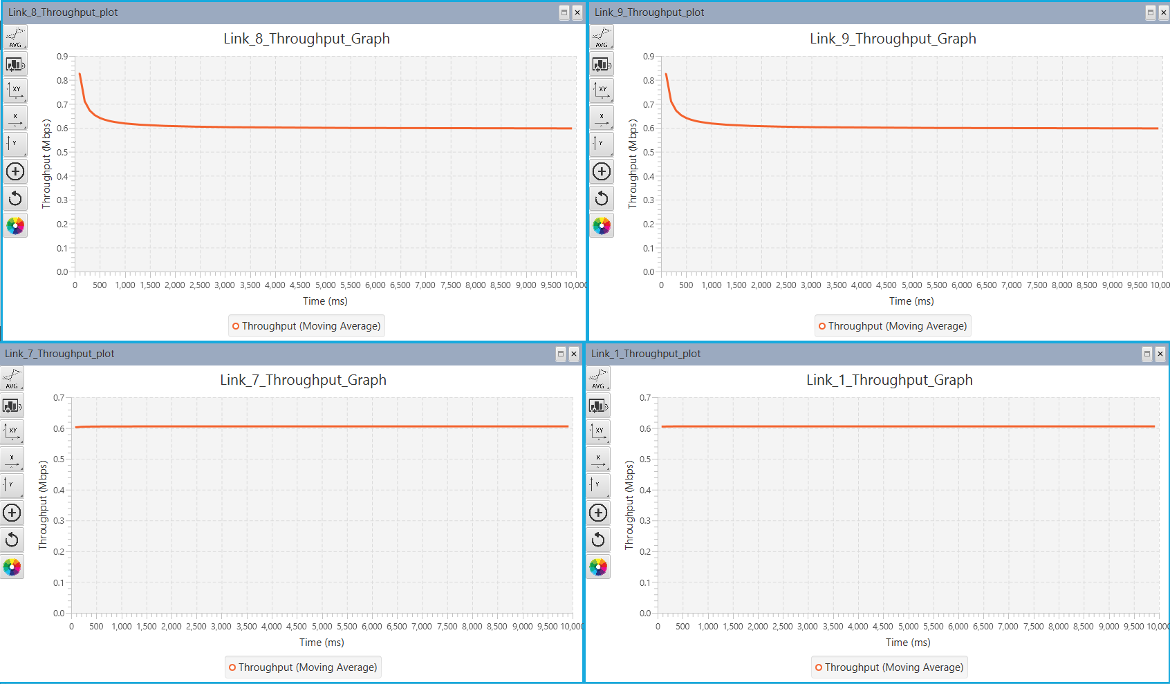

**Graphs for Part 2 :**

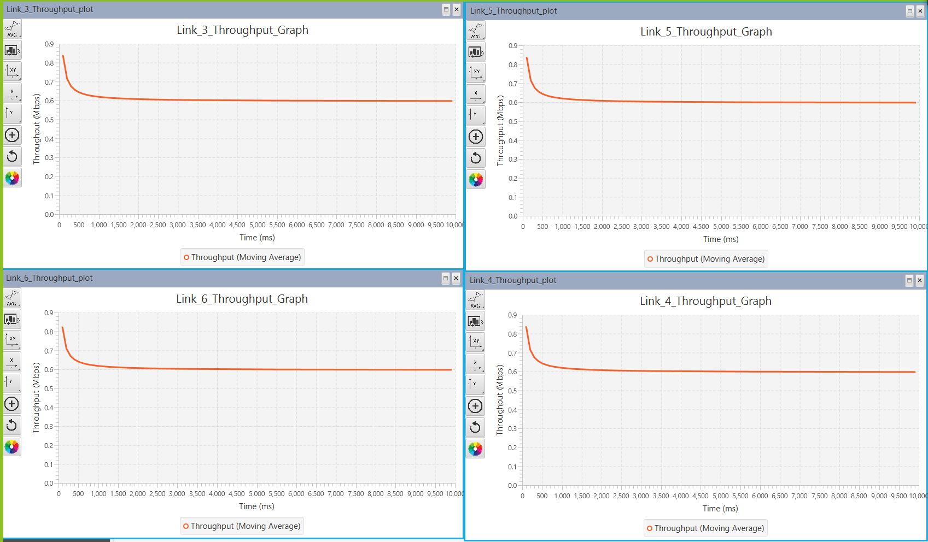

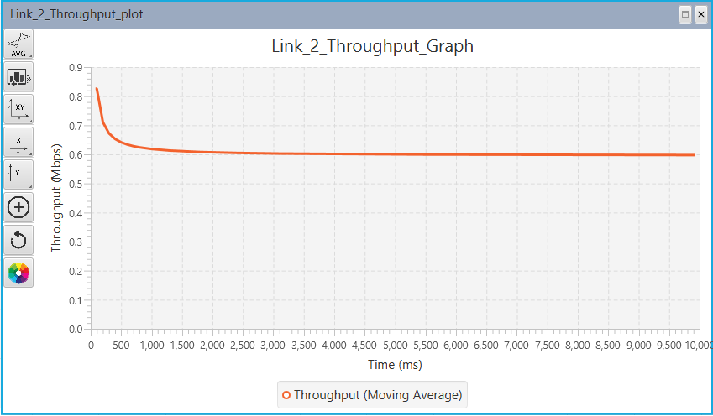

Ans 5) We observe that the overall path depends upon the net cost incurred. In case 1 , the net cost of L8-L9 was 2 (least cost), hence it was the preferred path , but in case 2 the other path was considered , because the path of L8-L9 increased significantly. Hence the least cost path is considered.

3.3.1) Total link costs are: Top link=70

Middle link=40

Bottom link=40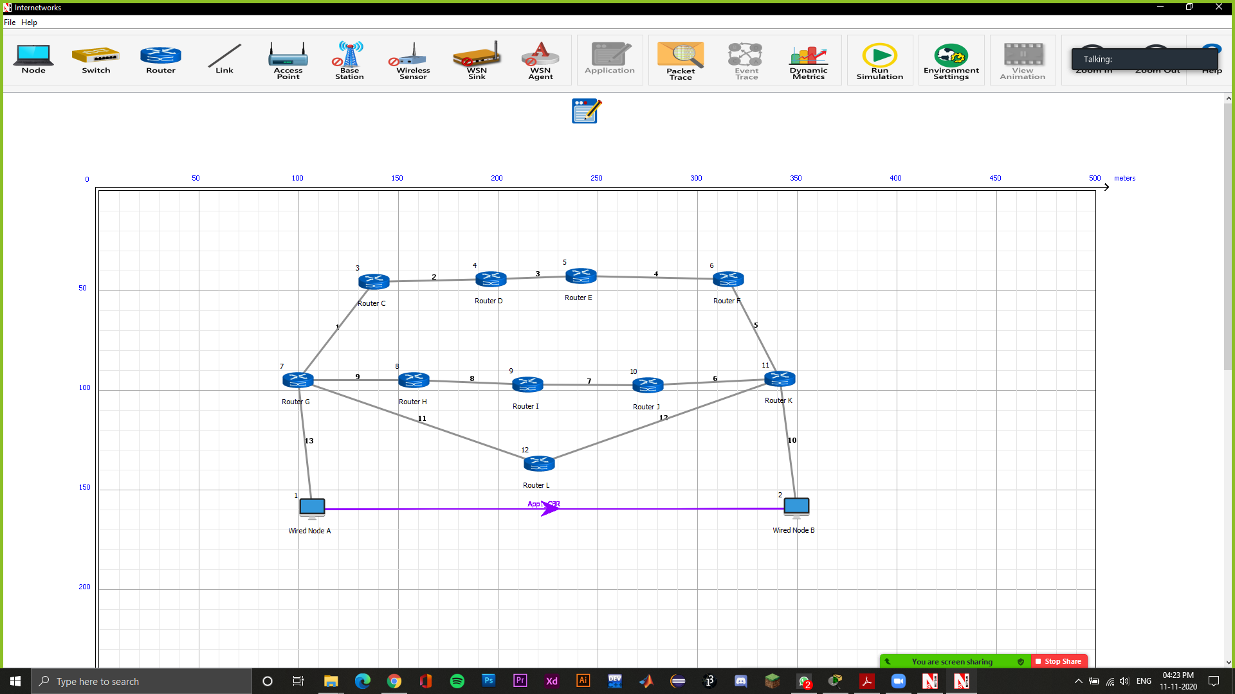

3.3.2) Even though the cost for the middle and the bottom links are the same but the packet chooses the bottom link because it involves the least number of hops. The table below verifies which links were used.

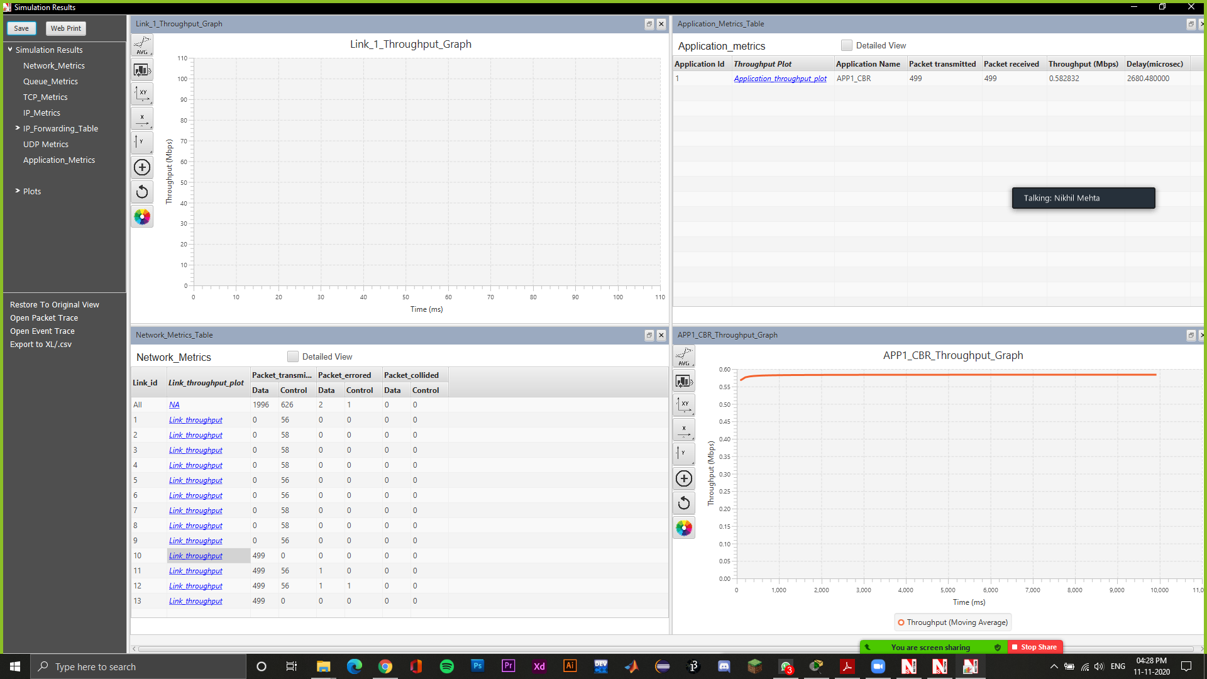

4.1.1) Since the links coming out of a router are of different networks, it means that router A is connected to 4 different networks and router C is connected to 2 different networks.

4.1.2) Wired link shared between two routers are in the same network.

For router C, we have

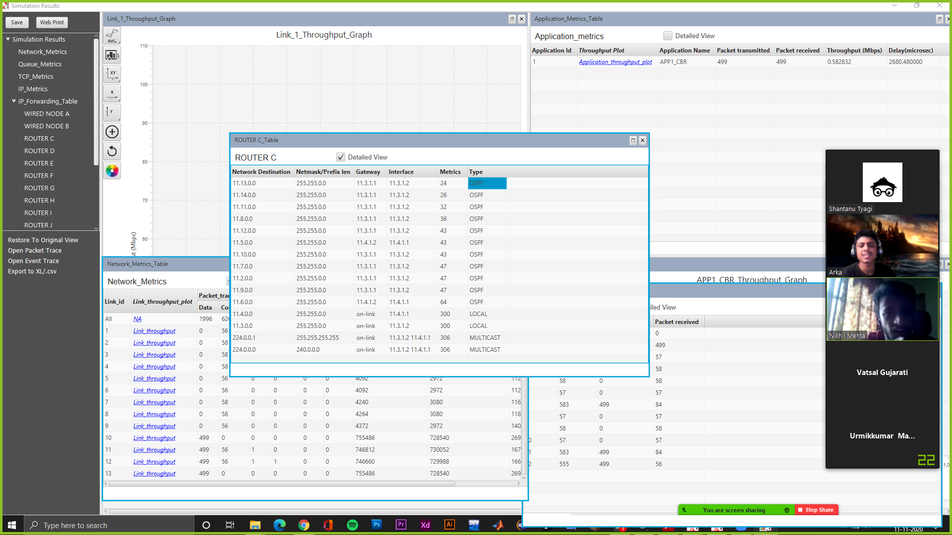

4.2)

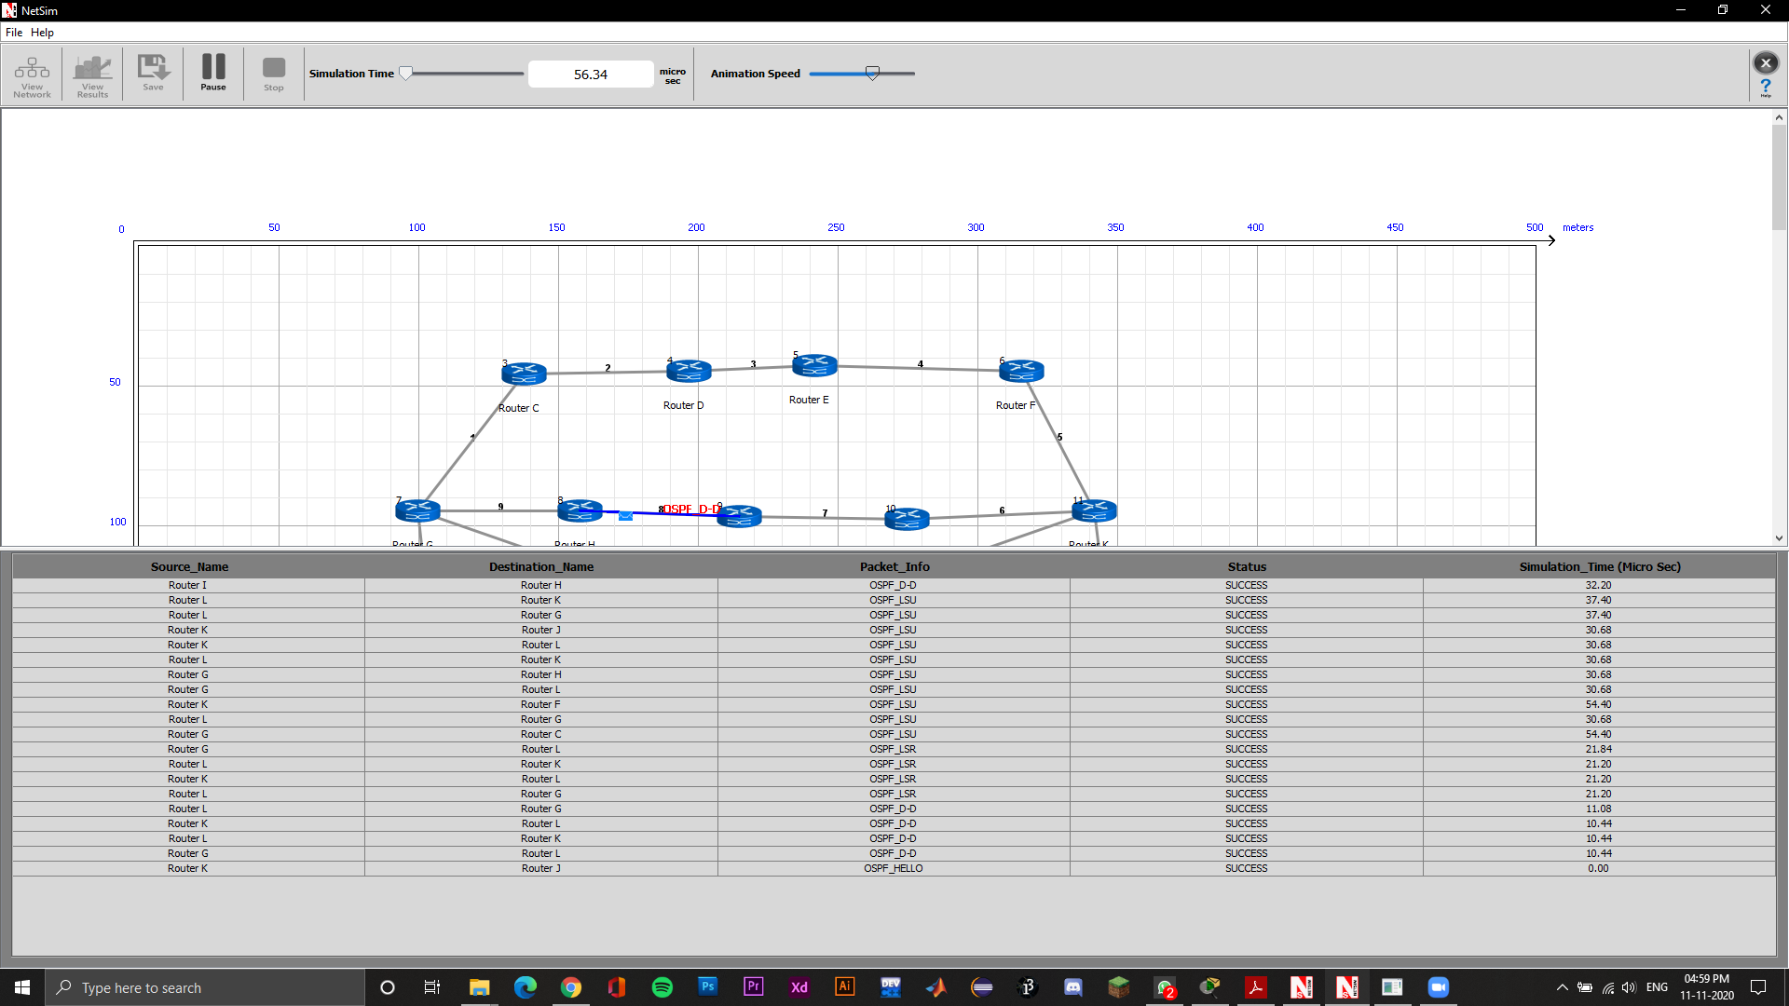

The above is a minimal description of a basic routing table :

In general a basic routing table includes the following information:

* **Destination:** The IP address of the packet's final destination
* **Next hop:** The IP address to which the packet is forwarded
* **Interface:** The outgoing network interface the device should use when forwarding the packet to the next hop or final destination.
* **Metric:**Assigns a cost to each available route so that the most cost-effective path can be chosen.
* **Routes:**Includes directly-attached subnets, indirect subnets that are not attached to the device but can be accessed through one or more hops, and default routes to use for certain types of traffic or when information is lacking.