Q-3

When the client connects with the server, the server pings the client with the message “Hello” and then the client also responds to the server with the same message, i.e. “Hello”. We now record the RTT value for each client. We calculate 𝚫T which is the max value of all the RTT values for different clients.

Time is being measured in microseconds.

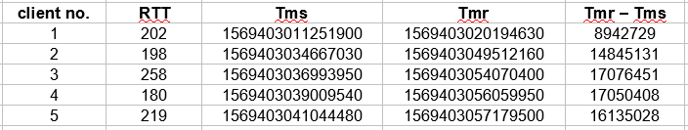

From above table, we get Maximum RTT as 258 microseconds.

We have (Tmr – Tms) as the time it takes to completely transfer a file from the server to the client. Since it includes the time taken for 1 packet to arrive at client and also the time taken to transmit file, thus it will always be much greater than RTT value. So we ignore it and display file as soon as it arrives.