LAB 4

**Question 1.2**

1) Browser - HTTP Version 1.1

Server - HTTP Version 1.1

2) Language Supported - English (US)

3) Computer IP Address - 192.168.43.119 (IPv4)

Server IP Address - 128.119.245.12 (IPv4)

4) Status Code returned - 200

5) Last Modified - Sat, 26 Sep 2020 05:59:01 GMT

6) Content Length - 128 Bytes

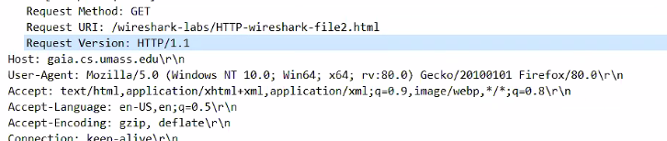

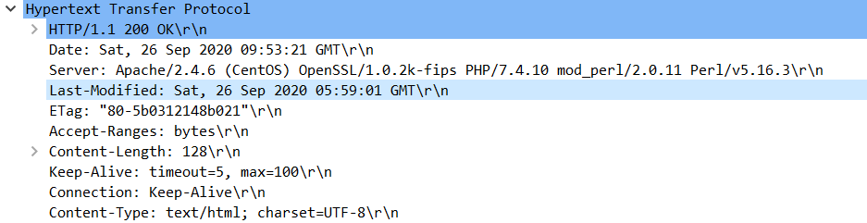

**Question 2.2**

1) No such line present.

2) Yes.Status Code is 200 hence it is explicitly sent from the server.

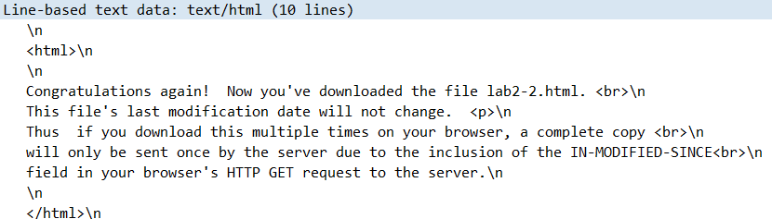

3) No IF-MODIFIED in 1st GET.

Second GET Request has an IF-MODIFIED followed by Last Modified - Sat, 26 Sep

2020 05:59:01 GMT.

4) Status Code is 304 (Description - Not Modified). The server explicitly didn’t explicitly

return the file as it was already present in the cache.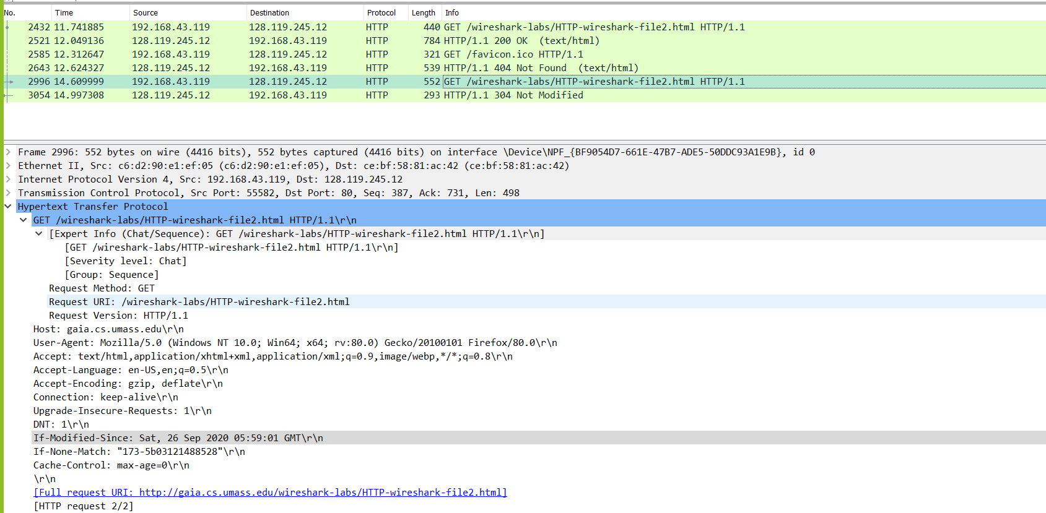

**Question 3.2**

1. Just one HTTP sent request message was sent by the browser. 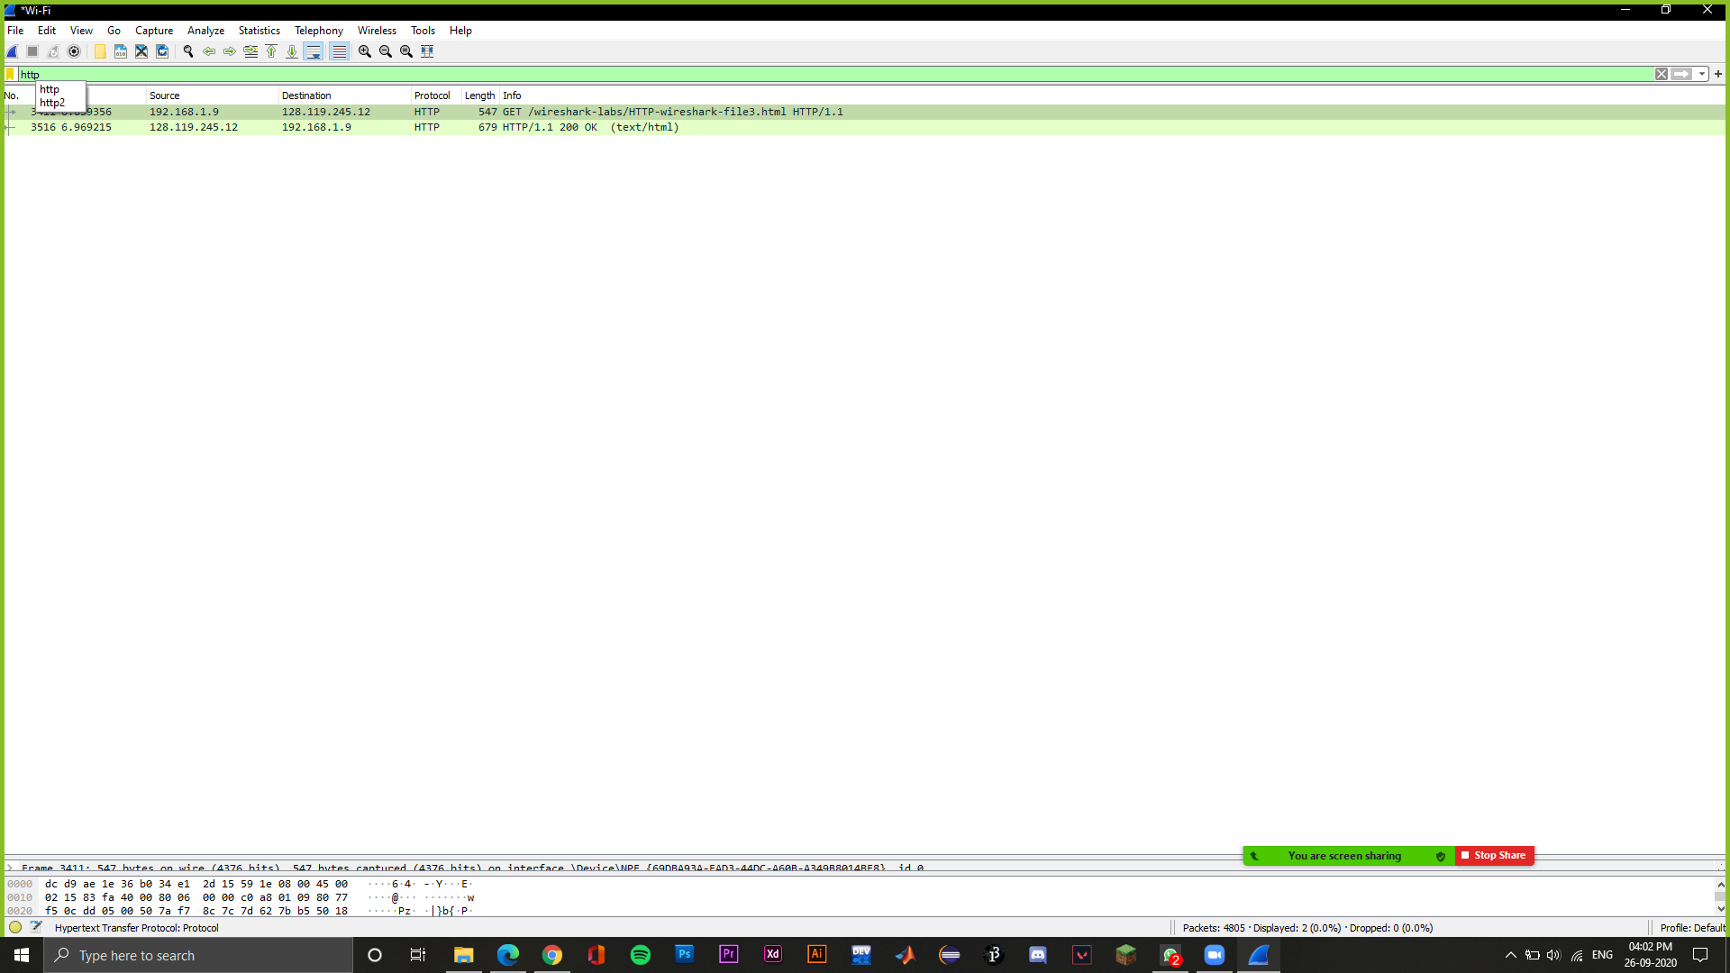
2. There are 4 TCP segments.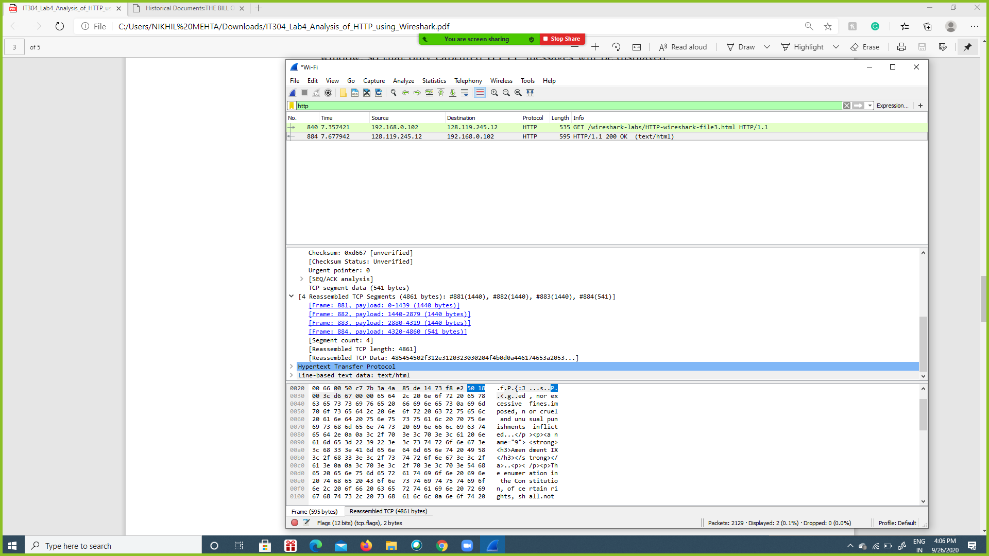
3. HTTP/1.1 200 OK (Above screenshot).

**Question 4.2**

1. 3 GET requests were sent:

GET /wireshark-labs/HTTP-wireshark-file4.html HTTP/1.1\r\n

GET /pearson.png HTTP/1.1\r\n

GET /~kurose/cover_5th_ed.jpg HTTP/1.1\r\n

They were sent to the destination: 128.119.245.12

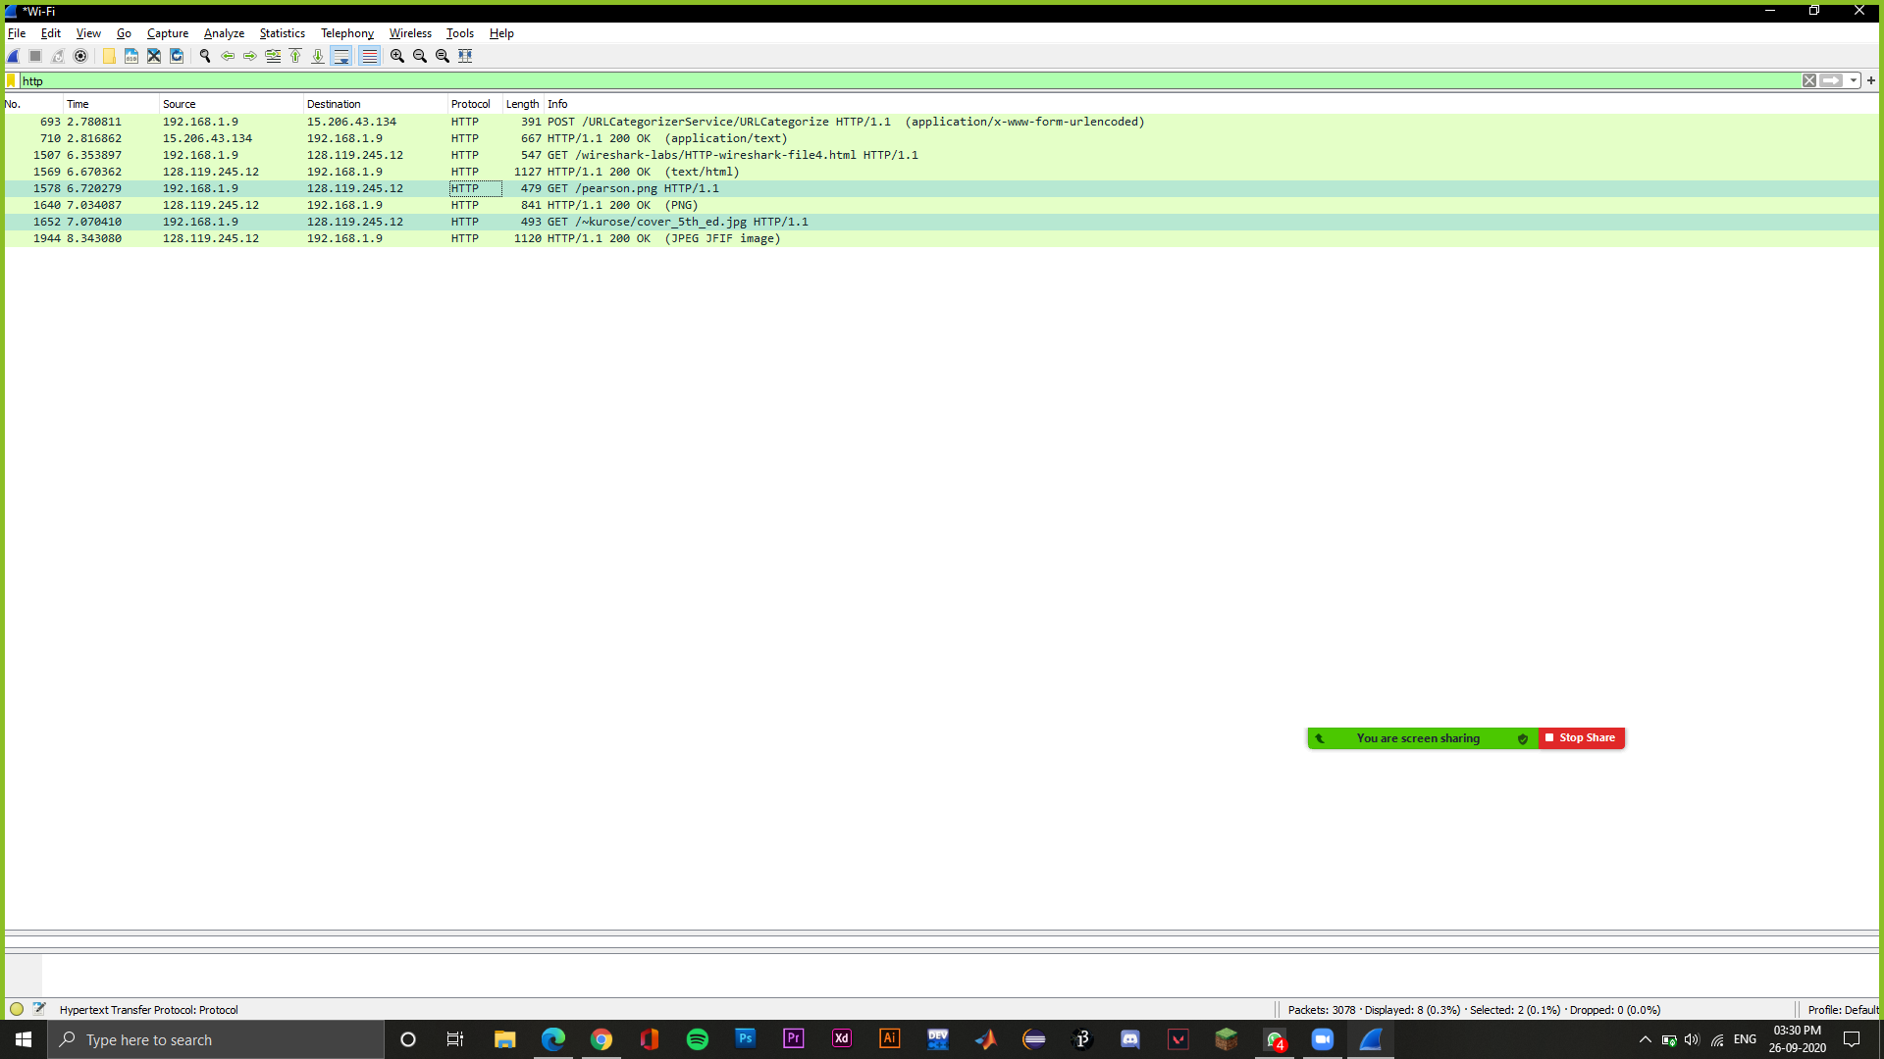

1. The two images were downloaded serially because the timestamps were different and also, the source port is incrementing each time which means that the images were received serially over separate TCP connections.

**Question 5.2**

1. The server’s response to initial GET request was:

HTTP/1.1 401 Unauthorized

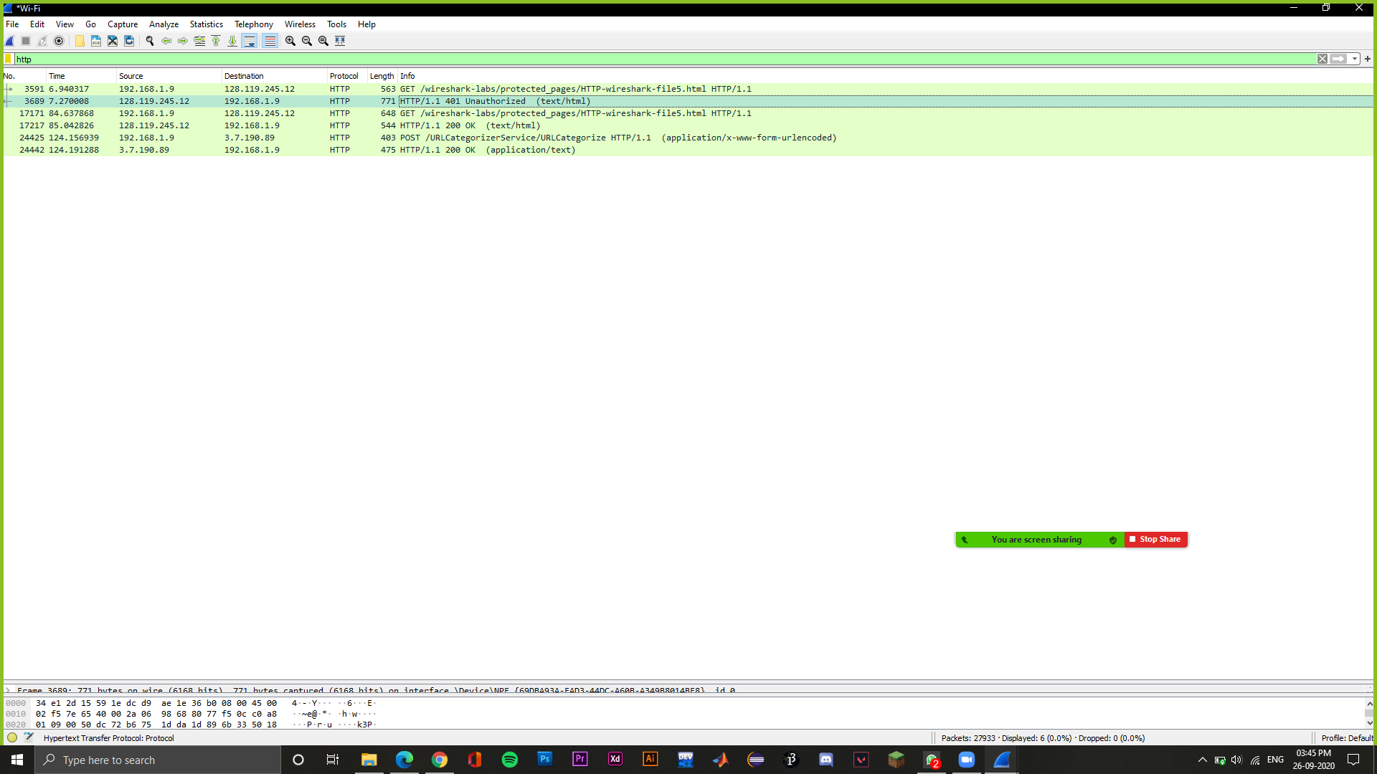

1. The second GET message contains an authorization field which is not present in the first GET message.

Screenshot of first GET request

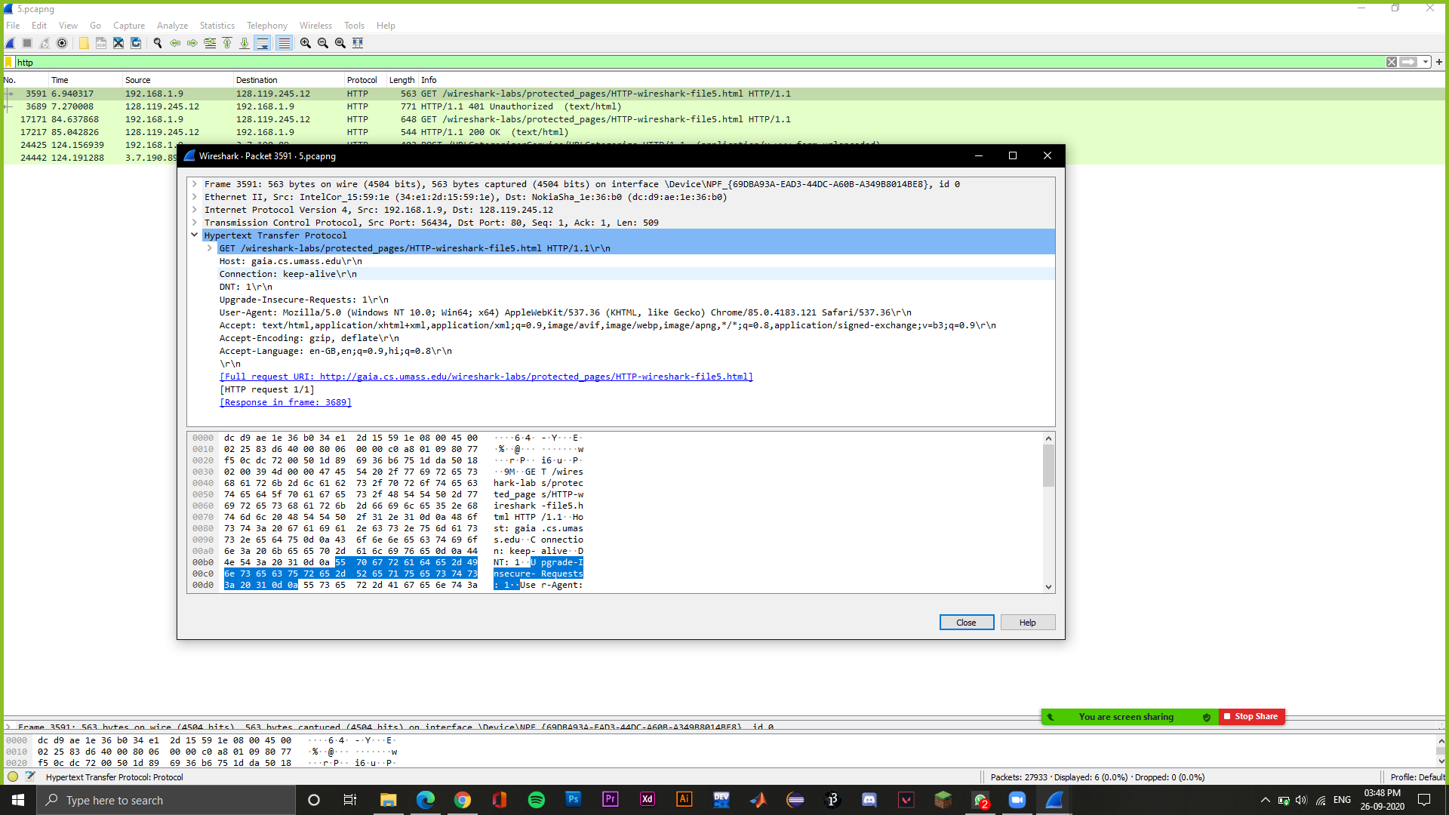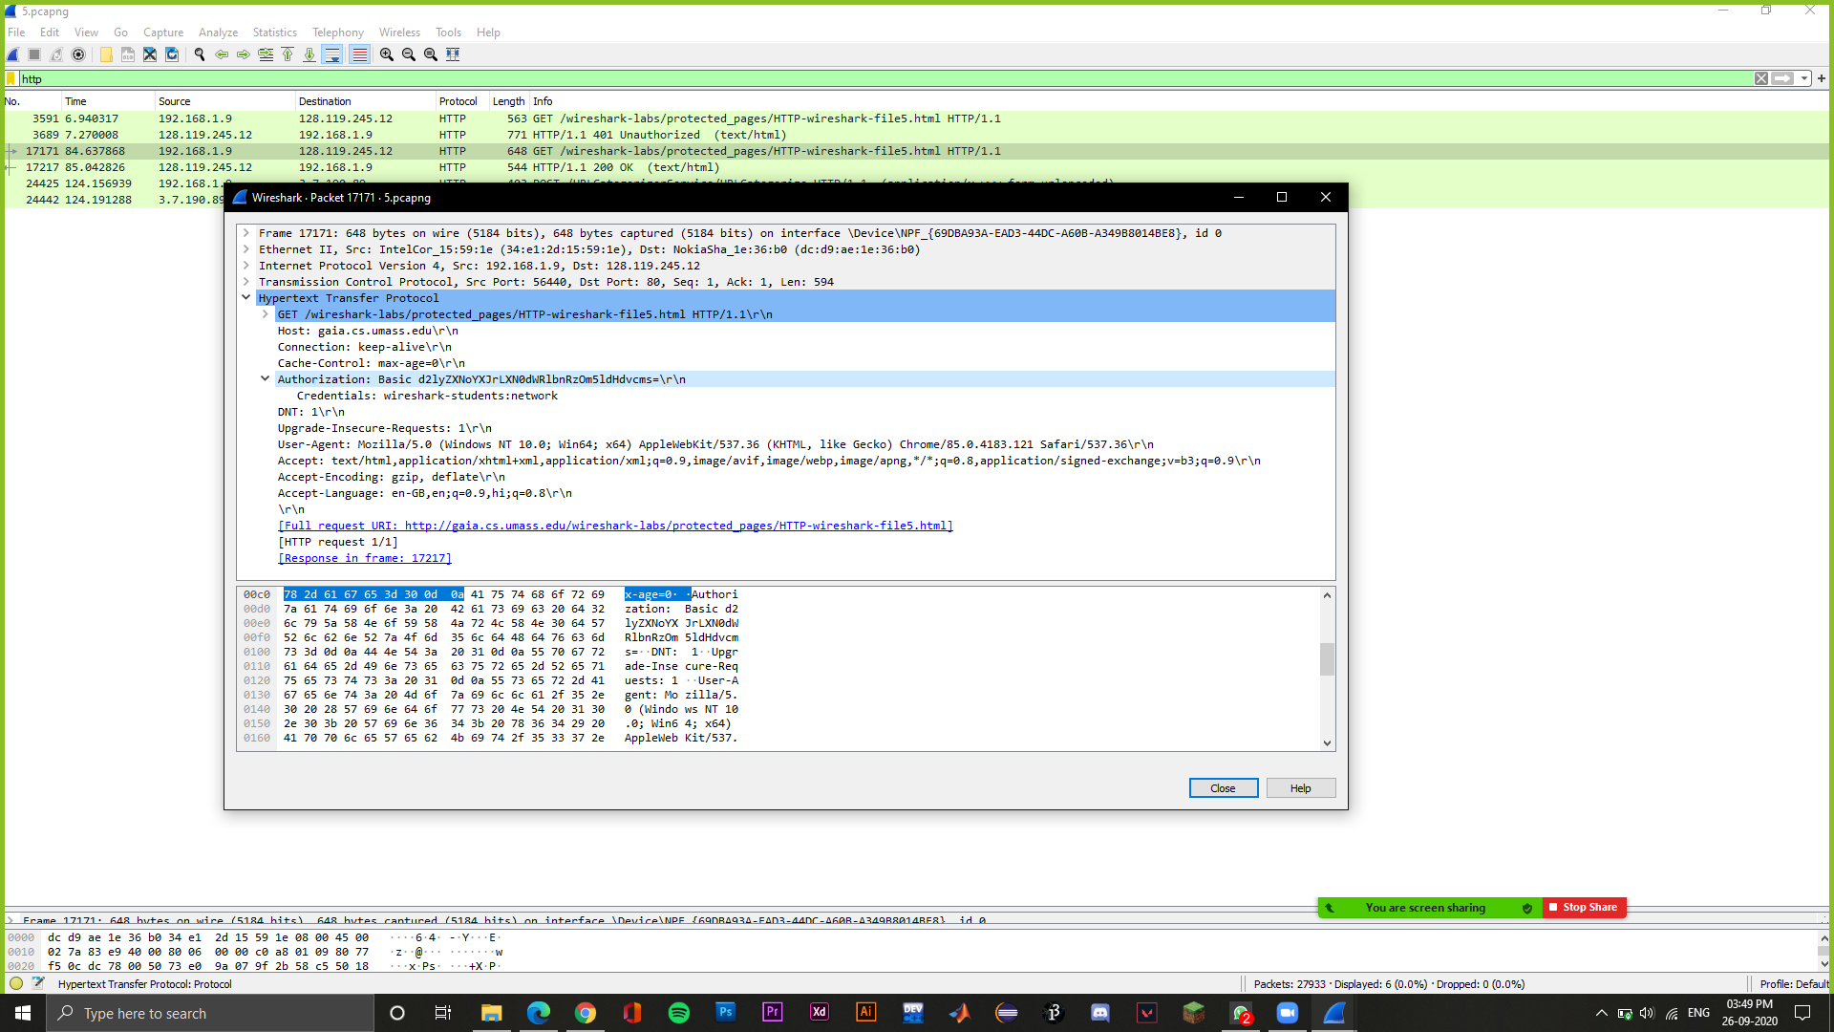

Screenshot of the second GET request 