**2.1.1**

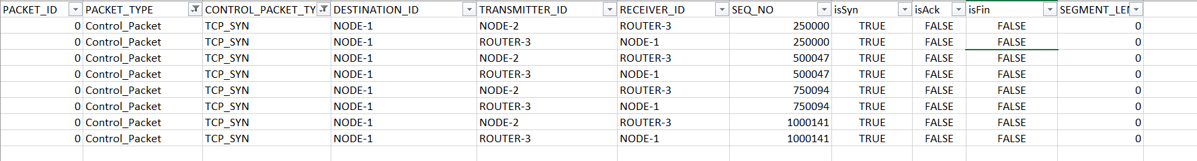

By analysing the syn flag signals we can see that the value of isSyn which is always true because it basically contains only syn messages and the value of isAck is always false because the syn signal contains only the syn message not the Ack message. In the SynAck signal we can see that the value of Syn and Ack both will be true.

**2.2.1**

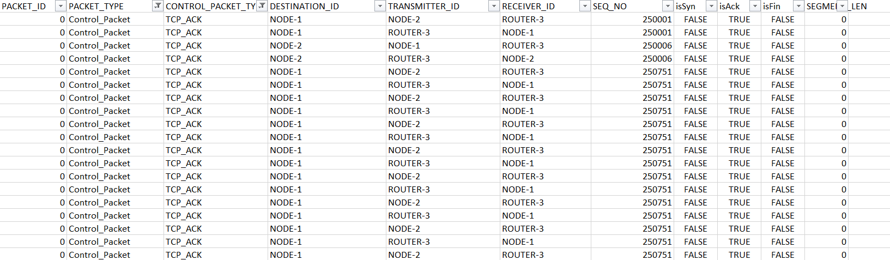

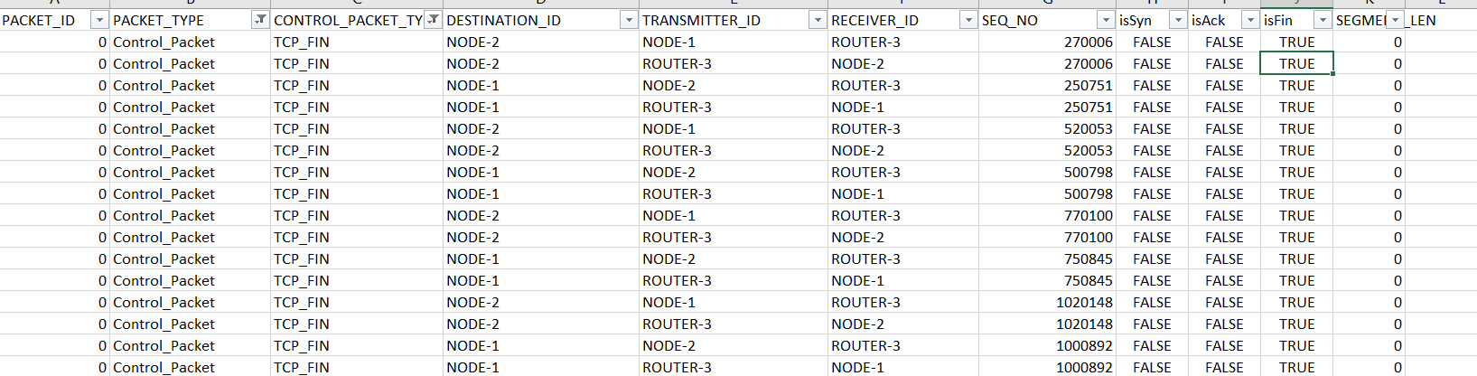

For the signal TCP_Ack the value of isSyn is false, value of isAck is true and the value of isFin is False as the TCP_Ack only contains the acknowledgement message.

While in the TCP_Fin, the value of isFin is true, Value of isAck is false and the value of isSyn is also false as the TCP_Fin signal contains only the fin message.

**2.3**

1- The sequence number for the first SYN packet is 250000. It is the seq number of node 2. The sequence number of the acknowledgement is 250005 and it is the sequence number of node 1. Both node 1 and node 2 will have different sequence numbers as in TCP the transmission occurs on either way.

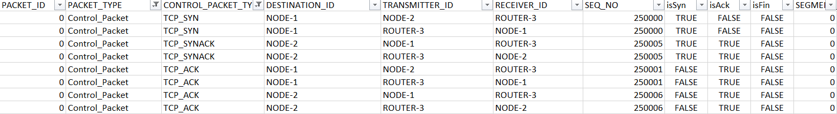

2- The sequence number of the first Fin is 270006 and it is the sequence number of node 1 and the sequence number of the acknowledgment is 250751 and it is the sequence number of node 3. Both node 1 and node 2 will have different sequence numbers as in TCP the transmission occurs on either way.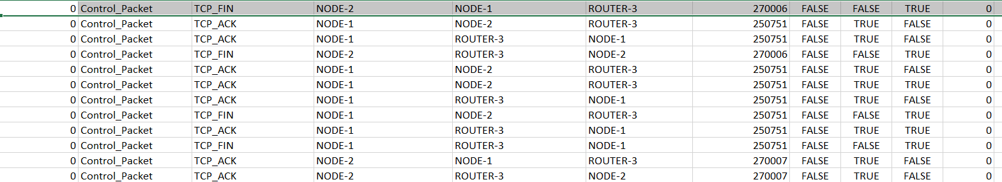

3-Connection Diagram:-

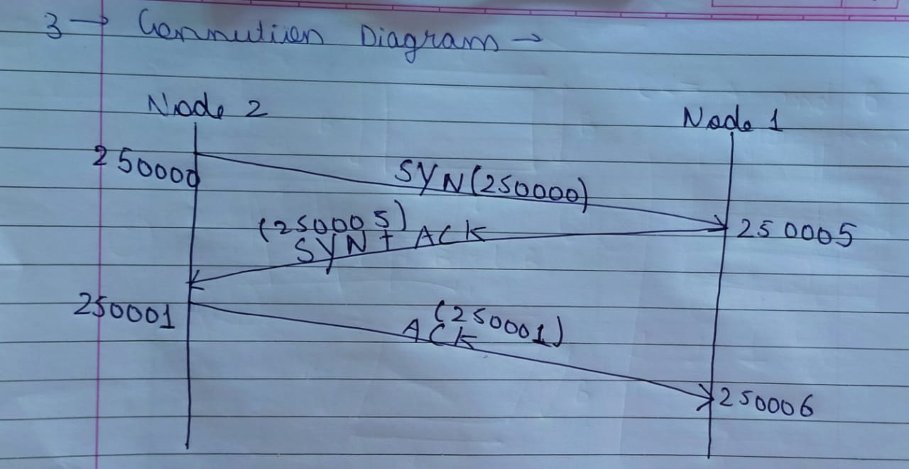

Termination Diagram:-

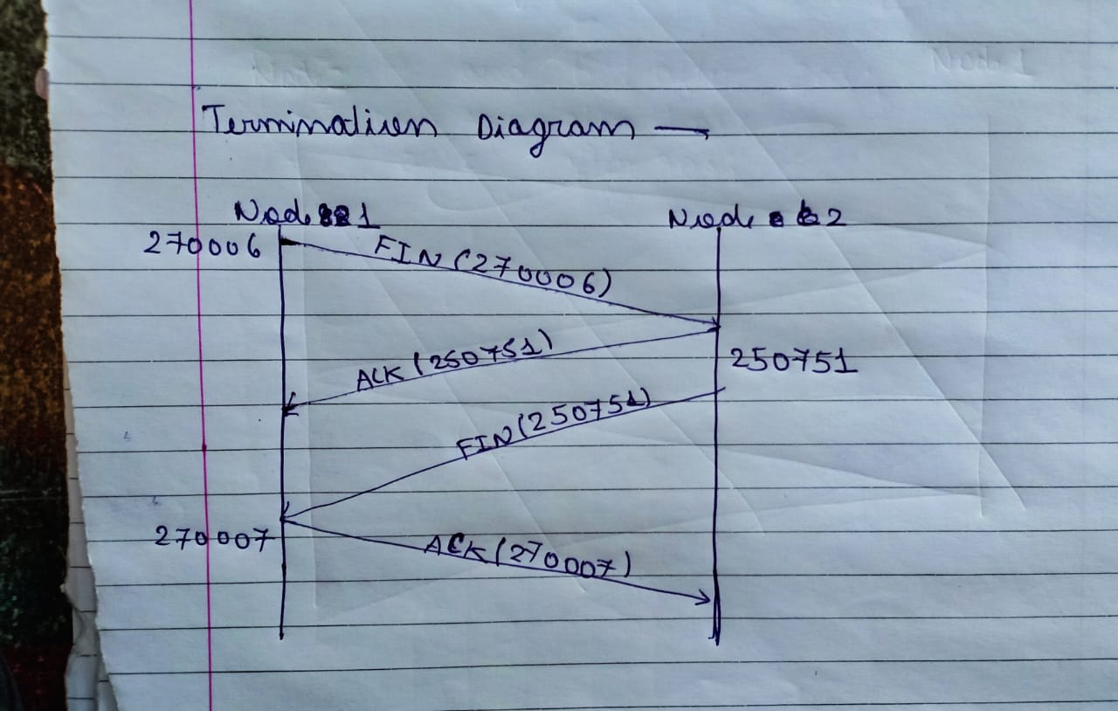

4- TCP uses 4 way finishing as when one node sends the TCP_Fin then there might be some data which is left for transmission and there might be some file which the other node may want to send to this node. So, finishing takes 1 more step than syn.

5-It takes 4 sessions to transfer the file from node 2 to node1 which can be seen below where we had set the filter of the signal to TCP_Syn and TCP_Fin and the Destination node to 1 and transmitter to node 2. By this we can see that there are 4 syn and 4 Fin signals and each pair of syn and fin is a session which has been initiated and terminated. 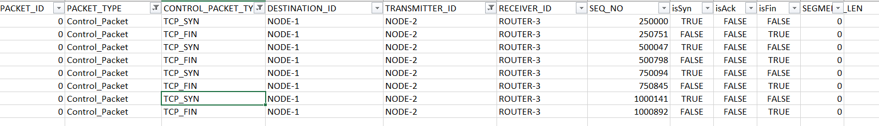

7-

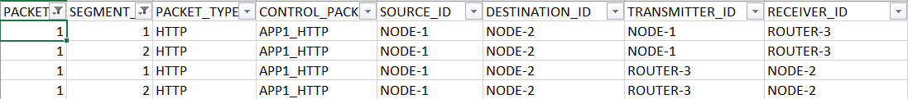

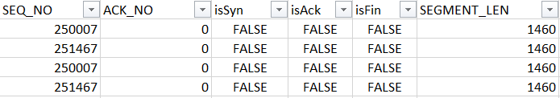

Analytical Diagram :

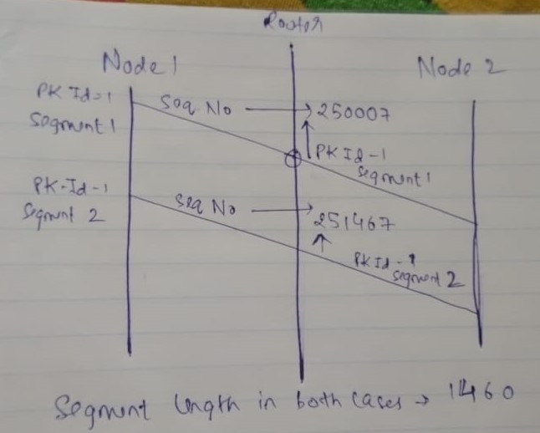

**8)**

* For the last segment - Sequence Number : 5460 + 4500 = 9960

* For the FIN Packet - Sequence Number : Sequence Number of Last Segment/packet + size of last segment = 9960+500 = 10460

**3.1**

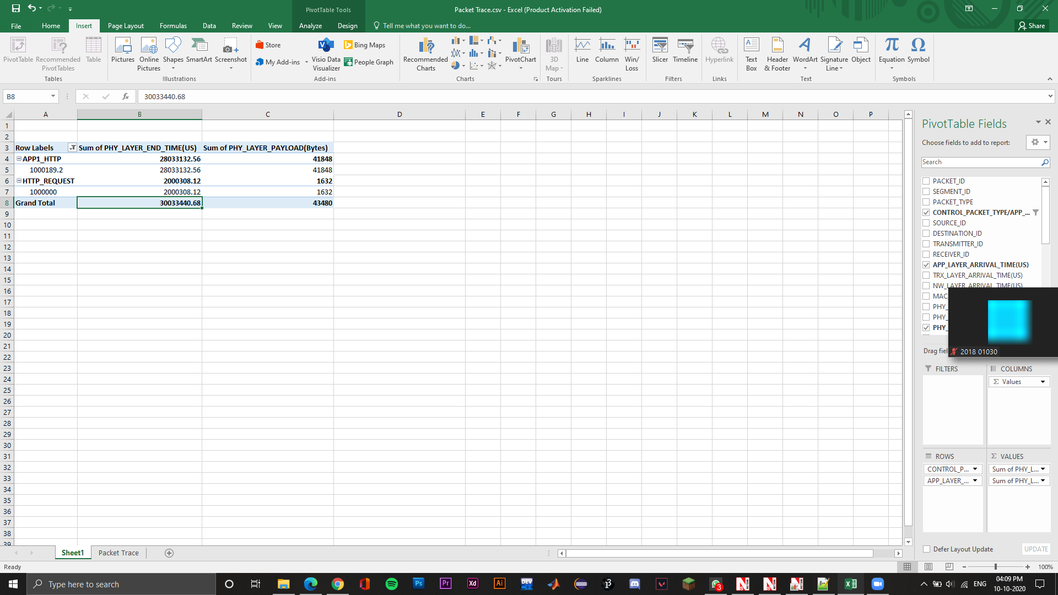

* Payload = 43,480

Time difference = 30033440.68 - 2000189.2 = 28033251.48

Fixed Throughput = 0.001551

* This screenshot shows us the moving average through:

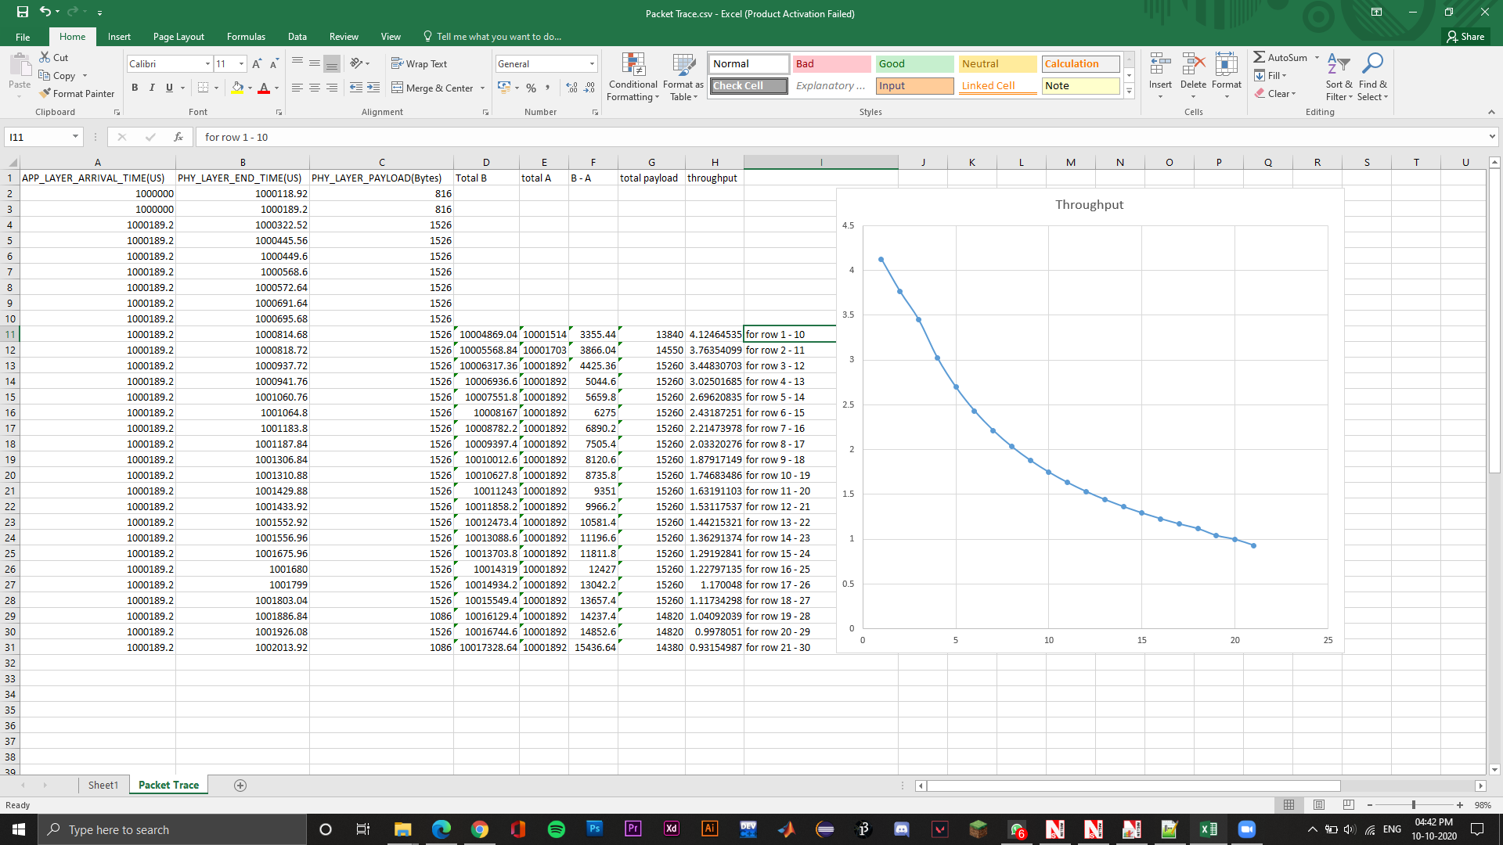

**3.2**

1. 4.1246 is the maximum throughput.
2. The screenshot shows the throughput

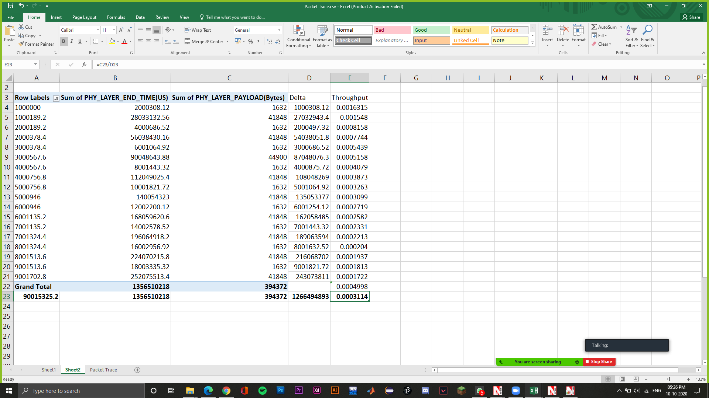

The value obtained is approximately twice the throughput obtained in the first part.

1. Max segment size = 150 bytes

Total data to be sent = 1000 bytes

Minimum packets to be sent = 1000/150

7 packets Out of these 7 packets, packet #1, 4 and 5 are lost. Hence these 3 packets of 150 bytes will be transmitted again.

Total bytes sent = 1000 + 3 150 = 1450 bytes

Packet send rate 10 bytes/second

Hence, time to send 1450 bytes = 1450/10 = 145 seconds

Throughput = Original bytes to be sent/Time required

= 1000/145 = 6.89 bytes 55 bits/sec