1.2.1)

IP Address of my computer (source computer in the packet) is 192.168.1.102

1.2.2) Value in the upper layer protocol field is ICMP (1)

1.2.3) There are 20 bytes in the IP header, and 84 bytes total length, this gives us 64 bytes in the payload of the IP datagram.

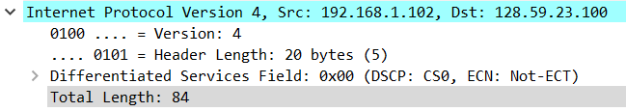

1.2.4) More fragment bit is 0, hence there is no fragmentation in the IP Datagram.

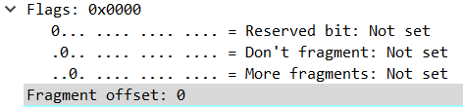

1.4.1) Identification, Time to live and Header checksum always change in the packets that were observed, as evident from the below mentioned screenshots.

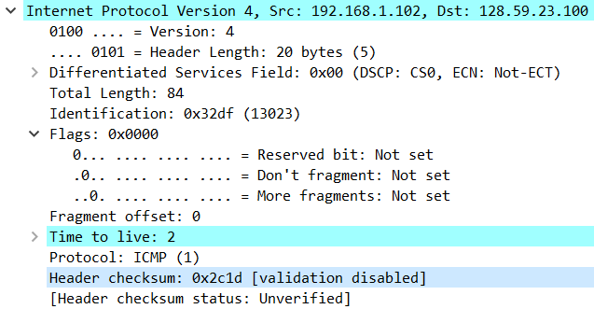

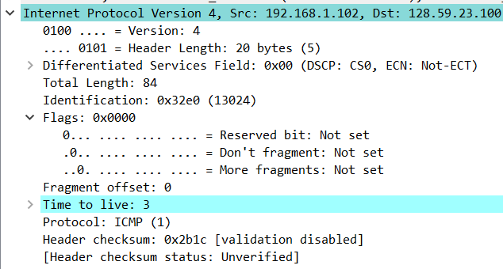

1.4.2)The fields that stay constant across the IP datagrams are:

* Version (This is because we are using IPv4 for all packets)
* Header length (This is because all of these are ICMP packets)
* Source IP (This is because we are sending the packets from the same source)
* Destination IP (This is because we are sending all the packets to the same destination)
* Differentiated Services (As we can see that all the packets are ICMP hence they use the same type of Service class)
* Upper Layer Protocol (This is because all of these are ICMP packets)

The fields that must stay constant are:

* Version (This is because we are using IPv4 for all packets)
* Header length (This is because all of these are ICMP packets)
* Source IP (This is because we are sending the packets from the same source)
* Destination IP (This is because we are sending all the packets to the same destination)
* Differentiated Services (As we can see that all the packets are ICMP hence they use the same type of Service class)
* Upper Layer Protocol (This is because all of these are ICMP packets)

The fields that must change are:

* Identification(This is because every IP packet must have a different id)
* Time to live (traceroute increments each subsequent packet)
* Header checksum (since header changes, hence checksum also must change)

1.4.3)- The value of the identification field increases by 1 when we move from one packet to another packet. We can see it in the above figures.

1.4.4)-

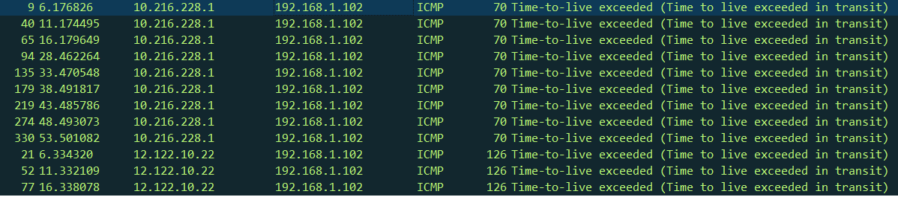

1.4.5)- Value of identification field is 40316

And value of TTL is 255

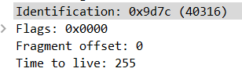

1.4.6) The identification field changes for all the ICMP TTL-exceeded replies because the identification field is a unique value for all the IP packets. When two or more IP datagrams have the same identification value, then it means that these IP datagrams are fragments of a single large IP datagram and it can be easily checked from the flags section where we can see fragment bits.

The TTL field always remains unchanged because the TTL for the first hop router is always the same.

1.5.1) IP Address of my computer (source computer in the packet) is 192.168.1.101

IP Address of destination is 143.89.14.34



1.5.2)The ICMP packet does not have a source and destination port numbers because it was designed to communicate network-layer information between hosts and routers, and not between application layer processes.

1.5.3)Each ICMP packet has a "Type" and a "Code" section. The Type/Code combination identifies the specific message being received. Since the network software itself interprets all ICMP messages, no port numbers are needed to direct the ICMP message to an application layer process.

The ICMP packet also has checksum, identifier, sequence number, and data fields.The data field contains the IP header and first 8 bytes of original datagram's data.

Type= 8

Code= 0

Checksum - 2 bytes

Identifier - 2 bytes

Sequence Number - 2 bytes

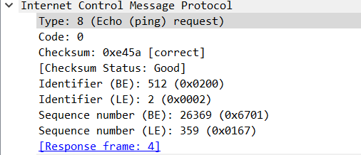

1.5.4)-

Type= 0

Code= 0

It has type,code,checksum,identifier, sequence number and data fields in it.

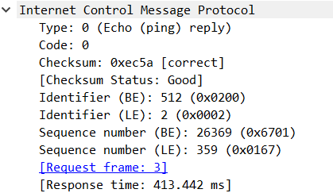

The ICMP packet also has checksum, identifier, sequence number, and data fields.The data field contains the IP header and first 8 bytes of original datagram's data.

Checksum - 2 bytes

Identifier - 2 bytes

Sequence Number - 2 bytes

1.6.1) IP Address of my computer (source computer in the packet) is 192.168.1.101

IP Address of destination is 138.96.146.2



1.6.2)No. If ICMP sent UDP packets the the IP protocol number should be 0x11

1.6.3)The ICMP echo packet has the same fields as the ping query packets, hence they are not different.

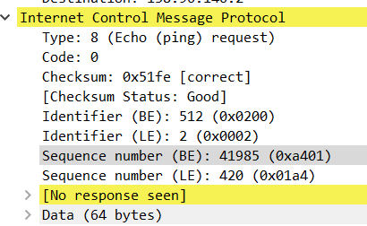

1.6.4)The ICMP error packet has more fields than the ping query packets. It contains both the IP header as well as the first 8 bytes of the original ICMP packet for which the error is considered.

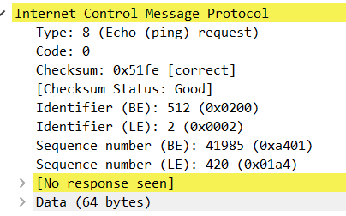

1.6.5)-The last three ICMP packets are of message type 0 (echo reply) rather than 11 (TTL expired). They are different because the datagrams have made it all the way to the destination host before the TTL has actually expired.

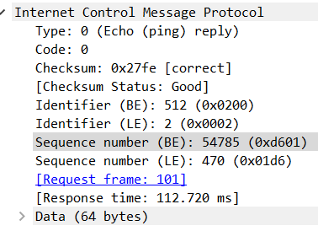

2. We were not able to ping from pc1 to pc2.

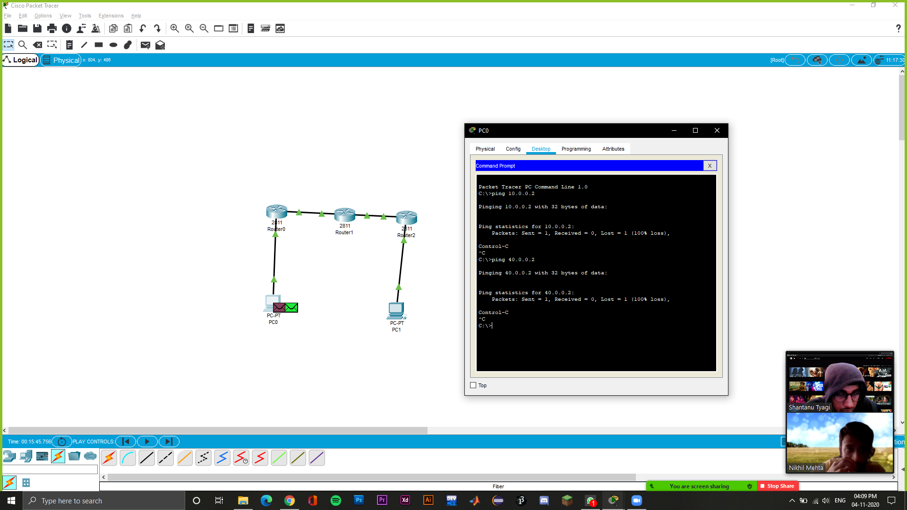

By default when a packet arrives in interface, router checks destination filed in packet and compare it with routing table. If it finds a match for destination network then it will forward that packet from related interface. If it does not find a match in routing table then it will discard that packet. This is the default behavior of router.

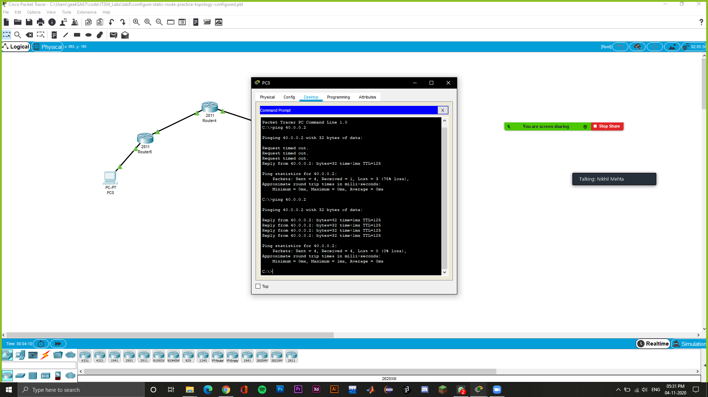

2.1 Exercise

The topology is shown in the screenshot below.

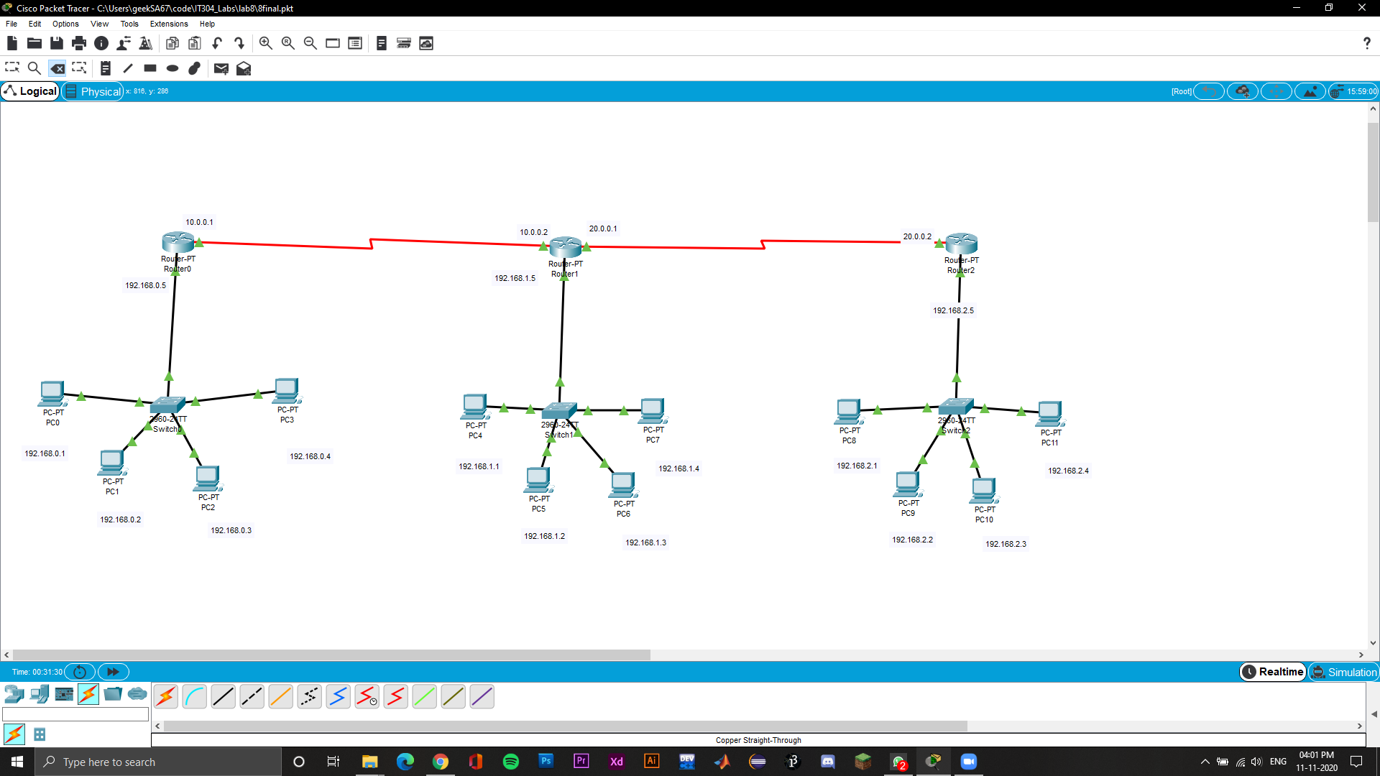

Now we ping different network PCs from the same network PC as seen in the screenshots below:

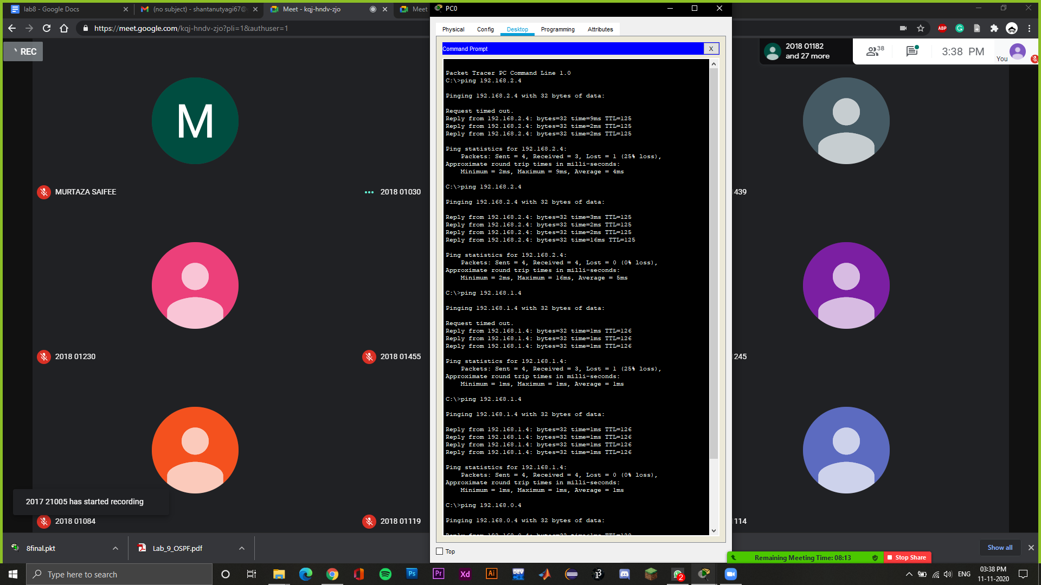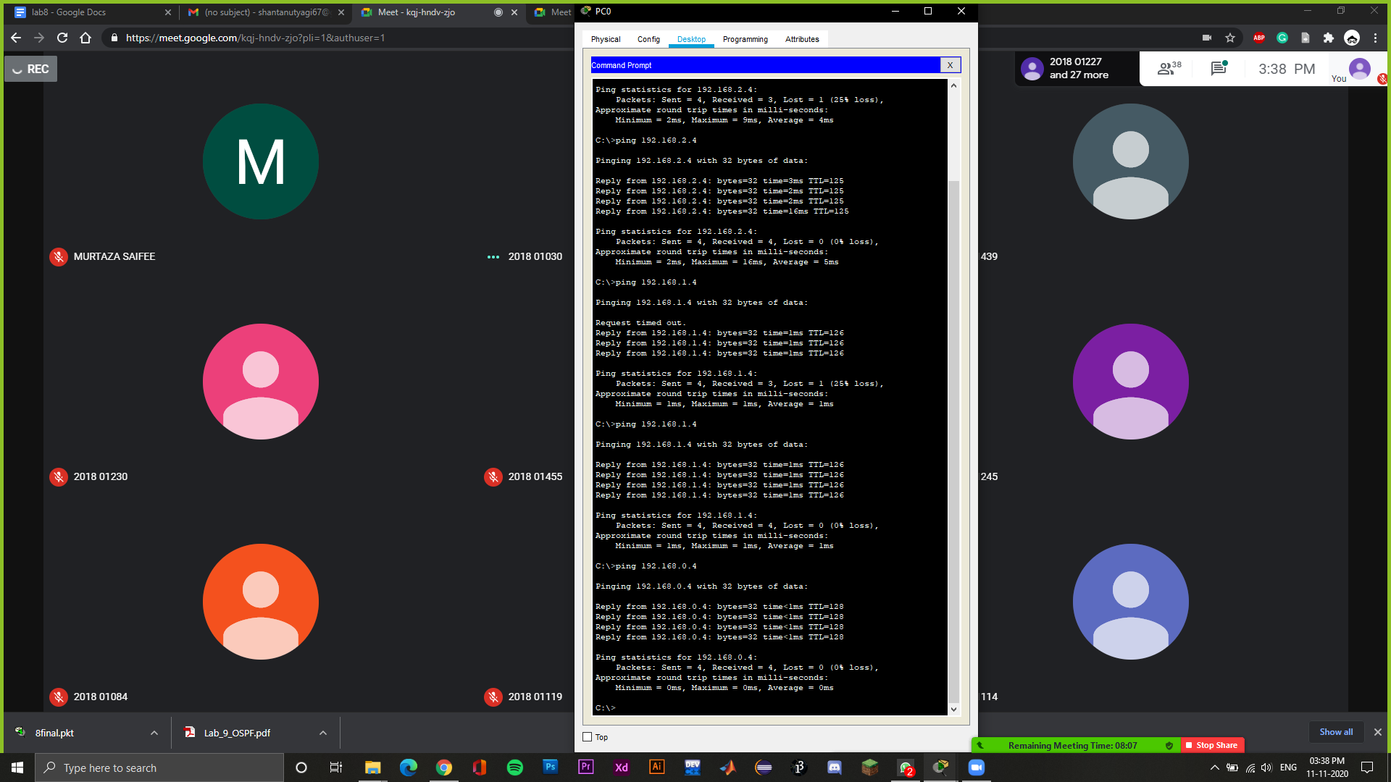

**UPDATED TOPOLOGY**

