Javascript:
How Js Works? Is it synchronous or asynchronous? Is it single threaded or multi threaded?
- Everything in js happens inside the execution context
- Execution context is a big box or container which whole js is executed
- big box and 2 components, memory component contains variables and functions as a key value pairs are stored also known as variable environment and other one is code component where one by one code is executed also known as thread of executed
- js is synchronous single threaded language
- where basically one by one code is executed
- also known as the thread of execution

What happens when we run js code?
- when we run the js program there are lots of things happening behind the scenes inside the Js engine
- there are two phase memory and code phase
- in the memory phase Js will allocate memory to all the variables and functions
- And in variables stored the special value as undefined whereas in function it stores the whole code
- second phase is code execution phase, Js run the whole program run line by line. Now the value of the variables will be placed. Then we see the function here we will invoke the function so here all together a new execution context is created. Again there will be Memory and code component. Again the phases executed and the return value will be returned where the function is invoked
- this is known as the call stack, it is a stack and at the bottom of the stack we have Global Execution context and whenever we have function then EC will be created and once done it will be popped.
- The only work is to handle the execution context
- and once done the GEC will be deleted

Hoisting:
- we can access the variable and functions even before we have initialise it
- So even before the code start executing the memory is allocated to all variables and functions
- If we console variables at the top and later on it has been initialise then in that case we will get the undefined as an output but if it is not initialised and we are still giving the console we will get an error as variable is not defined
- And in the case of function if we call the function at the top and at the bottom it has been defined then the function will be executed and we will get the output.
- whereas in case of arrow function or function expression and if we invoke at the top so in that case it will behave as a variable and as we have invoked we will get function is not defined whereas if we console just the function name then it will show undefined
- So only in normal function we will get the entire code of the function and if it is invoked then the function will execute and we will get output whereas if we console the function name then the entire code of function will be obtained as output.

- we have local memory and global memory space
- whenever the function is invoked the function variables will be added in the local memory space

Undefined and not defined in Js
- if the memory is not allocated then we will get a not defined error
- when the variable is initialised then in that special placeholder which is undefined will be allocated to that variable even before the code is executed so that's why we get the undefined as an output
- Js is loosely typed or weekly typed language if initially we have assigned variable as int then we can change to string and many more
- Not to do? a = undefined

Sope chain
- scope in js is directly related to the lexical environment
- we have a function and have consoled the variable a and the variable is not assigned in that function, it is initialised outside of the function
- so first we will check what the scope of the variable means where I can access the variable, second is the variable inside the scope
- whenever the global ec is created the lexical environment is also created
- The lexical environment is local memory along with the lexical environment of its parent
- lexical as a term means in hierarchy
- inner function is lexically inside the outer function it means inner function is physically inside outer function
- so along memory space along with variables and functions we also get the reference to the lexical environment of its parent
- outer environment (Gec) - function parent - function child
- here it will first check if the variable is available in the child and if it doesn't get checked for the parent which is the lexical environment of its child's parent and even if it doesn't find it then it will be checked in the global execution context which is basically the lexical environment of the parent outer function
- this is how we will get the output
- the mechanism of finding the variable is known as scope chain
- lexical environment - local memory + reference to the lexical environment of its parent
- The whole chain of the lexical environment is known as scope chain

Let and const declarations are hoisted?
- they are hoisted but they are in a temporal dead zone.
- temporal dead zone is a time since when the let variable is hoisted and the variable is been assigned, so the time between them is known as temporal dead zone
- so when we access the variable in the temporal dead zone then we get a reference error as cannot access the variable before initialization
- var variable store in a global variable space(window object), whereas let and const store in different memory space which is Script
- we can't declare the let variable again if we declare we will get a syntax error. Also in const a, if we don't assign then we will get same error
- const - in this we need to declare and initialise at the same line
- and if we do so we will get type error - Assignment to the constant variable

Block Scope
- what is a block in js?
- block is defined by {}
- block is also known as compound statement.
- block is used to combimed multiple js statment into group
- why we are grouping?
- we need to group these statements together so that we can use multiple statements in a place where js expect just one statement

What is a block Scope?
- What all variables and functions we can access within this block
- how hoisting work inside the block?
- let and const are hoisted in a block Scope. These are hoisted in separate memory space which are reserved for this block
- var is assigned in a global scope
- so let and const we can't access outside of the block Scope whereas var can be accessible outside the scope

Variable shadowing in JavaScript occurs when a variable declared within an inner scope (like a function or a block) shares the exact same name as a variable in an outer scope. When this happens, the inner variable shadows (hides) the outer variable, making it completely inaccessible inside that inner scope.
How Shadowing Works, When you reference a variable name, the JavaScript engine resolves it using lexical scope. It checks the immediate, innermost scope first. If a matching identifier exists there, JavaScript executes using that local value, ignoring the outer scope variable.
Function Scope Shadowing
let username = "Alice"; // Outer variable
function greetUser() {
let username = "Bob"; // Inner variable shadows the outer one
console.log(username); // Output: "Bob"
}
greetUser();
console.log(username); // Output: "Alice" (Outer scope remains untouched)
Block Scope Shadowing (let & const)
Because let and const are block-scoped, they can shadow outer variables within any code block enclosed by curly braces {} (such as if statements or loops).
const speedLimit = 60;
if (true) {
const speedLimit = 80; // Shadows outer const safely
console.log(speedLimit); // Output: 80
}
console.log(speedLimit); // Output: 60

Valid vs. Illegal Shadowing
You can shadow variables across different scopes using certain keyword combinations. However, crossing certain boundaries results in an Illegal Shadowing error.

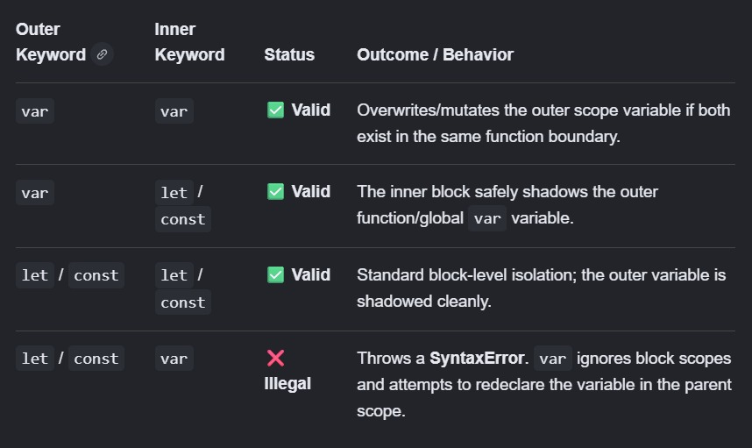

Example of Illegal Shadowing:
let status = "active";
if (true) {
var status = "pending"; // ❌ SyntaxError: Identifier 'status' has already been declared
}
Why this fails: The var keyword is function-scoped (not block-scoped). It tries to inject itself into the exact same scope level where let status is already occupying the identifier namespace

Closures:
- Closure is a function bind together with its lexical environment
- function along with its lexical scope together bundle is known as closure
- a closure is a combination of function bundled together with reference to its surroundings state(lexical environment)
- Closure are used for data privacy and data encapsulation
In other words, a closure gives a function access to its outer scope. In JavaScript, closures are created every time a function is created, at function creation time.

function init() {
var name = "Mozilla"; // name is a local variable created by init
function displayName() {
// displayName() is the inner function, that forms a closure
console.log(name); // use variable declared in the parent function
}
displayName();
}
init();

- Also when we return the function it returns the closure along with the lexical scope
function makeFunc() {
const name = "Mozilla";
function displayName() {
console.log(name);
}
return displayName;
}
const myFunc = makeFunc();
myFunc();

Uses of closure
- module design pattern
- carrying
- functions like once
- memorize
- maintaining the state in the async world
- setTimeout
- Iterators

Anonymous function - function without name is known as anonymous function
- Function statement - normal function
- Function expression - a function which acts as a value is known as function expression
- Difference between function statement and function expression is hoisting
- Function declaration - function statement is same as function declaration
- function without name is known as anonymous function. It is used at a place when the functions are used as value
- Named function expression - function expression with which we give the function with some name
- argument are something which we pass to the function method and the place where we get the value is known as parameter
- we can pass function inside function as a argument. And also we can return the function from that function
- the ability to use function as a value and can be passed as an argument to the function and can return from the function is known as first class functions. Also can be said first class citizens
- Same above function can be done to arrow function
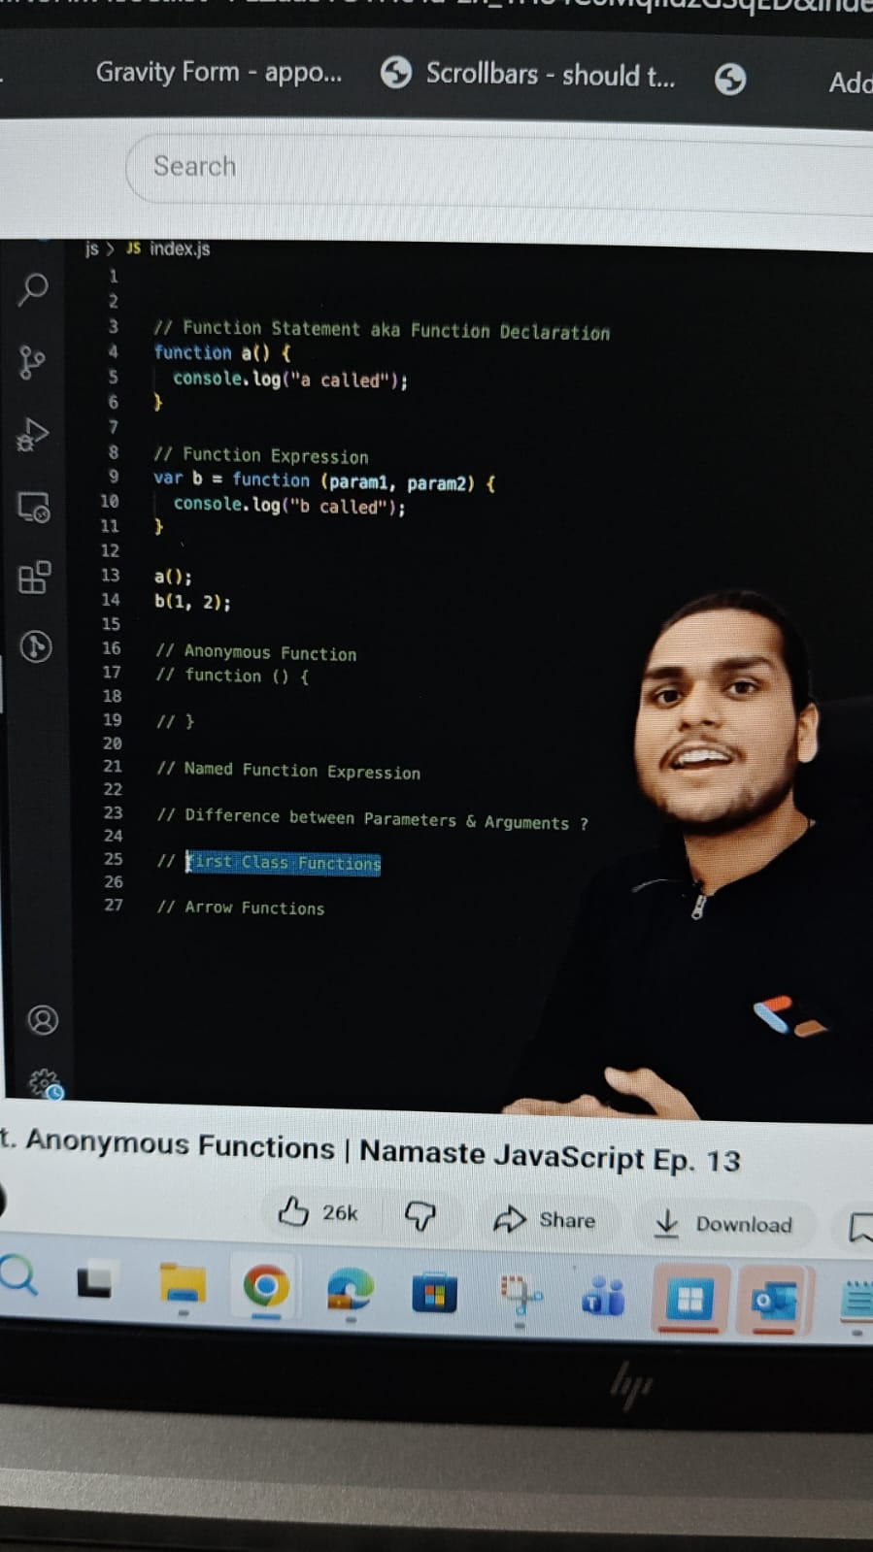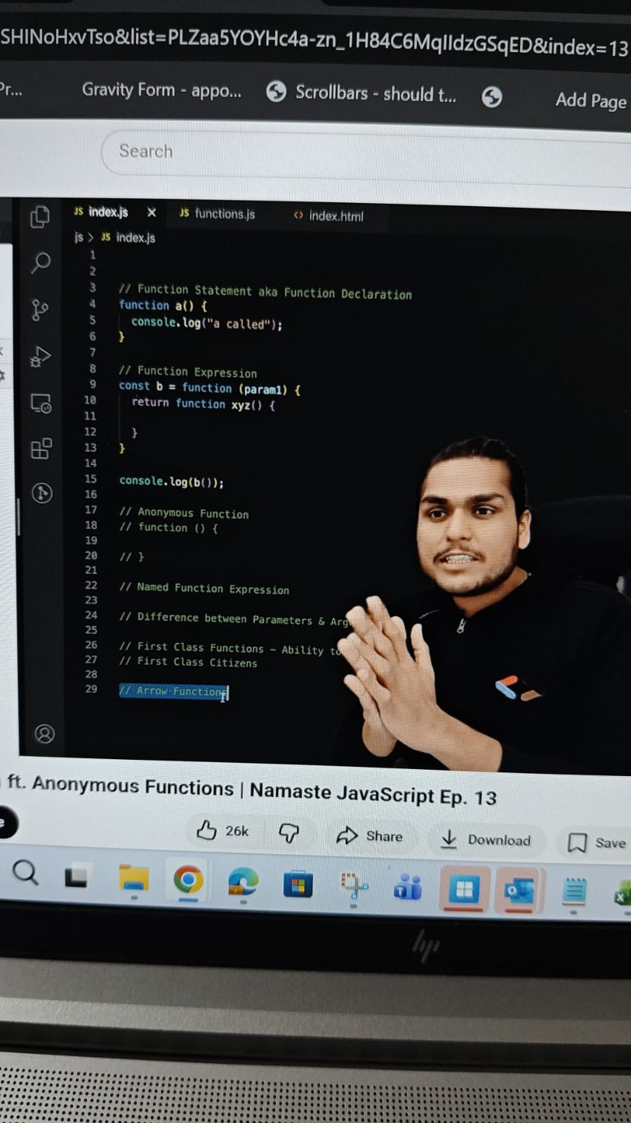

Higher Order function
- A function which takes another function as an argument or return function from it is known as higher order function
Callback
- callback function in js?
- Function are first class citizens in js. We can take a function and pass it to the other function. This function which we pass it to the other function is known as a callback function
- this callback functions are very powerful in js
- this gives access to the whole async world in a synchronous single threaded language
- js is a synchronous single threaded language which will do one thing at a time in a specific order
- but with the help of callback we can do asynchronous things inside js

- callback function in js?
- Function are first class citizens in js. We can take a function and pass it to the other function. This function which we pass it to the other function is known as a callback function
- this callback functions are very powerful in js
- this gives access to the whole async world in a synchronous single threaded language
- js is a synchronous single threaded language which will do one thing at a time in a specific order
- but with the help of callback we can do asynchronous things inside js
- so in the function x argument will be adding the callback function so now it's the x function responsibility when it will be called
- for eg: setTimeout
- Js has just one call stack and we can call it as a main thread so anything which is executing inside the page is executed through callstack only
- So if any operation blocks the callstack that is known as blocking the main thread,
- Suppose our one of the functions is taking so much time to execute the function and as we have only one callstack so everything will be blocked in this case
- we should never block our main thread if something is taking time, we need to use async operation which is setTimeout if it is taking some time.
- So if JS don't have the first class functions and if we don't have the callback function and if we are not able to pass a function from one function to another we won't be able to do asynchronous operation

Ex: Event listener
- garbage collection and remove event listener
- event listener are heavy which means it takes the memory
- whenever we attach an event listener it forms a closure and even when the callstack is empty it still does not free up the memory.
- we use closure for data hiding
Ex: Event listener
- garbage collection and remove event listener
- event listener are heavy which means it takes the memory
- whenever we attach an event listener it forms a closure and even when the callstack is empty it still does not free up the memory.
- we use closure for data hiding

Event loop:
- js is a synchronous single threaded language
- it has only one callstack and it can do only one thing at a time
- this callstack is present inside the Js engine
- and all the code inside the Js occurs inside the GEC
- browser has the js engine inside it and it also has local storage, timer, url(https://), netflix server, display into the UI, blootooth, Geo location
- in a js code which is running inside the callstack, we need to have this access which is provided by Browser so connection is needed
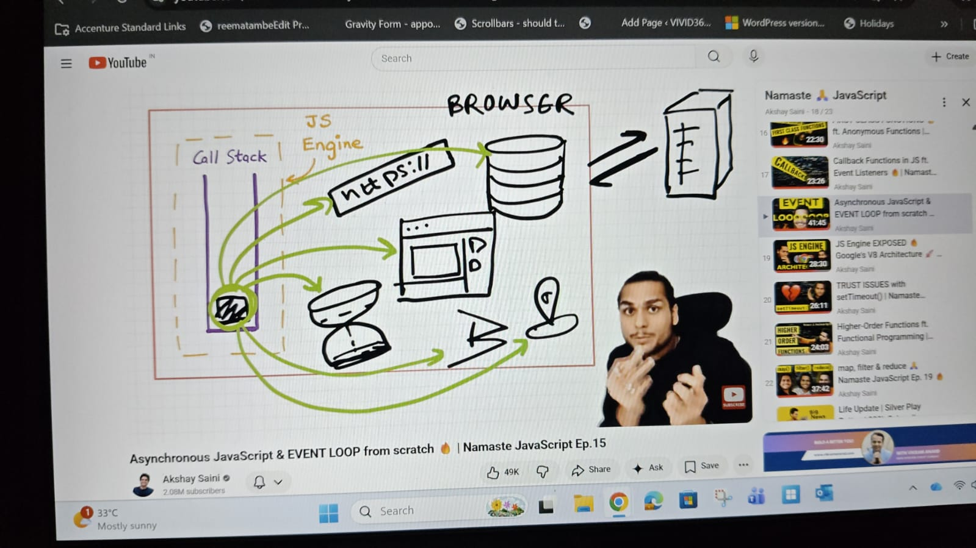
- We have web APIs to access the super power.
- webapis - setTimeout, dom APIs, fetch, local storage, console.log, location are not a part of the js and this is part of the browser
- so browsers give access to the Js within the callstack or the Js engine to use the superpower
- and we get it inside the callstack with the help of a global object which is window

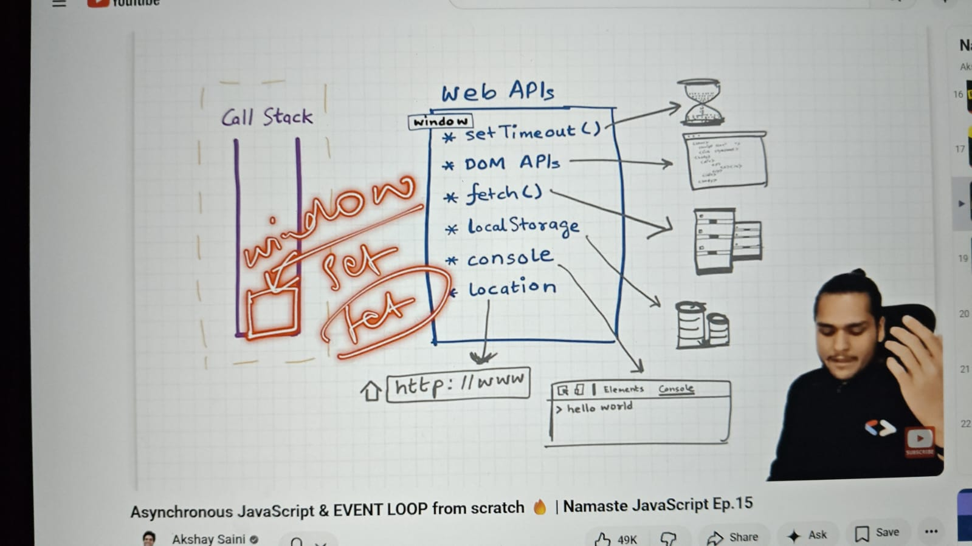

- whenever a code is executed it is created a GEC inside the callstack
- then the whole code will be run line by line
- The console log uses web APIs which are the console which we see in the browser
- this api is plugged through the window to our code the js code which is executed inside the GEC
- setTimeout - will call the setTimeout webapis and this gives us the timer features and it takes the callback function with delay and it registers a callback. And because we have given delay it also starts the 5000ms timer.
- and js moves to the next line and again it calls the console.log webapi and it logs the data in the console
- once all our code is done executing then the GEC will be removed from the callstack
- meanwhile this all thing is done in the background the timer is running
- as soon as the timer expired this callback function needed to be executed
- so somehow we need this callback to be in the callstack
- now here comes the event loop and callback queue

Callback queue and event loop
- how do these two work?
- we already know the 500ms was running and the callback was registered
- and these callback methods needs to be added to the callstack to execute the code
- and it cannot directly go to the callstack
- how does it go?
- it goes to the callstack through this callback queue
- so this timer expires it goes to the callback queue
- and the job of the event loop is to check this callback queue and put the functions of the callback queue into the callstack
- event loop acts as a gatekeeper and it checks if we have anything in the callback queue and if we have something just like our callback methods and it puts inside the callstack
- so as soon as the 500ms expire it put the callback function in these callback queue and event loop check if there is any method in the callback queue and push it in the callback queue
- so how it does is like it creates EC and executes the callback function
- And then later execute the console log web APIs and display the data

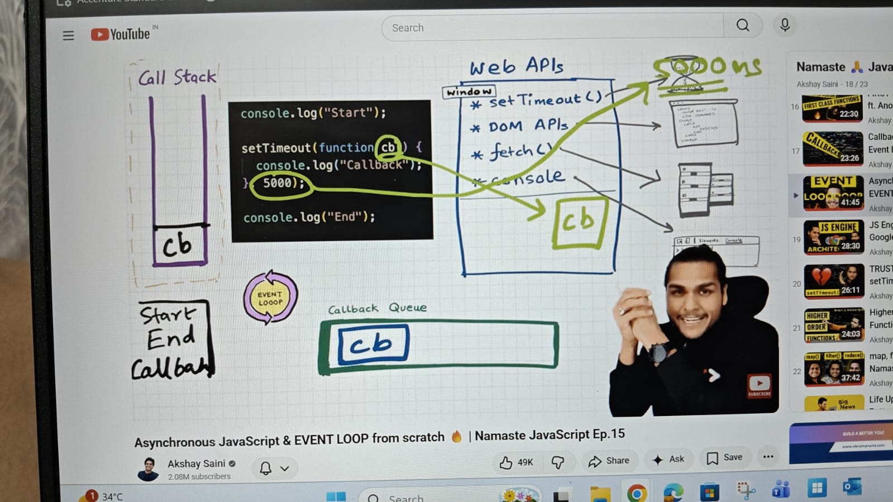
Event listener
- whenever the js code executes it creates a GEC and it puts inside the callstack and it runs the code one by one
- it goes to the first line and sees the console.log
- It calls the console webapi and it's log data in the console
- now the code goes to the next line
- this addeventlistener is another superpower which is given by the browser to the js engine through the window object in the form of the webapis which is DOM APis.
- dom is the document object model which is basically a html source code
- whenever we access this dom APIs it basically accesses the html code and tries to find buttons with some id
- and if we put in an event listener it also registers the callback on an event and that event is attached which is click event
- then it goes to the next line and execute the console.log data
- and then the GEC is removed from the callstack
- but the event handler will stay over here in the webapis environment untill and unless if we removed the event listener and close the browser waiting for the user to get click
- and once it is clicked it goes to the callback queue
- and it waits over here to get executed
- now the event loop will come into Picture.
- so the job of the event loop is to check the callback queue and the callstack
- so if the callstack is empty and it also sees the callback queue has also the function which is waiting for the function to execute so it puts in the callstack and it gets execute
- and the event listener callback function later on it also vanishes from the callback queue
- why can't we directly add the callback function in the callback queue?
- bcoz if the user clicks the event listener multiple times so that particular callbacks method will be added in that callback queue multiple time
- and later on it gets pushed in then callstack one by one with the help of event loop
- in real life scenario there will be multiple things that will happen so these is how we can give them the chance one after the other
- and as we know there is only one callstack and everything executes over there. So this is how it works

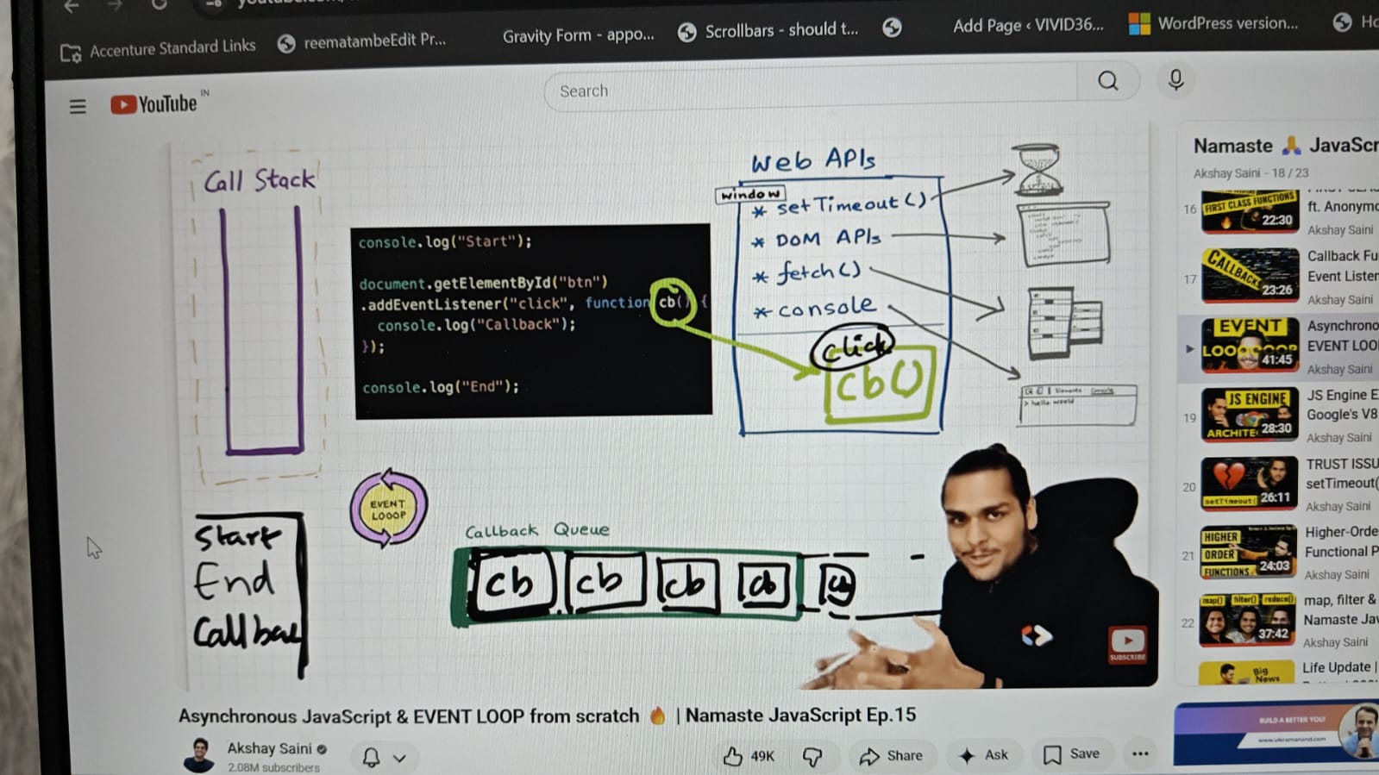

Fetch function:
- fetch is something which goes and requests the api calls
- and it returns a promise and we pass the callback function which will be executed once the promise is resolved
- so resolved as in when we get the data the callback function will be executed
- so will go by code, here GEC is created and pushed into the callstack the code is executed line by line
- start execute and then it goes to setTimeout and register the callback which cbt and similarly the timer is running
- fetch function is again a webapi which is used to make API calls and register the callback function which is cbf in our webapis
- waiting for cbt is Waiting for the timer to expire and the cbf is waiting for the data to be returned from the server
- so this fetch function will basically make an api call to the server and the server will return the data back to fetch. And once we get the data back to the fetch the callback function is ready to be executed
- suppose the server is very fast and it returns in 50 secs then the callback function is ready to be expected and it won't go to the callback queue it will basically goes to the mirco task queues
- it is same as callback queue but this queue has higher priority and the function inside the callback queue executes later
- What all goes inside the microtask queues? Promises
- now for example we have million lines of code and the event loop check if callstack is empty or not but it is still executing the million lines of code
- So the job of the event loop is to check if there is anything inside the microtask queues or callback queue and also the callstack is empty or not.
- in the meantime we get to know the timer expires
- CBT then wants to execute and it will be moved to the callback
- then once the callstack is empty then the event loop gives the chance to the microtask queue and its function pushes it into the callstack and later on once it is done the callback queue functions push into callstack
- So what comes into the microtask queues?
- all the callback function which comes through promises will go inside this microtask queue and there is something known as mutation observer
- mutation observer keeps on checking if there is a mutation in the dom tree or not. If there is some mutation in the dom tree it executes the callback function
- setTimeout, domapi, goes inside the callback queue
- microtask queue also known as task queue
- starvation of tasks inside the callback queue if the microtask queue has some more microtask queue so the callback queue won't get a chance.

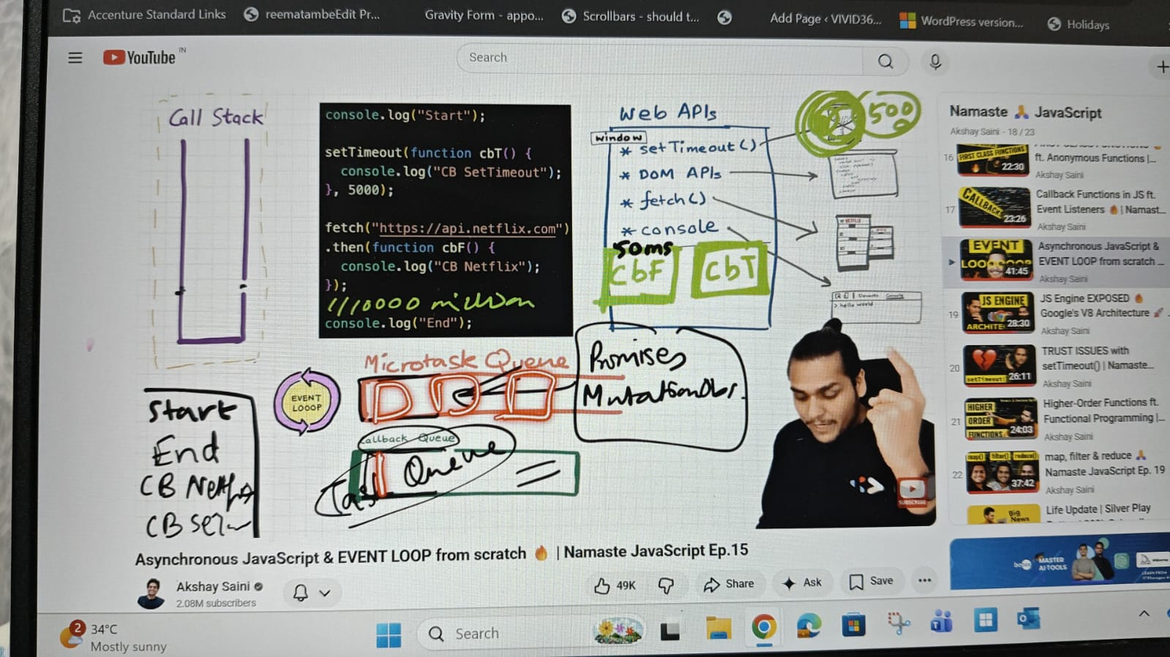

Higher order function
- one of the most amazing parts of Js is functional programming
- and functional programming is not possible without Higher order function
- function which takes function as an argument or returns a function from it is known as higher order function

- Array.prototype calculator, now this calculate function will be available in all arrays which we see
- when we add anything in prototype appears in all arrays
- radius.calculate so here how do we get the array. In this case where we do Array.calculate. over here in the calculate function the This over here points to the array which is this calculate been called upon
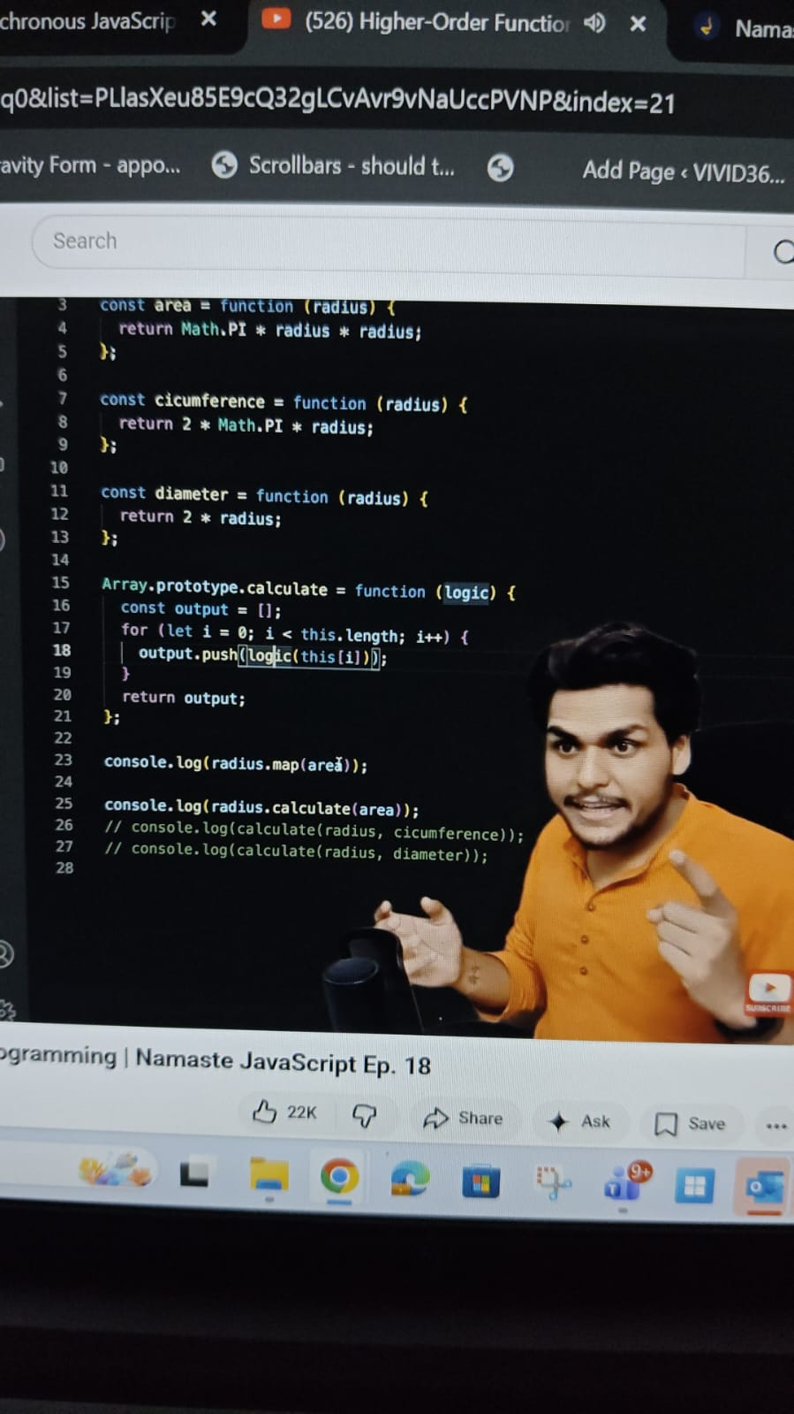

Map, filter and reduce
- these are higher order functions in Js
- Map function is used to transform an array
- filter function is used to filter the value inside an array
- Reduce is used at a place where you have to take all the elements of any array and come up with a single value out of them. Ex: sum or max or min
- reduce takes a function and the function has two parameters
- accumulater and current
- this function will iterate over each element of array
- and the second parameter curr represent the array value inside this reduce function
- accumulater the first parameter, used to accumulate the result we have to get out of those values which are present in the array
- The second argument of the function is the initial value which we need to pass in the accumulater

Async and Defer
- async and Defer are Boolean attributes which are used along with script to load the external script efficiently in web page
- when we load a web page then there are two major things happening in our browser one is html parsing and second is loading of scripts
- loading of scripts contains two parts one is fetching the script from the network and the second is executing the script line by line

Normal scenario
- browser is loading a web page the html parsing goes on as soon as script is encountered the html parsing stop and script is fetched from the network and then and there the script is executed and once done the html parsing continues

Async
- when the web page is loaded, the html parsing goes on and the script fetches parallely and once fetched the html parsing stops and script is executed and once done then the html parsing continues

Defer
- when the web page is loaded the html parsing goes on the script are fetched parallely and once the html parsing complete the scripts gets executed

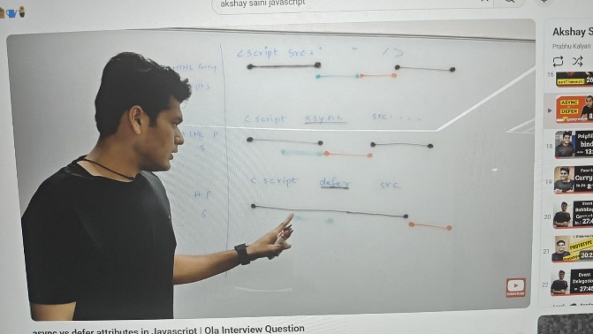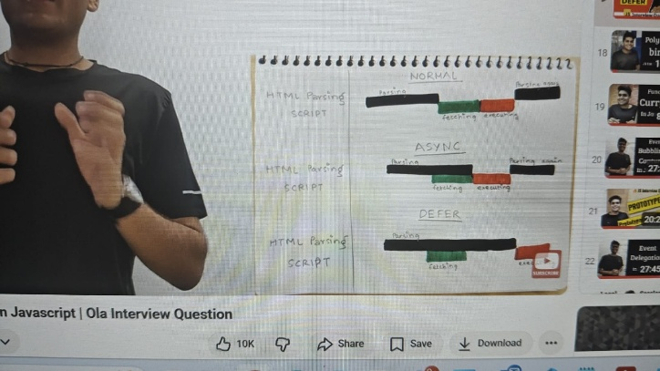

- async attribute does not guarantee the order of the scripts but defer does
- we have multiple scripts and for each we have a async attribute and one script is dependent on others then using the async attribute it does not guarantee that the script will be executed in order. In that case we need to use defer
- Suppose we want to load external scripts like Google analytics which are quite modular and independent of our normal code. So in that case it make sense to use the async attribute

Call, Apply and bind
- each and every function in js has access to this keyword
- in an object within the function this keyword refers to the object variable
- when we have two object and we have object 1 function to be used for the object 2 so with the call method we can do function borrowing
- this concept is known as function borrowing
- We can borrow function from other objects and use it with the data of some other objects
- name.printfullname.call( name2)
- here name is the object where we are borrowing the function and name 2 is the object where we are using that function
- in other ways we can also remove the method from the object and keep it outside so here in that case name the name is not required just the function with call method and object name where the method is needed
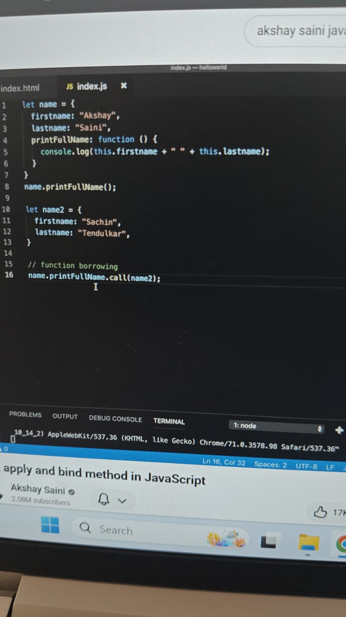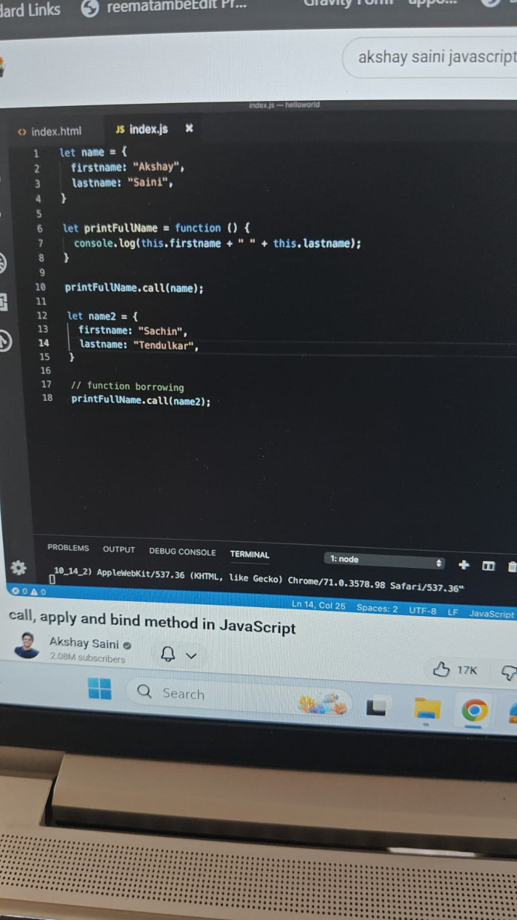

So the first argument of the call method will always be reference to this variable and later arguments can be arguments to the function
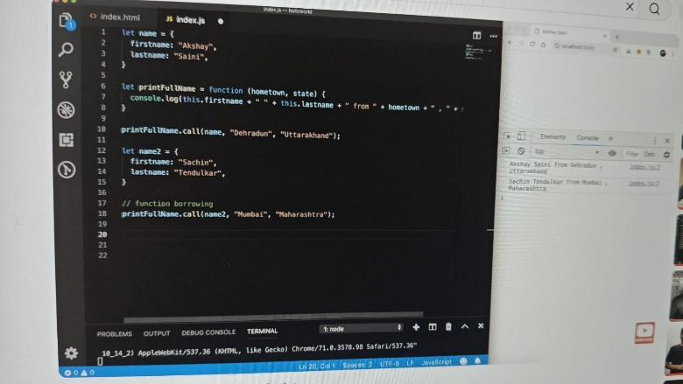
Apply method:
- the only difference between call and apply method is the way we pass arguments
- first argument will be always reference to the this variable and the second is the list of arguments that we have to pass in the function
- instead of arguments to pass individuals we pass it as an array list
- bind method is same as call method
- Instead of directly calling the method bind, bind method binds the function with object and returns the copy of that method
- so it will store it in a variable we have called it again later
