**JMeter**

Assume this Scenario:

Amazon’s great Indian Sale or Flipkart Big Billion day. Will the site have the same traffic on these special sale days or will it be higher? Definitely higher.

Rember our university results site? How fast will it be when you check for the results?

So, do you get it? What exactly are we trying to arrive at? User experience while using the site or the end product.

When will the user get excellent experience?

When the site/product delivers tremendous **performance**. That’s what we are going to learn from this tutorial series.

Performance Testing with JMeter.(open source)

Getting Started:

1. Download and install the latest apache JMeter from

<https://jmeter.apache.org/download_jmeter.cgi>

**First things first:**

Understanding the terminology

**Test Plan:**

Chain or series of steps that Jmeter is going to execute when the run button is pressed. A completer test plan will consist of one or more **Thread Groups**, logic controllers, sample generating controllers, **listeners**, timers, **assertions**, and configuration elements.

1. Adding Elements
2. Removing Elements
3. Saving the Test Plan
4. Running a test Plan
5. Stopping a test (**Stop**[immediate shutdown], **Shutdown**[graceful shutdow])
6. Logging the info and errors.

By default after installing Jmeter we will have Test Plan

Test Plan-Chain of events, whatever we add down to Testplan at the time of Execution or Run will get triggered, so the elements which are triggered under the Testplan collectiviely called as Test-Plan.

Completer TestPlan



Ex:

Maven project- Souce jave



Maven dependencies



Pom,xml



Like wise we should have Thread Groups one or multiple thread groups, assertions, timers. Listeners,

Right click on Test plan in J meter and select Add we can see all the components. (See image).

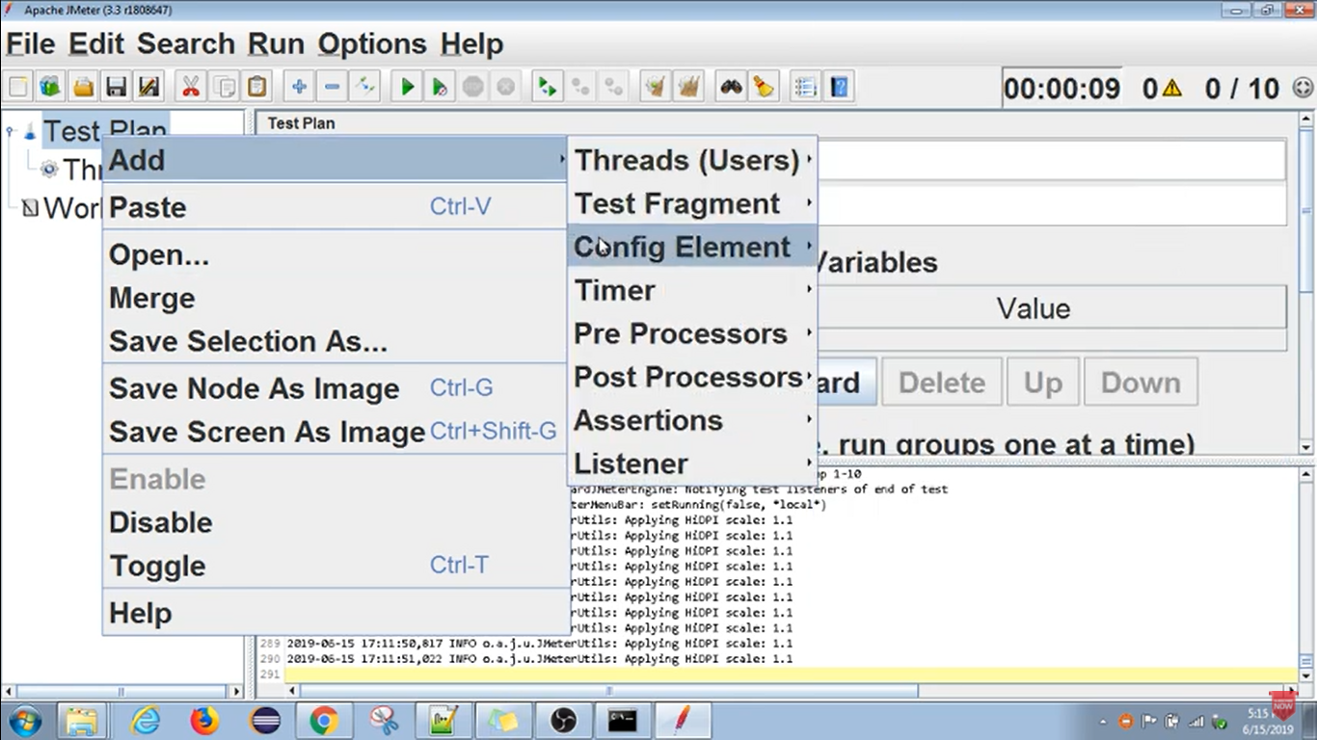

We can Add Elements, As well as we can Remove what we added thr Test Plan.

We can run a Test Plan,

Save a Test Plan,

Stop a Test Plan,

Shutdown a Test Plan,

There is a difference between **Stop** [Immediate shutdown(abrupt)] and **Shutdown** [graceful shutdown].

We can see Log obvious what is going on, or like what error is happening informations.

**Important components of a Test Plan:**

1. Thread Group
2. Controllers (Logic Controllers, Sampler)
3. Listeners
4. Timers
5. Assertions

**Thread Group:**

* Beginning point of any test plan. (like main method in java)
* The thread group element controls the number of threads were JMeter will use to execute your test
* All controllers and samplers must be under a thread group.
* Other elements, EX., Listeners, may be placed directly under the test plan so that it will be applicable for all the thread groups under the test plan.

Main properties of Thread Groups:

* Set the number of threads (simultation of number of concurrent users)
* Set the ramp-up period (**Time taken to threads up and running=Ramp up Period/Thread**). For Example, If I give 10 threads and ramp up duration as 100 seconds, then all the threads will be running in 100/10=10 seconds.

Which means for every 10 seconds one thread will start getting executed or

The second thread will execute after 10 seconds of the first thread.

* Set the number of times to execute the test