1.Question 8 and 9 is compulsory .pdf

Note:
1.Try inline CSS for styling.
2.Try select tag(try size attribute)
Example: <select>
<option>Apple</option>
<option>Banana</option>
<option>Pineapple</option>
</select>
3.Try textarea tag(try rows and cols attribute)
Example: <textarea></textarea>

- Create a web page to show your name
- Create a web page to show Student name in ordered list Output:

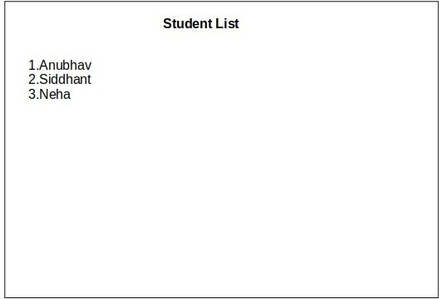

- Create nested list of Students

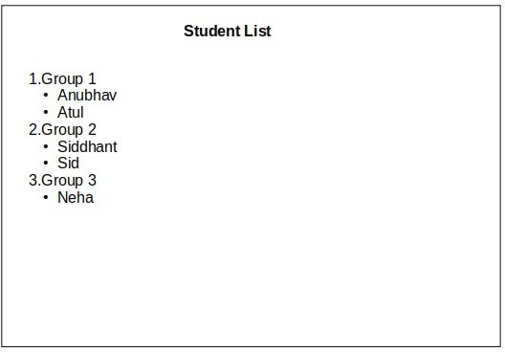

- Create a nested list.
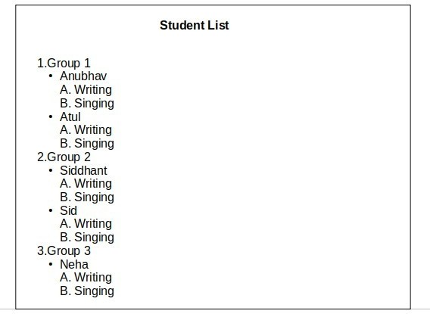

- Create a web page resume.

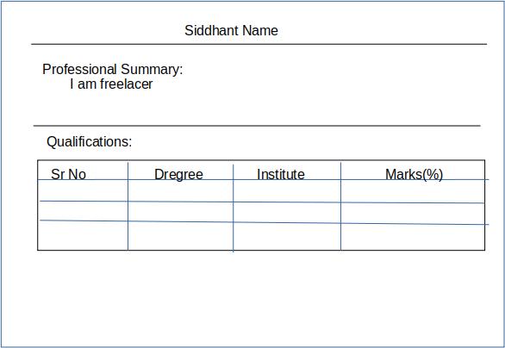
- ​
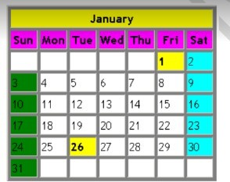

- ​

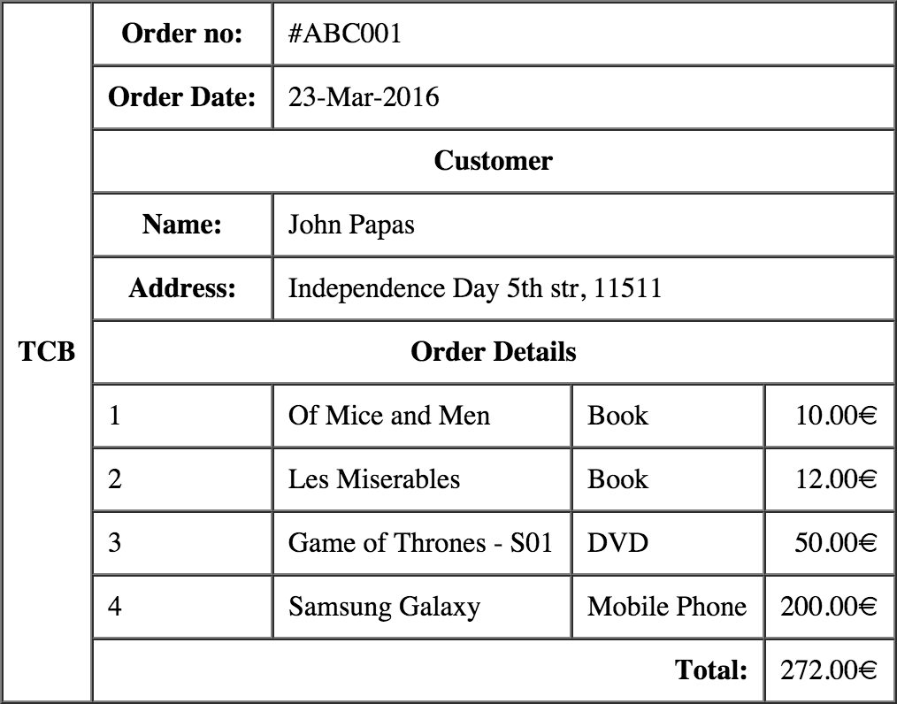
- ​

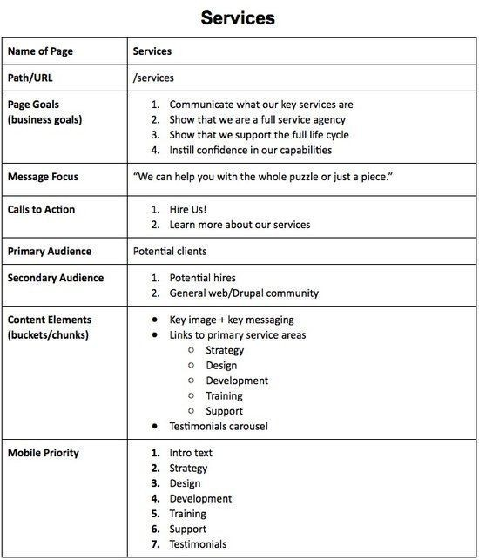
HTML assignments

9​
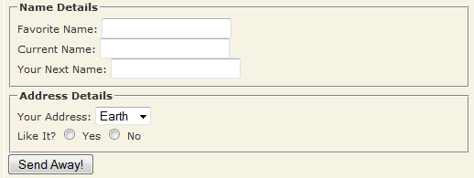

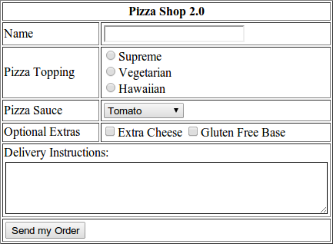
10.​

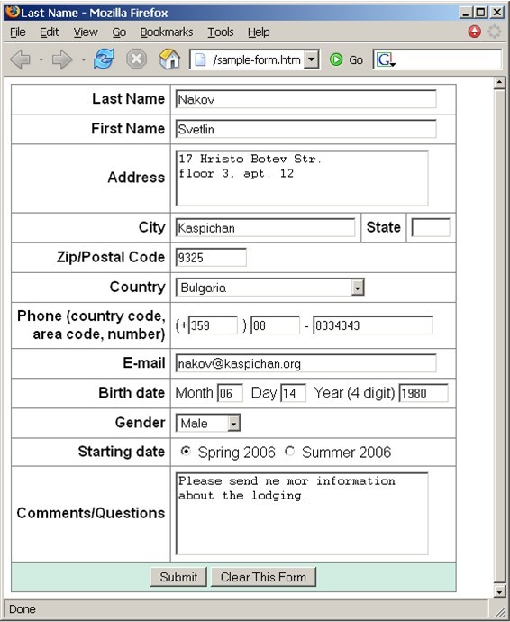
11.​

12.Design given page and link Q1,Q2 and Q3 on page to question 1 ,2,3

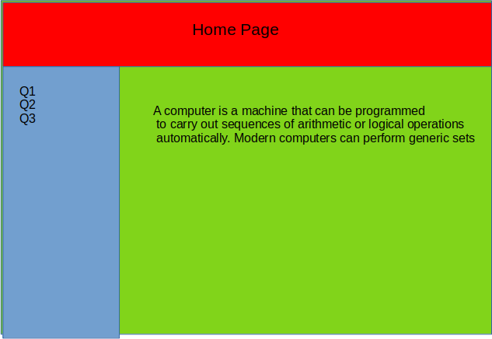
13.​
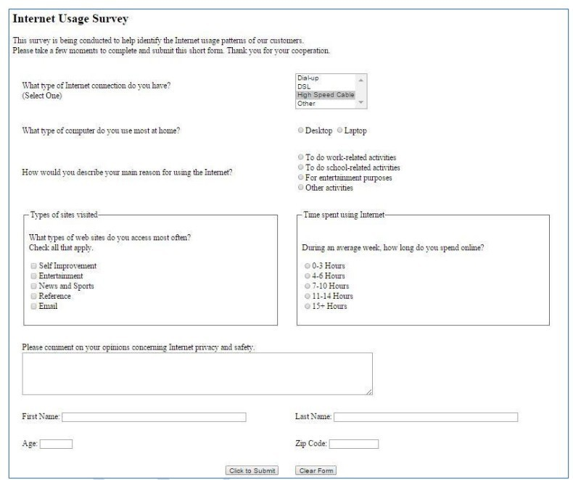

14.

