**NAAN MUDHALVAN**

**INTERNET OF THINGS- IBM**

**PROJECT – ENVIRONMENTAL MONITORING USING IOT**

**PHASE 5**

**TEAM MEMBERS**

1

DHIVYA PRADEEP (2021116006)

HEMANTH RV (2021116009)

KAILAASH RM (2021116016)

SHANTHINI DEVI P (2021116036)

THAARINI DEVI S (2021116047)

**V SEMESTER- 3rd YEAR**

**B.E BIOMEDICAL ENGINEERING**

**COLLEGE OF ENGINEERING GUINDY**

**ANNA UNIVERSITY, CHENNAI**

# PROJECT TITLE: ENVIRONMENTAL MONITORING USING IOT

**Problem Definition:**

1. **Project Scope and Objectives:**
   * The scope of our project is to implement an IoT-based environmental monitoring system in public parks.
   * Objectives: Provide real-time temperature and humidity data to park visitors, enhancing their outdoor experience and safety.
2. **Data Collection and Parameters:**
   * Identify the key environmental parameters to monitor: Temperature and humidity.
   * Specify the need for continuous data collection to support informed decision-making by park visitors.
3. **Environmental Challenges:**
   * Acknowledge the environmental challenges faced by park visitors due to changing weather conditions.
   * Highlight the importance of real-time data to mitigate these challenges and promote outdoor engagement.

**Design Thinking:**

1. **IoT Device Selection and Deployment:**
   * Select appropriate sensors for temperature and humidity monitoring.

Temperature sensors: Thermistors or digital temperature sensors.

Humidity Sensors:: **Capacitive Humidity Sensors:** These sensors are widely used for humidity measurement due to their accuracy and reliability.

* + Plan the deployment of these sensors in strategic locations within the parks for accurate data collection.

1. **Platform Development:**
   * Design a user-friendly web-based platform accessible to park visitors.
   * Implement real-time data visualization and display for temperature and humidity data.
2. **Data Integration and Communication:**
   * Determine the communication protocol (e.g., Wi-Fi, LoRaWAN) for data transmission from IoT devices to the platform.
   * Develop a backend system for data processing and integration with the platform.
3. **Power Supply and Maintenance:**
   * Choose suitable power supply options (e.g., batteries or solar panels) for IoT sensors.
   * Outline maintenance procedures to ensure continuous operation.
4. **User Engagement and Safety:**
   * Implement an alert system to notify users of extreme weather conditions.
   * Focus on user training and support to ensure effective utilization of the monitoring platform.
5. **Documentation and Reporting:**
   * Maintain comprehensive project documentation, including system architecture and user guides.
   * Provide periodic reports on environmental data and system performance to park management and the public

So through this project, we can monitor the environmental conditions like temperature and humidity in a park, through sensors and transfer the data with the help of IOT devices and keep the visitors noted about the conditions of the park, and also bring a sense of awareness when the condition gets worse and also act as alarming system as well.

**PHASE 3:**

In the next phase, we have interfaced the sensor with the microcontroller (ESP31). The simulation of the circuit was done using WOKWI simulator. Our project primarily focuses on temperature and humidity measurement in the environment. The output is displayed using LCD display.

**SENSOR USED:**

* **DHT22 SENSOR**
  + **DHT-** Digital Humidity and Temperature
  + It is low-cost digital sensor for sensing both temperature and humidity.

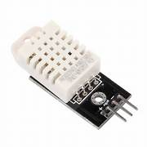

**MICRO-CONTROLLER USED:**

* **ESP32**
  + ESP32 is a series of low-cost, low-power system on a chip microcontrollers with integrated Wi-Fi and dual-mode Bluetooth.

**ESP32 PIN DIAGRAM:**

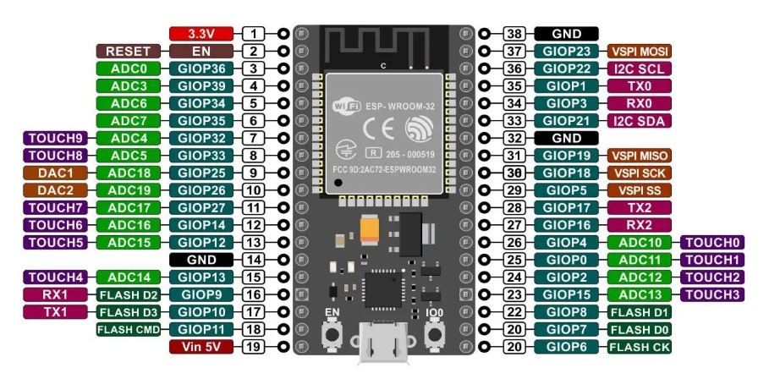

**CIRCUIT DESIGN:**

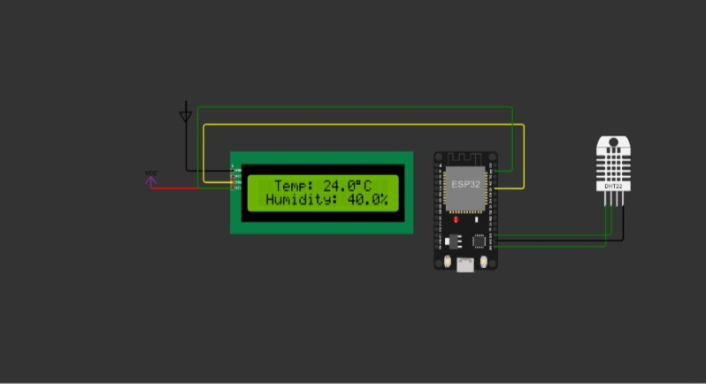

**PROGRAM: (**Using C)

#include "DHTesp.h"  
#include <LiquidCrystal_I2C.h>  
#define I2C_ADDR 0x27  
#define LCD_COLUMNS 16  
#define LCD_LINES 2  
  
const int DHT_PIN = 15;  
  
DHTesp dhtSensor;  
  
LiquidCrystal_I2C lcd(I2C_ADDR, LCD_COLUMNS, LCD_LINES);  
  
void setup() {  
  
 Serial.begin(115200);  
 dhtSensor.setup(DHT_PIN, DHTesp::DHT22);  
 lcd.init();  
 lcd.backlight();  
  
}  
  
void loop() {  
  
 TempAndHumidity data = dhtSensor.getTempAndHumidity();  
 Serial.println("Temp: " + String(data.temperature, 1) + "°C");  
 Serial.println("Humidity: " + String(data.humidity, 1) + "%");  
 Serial.println("---");  
   
 lcd.setCursor(0, 0);  
 lcd.print(" Temp: " + String(data.temperature, 1) + "\xDF"+"C ");  
 lcd.setCursor(0, 1);  
 lcd.print(" Humidity: " + String(data.humidity, 1) + "% ");  
 lcd.print("Wokwi Online IoT");  
  
 delay(1000);  
}

**EXPLANATION:**

* The code includes two libraries, "DHTesp.h" for working with the DHT22 sensor and "LiquidCrystal_I2C.h" for interfacing with the I2C-based LCD.
* The DHT_PIN constant specifies the digital pin to which the DHT22 sensor is connected, and the **dhtSensor** object is an instance of the DHTesp library for interacting with the sensor.
* An LCD object is created, specifying the I2C address and the dimensions of the LCD.
* In the **setup** function:
  + It initializes the serial communication at a baud rate of 115,200 for debugging and monitoring.
  + It sets up the DHT22 sensor on the specified pin.
  + It initializes the LCD and turns on the backlight.
* In the **loop** function:
  + It reads temperature and humidity data from the DHT22 sensor using dhtSensor.getTempAndHumidity() and stores the values in the data object.
  + It prints the temperature and humidity to the serial monitor with one decimal place and degree Celsius symbol (°C).
  + It updates the LCD display with the temperature and humidity readings and adds "Wokwi Online IoT" text on the second line.
  + It then introduces a 1-second delay before repeating the loop.

The code continuously reads and displays temperature and humidity data on the LCD while providing serial output for monitoring. The DHT22 sensor provides temperature in Celsius and relative humidity, and the LCD display shows this data along with some additional text.

**OUTPUT:**

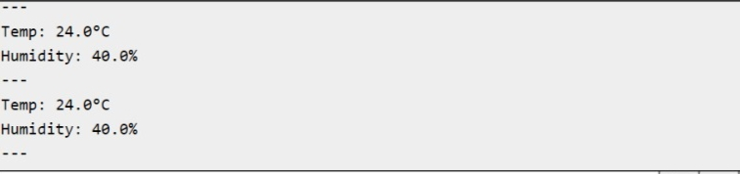

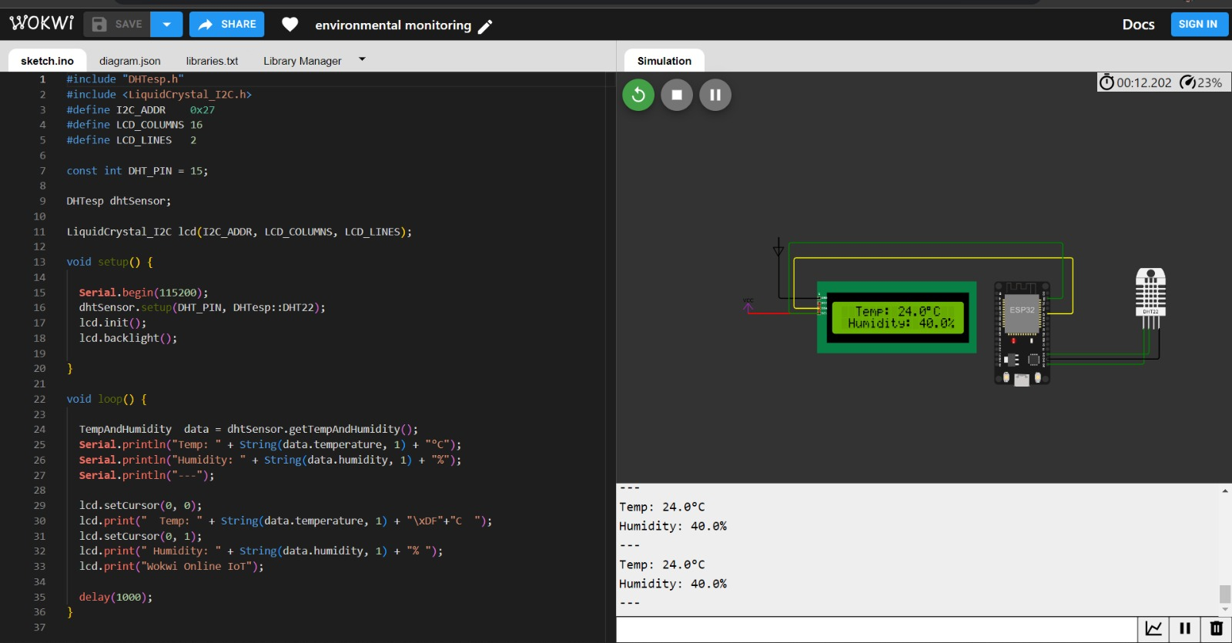

In this phase, we have developed a embedded HTML page of our Wowki simulation, which would show the temperature and humidity values.

**HTML CODE:**

html

<!DOCTYPE html>

<html>

<head>

<title>Wokwi App Embed</title>

</head>

<body>

<h1>ENVIRONMENTAL MONITORING USING IOT</h1>

<!-- Replace the URL in the src attribute with the URL of your Wokwi app -->

<iframe src="https://wokwi.com/projects/380580948468852737" width="800" height="600" frameborder="0"></iframe>

</body>

</html>

