TASK8Have a variable store an integer create an if statement to find out of its an even number 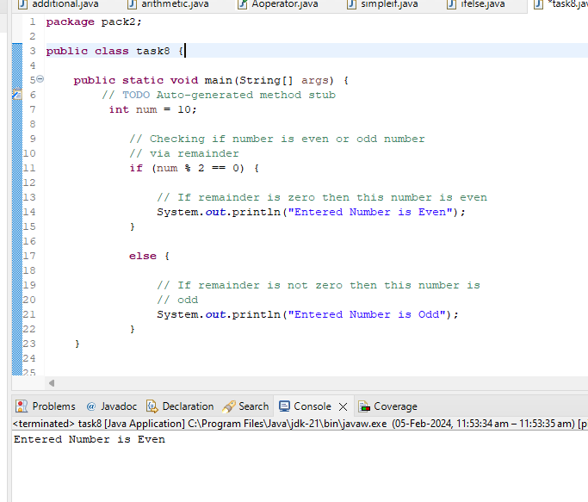

2.write a program to print the character from A toZ

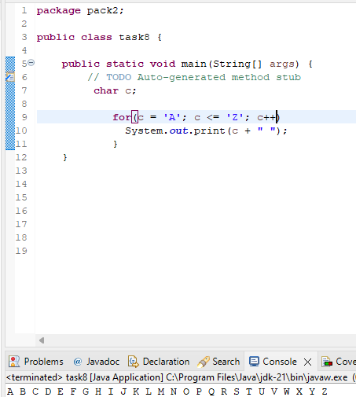

3. write a program to check prime number in java

4. write a program to print factorial of a given number

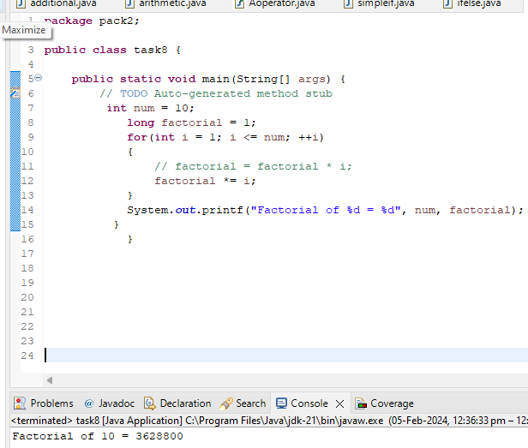

5.string msg guvi Greek

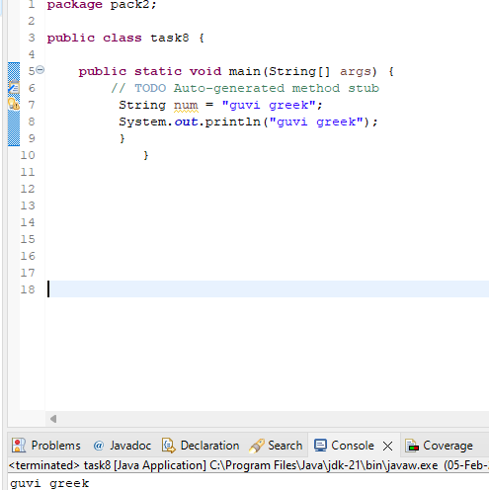

6. write a program welcome to guvi

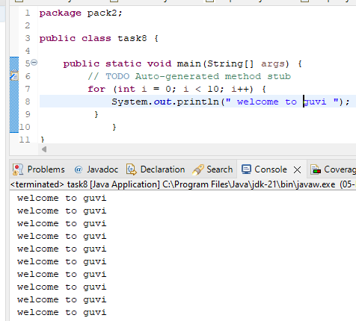

7.write a program for senior citizen or not

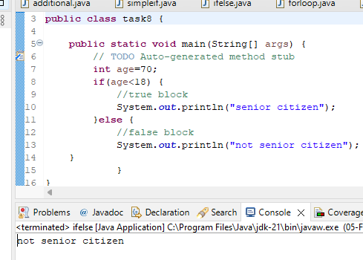

8.to count no.of digits in a integer

