TASK 9

1. WRITE A PROGRAM TIO CHECK WHETHER A GIVEN STRING IS A PALINDROME OR NOT USING LOOP AND IF ELSE STATEMENT

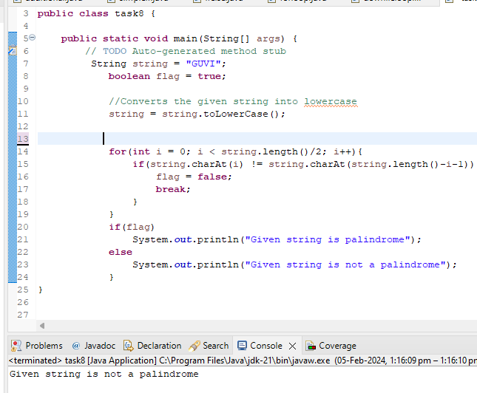

2 Sample output 12345678910

3 . sample output with pattern

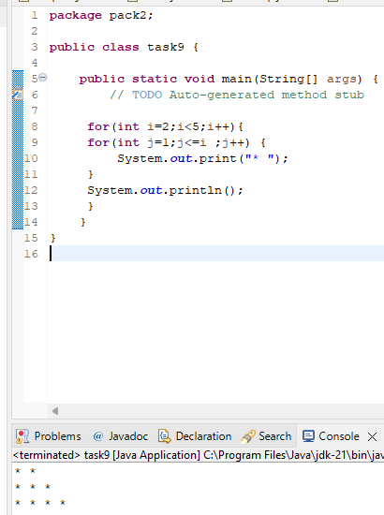

4.write a program to calculate largest number among three numbers

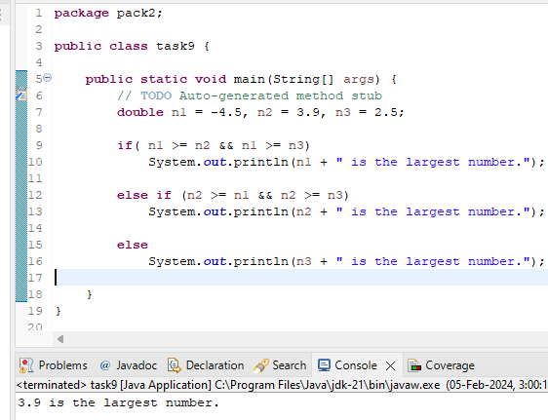

5. Write a program that reads in a string from the user and uses a loop to reverse the order of the character in the string .then ,output reverse thing