TASK 10

Create class person , attribute,name,age

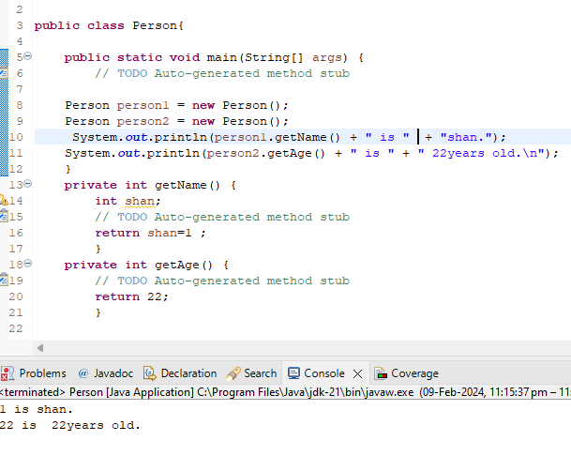

Create a class circle with radius as data member , create two constructor (no argument and two argument ) and a method to calculate circumference

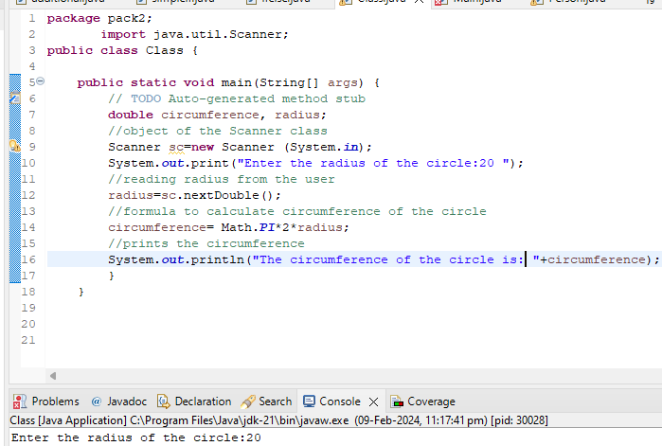

3.Create a class account with balance as data member

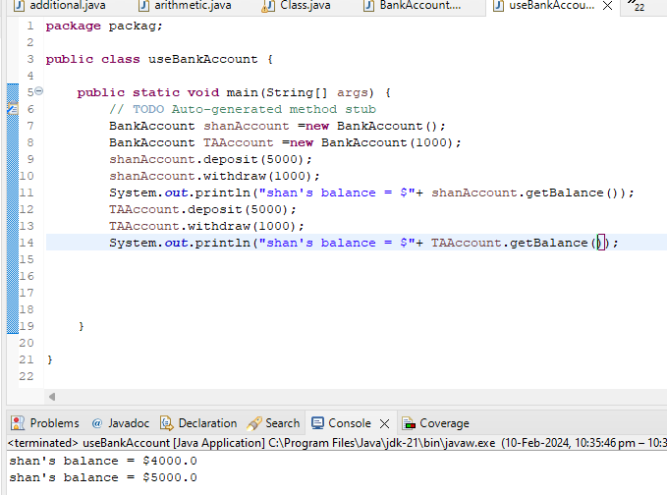

Create tea class prepare tea,add milk, add sugar

