TASK 11

1. What are the four access modifiers available in java and what is their significance in terms of class, method and variable accessibility?

The four types of access modifiers are: public, private, protected, and default . They determine the visibility and accessibility of these elements in your code. In this example, My Class is a public class, which means it's accessible from any other class in your application.

Default:

When we do not specify any access level for a class, method, or data members, then it assigns Default Access Modifier. The data members, methods, or class inside one package can only be accessed within the package. Any other class or method trying to access the data from outside the package or from other packages will not be granted access to the class or method.

Public:

The classes, methods, or constructors which are declared as Public can be accessed from anywhere. The keyword public is used to define the accessibility level of this type of Access Modifier. They can be accessed from within the same class, from a different class, within the package as well as outside the package.

Private:

Private methods and data members can only be accessed from within the class I. which they have been declared. They are specified using the private keyword. These modifiers cannot be accessed from outside the class or from any other outside package. Private Access Modifiers cannot be declared for any class or interface

Protected:

The methods and data members which are declared as protected are accessible by the classes within the package and the subclasses of those packages. This type of Access Modifier is specified using the protected keyword. Just like private access modifiers, protected access modifiers too cannot be declared for classes.

2.What is the difference between exceptions and errors?

Both exceptions and errors are the subclasses of a throwable class. The error implies a problem that mostly arises due to the shortage of system resources. On the other hand, the exceptions occur during runtime and compile time

S.No Errors and Exceptions

1. The error indicates trouble that primarily occurs due to the scarcity of system resources. The exceptions are the issues that can appear at runtime and compile time.

2. It is not possible to recover from an error .It is possible to recover from an exception.

3. In java, all the errors are unchecked. In java, the exceptions can be both checked and unchecked.

4. The system in which the program is running is responsible for errors .The code of the program is accountable for exceptions.

5. They are described in the java .lang. Error package. They are described in java .lang. Exception package

3. What are the difference between checked exception and unchecked exception?

\* Checked exceptions

\*Unchecked exceptions

Checked exceptions:

A checked exception is an exception that should be reported in the method in which it is thrown.

Unchecked exception:

An exception that occurs at the runtime or at the time of execution is known as an unchecked exception.

Checked Exception & Unchecked Exception

1. Checked exceptions happen at compile time when the source code is transformed into an executable code. Unchecked exceptions happen at runtime when the executable program starts running.

2. The checked exception is checked by the compiler .These types of exceptions are not checked by the compiler.

3. Checked exceptions can be created manually. They can also be created manually.

4. This exception is counted as a sub-class of the class. This exception happens in runtime, and hence it is not included in the exception class.

5. Java Virtual Machine requires the exception to to be caught or handled. Java Virtual Machine does not need the exception to be caught or handled.

4) Write a code of array index out of bounds exceptions & string index out of bounds exceptions?

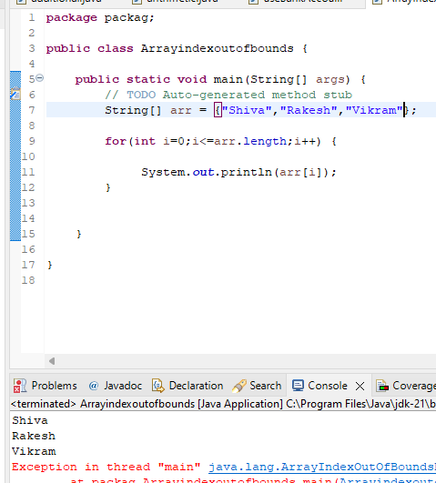

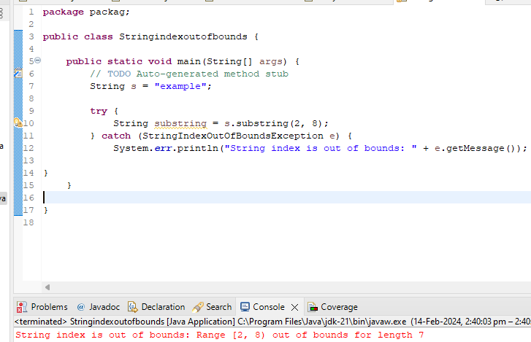

5. Implement exception handling in java program that reads data from file if the file does not exist throw a file not found exception and display an error message to the user.

7. write a java program that reads user input two integer and perform division. Handle the exception that is thrown when the second number is zero and display an error message to the user

