TASK 12

1. Write a java program to create on array list of strings and then remove all the elements from the array list.

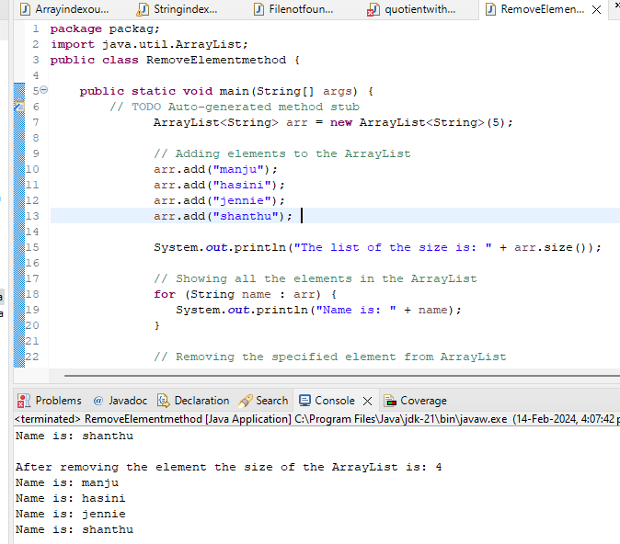

1. Write a java program to create a tree map of employee id’s and names then print out the names of all the employees in alphabetical order

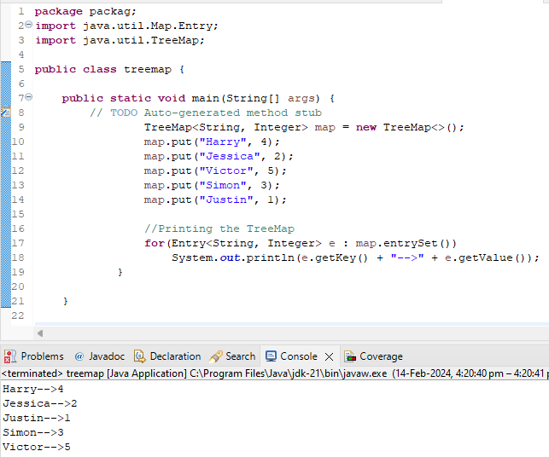

1. Write a program to convert list to array?

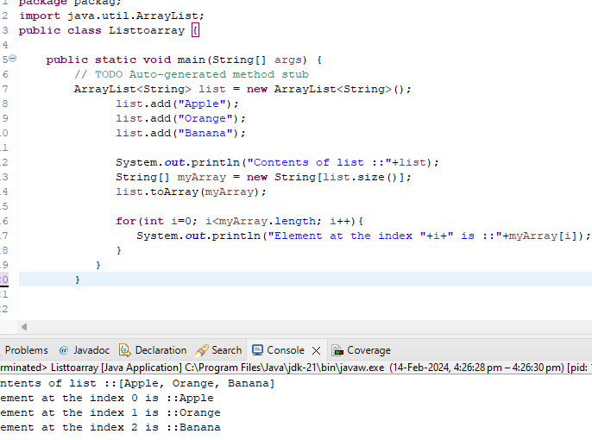

1. Create a package named "com.examole.hr" That includes an employee class. The following field Name- a string that represents the employee name Id- an integer that represents the employee id number Salary- a double that represents the employee salary

output

