Apache Maven

Apache Maven

Apache Maven is a build automation and dependency management tool mainly used for Java projects.
👉 It helps you:
- Download required libraries (JARs)
- Build the project
- Run tests
- Package the application (JAR/WAR)
- Deploy to repository

Why Maven is used?
Before Maven:
- We manually downloaded JAR files
- Version conflicts
- Hard to manage builds
With Maven:
- Automatic dependency download
- Standard project structure
- Easy builds with one command

Maven Installation on Windows
Prerequisite (Very Important)
✔ Java (JDK) must be installed
Step 1: Download Maven
- Open browser
- Go to Apache Maven official site
- Download Binary zip
  - Example: apache-maven-3.9.x-bin.zip

Step 2: Extract Maven
- Extract the zip file
- Place it in a proper location, for example:
C:\Program Files\Apache\maven
You should see:
C:\Program Files\Apache\maven\bin

Step 3: Set Environment Variables
1️⃣ Set MAVEN_HOME
- Open System Properties → Environment Variables
- Add New System Variable
Variable | Value
MAVEN_HOME | C:\Program Files\Apache\maven
2️⃣ Update Path
- Edit Path variable
- Add:
%MAVEN_HOME%\bin

Step 4: Verify Maven Installation
Open Command Prompt (new window) and run:
mvn -version
✅ Expected output:
- Maven version
- Java version
- OS details
If you see this → 🎉 Maven installed successfully

Maven Project Structure

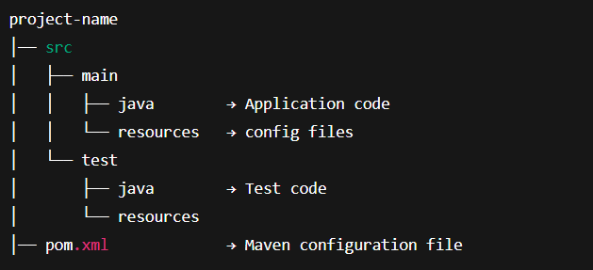

pom.xml (Project Object Model)
POM = Project Object Model
It contains:
- Project info
- Dependencies
- Build plugins
Important tags
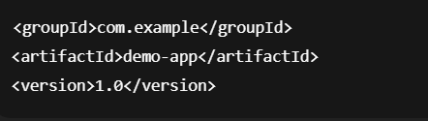

Dependencies
Dependencies are external libraries needed by the project.

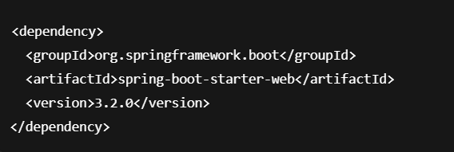
👉 Maven downloads this automatically from Maven Central Repository.

Maven Repositories
- Local Repository → .m2 folder in your system
- Central Repository → Default online repo
- Remote Repository → Company/private repo

Maven Lifecycle
Maven has 3 main lifecycles:
1️⃣ Clean

Deletes old compiled files (target folder)

2️⃣ Default (Build lifecycle)
Common phases:
- validate
- compile
- test
- package
- install
- deploy
Example:


3️⃣ Site
Creates project documentation.
Common Maven Commands
Command | Purpose
mvn clean | Delete old build
mvn compile | Compile source code
mvn test | Run tests
mvn package | Create JAR/WAR
mvn install | Install into local repo
mvn spring-boot:run | Run Spring Boot app
Local Repository (.m2)
- Location:
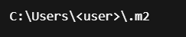
• Stores downloaded JARs
• Speeds up builds
• Shared by all projects

