Hi Bushra

Please found the below link to download theme files.

**https://github.com/shanthirs/KeenEye**

**Theme Name : callapp**

Steps to Integrate New Theme:

1. Download the theme file from github.

2. Then install the fresh wordpress.

3. Click "Appearance->Themes", click "Add New"

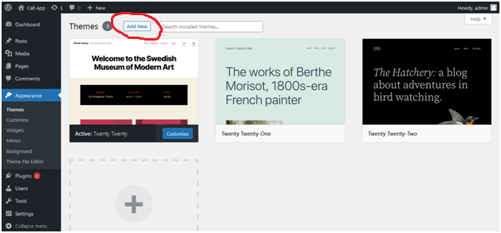

**Then click "Upload Theme" button.**

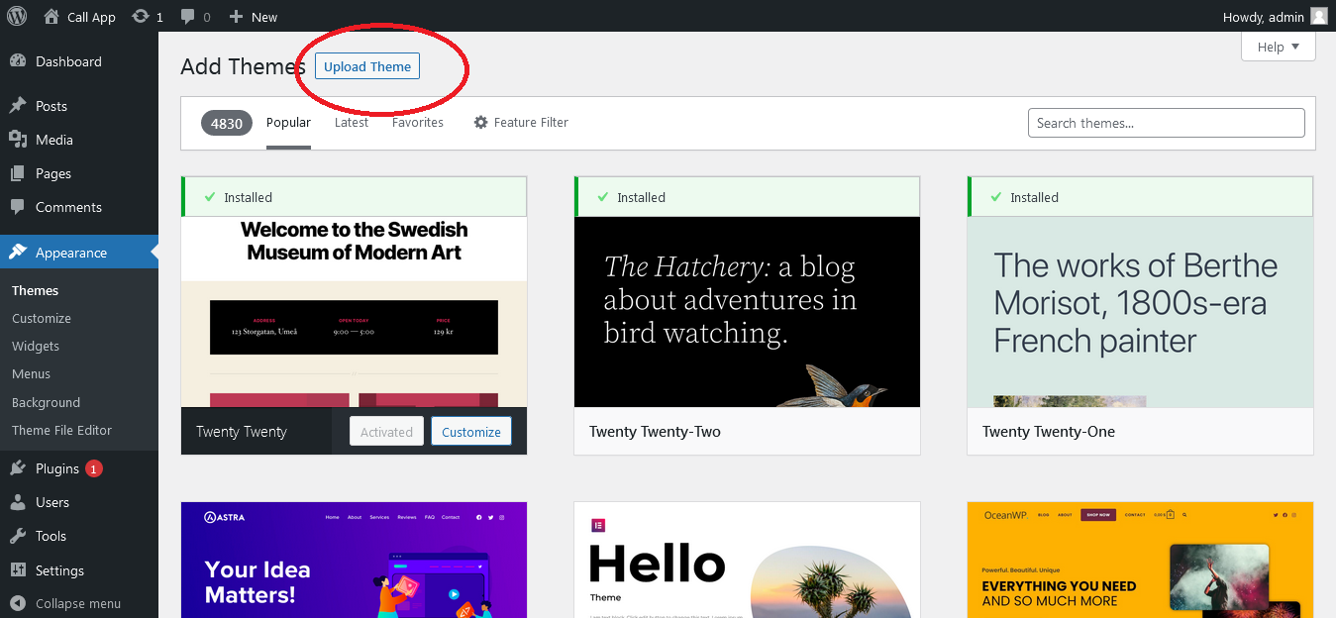

**Then upload the downloaded theme file**

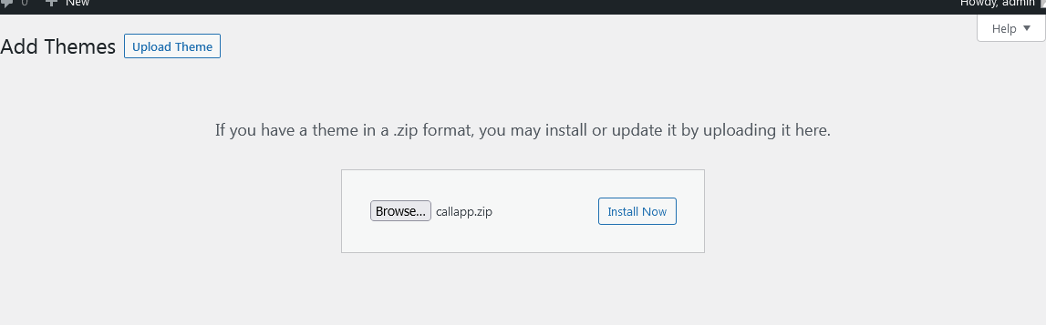

**Then click "Install Now" button. Below page and messages will be displayed.**



**Then click "Activate" link from that page.**

**After activating you will get the theme listed on the theme list.**

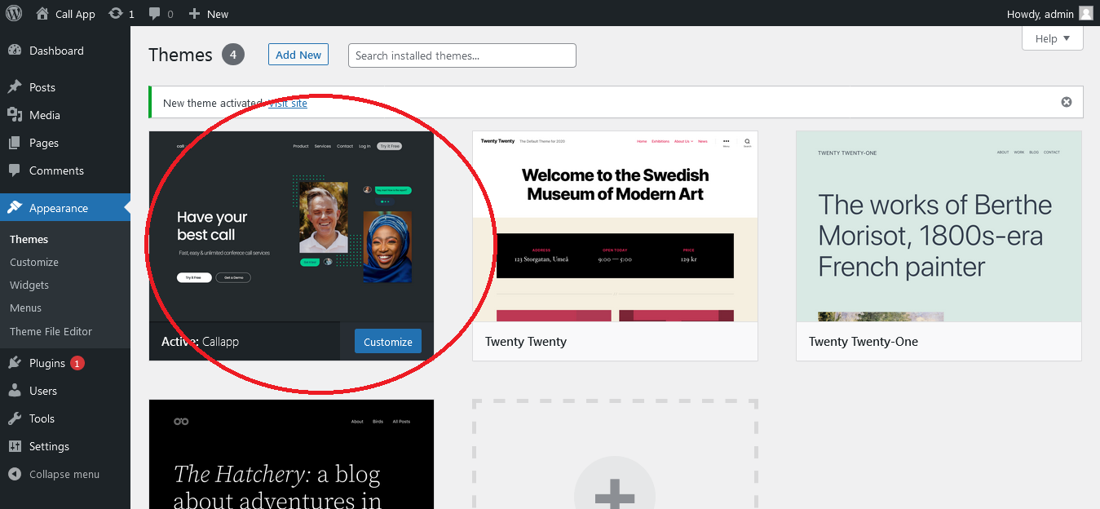

Before visiting the home page. Please do the below things to set the menus for header and menus for footer.

Next Step is to create menus. Click "Menus" from "Appearance" Menu.

**First Menu Main Menu** - Primary Menu used in header. Note: Please use the same menu name and options while creating menu.

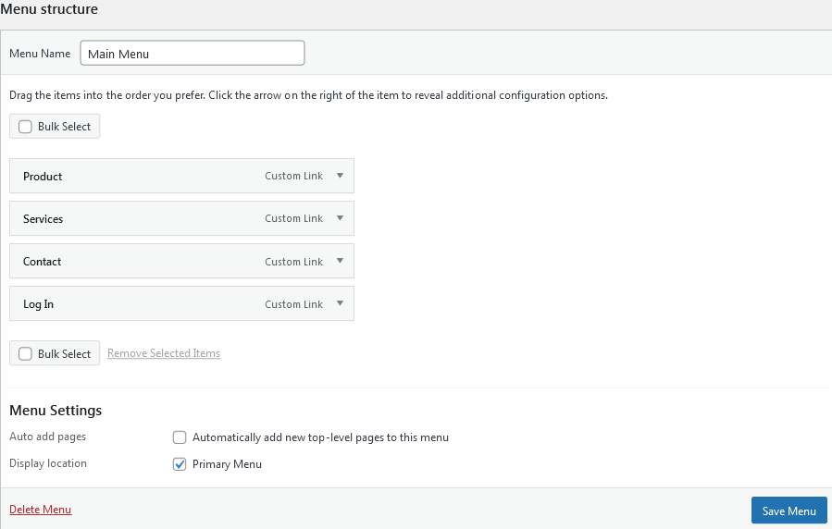

**Second Menu : Footer One menu** to set navigation in footer section.

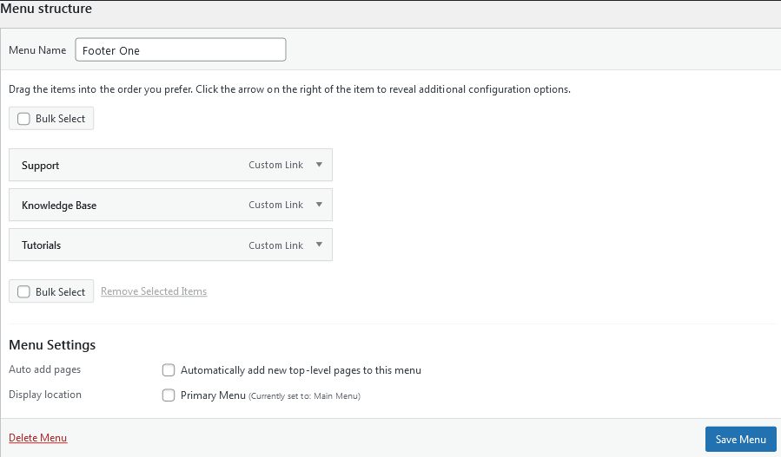

**Third Menu : Footer Two menu** to set navigation in footer section.

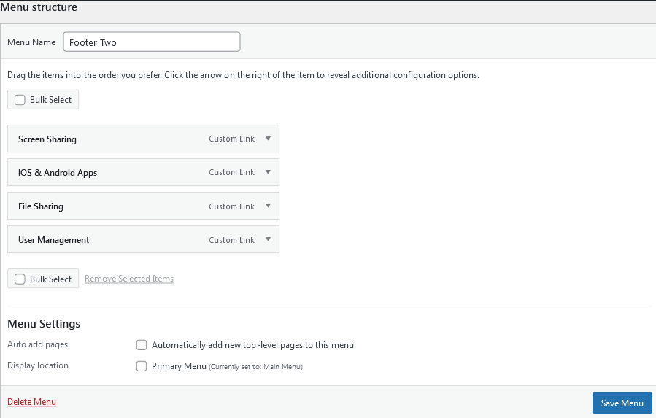

**Fourth Menu : Footer Three menu** to set navigation in footer section.

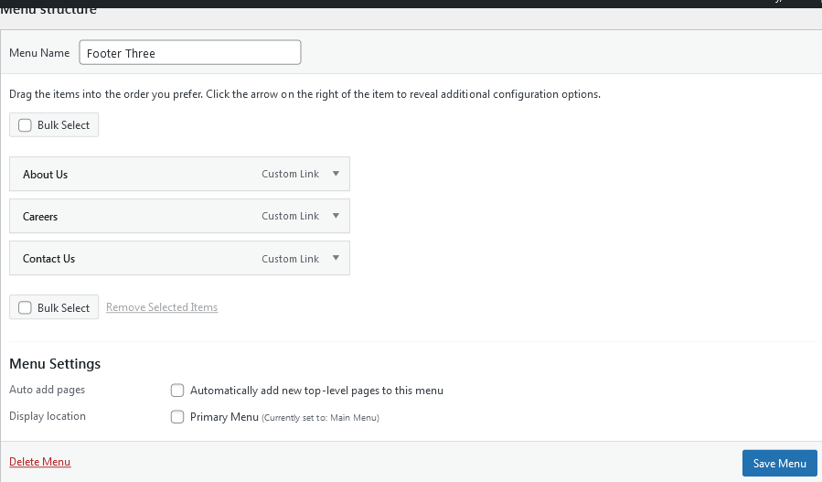

And then add these menus in the corresponding widgets.

Click "Widgets" from "Appearance" Menu.

Select "Footer One" navigation menu with the menu title "Help" for the "Footer Section One" widget.

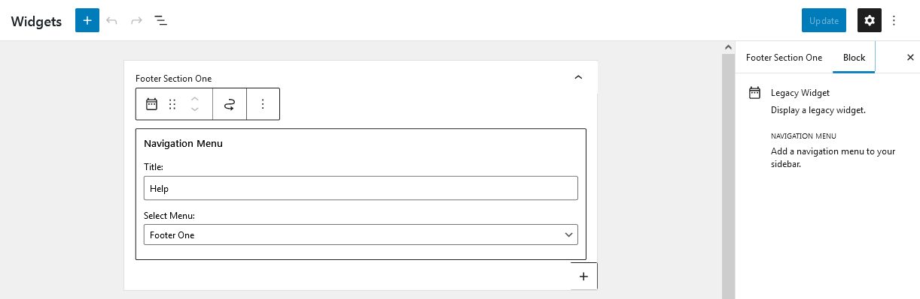

Select "Footer Two" navigation menu with the menu title "Features" for the "Footer Section Two" widget.

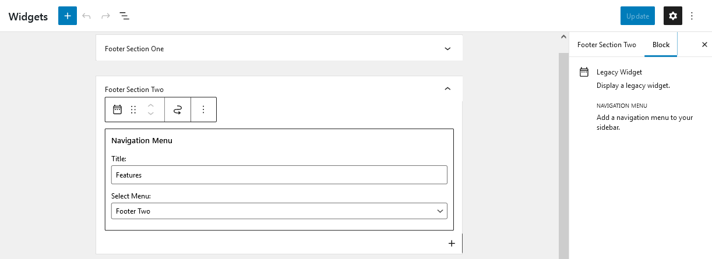

Select "Footer Three" navigation menu with the menu title "Company" for the "Footer Section Three" widget.

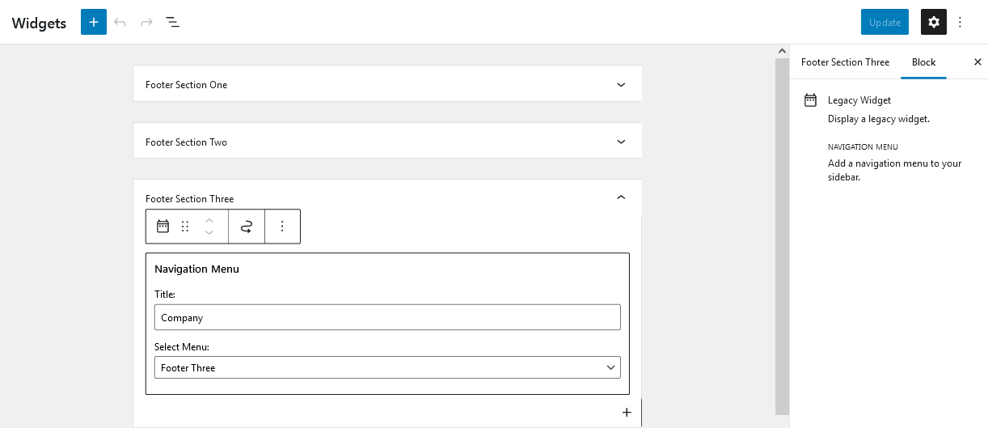

After finishing all the above. Next step is to Customize the theme settings for uploading logo and other details.

Click "Customize" from "Appearance" Menu.

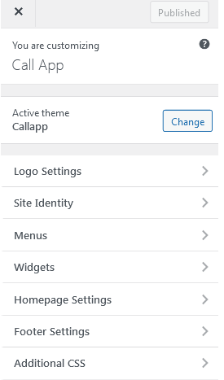

Click "Logo Settings". Upload Logo using this section.

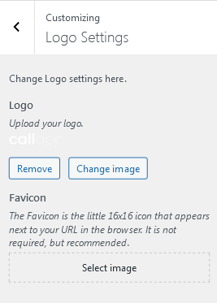

Next Menu Settings. Click back arrow to go to previous main page and then click "Menus"

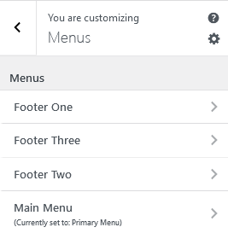

Set "Primary Menu" for "Main Menu".

Next Footer Settings. Click back arrow to go to previous main page and then click "Footer Settings".

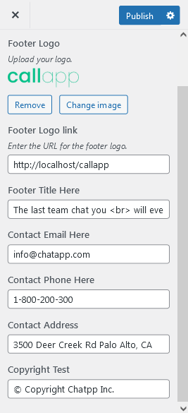

Upload logo for footer, footer logo url, then enter Footer title to list out the text below the logo. Next enter contact details like email, phone , address and copyright text.

After entering the details click "Publish" to reflect all the changes to the main site home page.

Above are the steps to make header and footer dynamic through customizer. If those options not set default static contents will get displayed.

Please let me know if anything i missed from the figma. More over these contents other that header and footer are kept as static in theme file. We can design those sections through elementor also.

Thanks.

R. Shanthi (5/5/2022)

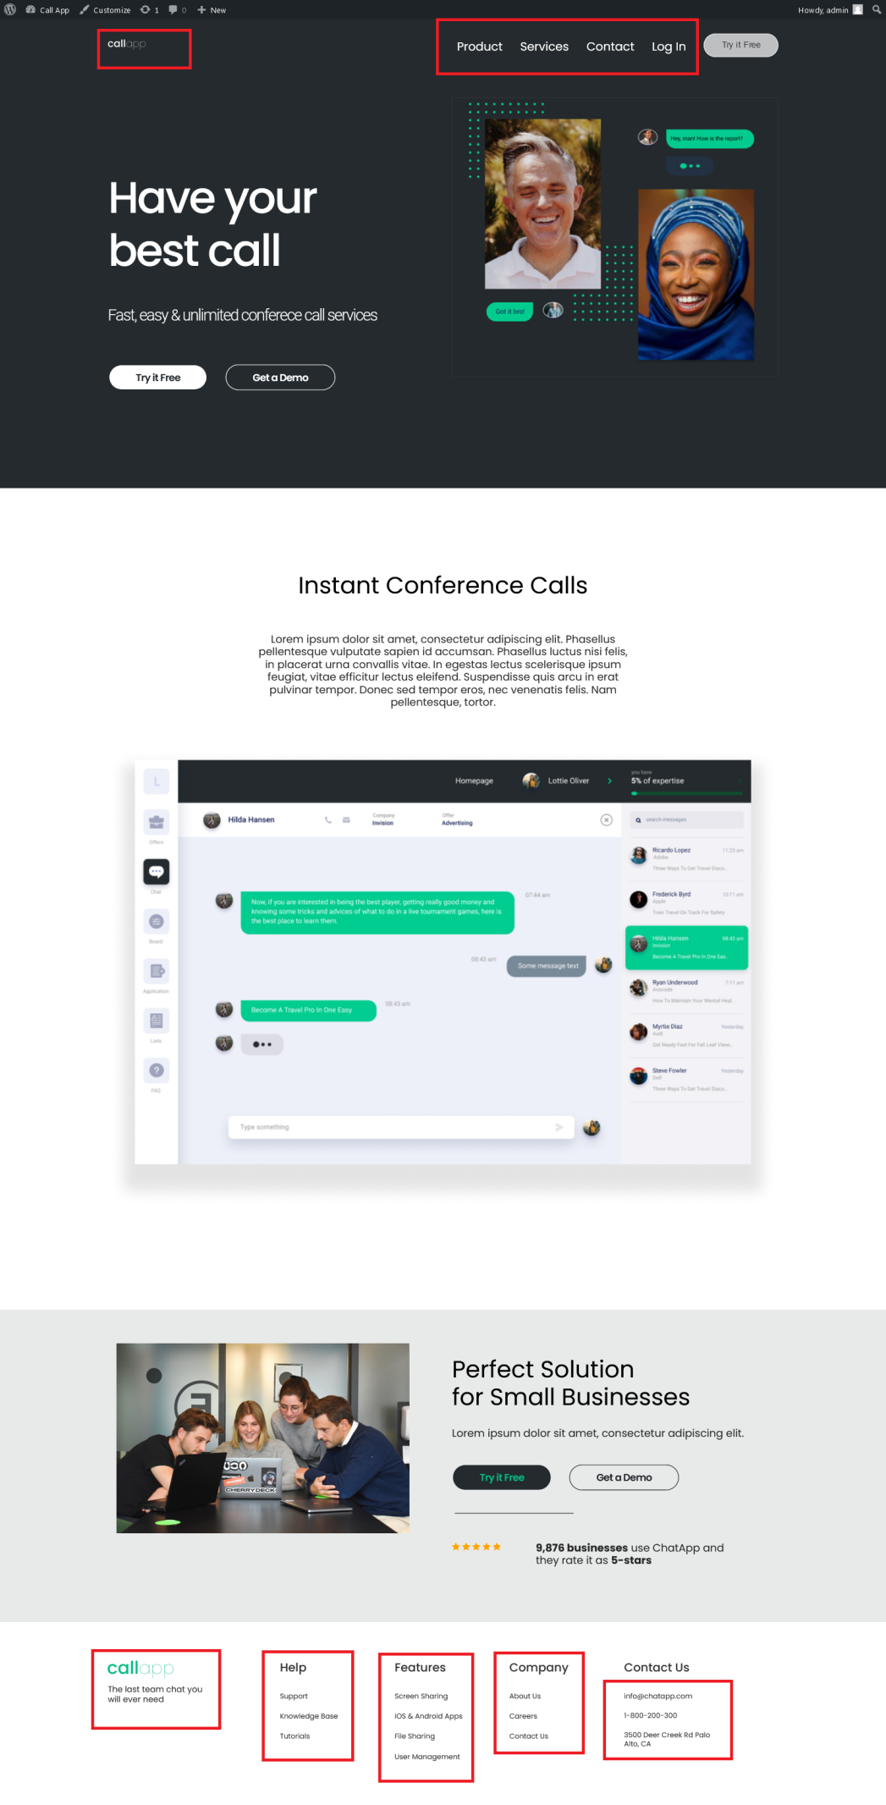

In the above home page sections that are marked are kept as dynamic , so user can change it using the customizer option from the theme.

Thanks.