**BANK LOAN REPORT QUERY DOCUMENT**

1. **BANK LOAN REPORT | SUMMARY**

**KPI’s:**

**Total Loan Applications**

**SELECT COUNT(id) AS Total_Applications FROM bank_loan_data**



**MTD Loan Applications**

**SELECT COUNT(id) AS Total_Applications FROM bank_loan_data**

**WHERE MONTH(issue_date) = 12**



**PMTD Loan Applications  
SELECT COUNT(id) AS Total_Applications FROM bank_loan_data**

**WHERE MONTH(issue_date) = 11**



**Total Funded Amount**

**SELECT SUM(loan_amount) AS Total_Funded_Amount FROM bank_loan_data**



**MTD Total Funded Amount**

**SELECT SUM(loan_amount) AS Total_Funded_Amount FROM bank_loan_data**

**WHERE MONTH(issue_date) = 12**



**PMTD Total Funded Amount**

**SELECT SUM(loan_amount) AS Total_Funded_Amount FROM bank_loan_data**

**WHERE MONTH(issue_date) = 11**



**Total Amount Received**

**SELECT SUM(total_payment) AS Total_Amount_Collected FROM bank_loan_data**



**MTD Total Amount Received**

**SELECT SUM(total_payment) AS Total_Amount_Collected FROM bank_loan_data**

**WHERE MONTH(issue_date) = 12**



**PMTD Total Amount Received**

**SELECT SUM(total_payment) AS Total_Amount_Collected FROM bank_loan_data**

**WHERE MONTH(issue_date) = 11**



**Average Interest Rate**

**SELECT AVG(int_rate)*100 AS Avg_Int_Rate FROM bank_loan_data**



**MTD Average Interest**

**SELECT AVG(int_rate)*100 AS MTD_Avg_Int_Rate FROM bank_loan_data**

**WHERE MONTH(issue_date) = 12**



**PMTD Average Interest**

**SELECT AVG(int_rate)*100 AS PMTD_Avg_Int_Rate FROM bank_loan_data**

**WHERE MONTH(issue_date) = 11**



**Avg DTI**

**SELECT AVG(dti)*100 AS Avg_DTI FROM bank_loan_data**



**MTD Avg DTI**

**SELECT AVG(dti)*100 AS MTD_Avg_DTI FROM bank_loan_data**

**WHERE MONTH(issue_date) = 12**



**PMTD Avg DTI**

**SELECT AVG(dti)*100 AS PMTD_Avg_DTI FROM bank_loan_data**

**WHERE MONTH(issue_date) = 11**



**GOOD LOAN ISSUED**

**Good Loan Percentage**

**SELECT**

**(COUNT(CASE WHEN loan_status = 'Fully Paid' OR loan_status = 'Current' THEN id END) * 100.0) /**

**COUNT(id) AS Good_Loan_Percentage**

**FROM bank_loan_data**



**Good Loan Applications**

**SELECT COUNT(id) AS Good_Loan_Applications FROM bank_loan_data**

**WHERE loan_status = 'Fully Paid' OR loan_status = 'Current'**



**Good Loan Funded Amount**

**SELECT SUM(loan_amount) AS Good_Loan_Funded_amount FROM bank_loan_data**

**WHERE loan_status = 'Fully Paid' OR loan_status = 'Current'**



**Good Loan Amount Received**

**SELECT SUM(total_payment) AS Good_Loan_amount_received FROM bank_loan_data**

**WHERE loan_status = 'Fully Paid' OR loan_status = 'Current'**



**BAD LOAN ISSUED**

**Bad Loan Percentage**

**SELECT**

**(COUNT(CASE WHEN loan_status = 'Charged Off' THEN id END) * 100.0) /**

**COUNT(id) AS Bad_Loan_Percentage**

**FROM bank_loan_data**



**Bad Loan Applications**

**SELECT COUNT(id) AS Bad_Loan_Applications FROM bank_loan_data**

**WHERE loan_status = 'Charged Off'**



**Bad Loan Funded Amount**

**SELECT SUM(loan_amount) AS Bad_Loan_Funded_amount FROM bank_loan_data**

**WHERE loan_status = 'Charged Off'**



**Bad Loan Amount Received**

**SELECT SUM(total_payment) AS Bad_Loan_amount_received FROM bank_loan_data**

**WHERE loan_status = 'Charged Off'**



**LOAN STATUS**

**SELECT**

**loan_status,**

**COUNT(id) AS LoanCount,**

**SUM(total_payment) AS Total_Amount_Received,**

**SUM(loan_amount) AS Total_Funded_Amount,**

**AVG(int_rate * 100) AS Interest_Rate,**

**AVG(dti * 100) AS DTI**

**FROM**

**bank_loan_data**

**GROUP BY**

**loan_status**

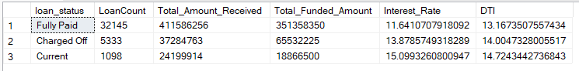

**SELECT**

**loan_status,**

**SUM(total_payment) AS MTD_Total_Amount_Received,**

**SUM(loan_amount) AS MTD_Total_Funded_Amount**

**FROM bank_loan_data**

**WHERE MONTH(issue_date) = 12**

**GROUP BY loan_status**

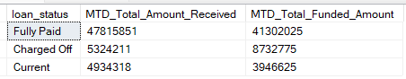

1. **BANK LOAN REPORT | OVERVIEW**

**MONTH**

**SELECT**

**MONTH(issue_date) AS Month_Munber,**

**DATENAME(MONTH, issue_date) AS Month_name,**

**COUNT(id) AS Total_Loan_Applications,**

**SUM(loan_amount) AS Total_Funded_Amount,**

**SUM(total_payment) AS Total_Amount_Received**

**FROM bank_loan_data**

**GROUP BY MONTH(issue_date), DATENAME(MONTH, issue_date)**

**ORDER BY MONTH(issue_date)**

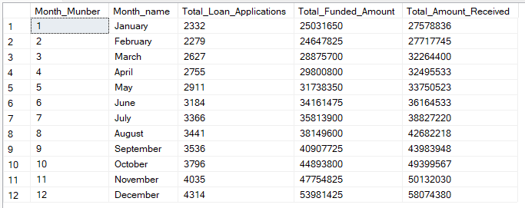

**STATE**

**SELECT**

**address_state AS State,**

**COUNT(id) AS Total_Loan_Applications,**

**SUM(loan_amount) AS Total_Funded_Amount,**

**SUM(total_payment) AS Total_Amount_Received**

**FROM bank_loan_data**

**GROUP BY address_state**

**ORDER BY address_state**

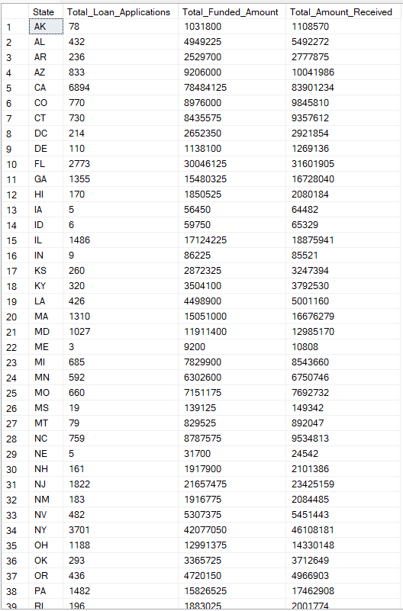

**TERM**

**SELECT**

**term AS Term,**

**COUNT(id) AS Total_Loan_Applications,**

**SUM(loan_amount) AS Total_Funded_Amount,**

**SUM(total_payment) AS Total_Amount_Received**

**FROM bank_loan_data**

**GROUP BY term**

**ORDER BY term**

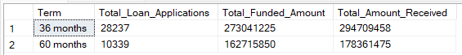

**EMPLOYEE LENGTH**

**SELECT**

**emp_length AS Employee_Length,**

**COUNT(id) AS Total_Loan_Applications,**

**SUM(loan_amount) AS Total_Funded_Amount,**

**SUM(total_payment) AS Total_Amount_Received**

**FROM bank_loan_data**

**GROUP BY emp_length**

**ORDER BY emp_length**

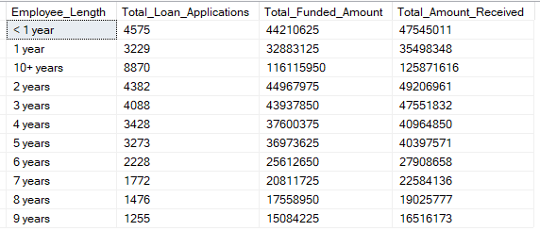

**PURPOSE**

**SELECT**

**purpose AS PURPOSE,**

**COUNT(id) AS Total_Loan_Applications,**

**SUM(loan_amount) AS Total_Funded_Amount,**

**SUM(total_payment) AS Total_Amount_Received**

**FROM bank_loan_data**

**GROUP BY purpose**

**ORDER BY purpose**

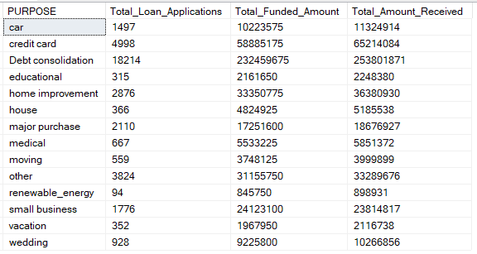

**HOME OWNERSHIP**

**SELECT**

**home_ownership AS Home_Ownership,**

**COUNT(id) AS Total_Loan_Applications,**

**SUM(loan_amount) AS Total_Funded_Amount,**

**SUM(total_payment) AS Total_Amount_Received**

**FROM bank_loan_data**

**GROUP BY home_ownership**

**ORDER BY home_ownership**

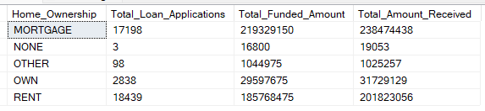

***Note: We have applied multiple Filters on all the dashboards. You can check the results for the filters as well by modifying the query and comparing the results.***

***For e.g***

***See the results when we hit the Grade A in the filters for dashboards.***

***SELECT***

***purpose AS PURPOSE,***

***COUNT(id) AS Total_Loan_Applications,***

***SUM(loan_amount) AS Total_Funded_Amount,***

***SUM(total_payment) AS Total_Amount_Received***

***FROM bank_loan_data***

***WHERE grade = 'A'***

***GROUP BY purpose***

***ORDER BY purpose***