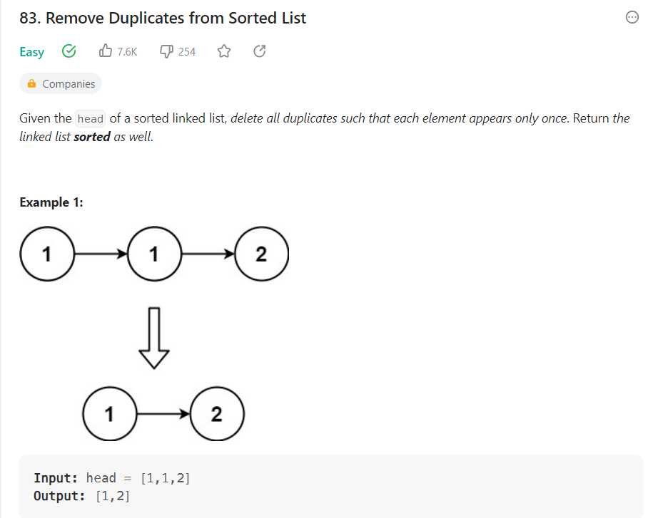

# Definition for singly-linked list.

# class ListNode:

#     def __init__(self, val=0, next=None):

#         self.val = val

#         self.next = next

class Solution:

    def deleteDuplicates(self, head: Optional[ListNode]) -> Optional[ListNode]:

        temp=head

        while temp!=None and temp.next !=None:

            if temp.val==temp.next.val:

                temp.next=temp.next.next

            else:

                temp=temp.next

        return head