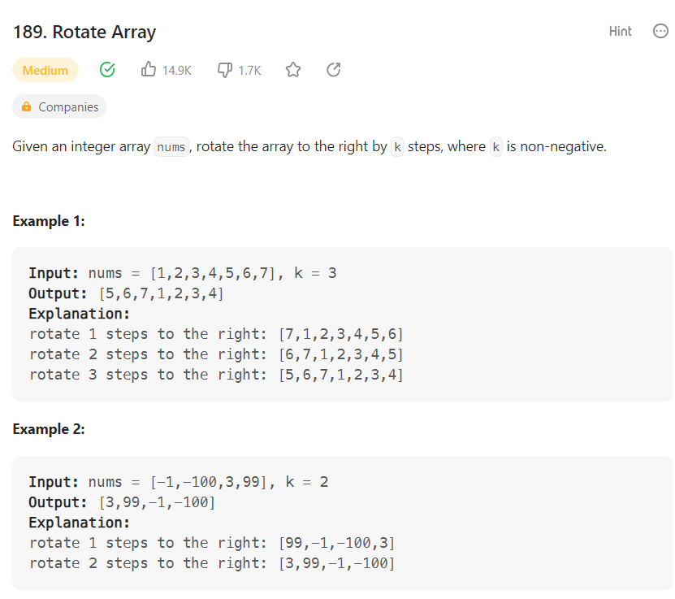

class Solution:

def rotate(self, nums: List[int], k: int) -> None:

"""

Do not return anything, modify nums in-place instead.

"""

'''while k:

safe=nums[-1]

for i in range(len(nums)-1,0,-1):

nums[i]=nums[i-1]

nums[0]=safe

k-=1---🡪 This code exceeds the time limit'''

#optimized code here:

k=k%len(nums)

left=0

right=len(nums)-1

#reverse the list

while left<right:

nums[left],nums[right]=nums[right],nums[left]

left+=1

right-=1

#reverse upto k value

left=0

right=k-1

while left<right:

nums[left],nums[right]=nums[right],nums[left]

left+=1

right-=1

#reverse the remaining

left=k

right=len(nums)-1

while left<right:

nums[left],nums[right]=nums[right],nums[left]

left+=1

right-=1