**Intelligence - Data Engineering - Assessment**

**TASK-5**

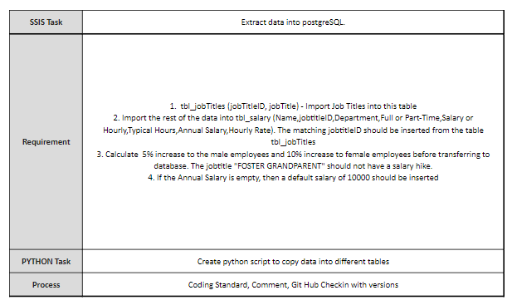

REPORTING MANAGER

PRAKASH RAMACHANDRAN, Senior Technical Architect

Intelligence

Done by Shanthosh. V

Trainee-Software Engineering

**TASK-1**

Pre-processing the dataset

Need to Add New columns (typical hours, hourly rate, salary or hourly, Gender) from the given data

Upload that into Postgresql Database using SSIS.

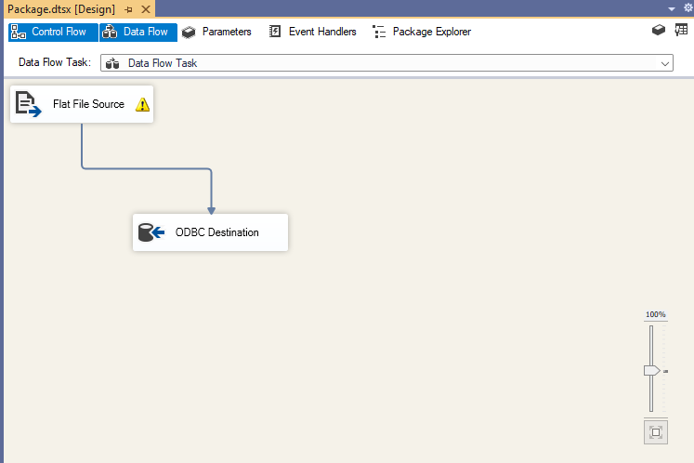

**TASK-2**

Create table tbl_jobtitle with two columns Job title and job titleID

Upload it into postgresql database using python

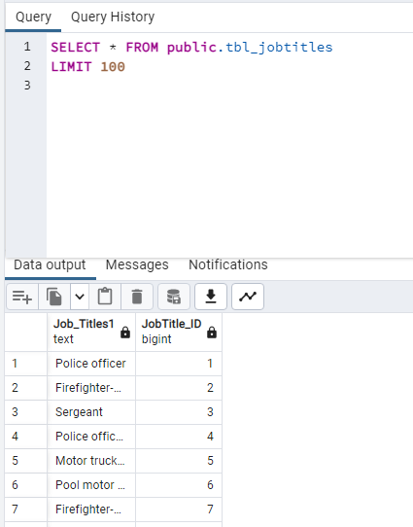

**TASK-3**

Create table tbl_salary with remaining columns and along with that need to add jobtitleID instead of jobtitle.

Upload it into postgresql database using python

