Single and Multi-node Modeling of Direct, Submerged, and Self- pressurization of a Cryogenic Propellant Tank using Nodal Tools
By:
Michael Baldwin, Sarah Nguyen, Brian Hamill, Andre LeClair, and Alok Majumdar
NASA Marshall Space Flight Center, Huntsville, AL 35812

Extended Abstract
The pressurization of cryogenic propellant tanks will always be an important process so long as cryogenic liquids are being considered as fuel sources or used for other in-space applications. Pressure control of the tank ullage is necessary for managing propellant flowrates to an engine or a receiver tank, and modeling of the process is used to predict the pressurant requirements and the amount of propellant boiloff. Direct ullage pressurization is the more traditional approach to tank pressurization, as the physics are straight-forward, and ample test (flight) data have been collected and analyzed over the past several decades. Submerged injection pressurization is an alternate method for tank pressurization and has been shown to reduce pressurant requirements, subcool the propellant, and reduce the risk of ullage collapse. Additionally, the pressurant gas entering the ullage is usually much colder when using the submerged pressurization approach, resulting in reduced propellant boiloff. These benefits are at the expense of vaporizing a small percentage of the propellent.
Both tank pressurization methods are viable options for current and future space missions, and it is important to have the capability of analyzing the tank ullage conditions for both approaches. Our previous work has demonstrated the development of a Generalized Fluid System Simulation Program (GFSSP) model, which contains a thermodynamic equilibrium heat and mass transfer subroutine capable of effectively analyzing both direct and submerged pressurization systems [1-2]. This subroutine has most recently been enhanced to include the non-equilibrium effect of pressurant dissolution into the propellant. To date the ullage has always been represented as a single node, and although the simulated single-node temperatures have good comparison with the volume-averaged ullage temperatures computed from test data, the physics of the thermal stratification in the ullage were never captured, and adjustment factors in the model were required.
The purpose of this paper is to introduce the development of a multi-node ullage model using GFSSP and to discuss the improvements of the simulated ullage temperature distribution and its resulting effects on ullage heat transfer processes. Test data from the Cryogenic Propellant Storage and Transfer Engineering Developmental Unit (CPST EDU) was used for model validation. For additional comparison, a Thermal Desktop (TD) model was also developed to analyze the CPST EDU direct ullage pressurization tests using both a single node and multi-node approach. The model includes the direct pressurant line, vent line, fill/drain line, and a TD FloCAD Compartment. The TD FloCAD Compartment is employed to represent the liquid and ullage as single volumes inside the tank, to include a liquid/vapor interface, and to generate network level objects such as lumps (analogous to nodes in GFSSP), paths, and ties between the fluid and thermal elements. An established heat load on the model tank was leveraged from a pre-existing higher-fidelity model correlated to CPST EDU test data.
Figure 1 below shows the eight-node ullage GFSSP model, and Figure 2 provides a comparison of predicted temperatures with CPST EDU test data temperatures at identical fill levels for one of the four submerged pressurization cases. The maximum error in this case is under 20%. Figure 3 provides an image of the TD model of the CPST EDU tank, and Figure 4 shows a comparison of one of the direct ullage pressurization TD cases with the test data.

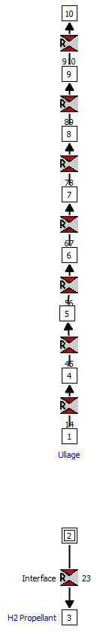
Figure 1: GFSSP eight-node ullage model of the CPST EDU tank

Figure 2: GFSSP model-predicted temperatures for a submerged injection CPST EDU test case

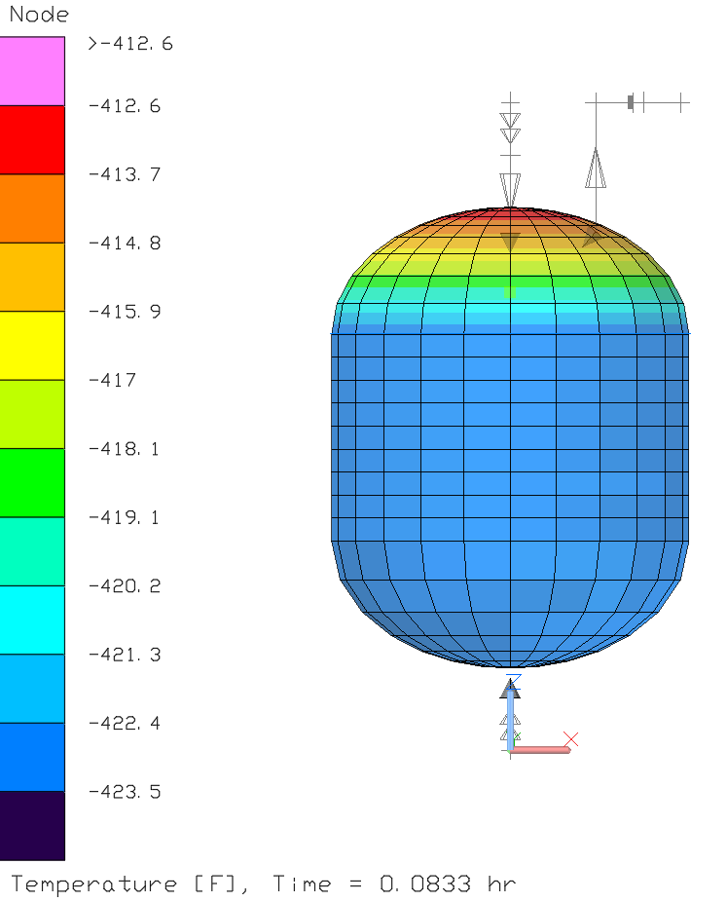
Figure 3: Thermal Desktop model of the CPST EDU tank

Figure 4: Thermal Desktop model-predicted pressures for a direct ullage injection and self-pressurization CPST EDU test case

References
[1] Baldwin, Michael, Alok K. Majumdar, and Andre LeClair. "Nodal Numerical Modeling of Submerged Helium Injection in a Cryogenic Propellant Tank."AIAA SCITECH 2023 Forum. 2023.
[2] Baldwin, Michael, Alok K. Majumdar, and Andre LeClair. "Nodal Modeling of Submerged Helium Injection Pressurization of a Cryogenic Propellant Tank."Space Cryogenic Workshop 2023 Forum. 2023.

