Deployment

Write a small document to describe how would you deploy your web service. How would you ensure your solution can scale to meet increased demand?

*Deploy Web service*

* Set Up and follow a Workflow for deployment on Production

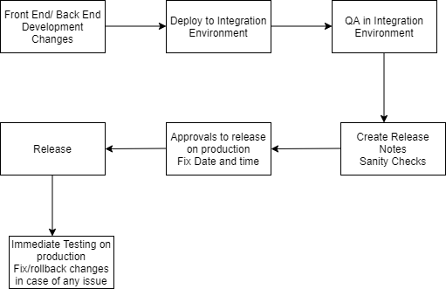

*Ensure Scalability*

* Create simple API Architecture from start.
* Take measures required to handle:

traffic by caching REST API request

handle server overload by using shared machines

unexpected user request by providing failed query message for better user experience.

* Identify real time blockers or bottlenecks at the time of release. This helps to analyse release trends with respect to types of development changes and variety of requests from the users. Also prepares us to anticipate next release.
* Identify reusability of code at the beginning and create generic folder structure for team.
* Split complex scripting into classes or extendable templates.
* Follow standards of coding like avoid hard coding, apply indentation, meaningful naming conventions, adding comments.
* Adapt to solutions that can give opportunity to improve performance.