# **Project 2 - Bonus**

# **Keerthana Bhuthala. Santhi Sushma Katragadda**

# **5251-1292 1748-9431**

We tested failure for all topologies for gossip and push sum.

How did we introduce failure?

We created a function failNodes to introduce failure into the topology by converting some of the noes to inactive. Number of failure nodes is given as percentage to the input after topology.

The function failNodes converts some of the nodes to inactive state.

How did we handle failure?

We handled failure scenario by checking if the node is in active state or inactive state before sending message or sum. For the scenario where the node is inactive we selected another neighbor randomly to replace the inactive node.

How did we plot?

We have plotted graphs for Full, Line and grid with x-axis to be percentage of failed nodes and y-axis to convergence time in logarithmic form.

Observation:

In the plots below, x-axis is the percentage of failed nodes that we give as input and y axis is the convergence time.

As we increase the percentage of failed nodes we see that convergence time becomes constant. As it increases it reaches a constant value.

Plots:

Gossip

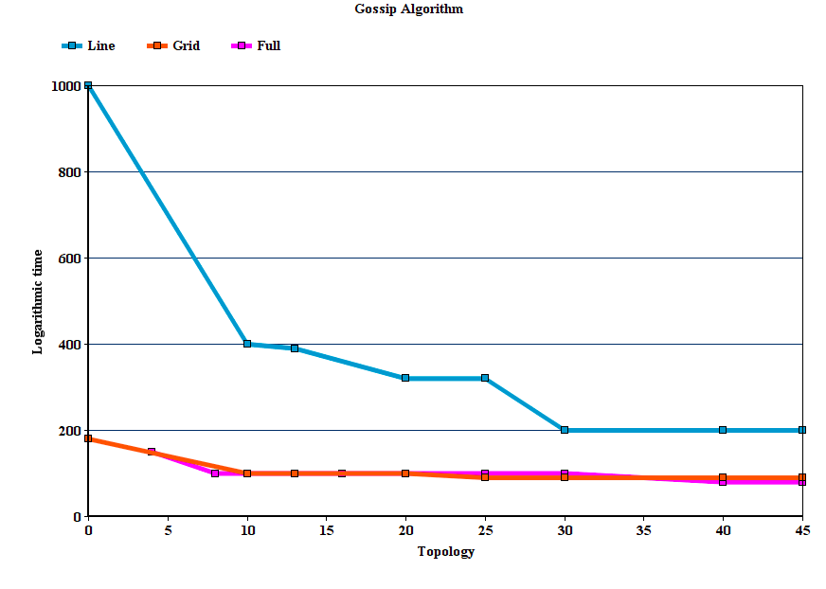

Push Sum

