**Sudoku Game with 3 levels easy, tough and medium.**

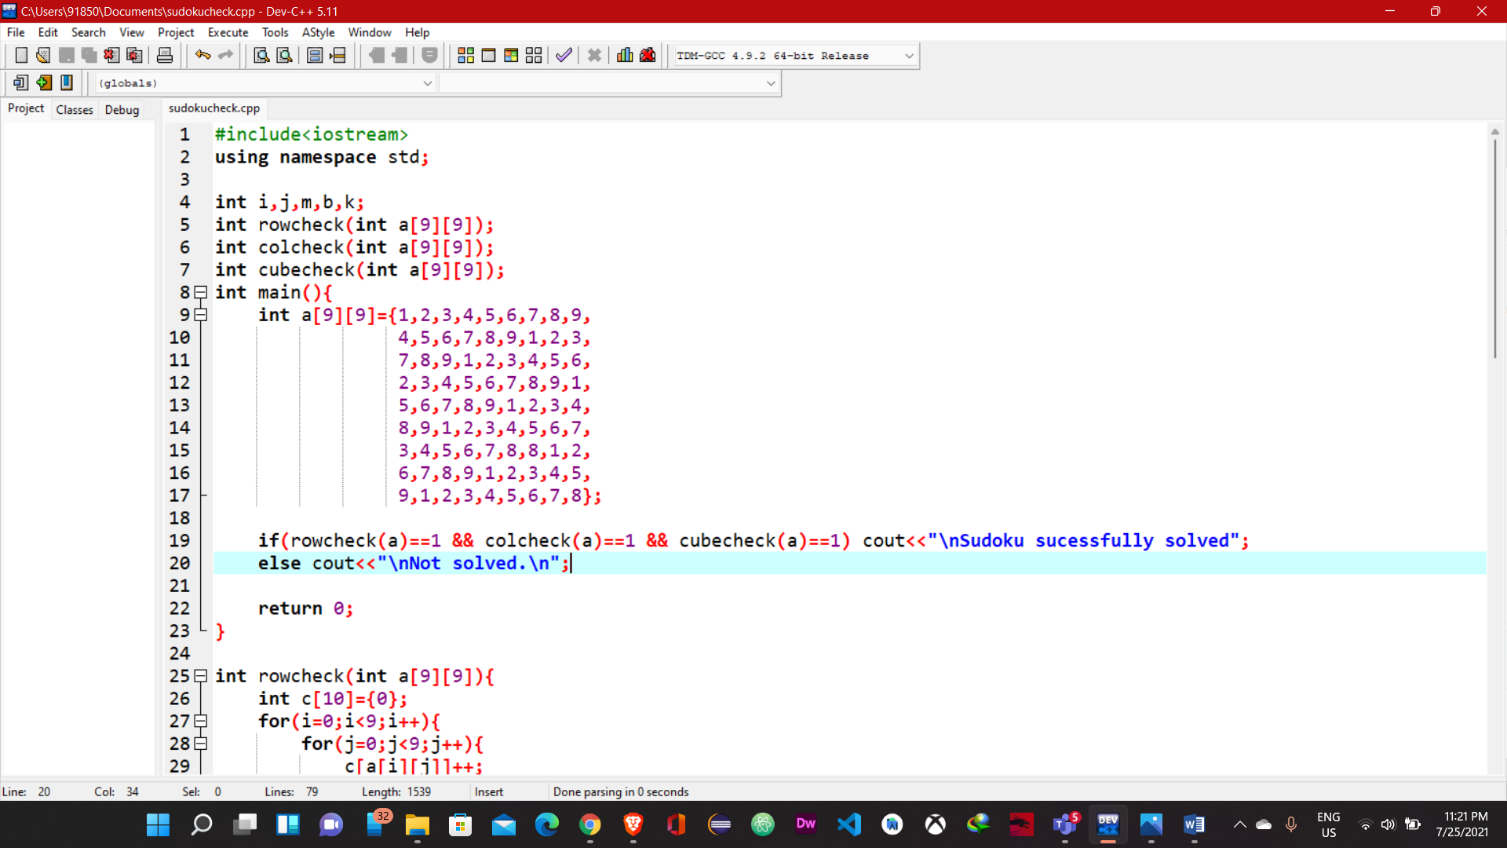

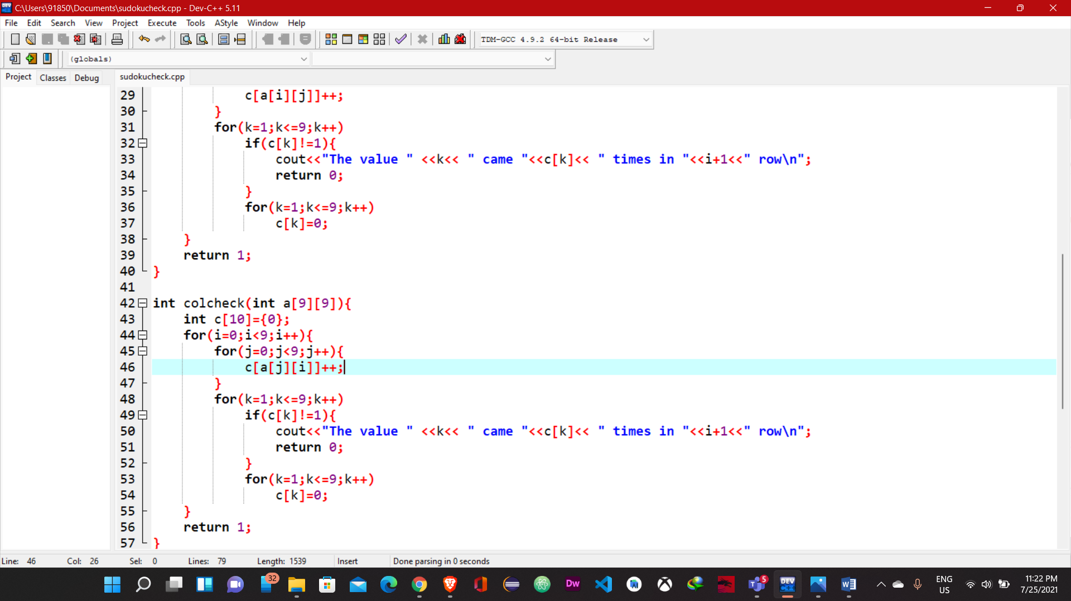

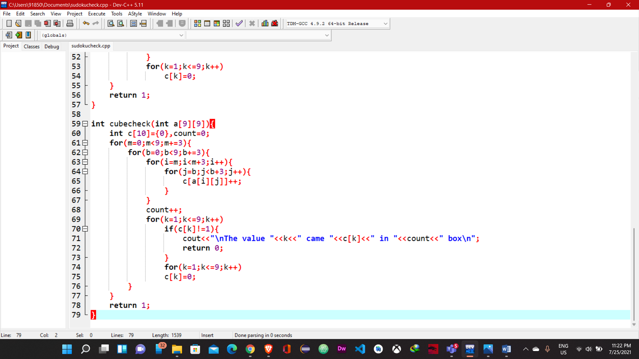

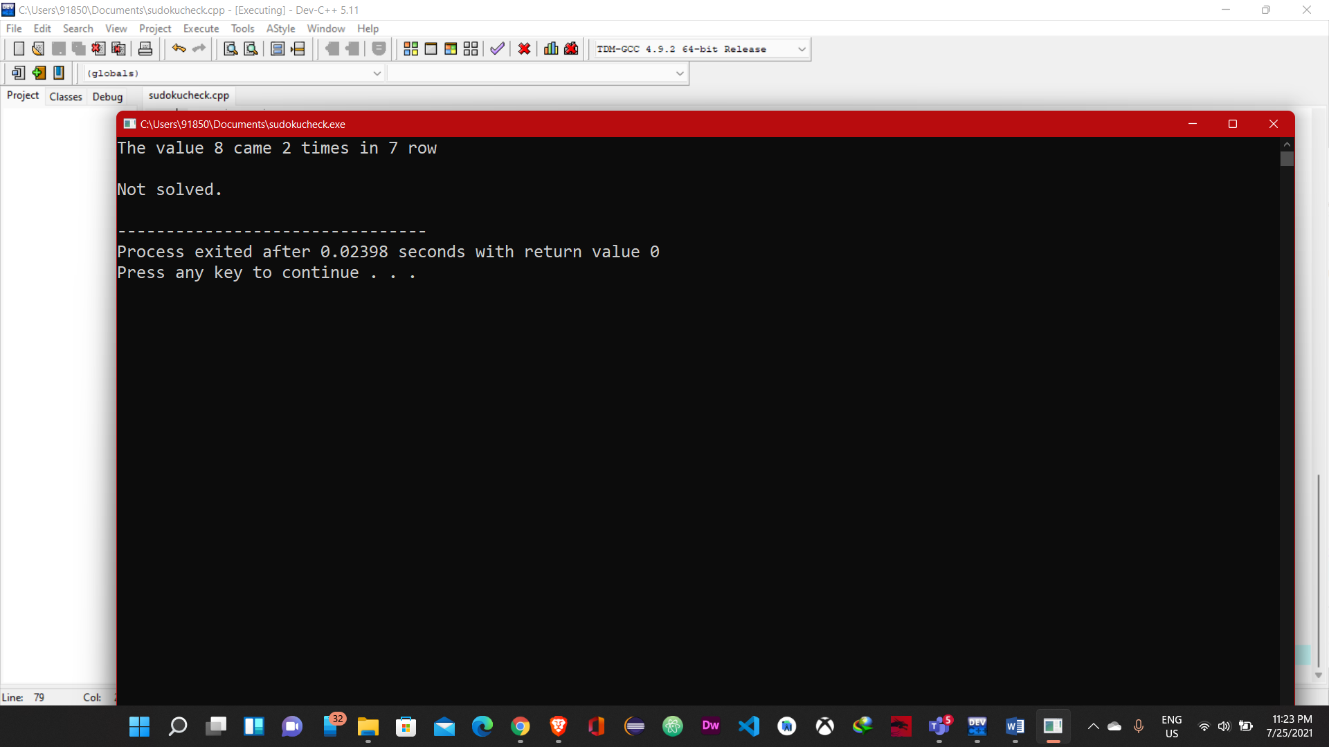

**Code:**

#include<iostream>

using namespace std;

int i,j,m,b,k;

int rowcheck(int a[9][9]);

int colcheck(int a[9][9]);

int cubecheck(int a[9][9]);

int main(){

int a[9][9]={1,2,3,4,5,6,7,8,9,

4,5,6,7,8,9,1,2,3,

7,8,9,1,2,3,4,5,6,

2,3,4,5,6,7,8,9,1,

5,6,7,8,9,1,2,3,4,

8,9,1,2,3,4,5,6,7,

3,4,5,6,7,8,8,1,2,

6,7,8,9,1,2,3,4,5,

9,1,2,3,4,5,6,7,8};

if(rowcheck(a)==1 && colcheck(a)==1 && cubecheck(a)==1) cout<<"\nSudoku sucessfully solved";

else cout<<"\nNot solved.\n";

return 0;

}

int rowcheck(int a[9][9]){

int c[10]={0};

for(i=0;i<9;i++){

for(j=0;j<9;j++){

c[a[i][j]]++;

}

for(k=1;k<=9;k++)

if(c[k]!=1){

cout<<"The value " <<k<< " came "<<c[k]<< " times in "<<i+1<<" row\n";

return 0;

}

for(k=1;k<=9;k++)

c[k]=0;

}

return 1;

}

int colcheck(int a[9][9]){

int c[10]={0};

for(i=0;i<9;i++){

for(j=0;j<9;j++){

c[a[j][i]]++;

}

for(k=1;k<=9;k++)

if(c[k]!=1){

cout<<"The value " <<k<< " came "<<c[k]<< " times in "<<i+1<<" row\n";

return 0;

}

for(k=1;k<=9;k++)

c[k]=0;

}

return 1;

}

int cubecheck(int a[9][9]){

int c[10]={0},count=0;

for(m=0;m<9;m+=3){

for(b=0;b<9;b+=3){

for(i=m;i<m+3;i++){

for(j=b;j<b+3;j++){

c[a[i][j]]++;

}

}

count++;

for(k=1;k<=9;k++)

if(c[k]!=1){

cout<<"\nThe value "<<k<<" came "<<c[k]<<" in "<<count<<" box\n";

return 0;

}

for(k=1;k<=9;k++)

c[k]=0;

}

}

return 1;

}