Project 2
Shanti O’Neil
2025-11-11
Table of Contents

Plot 1
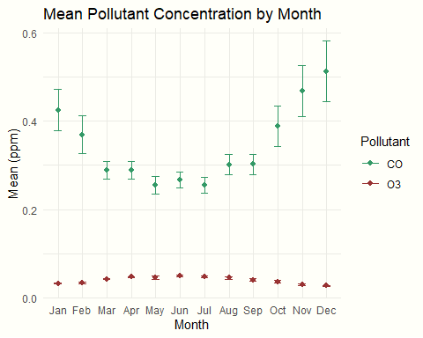

Plot 2
